Nithiyashree V K | Kumaraguru College of Technology

**Video Games Sales Analysis**

# Dataset

**1907** Rows and **13** Columns

Time Period : **1983 - 2012**

Visualization

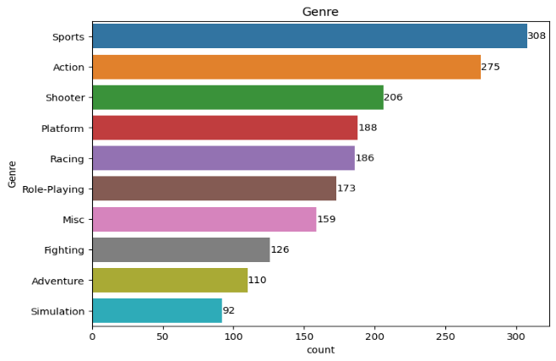

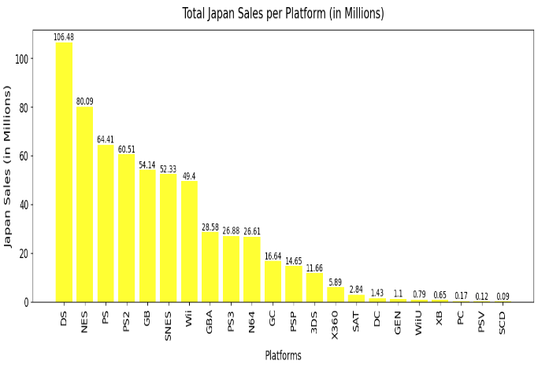

Inference & Implications

* Most Sold Genre is **Sports**
* Most Sold Publisher is **Electronic Arts**
* Many games were sold in the Platform **PS2**.
* Most of the Games were released in the year **2003**.
* It can be noted that, in Japan, Platform PS2 is in the 4rth Place, whereas in other countries it is in the 1st Position. PS2 has **less** customers in Japan.
* Platform **DS** holds the First Position in **Japan**, followed by NES and PS.
* The most popular genre in all other countries is **Sports**, whereas in Japan it is **Role-Playing**. The Customer Base is Different in **Japan**.