

Sri Lanka Institute of Information Technology

Assignment 1
Report

Data Warehousing and Business Intelligence [IT3021]

Submitted by:
Registration Number | Name | Email
IT23227804 | N.V.RANDUNUGE | it23227804@my.sliit.lk

Date of submission: 03/04/2026

Table of Contents

Introduction 3
Task 01: Dataset Description 4
Dataset Statistics 4
Entities Identified in the Database 5
Entity-Relationship Diagram (OLTP View) 6
Task 02: Preparation of Data Sources 7
Task 03: Solution Architecture 8
Task 04: Data Warehouse Design & Development 9
The Grain Statement 9
Schema Type: Star Schema 10
Slowly Changing Dimension 10
Hierarchies for SSAS 11
Design Assumptions & Decisions 11
Implementation in SQL Server 12
Stagging 13
Task 05: ETL Development with SSIS 15
Task 6 : Accumulating Fact Table 18
Extending the Fact Table Schema 19
Package 3 : Data Flow Detail 20
Validation 21

Introduction

This report presents the design and implementation of a data warehouse solution based on a hotel booking reservation dataset. The project follows the standard DWBI lifecycle, including data source preparation, data warehouse design, and the development of Extract, Transform, Load (ETL) processes using SQL Server Integration Services (SSIS). The primary objective is to transform transactional booking data into a dimensional model that supports analytical querying and reporting.

The solution is built using a star schema design, incorporating fact and dimension tables to enable efficient data analysis. Key concepts such as Slowly Changing Dimensions (SCD), data staging, and accumulating fact tables are applied to ensure historical accuracy and support advanced business insights.

Overall, this project shows how data can be organized and processed to support better insights and decision-making.

Task 01: Dataset Description

Dataset – Hotel Booking Reservation
Data Source – hotel-booking-reservation

The selected dataset is the Hotel Bookings Dataset (2024), containing 119,390 hotel reservation records across 30 hotels in 15 Indian cities. Each row represents a single, real booking event, capturing everything from the guest's country of origin and room preferences to the average daily rate they paid and whether they ultimately cancelled.
The dataset spans the full calendar year of 2024 (January through December), with approximately 10,000 bookings per month distributed evenly across all months. Hotels are split between two types, City Hotels and Resort Hotels, spread across major Indian cities including Mumbai, Delhi, Hyderabad, Kolkata, Goa, and more.

Dataset Statistics
Metric | Value
Total Booking Records | 119,390
Total Columns | 33
Date Coverage | January 2024 – December 2024 (full year)
Number of Hotels | 30 (15 City Hotels + 15 Resort Hotels)
Cities Covered | 15 Indian cities
Unique Guest Countries | 178 countries
Cancellation Rate | 37.0% (44,224 out of 119,390)
Average Daily Rate (ADR) | INR 102 avg (range: -6 to 5,400)
Missing Values | children: 4 rows; country: 488; agent: 16,340; company: 112,593
Table 1 - Dataset Statistics

Entities Identified in the Database

Although the raw data is a flat CSV file, it actually contains information about multiple real-world entities mixed together. The entities are:

- Hotel : captured via the hotel column. Contains hotel name, type (City/Resort), and city. This is master reference data.
- Booking (the core transaction) : each row is one booking. Captured via dates, stay length, ADR, booking changes, deposit type, and status.
- Guest / Customer : captured via adults, children, babies, customer_type, country, is_repeated_guest. Represents who made the booking.
- Room : captured via reserved_room_type and assigned_room_type. Note guests often get a different room than they requested.
- Meal Plan : captured via the meal column. Represents what dining package was included.
- Agent : captured via the agent column. A numeric ID for the travel agent who made the booking (NULL = direct booking).
- Market Segment : captured via market_segment, distribution_channel, deposit_type. How and through what channel the booking was made.
- Date : captured via arrival_date_year, arrival_date_month, arrival_date_week_number, arrival_date_day_of_month.

Entity-Relationship Diagram (OLTP View)
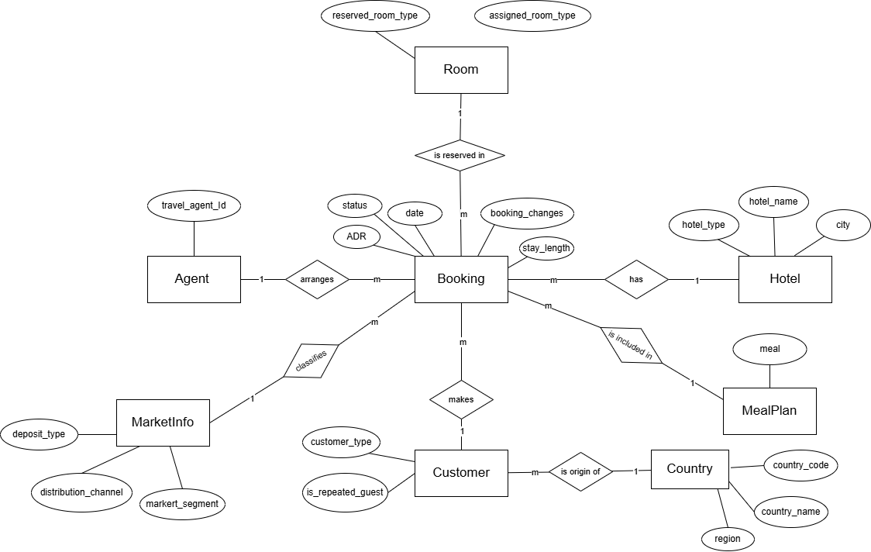
Figure 1 - Entity Relationship Diagram

Task 02: Preparation of Data Sources

Source | File / Object | Format | Contents | Feeds DW Object
Source 1 | source1_hotels (SQL Table) | SQL Server Table | hotel_id, hotel_name, hotel_type, city  30 rows of hotel master data | dim_hotel
Source 2 | source2_country_ref.xlsx | Excel (.xlsx) | country_code, country_name, region  177 country lookup rows | dim_country
Source 3 | source3_bookings_core.csv | CSV Flat File | All 119,390 booking transactions with 33 columns, the main OLTP event log | fact_bookings + dim_customer, dim_room, dim_meal, dim_agent, dim_market, dim_date
Table 2 - Data Sources Description

Task 03: Solution Architecture
Architecture Overview
The solution follows the classic four-layer DW/BI reference architecture:
Source → Staging/ETL → Data Warehouse → BI

Each layer has a distinct responsibility, and data flows strictly from left to right (or top to bottom). This separation of concerns means that a problem in one layer (for example, a corrupt source file) can be isolated and fixed without affecting the other layers.

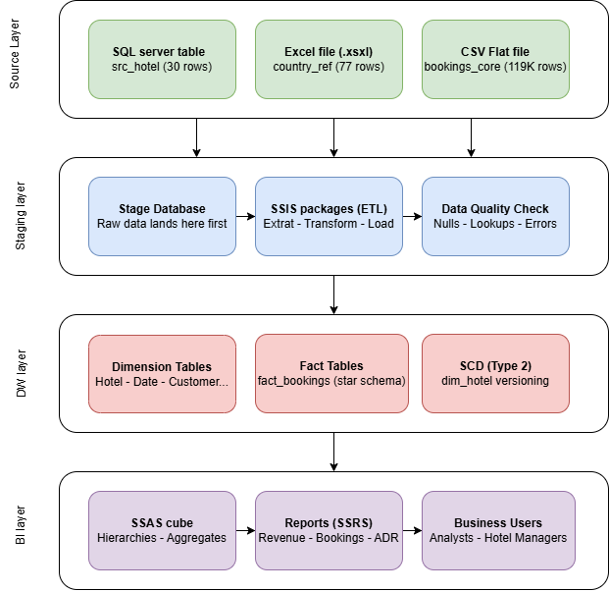
Figure 2 - Solution Architecture Diagram

Task 04: Data Warehouse Design & Development

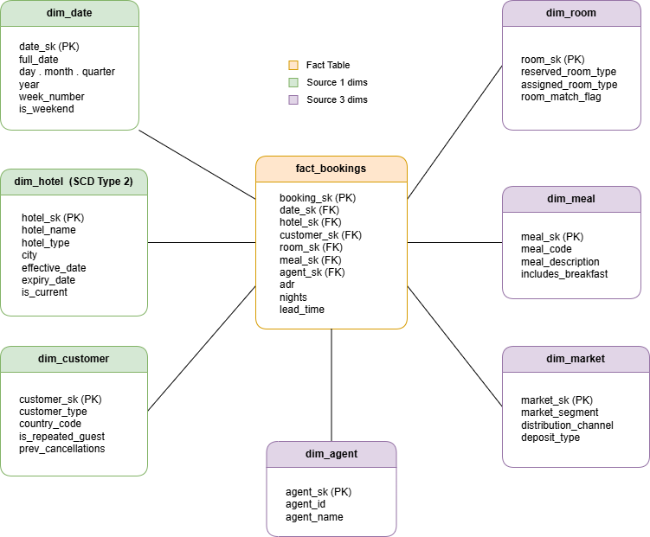
Figure 3 - Star Schema for Hotel Booking DW

The Grain Statement
The grain of this is that, each row in fact_bookings represents one hotel booking reservation -a single customer booking at a single hotel for a single arrival date.
This means, two bookings at the same hotel on the same day are two separate rows. One booking that was later cancelled is still one row (with is_canceled = 1). The grain never changes after it is defined.

Schema Type: Star Schema

This hotel bookings data warehouse design uses a Star Schema.
A Star Schema was chosen over a Snowflake Schema for its better query performance, as it uses simple joins between the fact table and dimension tables without complex chains. It is also more compatible with SQL Server Analysis Services (SSAS), making cube creation easier through automatic relationship detection. Additionally, it enhances readability, allowing business users and developers to understand the schema without deep SQL knowledge.

Slowly Changing Dimension

In this warehouse, dim_hotel uses SCD Type 2 because hotel classifications are meaningful historically. If a hotel was reclassified from a City Hotel to a Resort Hotel in July 2024, bookings made in January 2024 should correctly reflect "City Hotel”, not the new classification.

Consider a hotel starts as a City Hotel. In July it is reclassified as a Resort Hotel. Instead of overwriting the record, two rows now exist:

hotel_sk | hotel_id | hotel_name | hotel_type | city | eff_date | exp_date | is_current
1 | 1 | City Hotel - Mumbai | City Hotel | Mumbai | 2024-01-01 | 2024-06-30 | 0
2 | 1 | City Hotel - Mumbai | Resort Hotel | Mumbai | 2024-07-01 | NULL | 1

Old bookings (made before July) have hotel_sk = 1, so they correctly report as "City Hotel". New bookings (after July) have hotel_sk = 2 and correctly report as "Resort Hotel". The is_current = 1 flag tells SSIS which row to use when loading new bookings. The expiry_date = NULL on the current row means it has not yet been superseded.

Hierarchies for SSAS

Hierarchies that exist in this schema:

- Date hierarchy: Year → Quarter → Month → Day (all columns in dim_date)
- Hotel hierarchy: Hotel Type → City → Hotel Name (all columns in dim_hotel)
- Geography hierarchy: Region → Country → Country code
- Market hierarchy: Market Segment → Distribution Channel → Deposit Type (all in dim_market)

Design Assumptions & Decisions
- Assumption 1- No individual guest identity:
The dataset has no guest names, email addresses, or loyalty numbers. The dim_customer dimension therefore represents a customer profile (type + country + repeat status) rather than a named individual. Multiple bookings with the same profile share one customer_sk.
- Assumption 2 - NULL agents = direct bookings:
The 16,340 NULL values in the agent column are treated as direct/walk-in bookings. A dedicated dim_agent record (agent_id = 0, agent_name = "Direct / No Agent") is created so that the fact table foreign key is never NULL.
- Assumption 3 - NULL children = 0 children:
The 4 NULL values in the children column were replaced with 0 in the source preparation step (Task 2), as NULL children simply means no children — not missing data.
- Assumption 4 - room_match_flag is derived:
The column room_match_flag in dim_room is not in the source data — it is calculated during ETL as 1 if reserved_room_type = assigned_room_type, else 0.

Implementation in SQL Server

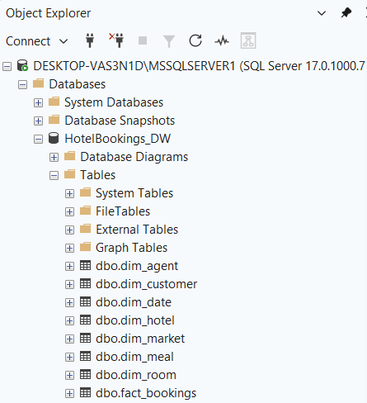
Figure 4 - Screenshot of Object Explorer in SSMS

Verification query to confirm row counts
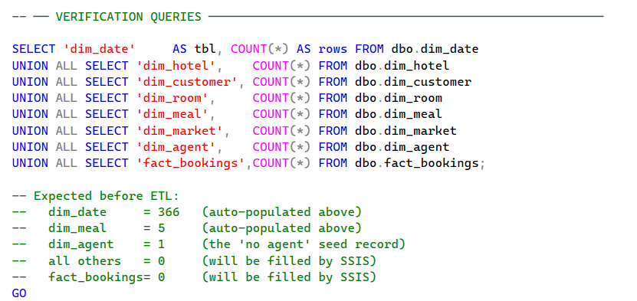
Figure 5 – Screenshot of Verification Queries
Results of the verification query:

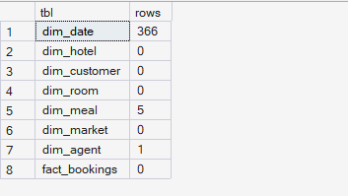
Figure 6 - Screenshot of the query result

Three tables are pre-populated: dim_date (366 rows for all of 2024), dim_meal (5 rows), and dim_agent (1 seed row for direct bookings).

Stagging
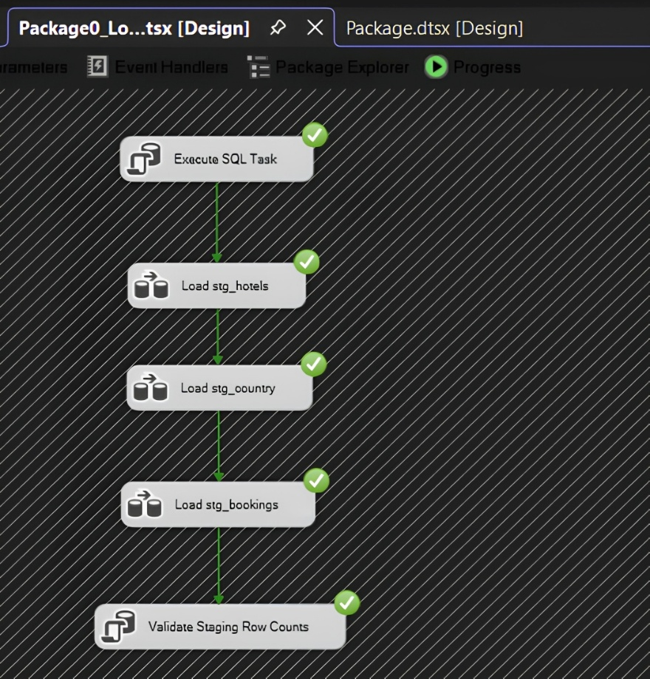
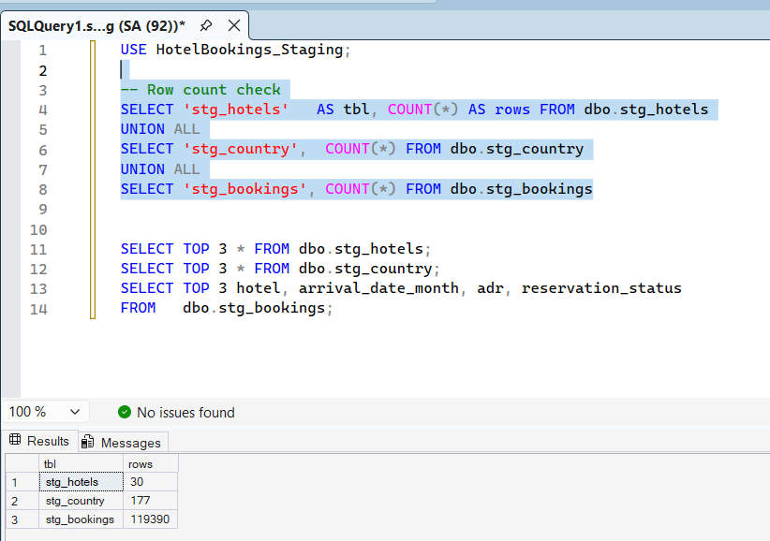

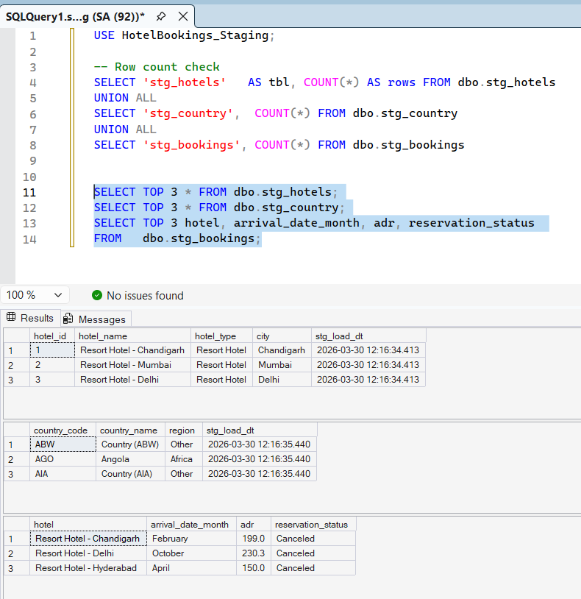

Task 05: ETL Development with SSIS

The ETL is split into several packages :

Package | File name | Reads from | Writes to
Package 1 | Package1_Load_Dimensions.dtsx | SQL table, Excel file, CSV | All 7 dimension tables
Package 2 | Package2_Load_Fact.dtsx | Bookings CSV | fact_bookings
Package 3 (Task 6) | Package3_Accum_Fact.dtsx | Completions CSV | fact_bookings (UPDATE)

Package 1 : Load Dimensions
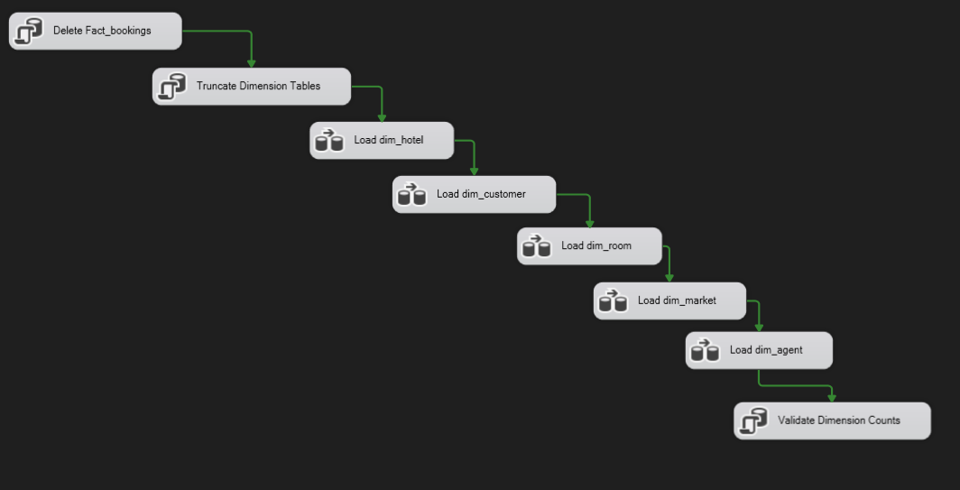
Figure 7 - Screenshot of SSIS Package1

Slowing changing dimensions

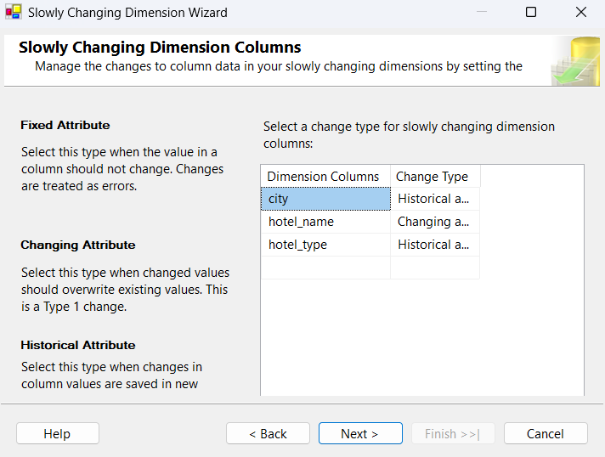

Package 2 : Load fact table

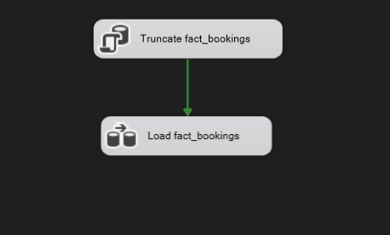
Figure 8 - Screenshot of SSIS Package 2
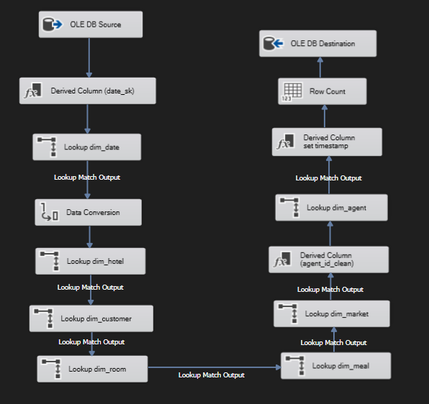
Figure 9 - Inside Load fact_bookings

Task 6 : Accumulating Fact Table
In this project, a hotel booking passes through two key milestones:
- Creation — the booking enters the data warehouse during the initial ETL load (Package 2).
- Completion — the booking is later marked as fully processed, with an associated completion timestamp.

The two additional columns added to fact_bookings to support this pattern are described in the table below.

Column Name | Data Type | Description
accm_txn_create_time | DATETIME | Records when the booking row was first inserted into the data warehouse fact table. Set to GETDATE() at load time by a Derived Column transform in Package 2.
accm_txn_complete_time | DATETIME | Records when the booking transaction was marked as completed. Initially NULL; updated by Package 3 when a completion record is received.
txn_process_time_hours | FLOAT | Computed as the difference in hours between accm_txn_complete_time and accm_txn_create_time. Calculated by Package 3 at the time of update.

Extending the Fact Table Schema

The fact_bookings table created in Task 4 is altered to add the three new columns. The SQL below was executed in SQL Server Management Studio (SSMS) against the HotelBookings_DW database
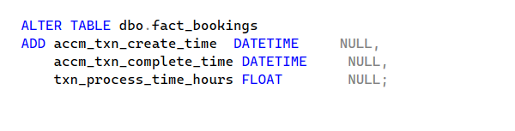
Setting accm_txn_create_time in Package 2

Package 2 (Package2_Load_Fact.dtsx) was updated to populate accm_txn_create_time at insert time. This was done by adding a Derived Column transform immediately before the OLE DB Destination inside the Package 2 Data Flow Task

Preparing the Completion Dataset
A separate source dataset was prepared to simulate the arrival of booking completion records. This file (source4_completions.csv) represents downstream system updates that confirm a booking transaction has been fully processed.

Sample File Content
txn_id,accm_txn_complete_time
1001,2024-08-17 14:23:00
1042,2024-08-18 09:45:30
2089,2024-08-20 16:10:15
3154,2024-08-21 11:00:00
5003,2024-08-22 08:30:45

Accumulating Fact Update Package

A new SSIS package named Package3_Accum_Fact.dtsx was created to read the completions CSV and update the corresponding rows in the fact_bookings table. This package implements the accumulating fact update pattern: it reads each completion record, matches it to a fact row using the natural key, and executes an SQL UPDATE to set accm_txn_complete_time and compute txn_process_time_hours.

Package 3 : Data Flow Detail
# | Component Name | Component Type | What it does
1 | Flat File Source — completions CSV | Flat File Source | Reads source4_completions.csv row by row. Outputs two columns: txn_id (DT_I4) and accm_txn_complete_time (DT_STR).
2 | Convert completion timestamp | Data Conversion | Converts the accm_txn_complete_time string column from DT_STR to DT_DBTIMESTAMP so it can be used in a datetime comparison and UPDATE. Output column named: completion_ts.
3 | Compute process time hours | Derived Column | Adds a new column txn_process_time_hours_calc using the expression: (DT_R8)((completion_ts - accm_txn_create_time_from_fact) is not directly available here — instead the SQL UPDATE in the OLE DB Command calculates it inline). See note below.
4 | OLE DB Command — update fact_bookings | OLE DB Command | Executes one parameterized SQL UPDATE statement per row, matching on booking_id = txn_id and setting both accm_txn_complete_time and txn_process_time_hours in a single statement.

Validation
Validation Query 1 : Count of rows with completion time set

SELECT COUNT(*) AS completed_bookings
FROM dbo.fact_bookings
WHERE accm_txn_complete_time IS NOT NULL;

Result : equal the number of rows in source4_completions.csv that matched a booking_id in fact_bookings

Validation Query 2 : Spot-check - verify process time calculation

SELECT TOP 10
booking_id,
accm_txn_create_time,
accm_txn_complete_time,
txn_process_time_hours,
DATEDIFF(SECOND, accm_txn_create_time, accm_txn_complete_time) / 3600.0
AS cross_check_hours
FROM dbo.fact_bookings
WHERE accm_txn_complete_time IS NOT NULL
ORDER BY booking_id;

Result: identical txn_process_time_hours and cross_check_hours for every row, confirming the DATEDIFF calculation stored by Package 3 matches an independent recalculation

Validation Query 3 : Confirm NULL rows (bookings not yet completed)

SELECT COUNT(*) AS pending_bookings
FROM dbo.fact_bookings
WHERE accm_txn_complete_time IS NULL;

Result: completed_bookings + pending_bookings = 119,390 (total fact rows). All rows are accounted for

Validation Query 4 : Average processing time by hotel type

SELECT d.hotel_type,
COUNT(*) AS completed_count,
AVG(f.txn_process_time_hours) AS avg_process_hours,
MIN(f.txn_process_time_hours) AS min_process_hours,
MAX(f.txn_process_time_hours) AS max_process_hours
FROM dbo.fact_bookings f
JOIN dbo.dim_hotel d ON f.hotel_sk = d.hotel_sk
WHERE f.accm_txn_complete_time IS NOT NULL
GROUP BY d.hotel_type
ORDER BY avg_process_hours DESC;

Demonstrates a real business insight enabled by the accumulating fact pattern. Shows the average processing time in hours per hotel type, allowing comparison of operational efficiency across hotel categories.
