

Sri Lanka Institute of Information Technology

Assignment 2
Report

Data Warehousing and Business Intelligence [IT3021]

Submitted by:
Registration Number | Name | Email
IT23227804 | N.V.RANDUNUGE | it23227804@my.sliit.lk

Date of submission: 03/04/2026

Table of Contents
Data Source 3
SSAS Cube Implementation 3
Creating Data Cubes 3
Creating KPI 3
Creating a Role 3
Browsig Cube data 3
Demostration of OLAP Operations 3
Roll-up 3
Drill-down 3
Slice 3
Pivot 3
Dice 3
PowerBI 3

Data Source
The data source used for Assignment 2 is the data warehouse developed in Assignment 1, based on the Hotel Booking Dataset.
The dataset contains 119,390 booking records across 30 hotels located in 15 cities. It includes customer details, booking information, hotel attributes, and transaction-related data.
The data warehouse follows a star schema, with fact_bookings as the central fact table connected to multiple dimensions such as dim_hotel, dim_customer, and dim_date.
This structure enables efficient analytical processing and supports OLAP operations.
Original data set link: hotel-booking-reservation

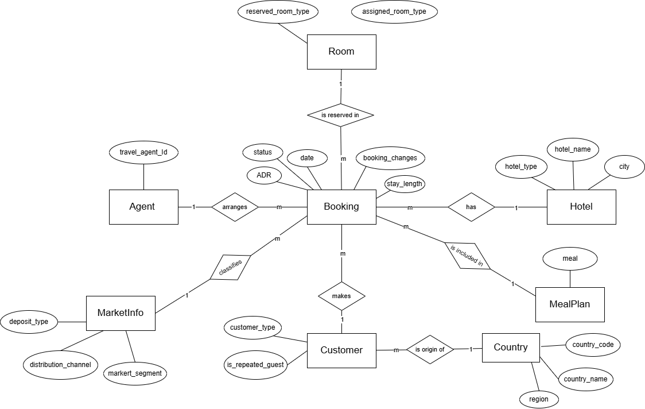
ER Diagram
Figure 1 - ER Diagram

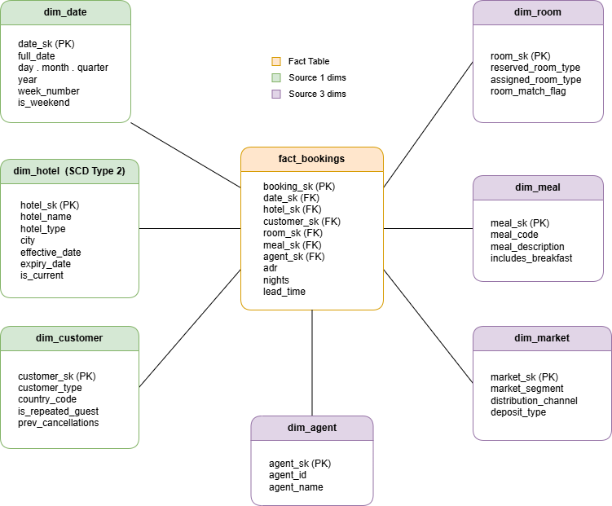
Figure 2 - Star Schema for Hotel Booking DW

SSAS Cube Implementation
Creating Data Source

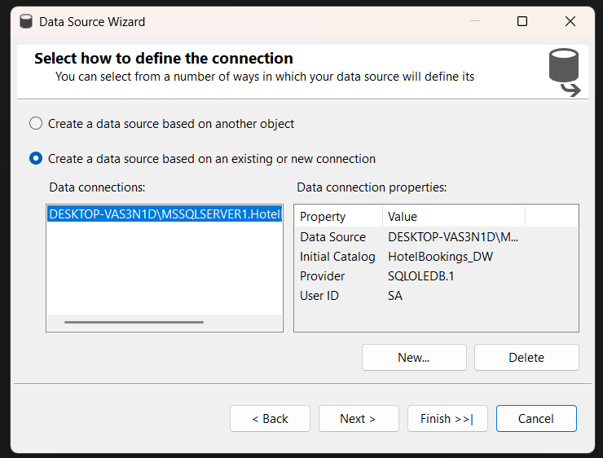

Creating Data Source View
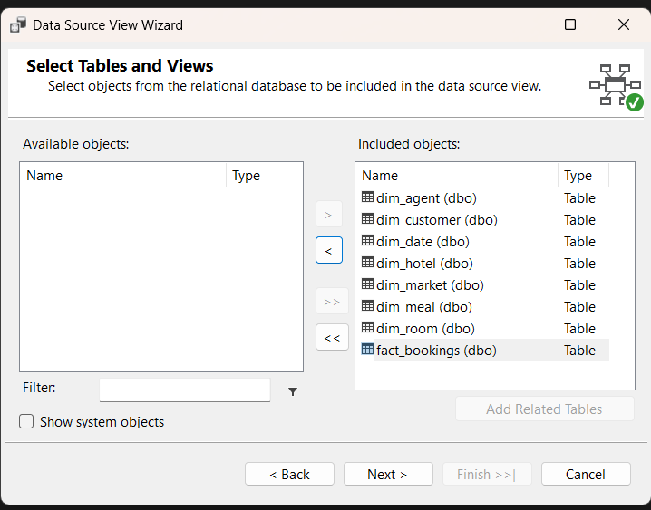
Creating dimensions
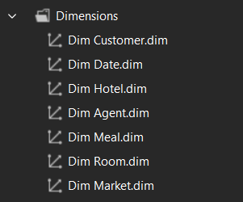

Creating cube
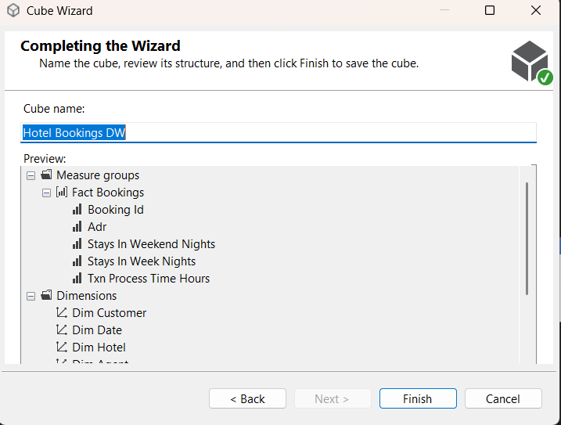

Building hierarchies
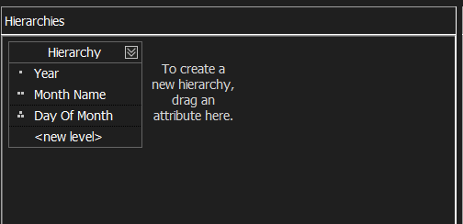
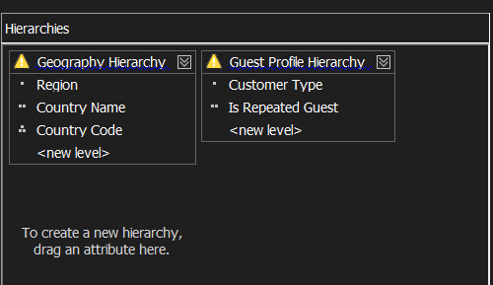
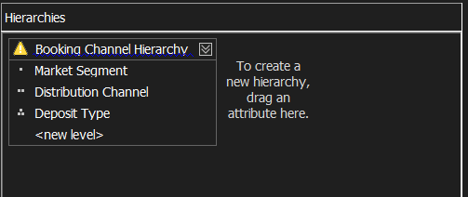
Cube Structure

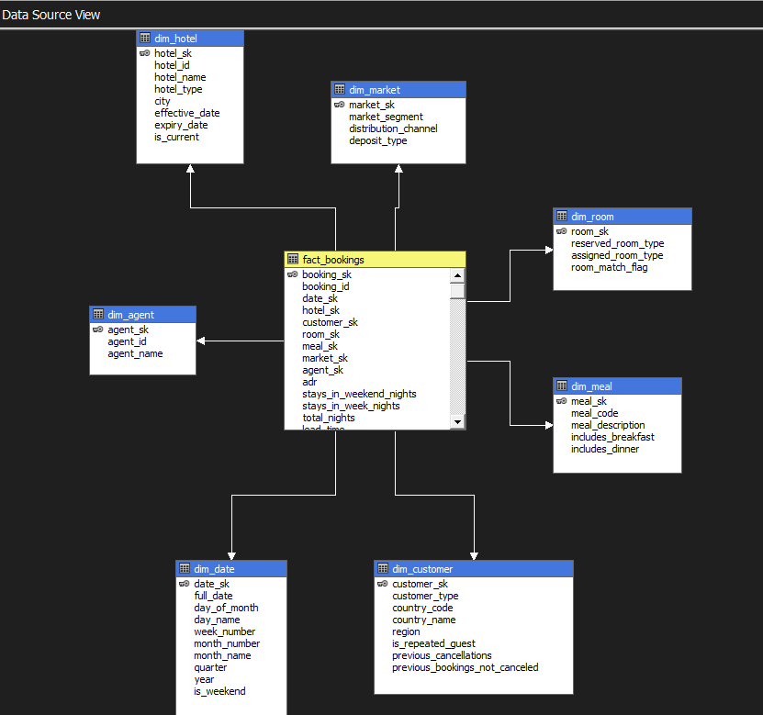
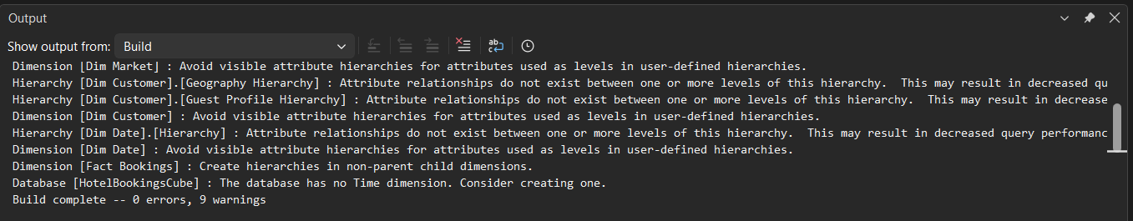

Creating Data Cubes

Creating KPI

Creating a Role

Browsig Cube data

Demostration of OLAP Operations

Roll-up

Drill-down

Slice

Pivot

Dice

PowerBI
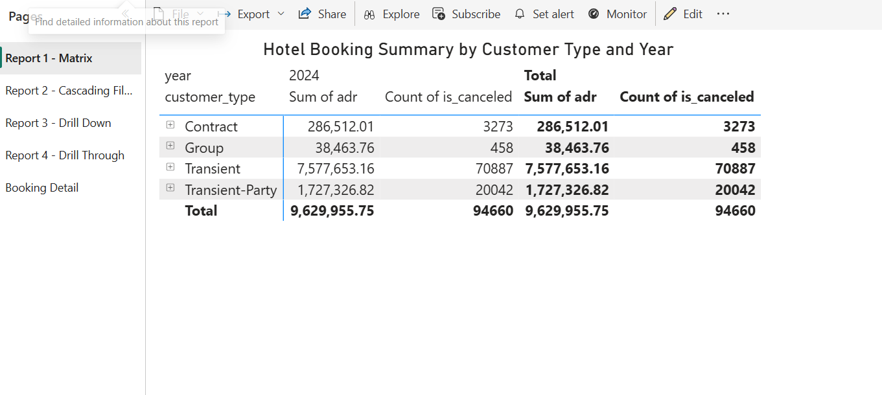
Figure 3 - Report 1 - Matrix
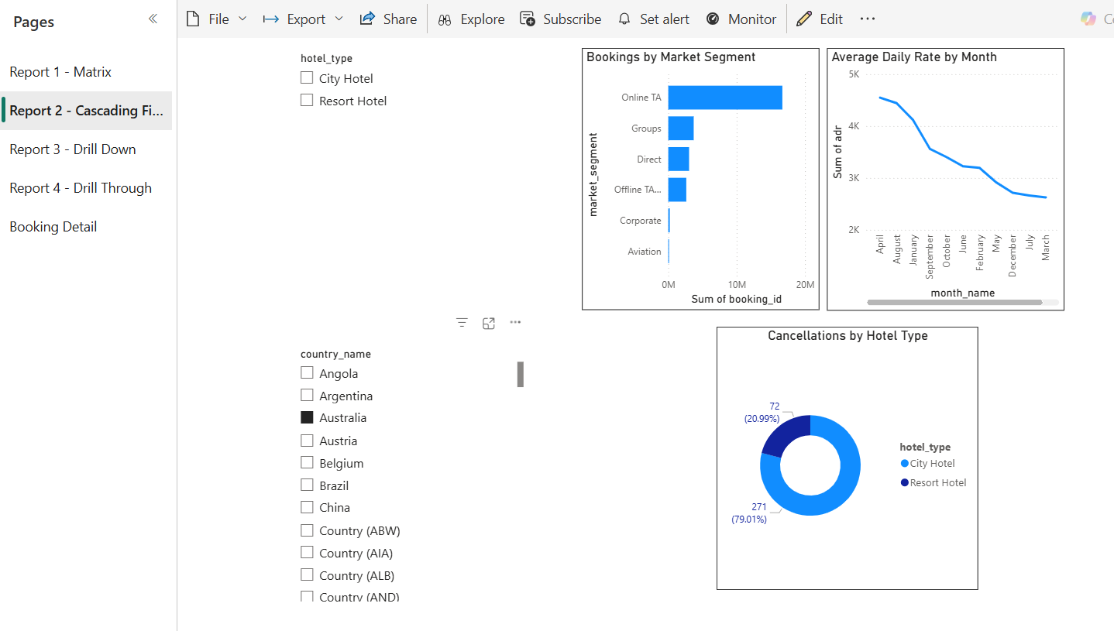
Figure 4 - Report 2 - Cascading Filters
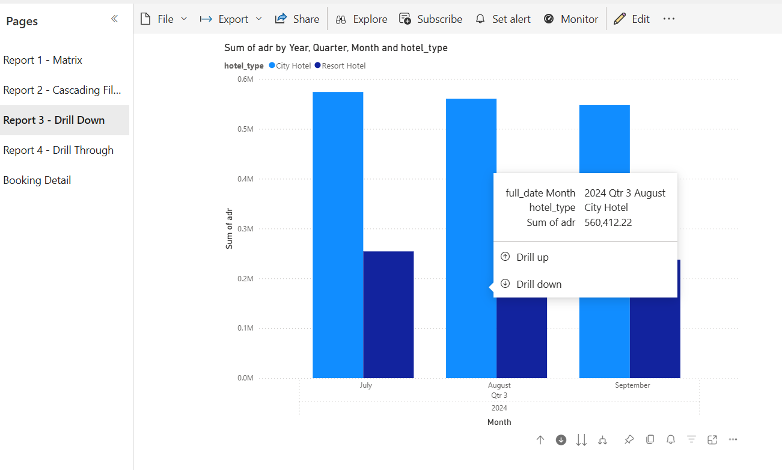
Figure 5 - Report 3 - Drill Down

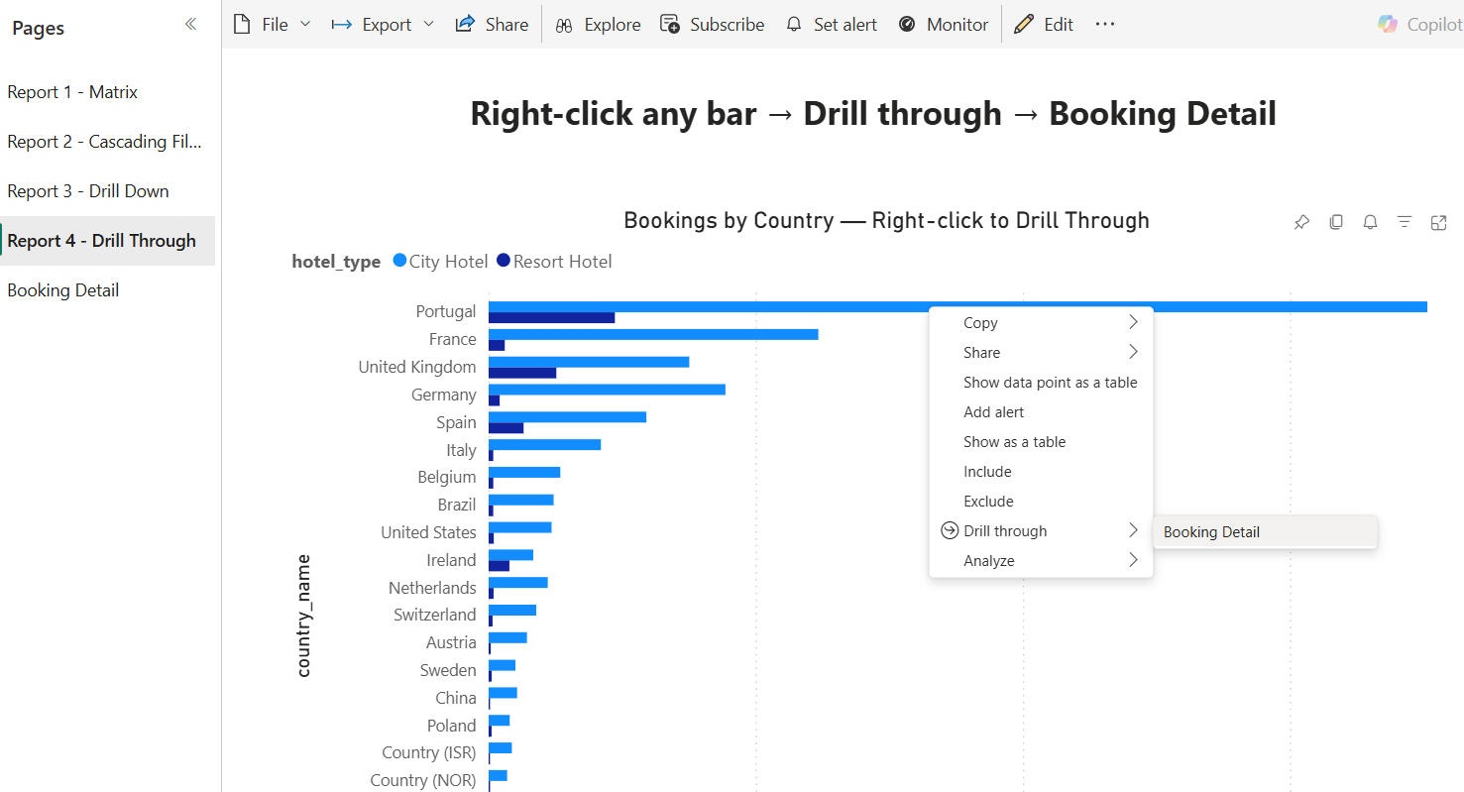
Figure 6 - Report 4 - Drill Through

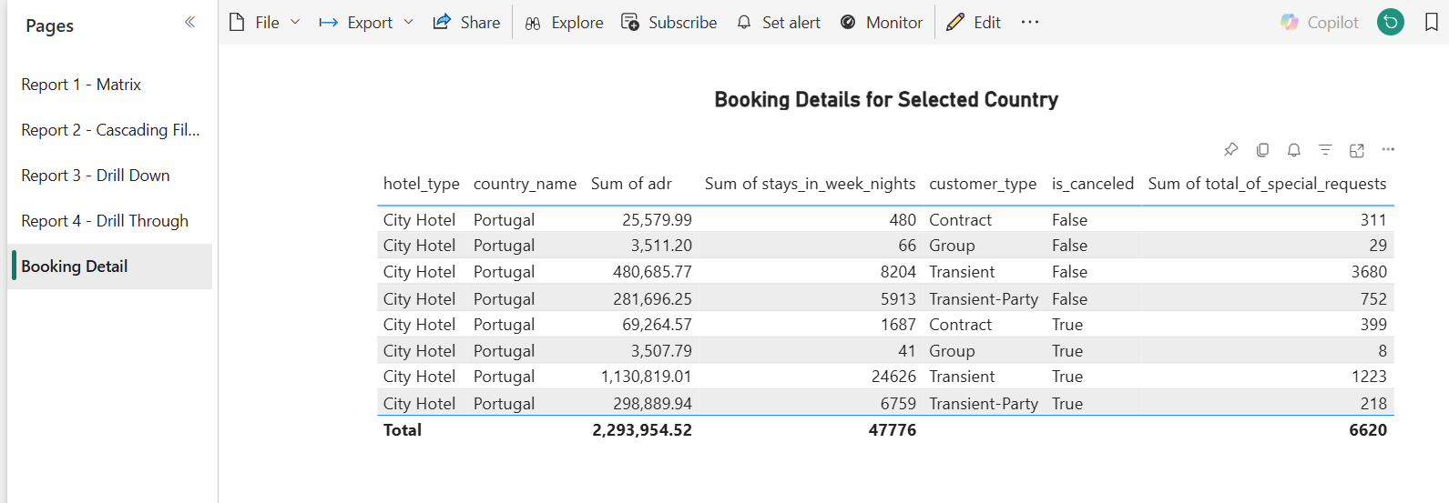
Figure 7 - Booking details when drill through any bar

