**BDM Assignment-2**

**Representation of Goods Flow and Relationships in the Supply Chain:**

// Create Suppliers

CREATE (s1:Supplier {name: 'Supplier A', location: 'China'})

CREATE (s2:Supplier {name: 'Supplier B', location: 'India'})

// Create Manufacturers

CREATE (m1:Manufacturer {name: 'Manufacturer X', location: 'USA'})

CREATE (m2:Manufacturer {name: 'Manufacturer Y', location: 'Germany'})

// Create Distributors

CREATE (d1:Distributor {name: 'Distributor Z', location: 'UK'})

CREATE (d2:Distributor {name: 'Distributor W', location: 'Australia'})

// Create Retailers

CREATE (r1:Retailer {name: 'Retailer A', location: 'USA'})

CREATE (r2:Retailer {name: 'Retailer B', location: 'Canada'})

// Create Customers

CREATE (c1:Customer {name: 'Customer 1', location: 'California'})

CREATE (c2:Customer {name: 'Customer 2', location: 'New York'})

// Create Products

CREATE (p1:Product {name: 'Smartphone', price: 699})

CREATE (p2:Product {name: 'Laptop', price: 999})

CREATE (p3:Product {name: 'Headphones', price: 199})

// Create Orders

CREATE (o1:Order {order_id: 'ORD1001', date: '2025-01-15'})

CREATE (o2:Order {order_id: 'ORD1002', date: '2025-01-16'})

// Create Pricing

CREATE (price1:Pricing {product: 'Smartphone', price: 699})

CREATE (price2:Pricing {product: 'Laptop', price: 999})

CREATE (price3:Pricing {product: 'Headphones', price: 199})

// Create Relationships

// Suppliers to Manufacturers

CREATE (s1)-[:SUPPLIES]->(m1)

CREATE (s2)-[:SUPPLIES]->(m2)

// Manufacturers to Products

CREATE (m1)-[:PRODUCES]->(p1)

CREATE (m1)-[:PRODUCES]->(p2)

CREATE (m2)-[:PRODUCES]->(p3)

// Manufacturers to Distributors

CREATE (m1)-[:SUPPLIES_TO]->(d1)

CREATE (m2)-[:SUPPLIES_TO]->(d2)

// Distributors to Retailers

CREATE (d1)-[:SELLS_TO]->(r1)

CREATE (d2)-[:SELLS_TO]->(r2)

// Retailers to Customers

CREATE (r1)-[:SELLS]->(c1)

CREATE (r2)-[:SELLS]->(c2)

// Orders to Products

CREATE (o1)-[:CONTAINS]->(p1)

CREATE (o1)-[:CONTAINS]->(p2)

CREATE (o2)-[:CONTAINS]->(p3)

// Orders to Customers

CREATE (o1)-[:PLACED_BY]->(c1)

CREATE (o2)-[:PLACED_BY]->(c2)

// Products to Pricing

CREATE (p1)-[:HAS_PRICE]->(price1)

CREATE (p2)-[:HAS_PRICE]->(price2)

CREATE (p3)-[:HAS_PRICE]->(price3)

**QUERIES**

Query 1: Find All Retailers and the Distributors They Buy From

This query returns retailers and the distributors they buy products from:

MATCH (d:Distributor)-[:SELLS_TO]->(r:Retailer)

RETURN d.name AS Distributor, r.name AS Retailer

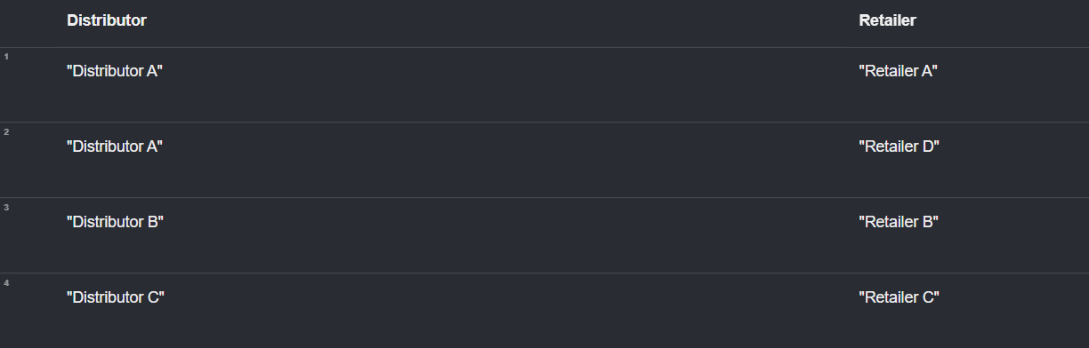

The query lists retailers and the distributors they buy products from. The results show that:

Distributor A supplies Retailer A and Retailer D.

Distributor B supplies Retailer B.

Distributor C supplies Retailer C.

Query 2: Find All Products and the Manufacturers That Produce Them

This query shows products and the manufacturers who produce them:

MATCH (m:Manufacturer)-[:PRODUCES]->(p:Product)

RETURN m.name AS Manufacturer, p.name AS Product

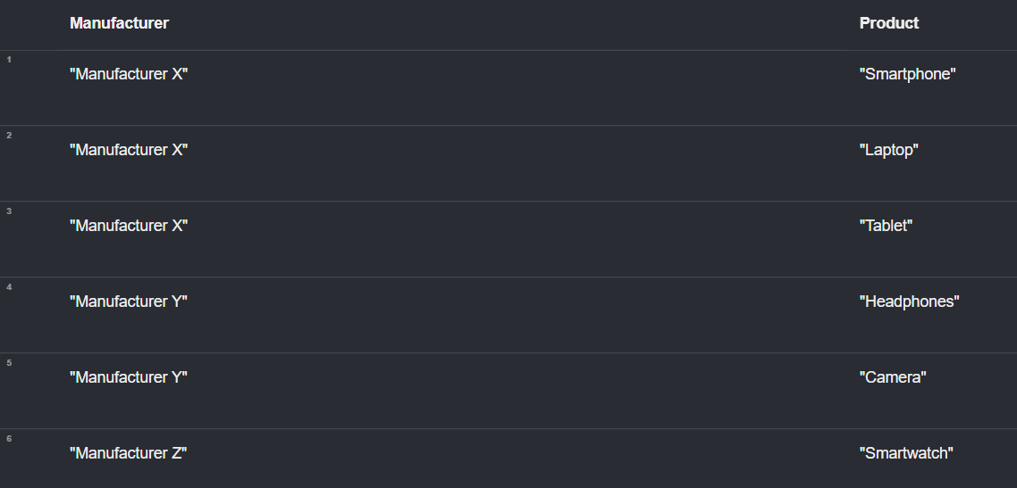

The query shows the relationship between manufacturers and the products they produce. The results indicate that:

Manufacturer X produces Smartphone, Laptop, and Tablet.

Manufacturer Y produces Headphones and Camera.

Manufacturer Z produces Smartwatch.

Query 3: Find All Suppliers and the Manufacturers They Supply To

This query shows suppliers and the manufacturers they supply products to:

MATCH (s:Supplier)-[:SUPPLIES]->(m:Manufacturer)

RETURN s.name AS Supplier, m.name AS Manufacturer

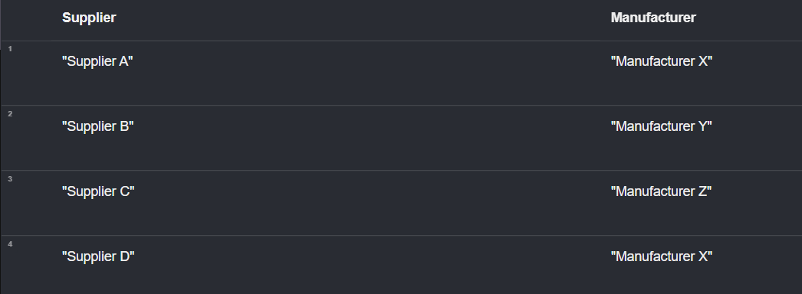

The query retrieves the suppliers and the manufacturers they supply products to. The results show:

Supplier A supplies to Manufacturer X.

Supplier B supplies to Manufacturer Y.

Supplier C supplies to Manufacturer Z.

Supplier D supplies to Manufacturer X.

Query 4: Find Orders and the Total Number of Products in Each Order

This query returns orders and the total number of products in each order:

MATCH (o:Order)-[:CONTAINS]->(p:Product)

RETURN o.order_id AS Order_ID, COUNT(p) AS Total_Products

The query retrieves the orders and the total number of products in each order. The results show:

Order ID "ORD1001" contains 2 products.

Order ID "ORD1002" contains 1 product.

Order ID "ORD1003" contains 1 product.

Order ID "ORD1004" contains 1 product.

Order ID "ORD1005" contains 1 product

Query 5: Find Orders and the Products They Contain

This will return orders and the products they contain:

MATCH (o:Order)-[:CONTAINS]->(p:Product)

RETURN o.order_id AS Order_ID, p.name AS Product_Name

The query retrieves orders and the products they contain. The results show:

Order ID "ORD1001" contains a Smartphone and a Laptop.

Order ID "ORD1002" contains Headphones.

Order ID "ORD1003" contains a Smartwatch.

Order ID "ORD1004" contains a Tablet.

Order ID "ORD1005" contains a Camera.

**GRAPH**

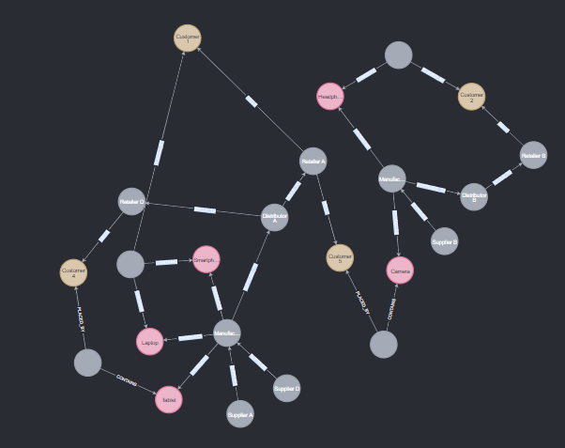

**INFERENCE**

Customer 1 purchases a Laptop from Retailer D, which is sourced from Distributor A, Retailer A, and Supplier A.

Customer 2 buys a Headphones from Retailer A, which is sourced through Distributor A and Manufacturer A.

Customer 3 buys a Camera through Retailer B, sourced from Distributor B, Supplier B, and Manufacturer B.

Customer 4 purchases a Tablet from Retailer B, sourced from Supplier A and Distributor B.