Advanced RAG Project - Detailed Architecture

1. System Overview
The project is a Retrieval-Augmented Generation (RAG) application with: a React/Vite frontend, a FastAPI backend, Pinecone as vector store (with integrated embedding and reranking), Google Gemini for final response generation, and Redis for a 3-tier query cache.
2.. Project flow
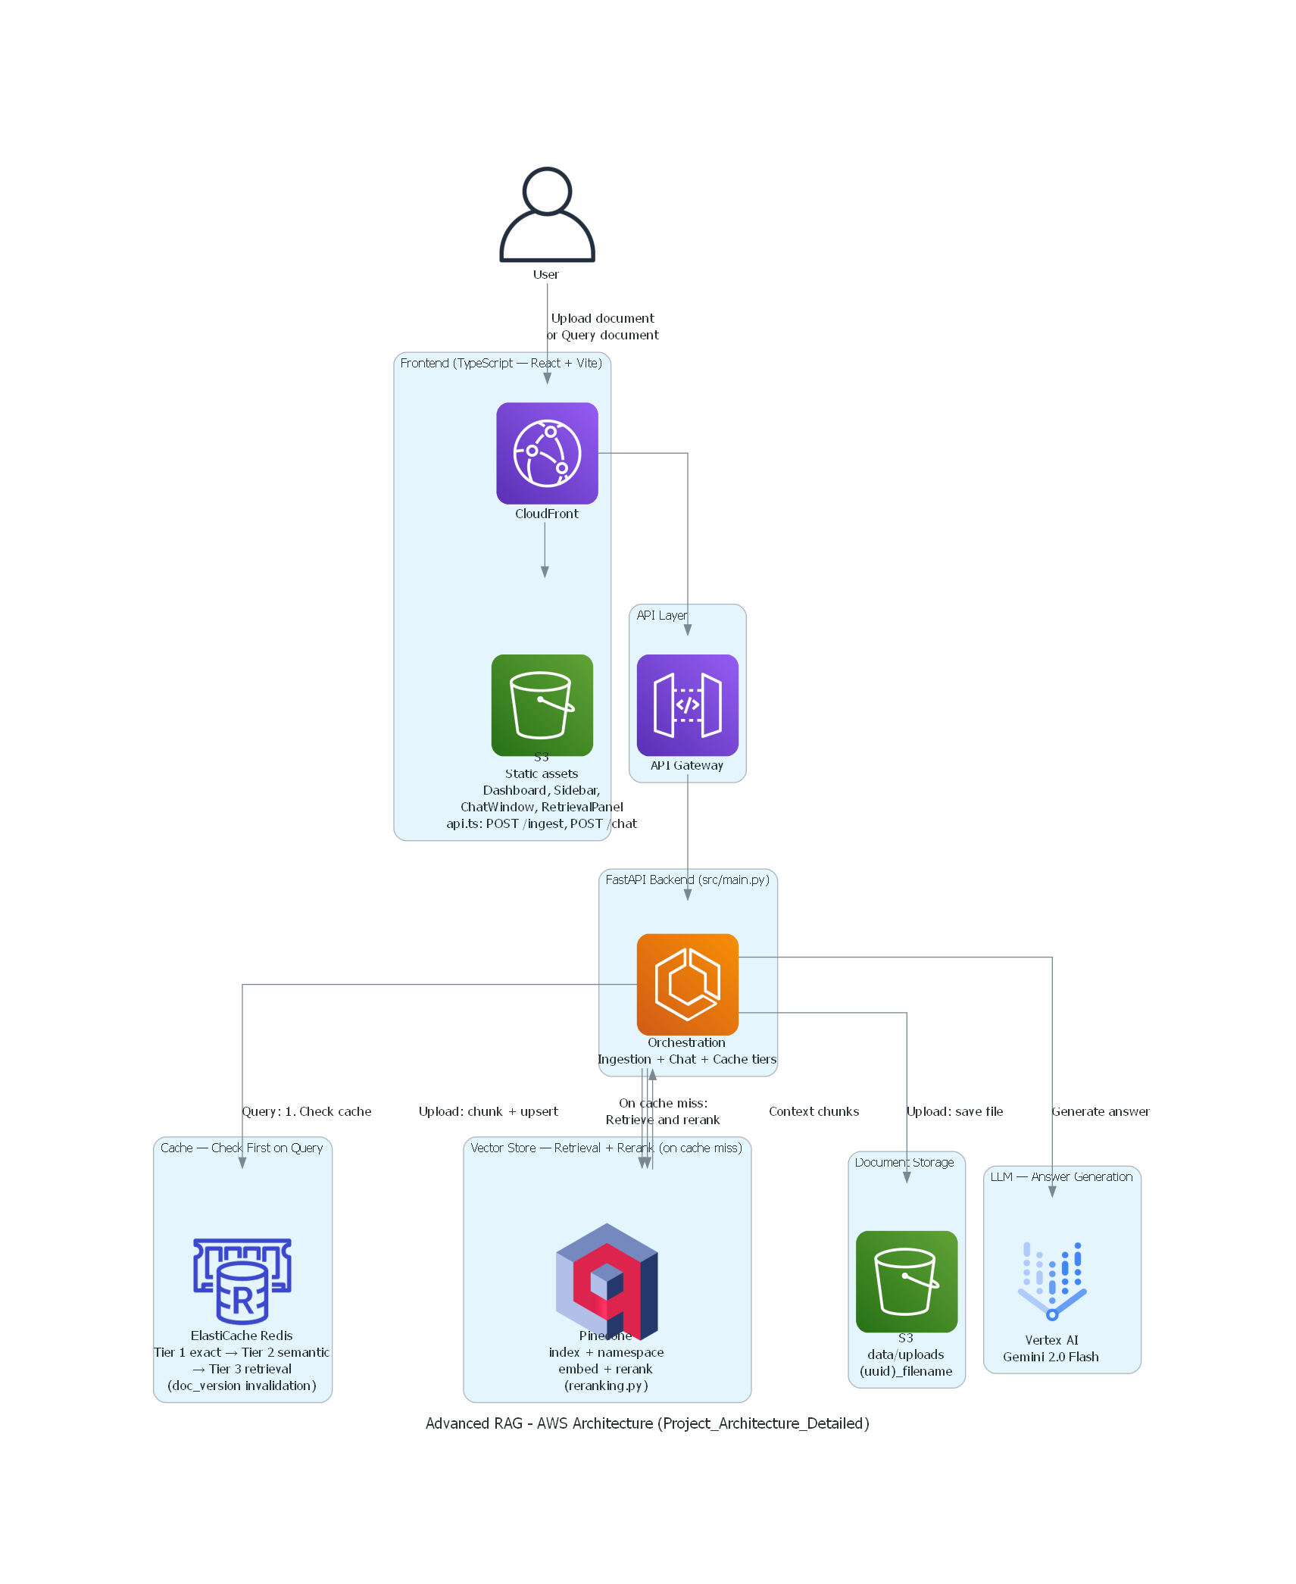

User uploads a document . The document can be chunked using either of the two strategies
a) The Parent–Child chunking strategy is designed to balance efficient vector retrieval with rich contextual information for the language model.

How It Works:
- The document is first split into larger parent chunks using a recursive text splitting method (for example, the recursive character splitter available in LangChain).
- Each parent chunk is then further divided into smaller child chunks.
- Only the child chunks are embedded and stored in the vector database (e.g., Pinecone).
- Each child chunk is stored along with metadata that includes a parent_id, which references the corresponding parent chunk.
- During retrieval, the system first retrieves the most relevant child chunks based on vector similarity.
- Using the parent_id, the system locates the associated parent chunk, which contains a larger portion of the document.
- These parent chunks are then passed to the language model during the generation phase to provide richer context.
b) The Sentence Window strategy splits a document into chunks based on complete sentences using NLP sentence tokenization (via NLTK). This ensures that chunks never break in the middle of a sentence, preserving semantic meaning.

Parameters
- sentences_per_chunk (int, default = 3)
Number of consecutive sentences grouped together to form a single chunk.
- window_size (int, default = 2)
Number of surrounding sentences included in the metadata on each side of the chunk. These sentences are not embedded, but are stored to provide additional context during retrieval.

How It Works:
- The document text is first tokenized into individual sentences.
- Sentences are grouped sequentially into chunks based on the sentences_per_chunk parameter.
- Each chunk is embedded and stored in the vector database.
- The metadata associated with each chunk includes:
  - The original chunk text.
  - Additional surrounding sentences defined by window_size.

Step 2 – File Validation and Indexing
Once a file is uploaded, the system first verifies whether the file already exists in the vector database (Pinecone). This check prevents duplicate data from being indexed.
- If the file already exists, the system skips the indexing process.
- If the file does not exist, the document is processed and divided into chunks based on the selected chunking strategy.
These chunks are then embedded using the embedding model Llama Text Embed v2 and upserted into the Pinecone index along with their associated metadata.
After the indexing process is completed, the user is prompted to query the database and interact with the stored document through the chat interface.
Step 3 – Caching and retrieval
The user query is embedded and first checked in cache(Redis) for a 3 tier retrieval .
Tier | Name | Behaviour
Tier 1 | Exact Cache | If the incoming query exactly matches a previously seen query (after normalization), return the cached response immediately. No retrieval, no LLM call.
Tier 2 | Semantic Cache | If no exact match is found, compute the query embedding and compare it against cached query embeddings using cosine similarity. If similarity exceeds a configurable threshold, return the cached response. No retrieval, no LLM call.
Tier 3 | Retrieval Cache | If no semantic match is found, check if relevant chunks for this query (or a similar query) already exist in cache. If yes, skip the vector DB call and pass the cached chunks directly to the LLM for generation. Only the LLM call happens — retrieval is skipped.
The system implements a three-tier caching mechanism to reduce latency and improve response time. If a query does not match any of the cached results across the three tiers, it falls back to the full Retrieval-Augmented Generation (RAG) pipeline.

Cache Miss Flow
If all three cache tiers miss:
- The system executes the full pipeline:
Retrieval → Reranking → Generation.
- Once the response is generated, the results are stored across all three cache tiers to improve performance for future queries.
- For every retrieval operation, the system also records:
  - Latency (response time)
  - Similarity score of the retrieved chunks.
The embedding model used within the caching mechanism is Llama Text Embed v2.

Full RAG Pipeline
When a query is not resolved by any cache tier:
- Semantic Retrieval
The system performs semantic search in the vector database (Pinecone) to retrieve the top 10 most relevant chunks.
- Reranking
These retrieved chunks are then reranked using BGE Reranker v2 M3, selecting the top 5 most relevant chunks.
- Context Assembly Based on Chunking Strategy
  - Parent–Child Strategy: The retrieved child chunks are mapped to their corresponding parent chunks, which provide larger contextual sections.
  - Sentence Window Strategy: The retrieved chunks are expanded using the context window stored in metadata, combining surrounding sentences to provide additional context.
- Answer Generation
The final contextual chunks are passed to the language model Gemini 2.0 Flash to generate the final response.

3. Backend Module Architecture
Module | Role | Key Functions / Notes
main.py (root) | ASGI loader | Loads src/main.py and exposes app.
src/main.py | API layer + orchestration | FastAPI app, CORS, endpoints, cache tiers, document lifecycle endpoints.
src/pipeline.py | RAG workflow core | ingest_file and run_pipeline with strategy-specific behavior.
src/ingestion.py | File extraction + metadata persistence | Extracts PDF/TXT/MD, tracks uploads in data/uploaded_documents.json.
src/chunking/parent_child.py | Hierarchical chunking | Parent chunks (~1500) and child chunks (~300), parent linkage via parent_id.
src/chunking/sentence_window.py | Sentence window chunking | Sentence cores + context windows, combined text stored for retrieval.
src/embedding.py | Pinecone index and vector operations | Creates index if missing, duplicate checks, upsert, delete vectors.
src/reranking.py | Retrieval + rerank | Pinecone search with rerank model, returns normalized hit payload.
src/generation.py | Final answer generation | Calls Gemini model with strict system prompt and chunk context.
src/cache/redis_backend.py | Redis 3-tier cache backend | TTL-based exact/semantic/retrieval caches + doc_version invalidation.
src/cache/embedding_cache.py | Cache embedding utilities | query normalization, hashing, embedding generation, cosine similarity.

4. Frontend Architecture
- UI/src/pages/Dashboard.tsx is the stateful shell for username, upload, document selection, chat, and cache controls.
- UI/src/services/api.ts centralizes axios calls to backend endpoints.
- Component split: Sidebar (operations), ChatWindow (Q&A), RetrievalPanel (source chunks), DebugFooter (cache metrics).
- Chunking strategy is selected at UI and passed to both ingest and chat endpoints.

5. Runtime Sequence Diagrams

5.1 Ingestion Flow

User -> UI -> POST /ingest (file, namespace, chunking_strategy)
-> FastAPI save file under data/uploads/_
-> ingestion.extract_text (PDF/TXT)
-> strategy chunking
- parent_child: parent/child chunks
- sentence_window: sentence windows
-> embedding.upsert_chunks -> Pinecone namespace
-> ingestion.mark_document_ingested + uploaded_documents.json update
-> UI refreshes /documents list

5.2 Query / Chat Flow

User -> UI -> POST /chat (query, file_path, chunking_strategy)
-> Cache Tier 1 (exact normalized query hash)
-> miss -> Cache Tier 2 (semantic embedding similarity)
-> miss -> Cache Tier 3 (retrieval chunk similarity)
-> miss -> pipeline.run_pipeline:
-> reranking.rerank(query, top_k, top_n, source, method, namespace)
-> strategy-specific context resolution
-> generation.generate_answer(query, contexts)
-> Store result in all cache tiers
-> Return answer + source chunks + cache metadata

6. Data Model and Storage
Storage | Data | Purpose
Pinecone index | Chunk vectors + metadata (source, method, page, ...) | Retrieval and reranking.
Redis | 3 cache tiers + doc version + document hash metadata | Low-latency response and reduced retrieval/generation cost.
data/uploads/ | Uploaded raw files with UUID-prefixed names | Persist source files.

7. API Surface
- GET /health - health check.
- POST /ingest - upload + chunk + upsert.
- POST /chat - cached and pipeline-assisted Q&A.
- GET /documents - list uploaded docs (deduped by logical name).
- DELETE /documents/{filename} - delete file + vectors + document hash.
- POST /cache/clear and GET /cache/stats - cache operations.
- DELETE /vectors - full vector and file reset.

8. Configuration and Dependencies
- Configuration in src/config.py with env-driven keys and cache thresholds/TTLs.
- Python stack includes FastAPI, Pinecone, Google GenAI, Redis, LangChain text splitters, NLTK, PyPDF.
- docker-compose.yml provisions Redis + RedisInsight for local operations.

9. Architectural Strengths
- Pluggable chunking strategy per document/query path.
- Multi-tier cache design balances precision, recall, and latency.
- Namespace-aware retrieval supports multi-tenant style segregation.
- Separation of ingestion, retrieval, reranking, and generation modules simplifies maintenance.

