LAB Logbook

Lab 1
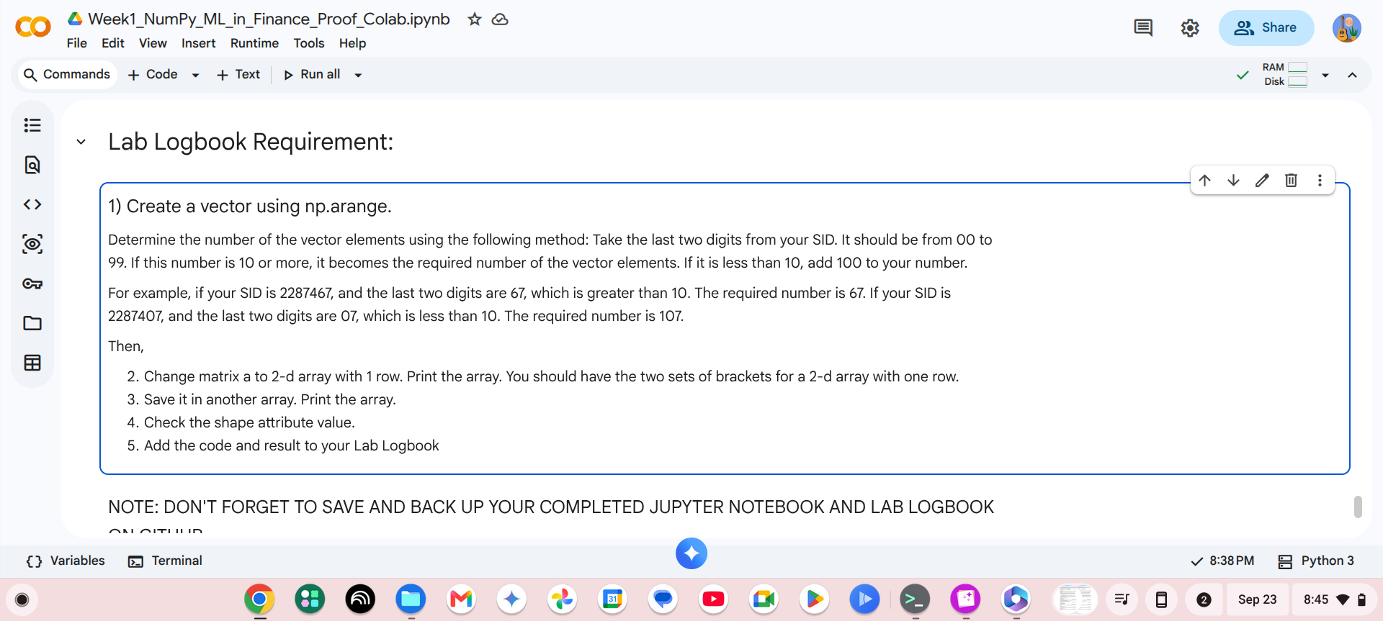

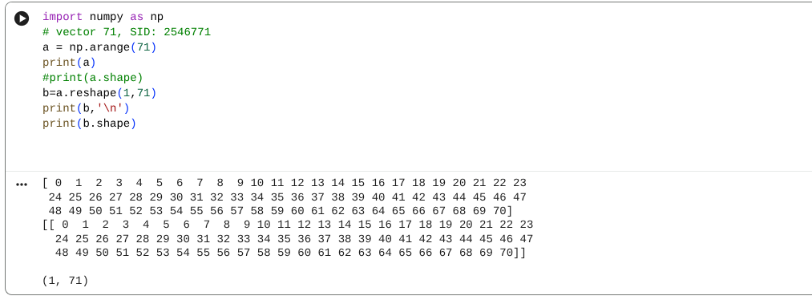

Lab 2

Lab Logbook Requirement:

- Determine a number (n) equal to the last digit of your SID. If the last digit of your SID is '0', then use 10.
- Group by "relationship" and "hours-per-week". The first grouping should be by relationship.
- Reduce all "hours-per-week" column values ​​in the original DataFrame by the value 'n'. Use a function.
- Group ​​by "relationship" and the reduced "hours-per-week".
- Add the code and result to your Lab Logbook.
Code:

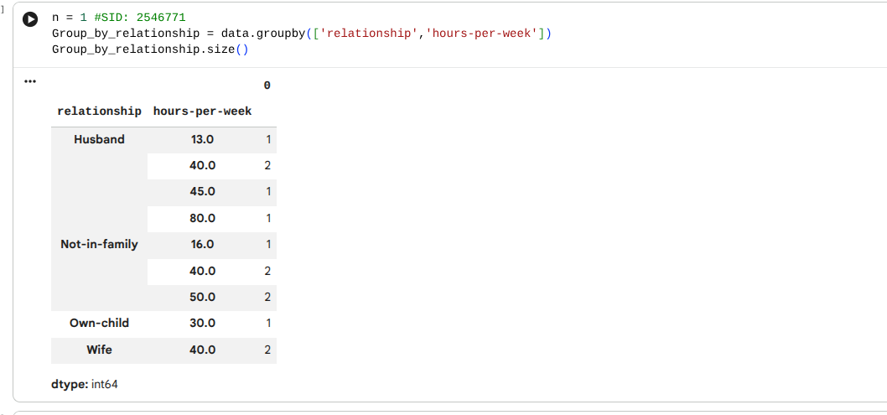
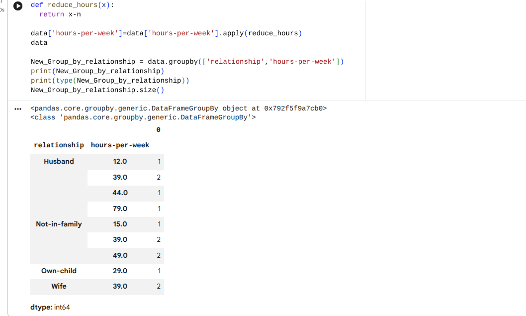

Lab 3
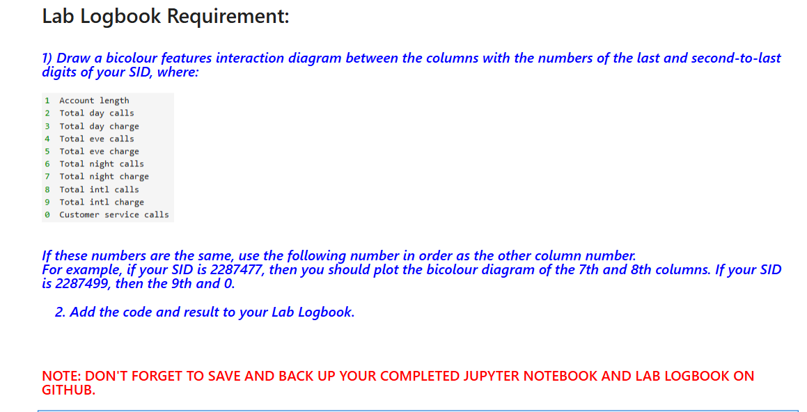
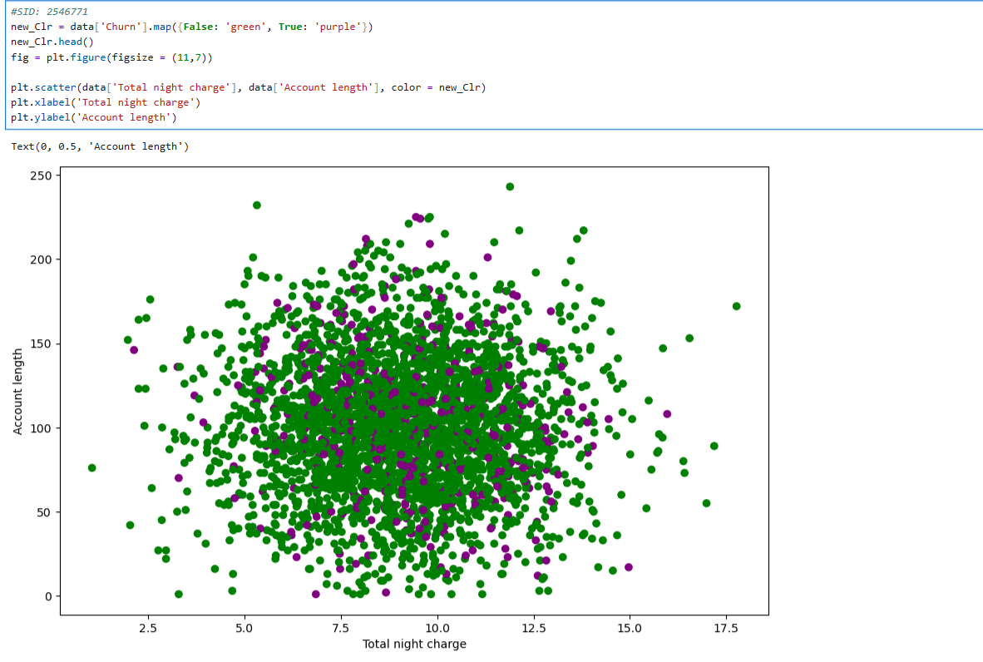

Lab 4

Lab 5

Lab 6

Lab 7

Lab 8

Lab 9

Lab 10

Lab 11

Lab 12

