Cloud Cost Optimization Project
Overview
Results-driven Cloud & DevOps practitioner with hands-on experience in building serverless automation solutions on AWS. Skilled in improving cost efficiency, scalability, and operational performance through automation.
Reference:
GitHub: https://github.com/Nithya-95/Cloud-Cost-Optimization.git
Project 1: AWS EBS Snapshot Cleanup Automation
Objective
Optimize storage usage by automatically removing unused and orphaned EBS snapshots.
Tools & Technologies
- AWS Lambda — Runs your code automatically in response to events without needing to manage servers.
- Python (Boto3) — Python SDK that lets your code interact programmatically with AWS services.
- Amazon EC2 / EBS / Snapshots — EC2 provides virtual servers, EBS offers persistent block storage, and Snapshots back up EBS volumes.
- Amazon EventBridge Scheduler — Executes tasks or triggers events on a defined schedule across AWS services.
- IAM — Manages secure access and permissions for users, roles, and services in AWS.
- CloudWatch Logs — Collects, stores, and monitors log data from AWS resources and applications.

Step-by-Step Implementation
- Identify Problem
  - Accumulation of unused EBS snapshots increased storage costs.
- Define Cleanup Logic
  - Identify snapshots based on below condition:
    - Snapshots without volume IDs
    - Snapshots linked to deleted volumes
    - Old or unused snapshots

- Design Serverless Workflow
  - Use AWS Lambda for automation
- Architecture
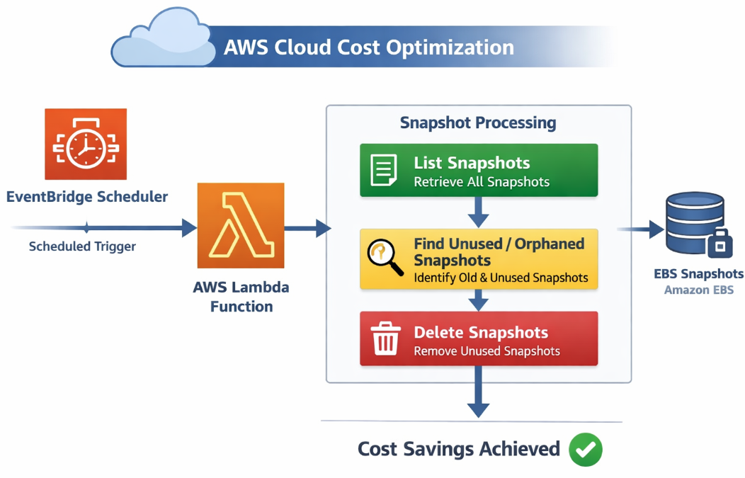
- Set Up IAM Roles
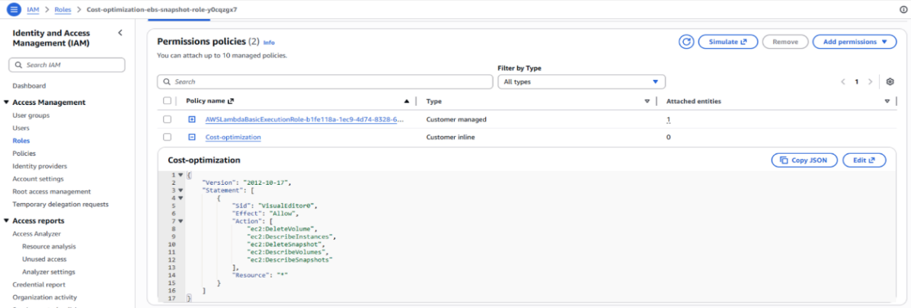
  - Grant permissions for snapshot management and EC2 access

- Develop Lambda Function
  - Python script using Boto3 to:
    - List all snapshots
    - Filter unused/orphaned snapshots
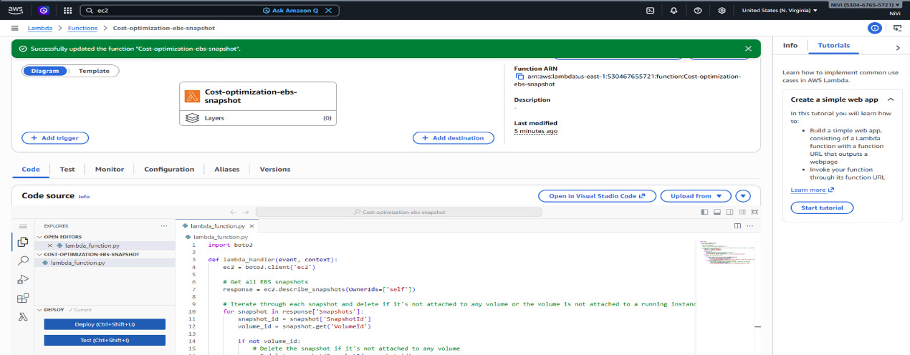
    - Delete unnecessary snapshots
- Schedule Automation
  - Configure Event Bridge to run cleanup periodically (e.g., daily/weekly)
- Testing & Validation
  - Test logic on sample resources
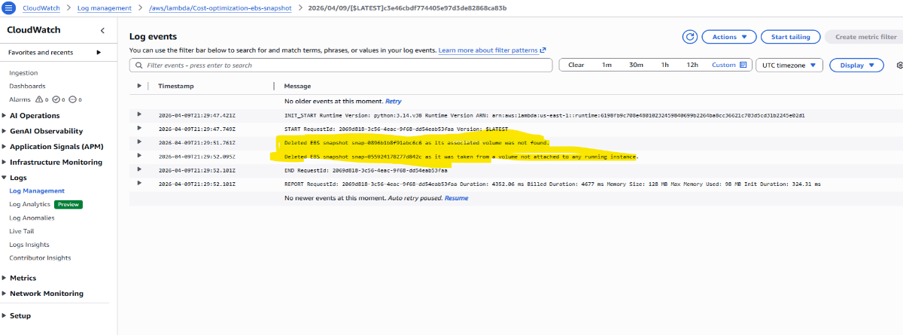
  - Verify correct deletion behaviour

Outcome
- Reduced storage costs
- Improved resource hygiene
- Automated maintenance tasks

Project 2: AWS EC2 Cost Optimization with Serverless Automation
Objective
Reduce unnecessary AWS costs by automating EC2 instance start and stop schedules.
Tools & Technologies
- AWS Lambda — Runs your code automatically in response to events without needing to manage servers.
- Python (Boto3) — Python SDK that lets your code interact programmatically with AWS services.
- Amazon EC2— EC2 provides virtual servers
- Amazon EventBridge Scheduler — Executes tasks or triggers events on a defined schedule across AWS services.
- IAM — Manages secure access and permissions for users, roles, and services in AWS.
Step-by-Step Implementation
- Identify Problem
  - EC2 instances were running continuously, increasing costs.
- Design Solution
  - Plan a serverless architecture using AWS Lambda and EventBridge Scheduler.
  - Define schedules for stopping and starting instances.
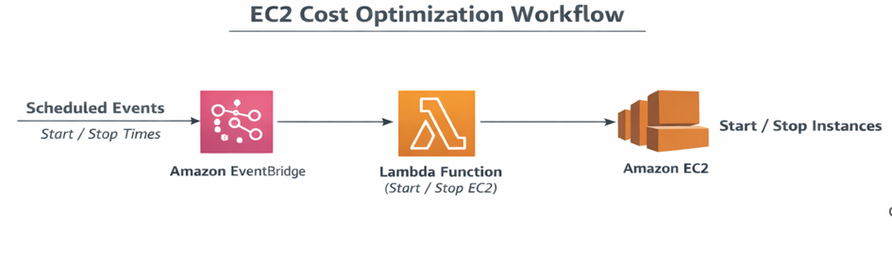
- Architecture

- Set Up IAM Roles
  - Create IAM roles with permissions to manage EC2 instances securely.
ec2:StartInstances,
ec2:StopInstances,
ec2:DescribeInstances

- Develop Lambda Function
  - Write Python script using Boto3 to:
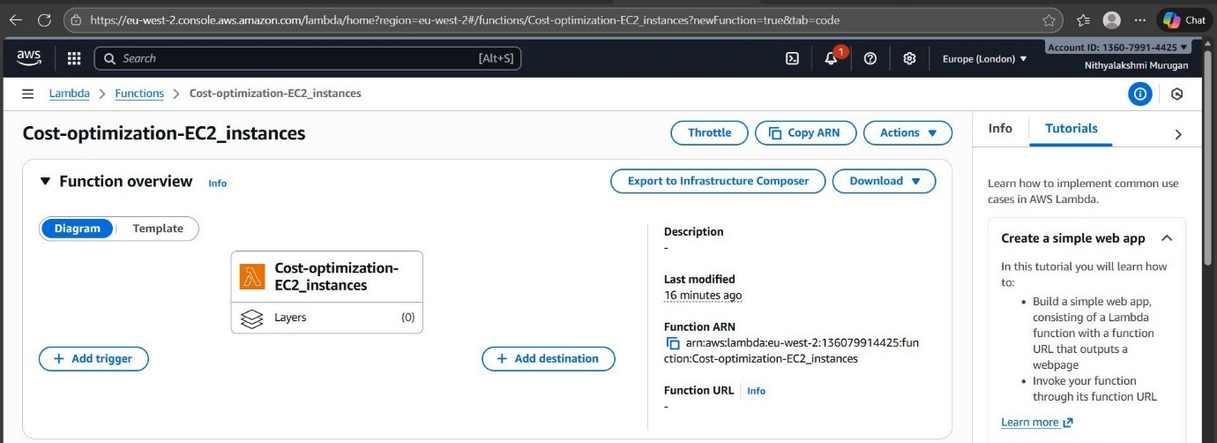
    - Start/Stop EC2 instances at defined times

- Configure EventBridge Scheduler
  - Create scheduled triggers:
    - Morning → Start instances
    - Evening → Stop instances

- Testing
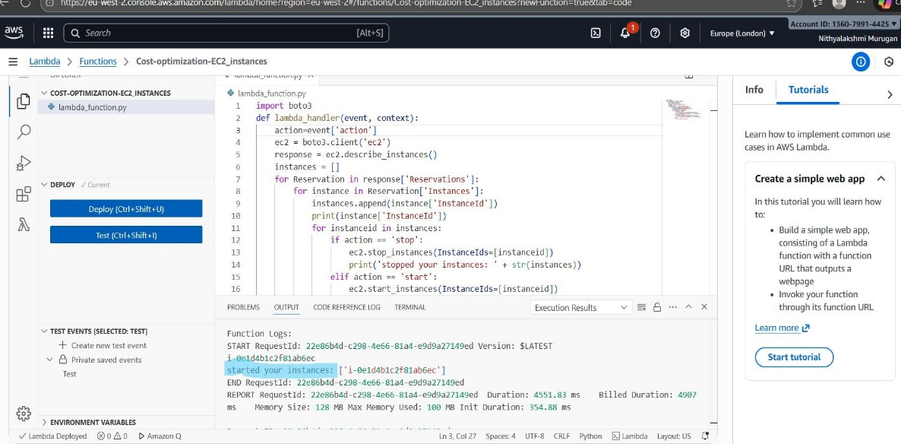
  - Validate automation process

Outcome
- Reduced cloud costs significantly
- Eliminated manual intervention
- Improved operational efficiency

Key Skills Demonstrated
- Serverless Architecture (AWS Lambda)
- Cloud Cost Optimization
- Python Scripting (Boto3)
- AWS Resource Management
- AWS Compute Resources
- Scheduling & Event Automation
- Secure IAM Role Design

