Project Documentation
Citizen AI – City Analysis & Citizen Services Assistant

1. Introduction
• Project Title : Citizen AI – City Analysis & Citizen Services Assistant
• Team Member : NITHYA S
• Team Member : NIVEDHA M
• Team Member : POWRNIKA S
• Team Member : PREETHA S

2. Project Overview
- Purpose :
The purpose of Citizen AI is to empower citizens and city officials with real-time, AI-generated insights. The system provides detailed city analysis (crime rates, accident statistics, safety assessments) and answers queries about public services, policies, and civic issues. It promotes transparency and encourages civic engagement.
- Features:
Conversational Interface – Natural language interaction for user queries and city analysis.
City Analysis – Generates detailed statistics about crime, accidents, and overall safety.
Citizen Services – Provides answers about public services, policies, and government schemes.
Gradio UI – Simple web interface with tabbed layout for easy navigation.

3. Architecture
Frontend (Gradio): Provides interactive tabs for city analysis and citizen services.
Backend (IBM Granite LLM): Handles NLP, text generation, and response formulation.
Libraries: Transformers, Torch, Gradio.

4. Setup Instructions
Prerequisites:
o Python 3.9 or later
o pip and internet access
Installation Process:
o Install dependencies using pip install transformers torch gradio
o Load the IBM Granite model and tokenizer
o Launch the Gradio application

5. Folder Structure
Citizen_AI.ipynb – Main notebook containing implementation.
Functions included: generate_response, city_analysis, citizen_interaction.
Gradio interface – Tabs for City Analysis and Citizen Services.

6. Running the Application
- Install dependencies and run the notebook.
- Open the Gradio interface from the URL provided.
- In the City Analysis tab, enter a city name to get analysis of crime and safety.
- In the Citizen Services tab, enter a question to get AI-generated information about government services.

7. API Documentation
Functions:
generate_response(prompt) – Generates AI-powered text response.
city_analysis(city_name) – Returns crime index, accident data, and safety assessment.
citizen_interaction(query) – Provides answers to public service and policy queries.

8. Authentication
This project currently runs without authentication. Future enhancements may include:
- OAuth2 or JWT authentication for secure access
- Role-based access (Citizen, Government Official, Analyst)

9. User Interface
The interface includes:
Tab for City Analysis – Input city name and get AI-generated results.
Tab for Citizen Services – Input queries about government services and policies.
Outputs are displayed in real-time with a clean, tabbed layout.

10. Testing
Testing Phases:
Unit Testing – For model functions and response generation.
Manual Testing – For user interface workflows.
Edge Case Handling – Empty city name, invalid inputs, random queries.

11. Screenshots

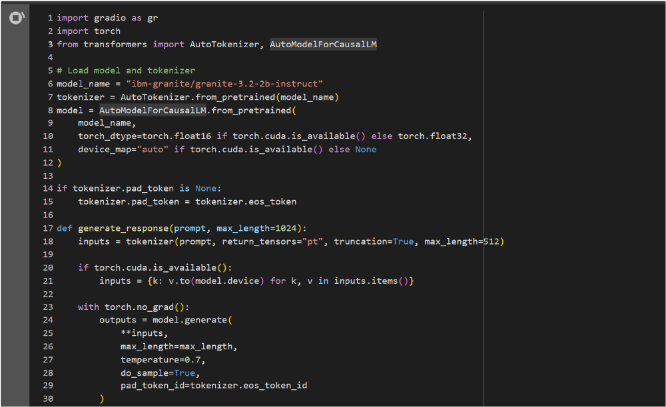

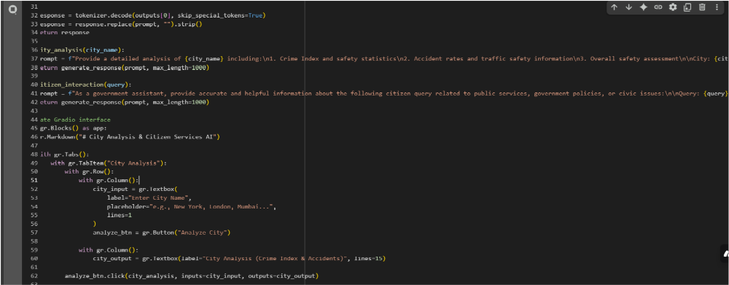

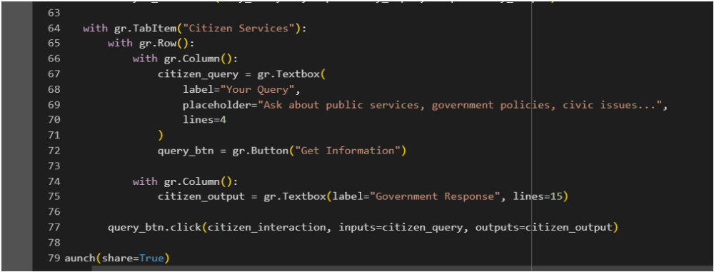

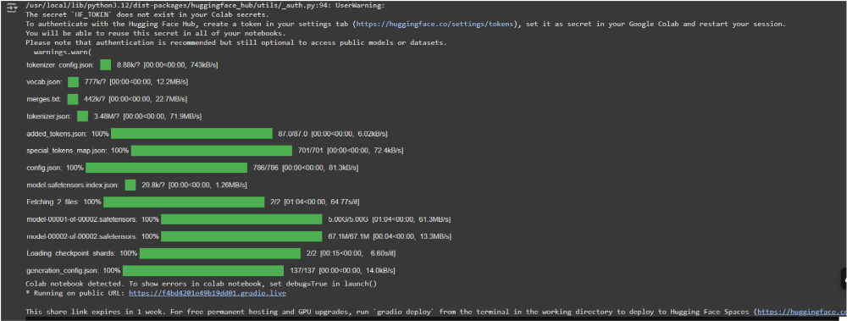

OUTPUT :

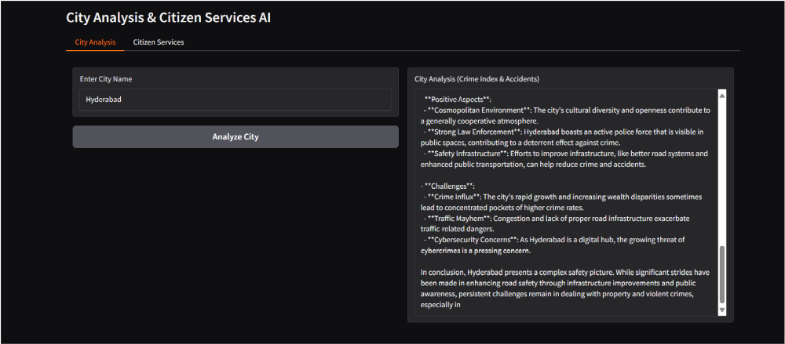

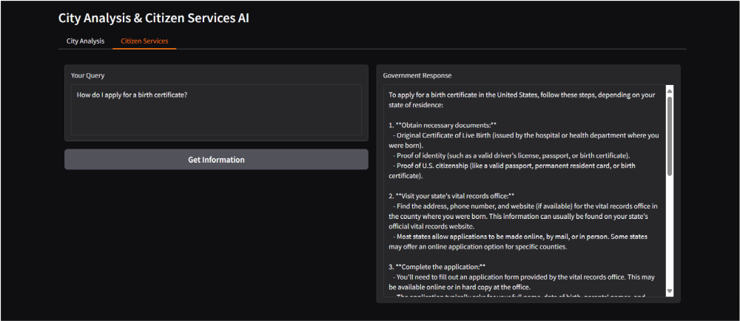

12. Known Issues
- AI-generated statistics are approximations and may not reflect real-world data.
- Model output is dependent on training data and prompt quality.
- UI customization is limited with Gradio.

13. Future Enhancements
- Integration with real government and city datasets for accurate statistics.
- Add support for multiple languages for accessibility.
- Create dashboards with visualizations of city trends and safety analytics.
- Implement secure login and role-based access.

