**Assignment – 1**

1. **Install Power BI Desktop and share the final screenshot of the report view page which appears when power desktop starts.**

**Download link:** <https://powerbi.microsoft.com/en-us/downloads/>

**Screenshot:** Report View page.

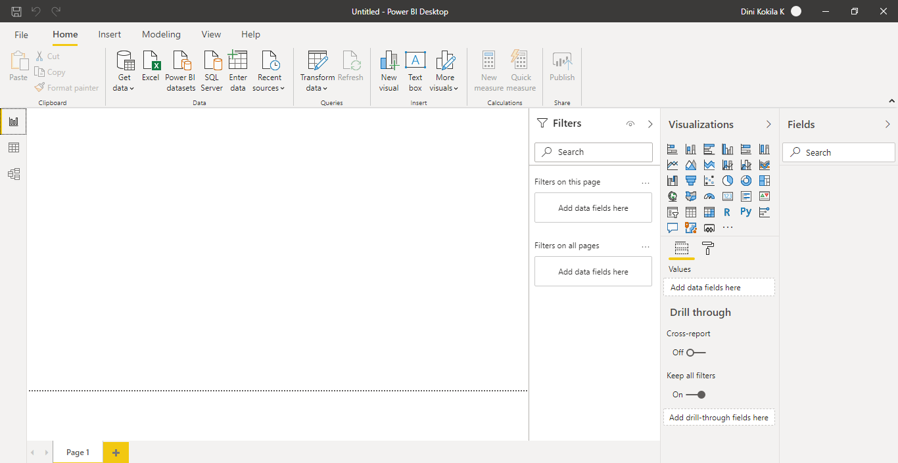

1. **Prepare a document and with the following screenshot**

**− Report View**

**− Data View**

**− Model View**

**− Power Query Editor**

**− Advance Editor**

**Report View:** Power BI Desktop includes a Report view, where you can create any number of report pages with visualizations. Report view in Power BI Desktop provides a similar design experience to the report's editing view in the Power BI service. You can move visualizations around, copy and paste, merge, and so on.

**Screenshot:**

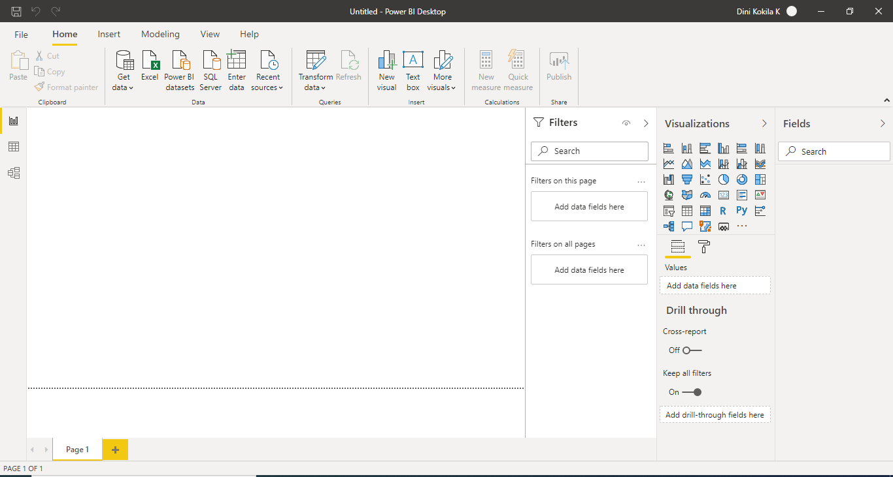

**Data View:** Data view helps you inspect, explore, and understand data in your Power BI Desktop model. It is different from how you view tables, columns, and data in Power Query Editor. With Data view, you are looking at your data after it has been loaded into the model.

**Screenshot:**

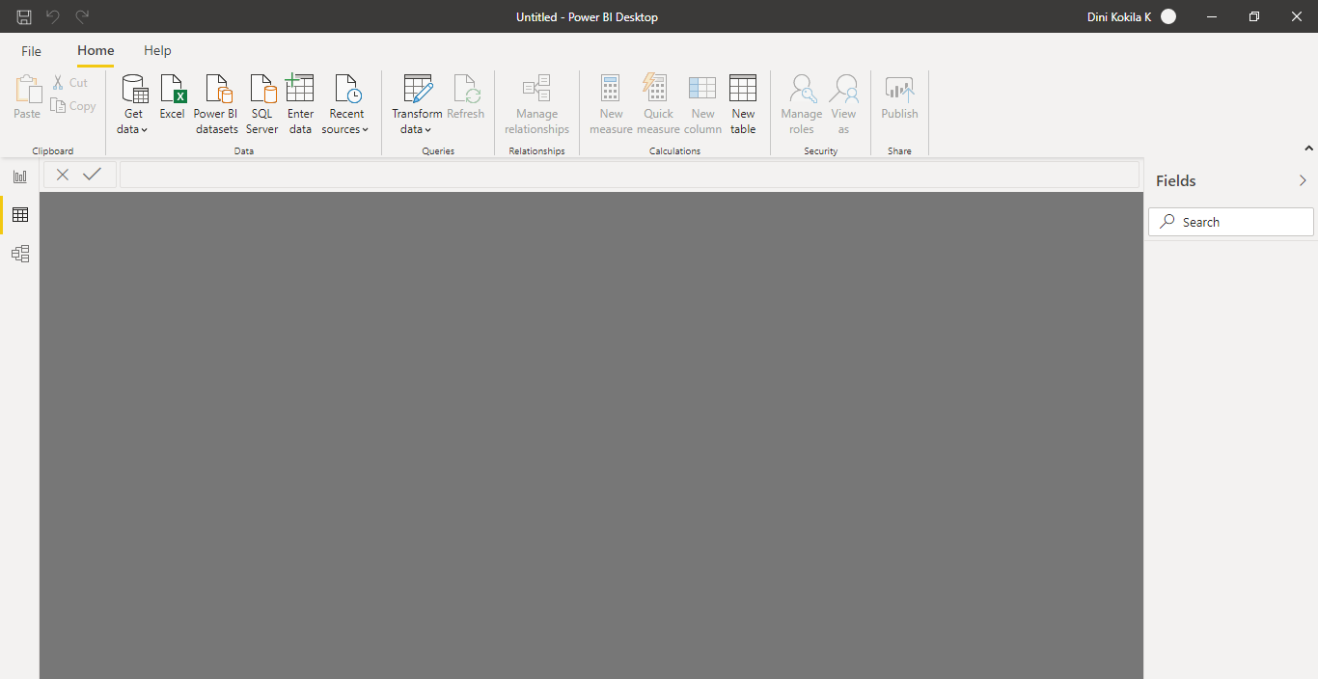

**Model View:** Model view shows all the tables, columns, and relationships in your model. This view can be especially helpful when your model has complex relationships between many tables.

**Screenshot:**

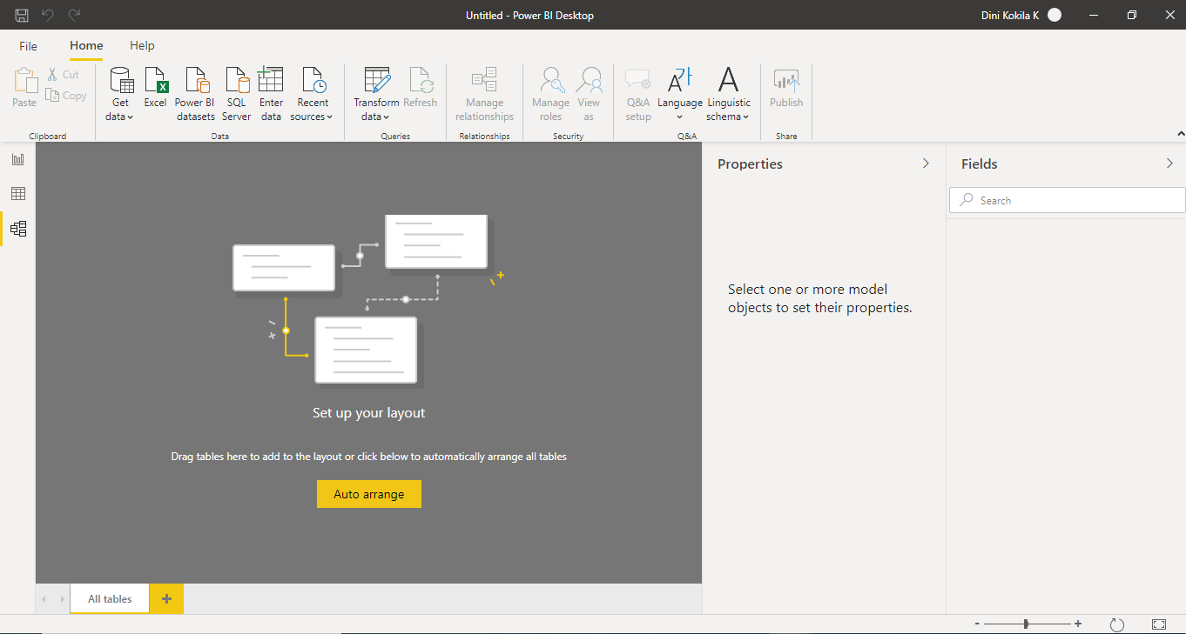

**Power Query Editor:** Here’s how Power Query Editor appears once a data connection is established:

1. In the ribbon, many buttons are now active to interact with the data in the query.
2. In the left pane, queries are listed and available for selection, viewing, and shaping.
3. In the centre pane, data from the selected query is displayed and available for shaping.
4. The **Query Settings** pane appears, listing the query’s properties and applied steps.

**Screenshot:**

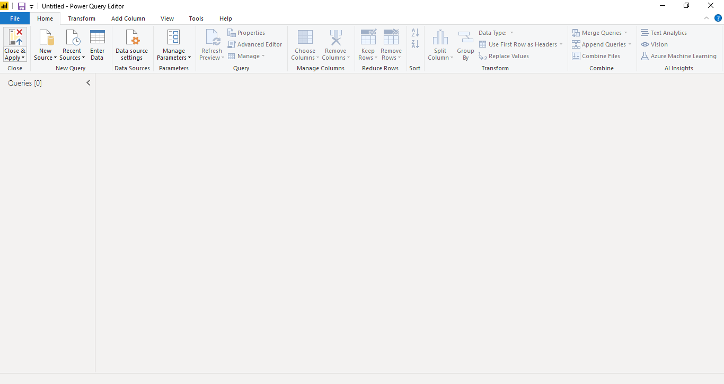

**Advance Editor: a**dvanced Editor with Power Query can perform a lot of complex steps with any kind of data source.

**Screenshot:**

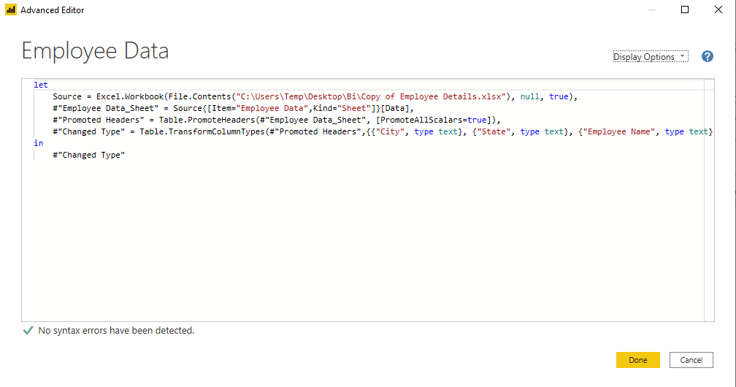

**3.Prepare a document with details of the following along with their price**

**− Power BI Desktop**

**− Power BI Pro**

**− Power BI Premium**

**Solution:**

**Power BI Desktop** - Power BI Desktop is the free version of Power BI that you can install on your local computer as a program, and acts as a companion desktop application to the full version of Power BI. If you need to consolidate your data sources, create your own reports and conduct your own analysis or test its capabilities.

**Pricing- FREE**

**Power BI Pro:** Power BI Pro is the full version of Power BI, complete with the ability to use Power BI for both building dashboards and reports and unlimited viewing, sharing and consumption of your created reports (and reports shared by others) - the latter not possible with Power BI Desktop.

**Pricing- $9.99 Monthly price per user**

**Power BI Premium:** Power BI Premium differs from the free version and Power BI pro in its licensing model, which only suits a specific size and type of organisation and business scenario. You can purchase Premium in a range of capacity sizes that offer different numbers of memory and virtual cores that can scale as your data analysis requirements change.

**Pricing- $ 4,995 monthly price**