AI LAB ASSIGNMENT 11.4:

NAME:V.NITHYA

HALLTICKET NO:2403A52346

TASK 1: write a python class named as a stack and perform various operations like push(),pop(),peek(),and is_empty().perform stack operations with an example. perform optimisation & alternatives by using collections,deque.

CODE:

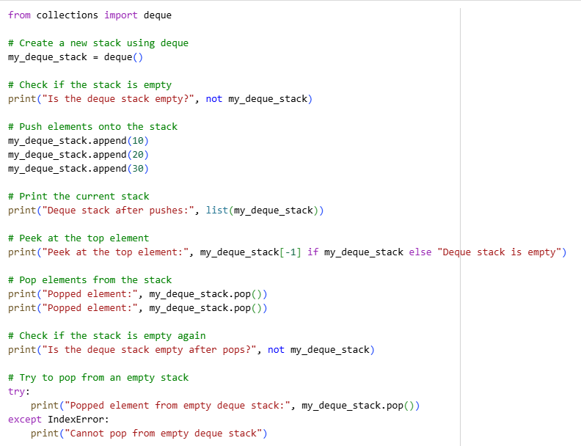

OUTPUT:

TASK2: Write a python class named as a queue and perform enque,dequeue,and is_empty().suggest more efficient implementation using collection.deque.

CODE:

OUTPUT:

TASK3: write a python class named as a singly linked list and perform insert_at_end(),delete_value(),and traverse().generate inline comments explaining pointer updates (which are non-trivial). suggest test cases to validate all operations

CODE:

OUTPUT:

TASK4:   
write a python class named as a binary search tree and perform insert(),search(),and inorder_traversal().complete missing methods and add docstrings to the code. test with a list of integers and compare outputs of search() for present vs absent elements.

CODE:

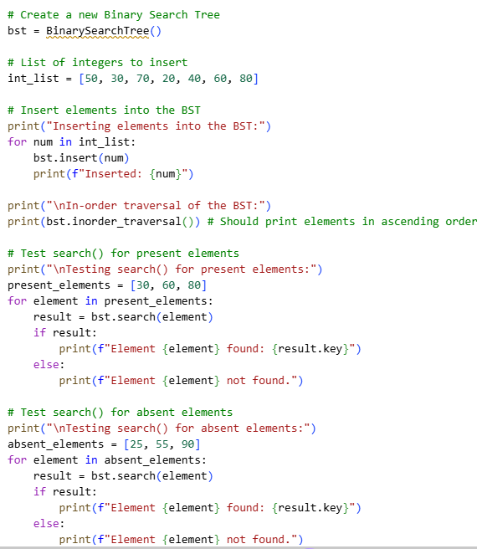

OUTPUT:

TASK5: write a python class named as a graph using an adjacency list,with traversal methods bfs() and dfs().generate BFS and DFS implementations with inline comments. Compare recursive vs iterative DFS.

CODE:

OUTPUT:

