**TASK 1:**

import numpy as np

import matplotlib.pyplot as plt

class NeuralNetwork():

  def __init__(self, input_size, hidden_size, output_size):

    super(NeuralNetwork, self).__init__()

    self.weights_input_to_hidden = np.random.random((input_size, hidden_size))

    self.weights_hidden_to_output = np.random.random((hidden_size, output_size))

  # For Task 2, change the sigmoid function to tan-h and reLU here

  ## TASK 2 CODE STARTS HERE

  def sigmoid(self, x, deriv = False):

    if deriv:

      return x * (1 - x)

    return 1 / (1 + np.exp(-x))

  ## TASK 2 CODE ENDS HERE

  def train(self, train_x, train_y, num_epochs):

    loss_dict = {}

    for epoch in range(num_epochs):

        # Forward prop

        self.l0 = train_x

        self.l1 = self.sigmoid(np.dot(self.l0, self.weights_input_to_hidden))

        l2 = self.sigmoid(np.dot(self.l1, self.weights_hidden_to_output))

        # Backprop

        # Finding final and hidden layer losses

        loss = train_y - l2

        if epoch % 10 == 0:

          print('Epoch {}/{} \tLoss:{}'.format(epoch+1, num_epochs, np.mean(np.abs(loss))))

          #plt.plot(epoch+1,np.mean(loss))

        l2_delta = loss * self.sigmoid(l2, deriv = True)

        l1_error = l2_delta.dot(self.weights_hidden_to_output.T)

        l1_delta = l1_error * self.sigmoid(self.l1, deriv = True)

        # Optimizing weights

        self.weights_hidden_to_output += self.l1.T.dot(l2_delta)

        self.weights_input_to_hidden += self.l0.T.dot(l1_delta)

        # Store loss in a dictionary

        loss_dict[epoch] = np.abs(np.mean(loss))

    return loss_dict

  def test(self, test_x):

    self.l0 = test_x

    self.l1 = self.sigmoid(np.dot(self.l0, self.weights_input_to_hidden))

    output = self.sigmoid(np.dot(self.l1, self.weights_hidden_to_output))

    if output < 0.5:

      return 0

    return output

    # Training Set

arr_x = np.array([[0,0,0],

                [1,1,1],

                [1,0,0],

                [0,0,1],

                [1,1,0],

                [1,0,1]])

arr_y = np.array([[0],

                 [1],

                 [1],

                 [1],

                 [0],

                 [0]])

nn = NeuralNetwork(input_size=3, hidden_size = 1, output_size = 1)

loss = nn.train(train_x = arr_x, train_y = arr_y, num_epochs = 50)

plt.plot(list(loss.keys()),list(loss.values()))

OUTPUT OF TASK 1: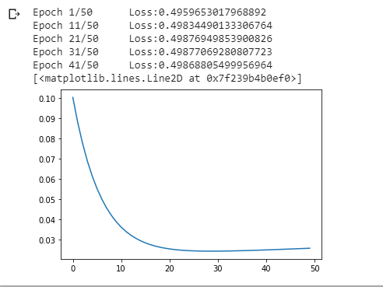

TASK 2:

import numpy as np

import matplotlib.pyplot as plt

class NeuralNetwork():

  def __init__(self, input_size, hidden_size, output_size):

    super(NeuralNetwork, self).__init__()

    self.weights_input_to_hidden = np.random.random((input_size, hidden_size))

    self.weights_hidden_to_output = np.random.random((hidden_size, output_size))

  # For Task 2, change the tanh function to tan-h and reLU here

  ## TASK 2 CODE STARTS HERE

  # TanH Function

  def tanh(self, x, deriv = False):

    f = np.tanh(x)

    if deriv:

      return 1 - f**2

    return f

  ## TASK 2 CODE ENDS HERE

  def train(self, train_x, train_y, num_epochs):

    loss_dict = {}

    for epoch in range(num_epochs):

        # Forward prop

        self.l0 = train_x

        self.l1 = self.tanh(np.dot(self.l0, self.weights_input_to_hidden))

        l2 = self.tanh(np.dot(self.l1, self.weights_hidden_to_output))

        # Backprop

        # Finding final and hidden layer losses

        loss = train_y - l2

        if epoch % 1000 == 0:

          print('Epoch {}/{} \tLoss:{}'.format(epoch+1, num_epochs, np.mean(np.abs(loss))))

          #plt.plot(epoch+1,np.mean(loss))

        l2_delta = loss * self.tanh(l2, deriv = True)

        l1_error = l2_delta.dot(self.weights_hidden_to_output.T)

        l1_delta = l1_error * self.tanh(self.l1, deriv = True)

        # Optimizing weights

        self.weights_hidden_to_output += self.l1.T.dot(l2_delta)

        self.weights_input_to_hidden += self.l0.T.dot(l1_delta)

        # Store loss in a dictionary

        loss_dict[epoch] = np.abs(np.mean(loss))

    return loss_dict

  def test(self, test_x):

    self.l0 = test_x

    self.l1 = self.tanh(np.dot(self.l0, self.weights_input_to_hidden))

    output = self.tanh(np.dot(self.l1, self.weights_hidden_to_output))

    if output < 0.5:

      return 0

    return output

nn = NeuralNetwork(input_size=3, hidden_size = 5, output_size = 1)

loss = nn.train(train_x = arr_x, train_y = arr_y, num_epochs = 5000)

plt.plot(list(loss.keys()),list(loss.values()))

OUTPUT OF TASK 2A:

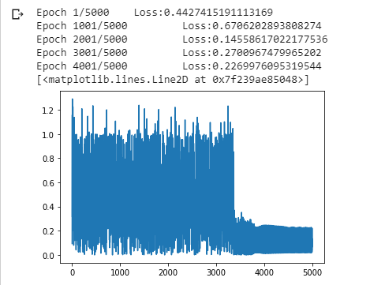

import numpy as np

import matplotlib.pyplot as plt

class NeuralNetwork():

  def __init__(self, input_size, hidden_size, output_size):

    super(NeuralNetwork, self).__init__()

    self.weights_input_to_hidden = np.random.random((input_size, hidden_size))

    self.weights_hidden_to_output = np.random.random((hidden_size, output_size))

  ## TASK 2 CODE STARTS HERE

  # Rectified Linear Unit (ReLU) Function

  def relu(self, x, deriv = False):

    if deriv:

      if x.any() > 0:

        return 1

      else:

        return 0

    else:

      return x * (x > 0)

  ## TASK 2 CODE ENDS HERE

  def train(self, train_x, train_y, num_epochs):

    loss_dict = {}

    for epoch in range(num_epochs):

        # Forward prop

        self.l0 = train_x

        self.l1 = self.relu(np.dot(self.l0, self.weights_input_to_hidden))

        l2 = self.relu(np.dot(self.l1, self.weights_hidden_to_output))

        # Backprop

        # Finding final and hidden layer losses

        loss = train_y - l2

        if epoch % 1000 == 0:

          print('Epoch {}/{} \tLoss:{}'.format(epoch+1, num_epochs, np.mean(np.abs(loss))))

          #plt.plot(epoch+1,np.mean(loss))

        l2_delta = loss * self.relu(l2, deriv = True)

        l1_error = l2_delta.dot(self.weights_hidden_to_output.T)

        l1_delta = l1_error * self.relu(self.l1, deriv = True)

        # Optimizing weights

        self.weights_hidden_to_output += self.l1.T.dot(l2_delta)

        self.weights_input_to_hidden += self.l0.T.dot(l1_delta)

        # Store loss in a dictionary

        loss_dict[epoch] = np.abs(np.mean(loss))

    return loss_dict

  def test(self, test_x):

    self.l0 = test_x

    self.l1 = self.relu(np.dot(self.l0, self.weights_input_to_hidden))

    output = self.relu(np.dot(self.l1, self.weights_hidden_to_output))

    if output < 0.5:

      return 0

    return output

nn = NeuralNetwork(input_size=3, hidden_size = 5, output_size = 1)

loss = nn.train(train_x = arr_x, train_y = arr_y, num_epochs = 5000)

plt.plot(list(loss.keys()),list(loss.values()))

OUTPUT OF TASK2B: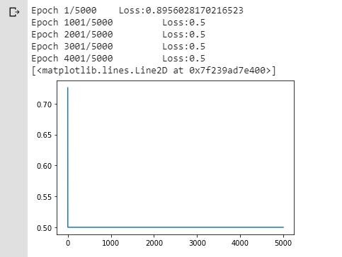

TASK3:

import numpy as np

import matplotlib.pyplot as plt

class NeuralNetwork():

  def __init__(self, input_size, hidden_size, output_size):

    super(NeuralNetwork, self).__init__()

    self.weights_input_to_hidden = np.random.random((input_size, hidden_size))

    self.weights_hidden_to_output = np.random.random((hidden_size, output_size))

  # For Task 2, change the sigmoid function to tan-h and reLU here

  ## TASK 2 CODE STARTS HERE

  def sigmoid(self, x, deriv = False):

    if deriv:

      return x * (1 - x)

    return 1 / (1 + np.exp(-x))

  ## TASK 2 CODE ENDS HERE

  def train(self, train_x, train_y, num_epochs):

    loss_dict = {}

    for epoch in range(num_epochs):

        # Forward prop

        self.l0 = train_x

        self.l1 = self.sigmoid(np.dot(self.l0, self.weights_input_to_hidden))

        l2 = self.sigmoid(np.dot(self.l1, self.weights_hidden_to_output))

        # Backprop

        # Finding final and hidden layer losses

        loss = train_y - l2

        if epoch % 10 == 0:

          print('Epoch {}/{} \tLoss:{}'.format(epoch+1, num_epochs, np.mean(np.abs(loss))))

          #plt.plot(epoch+1,np.mean(loss))

        l2_delta = loss * self.sigmoid(l2, deriv = True)

        l1_error = l2_delta.dot(self.weights_hidden_to_output.T)

        l1_delta = l1_error * self.sigmoid(self.l1, deriv = True)

        # Optimizing weights

        self.weights_hidden_to_output += self.l1.T.dot(l2_delta)

        self.weights_input_to_hidden += self.l0.T.dot(l1_delta)

        # Store loss in a dictionary

        loss_dict[epoch] = np.abs(np.mean(loss))

    return loss_dict

  def test(self, test_x):

    self.l0 = test_x

    self.l1 = self.sigmoid(np.dot(self.l0, self.weights_input_to_hidden))

    output = self.sigmoid(np.dot(self.l1, self.weights_hidden_to_output))

    if output < 0.5:

      return 0

    return output

    # Training Set

arr_x = np.array([[0,0,0,0],

                [1,1,1,1],

                [1,0,0,0],

                [0,0,1,0],

                [1,1,0,0],

                [1,0,1,1],

                [0,0,1,1],

                [1,0,0,1]])

arr_y = np.array([[1],

                 [1],

                 [1],

                 [0],

                 [0],

                 [1],

                [1],

                [0]])

nn_3 = NeuralNetwork(input_size=4, hidden_size = 1, output_size = 1)

loss = nn.train(train_x = arr_x, train_y = arr_y, num_epochs = 50)

plt.plot(list(loss.keys()),list(loss.values()))

nn_3.test(np.array([0,1,0,0]))

OUTPUT FOR TASK 3A:

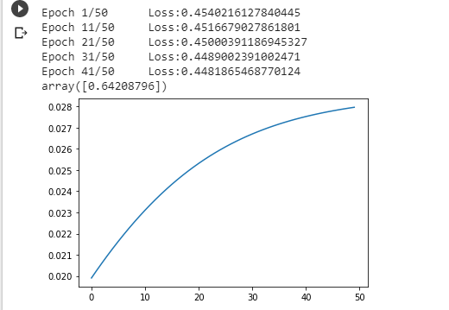

TASK 3B:

import numpy as np

import matplotlib.pyplot as plt

class NeuralNetwork():

  def __init__(self, input_size, hidden_size, output_size):

    super(NeuralNetwork, self).__init__()

    self.weights_input_to_hidden = np.random.random((input_size, hidden_size))

    self.weights_hidden_to_output = np.random.random((hidden_size, output_size))

  # For Task 2, change the sigmoid function to tan-h and reLU here

  ## TASK 2 CODE STARTS HERE

  def sigmoid(self, x, deriv = False):

    if deriv:

      return x * (1 - x)

    return 1 / (1 + np.exp(-x))

  ## TASK 2 CODE ENDS HERE

  def train(self, train_x, train_y, num_epochs):

    loss_dict = {}

    for epoch in range(num_epochs):

        # Forward prop

        self.l0 = train_x

        self.l1 = self.sigmoid(np.dot(self.l0, self.weights_input_to_hidden))

        l2 = self.sigmoid(np.dot(self.l1, self.weights_hidden_to_output))

        # Backprop

        # Finding final and hidden layer losses

        loss = train_y - l2

        if epoch % 10 == 0:

          print('Epoch {}/{} \tLoss:{}'.format(epoch+1, num_epochs, np.mean(np.abs(loss))))

          #plt.plot(epoch+1,np.mean(loss))

        l2_delta = loss * self.sigmoid(l2, deriv = True)

        l1_error = l2_delta.dot(self.weights_hidden_to_output.T)

        l1_delta = l1_error * self.sigmoid(self.l1, deriv = True)

        # Optimizing weights

        self.weights_hidden_to_output += self.l1.T.dot(l2_delta)

        self.weights_input_to_hidden += self.l0.T.dot(l1_delta)

        # Store loss in a dictionary

        loss_dict[epoch] = np.abs(np.mean(loss))

    return loss_dict

  def test(self, test_x):

    self.l0 = test_x

    self.l1 = self.sigmoid(np.dot(self.l0, self.weights_input_to_hidden))

    output = self.sigmoid(np.dot(self.l1, self.weights_hidden_to_output))

    if output < 0.5:

      return 0

    return output

    # Training Set

arr_x = np.array([[0,0,0,0],

                [1,1,1,1],

                [1,0,0,0],

                [0,0,1,0],

                [1,1,0,0],

                [1,0,1,1],

                [0,0,1,1],

                [1,1,0,1]])

arr_y = np.array([[1],

                 [1],

                 [1],

                 [1],

                 [0],

                 [0],

                [0],

                [0]])

nn_3 = NeuralNetwork(input_size=4, hidden_size = 5, output_size = 1)

loss = nn.train(train_x = arr_x, train_y = arr_y, num_epochs = 5000)

plt.plot(list(loss.keys()),list(loss.values()))

nn_3.test(np.array([0,1,0,0]))

OUTPUT OF TASK 3B:

