**VALLIAMMAL COLLEGE FOR WOMEN**

Department of computer science

**Team ID :** SWTID1741248608149822

**Team Size :** 5

**Team Leader :** NITHYA A

**Team member :** MYTHILI M

**Team member :** NAMITHA T

**Team member :** NARMADHAA K U

**Team member :** NIVETHA E

**FitFlex:** Your Personal Fitness Companion(React Application)

**Introduction:**

FitFlex is a revolutionary fitness app designed to transform your workout experience. It offers an intuitive interface, dynamic search, and a vast library of exercises for all fitness levels. Join FitFlex to embark on a personalized fitness journey and achieve your wellness goals.

**Description:**

Welcome to the forefront of fitness exploration with FitFlex! Our innovative fitness app is meticulously designed to revolutionize the way you engage with exercise routines, catering to the diverse interests of both fitness enthusiasts and seasoned workout professionals. With a focus on an intuitive user interface and a comprehensive feature set, FitFlex is set to redefine entire fitness discovery and exercise experience.

**Scenario based Intro:**

You lace up your sneakers, determined to get serious about your fitness. But where do you start? Suddenly, you remember FitFlex, the innovative app that promised to revolutionize your workouts. With a tap, you open the app. Vibrant visuals flood the screen – personalized workout plans, diverse exercise categories, and a supportive community. This isn't your typical fitness app. FitFlex feels...different. Intrigued, you select a workout and get ready to experience the future of fitness.

**Project Goals and Objectives:**

The overarching aim of FitFlex is to offer an accessible platform tailored for individuals passionate about fitness, exercise, and holistic well-being. Our key objectives are as follows:

**✔ User-Friendly Experience:** Develop an intuitive interface that facilitates easy navigation, enabling users to effortlessly discover, save, and share their preferred workout routines.

**Features of FitFlex:**

**✔ Visual Exercise Exploration:** Engage with workout routines through curated image galleries, allowing users to explore different exercise categories and discover new fitness challenges visually.

**✔ Advanced Search Feature:** Easily find specific exercises or workout plans through a powerful search feature, enhancing the app's usability for users with varied fitness preferences.

**Technical Architecture:**

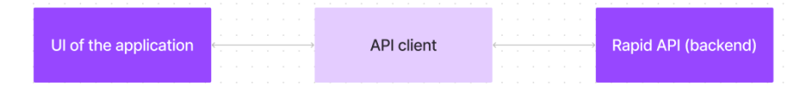

***PRE-REQUISITES:***

**✔ Node.js and npm:** Node.js is a powerful JavaScript runtime environment that allows you to run JavaScript code on the local environment. It provides a scalable and efficient platform for building network applications. Install Node.js and npm on your development machine, as they are required to run JavaScript on the server-side.

**● Download:** <https://nodejs.org/en/download/>

**● Installation instructions:** <https://nodejs.org/en/download/package-manager/>

**✔ HTML, CSS, and JavaScript:** Basic knowledge of HTML for creating the structure of your app, CSS for styling, and JavaScript for client-side interactivity is essential.

✔Version Control: Use Git for version control, enabling collaboration and tracking changes throughout the development process. Platforms like GitHub or Bitbucket can host your repository.

• Git: Download and installation instructions can be found at: <https://git-scm.com/downloads>

✔ Development Environment: Choose a code editor or Integrated Development Environment (IDE) that suits your preferences, such as Visual Studio Code, Sublime Text, or WebStorm

. • Visual Studio Code: Download from <https://code.visualstudio.com/download>

To get the Application project from drive: Follow below steps:

✔ **Get the code:**

• Download the codefrom the drive link given below: https://drive.google.com/drive/folders/14f9eBQ5W7VrLdPhP2W6PzOU_HCy8UMex?usp=sharing Install Dependencies:

• Navigate into the cloned repository directory and install libraries: cd fitness-app-react npm install

✔ Start the Development Server:

• To start the development server, execute the following command: npm start

**Access the App:**

• Open your web browser and navigate to <http://localhost:3000>.

• You should see the application's homepage, indicating that the installation and setup were successful.

**Projectstructure:** 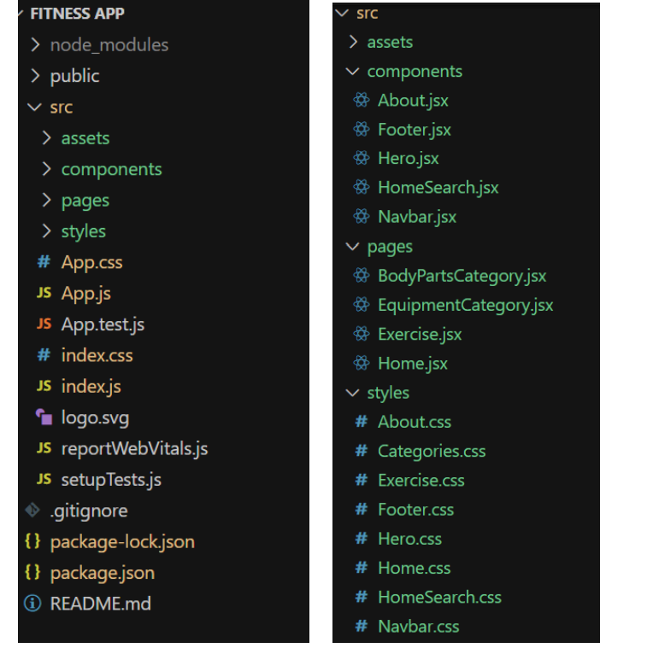

**Project demo:**

Before starting to work on this project, let’s see the demo.

Demolink: <https://drive.google.com/drive/folders/14f9eBQ5W7VrLdPhP2W6PzOU_HCy8UMex?usp=sharing>

Milestone 1:

Project Development ❖ Setup the Routing paths Setup the clear routing paths to access various files in the application

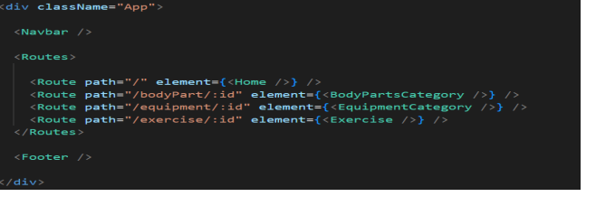

❖ Develop the Navbar and Hero components

❖ Code the popular search/categories components and fetch the categories from rapid Api.

❖ Additionally, we can add the component to subscribe for the newsletter and the footer.

❖ Now, develop the category page to display various exercises under the category.

❖ Finally, code the exercise page, where the instructions, other details along with related videos from the YouTube will be displayed.

**Project Execution:**

After completing the code, run the react application by using the command “npm start” or “npm run dev” if you are using vite.js Here are some of the screenshots of the application.

**Hero component :**

this section would showcase trending workouts or fitness challenges to grab users' attention

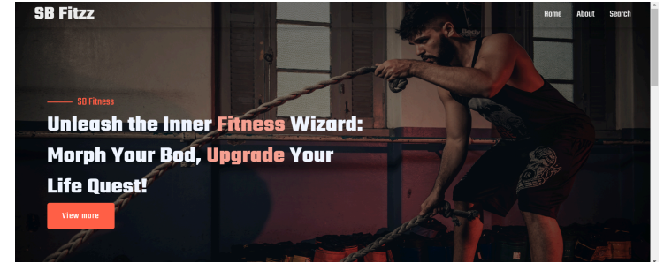

**About**

FitFlex isn't just another fitness app. We're meticulously designed to transform your workout experience, no matter your fitness background or goals.

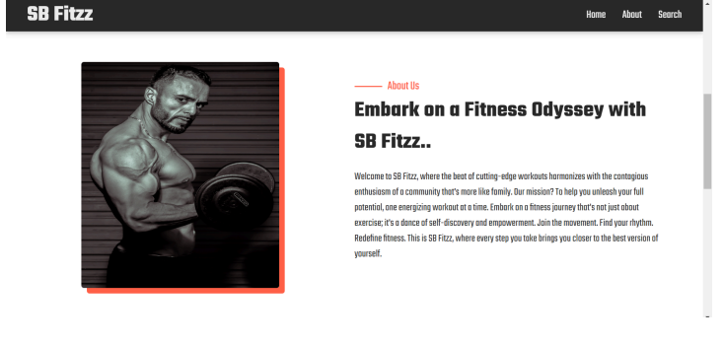

**Search**

Fitzz makes finding your perfect workout effortless. Our prominent search bar empowers you to explore exercises by keyword, targeted muscle group, fitness level, equipment needs, or any other relevant criteria you have in mind. Simply type in your search term and let FitFlex guide you to the ideal workout for your goals.

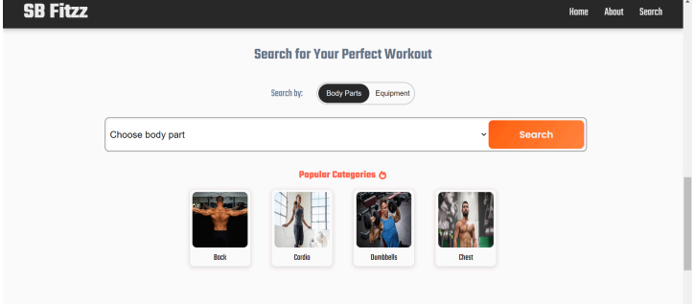

**Category page:**

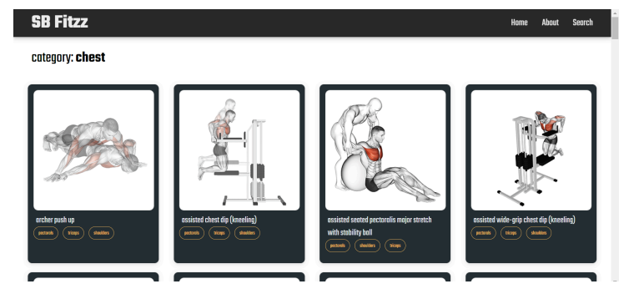

**Conclusion**

The fitness management system plays a crucial role in promoting a healthier lifestyle by providing users with tools to track their workouts, monitor their progress, and maintain a balanced diet. By integrating technology with fitness, this project enhances accessibility, convenience, and motivation for individuals looking to achieve their health goals. The system's user-friendly interface, real-time tracking, and personalized recommendations make it a valuable asset for fitness enthusiasts, trainers, and gym owners alike.

With continuous advancements, this project can be further improved by incorporating AI-based recommendations, wearable device integration, and social engagement features. Ultimately, a well-designed fitness management system encourages consistency, discipline, and overall well-being, making fitness more effective and enjoyable for users.