**CRICKET CASSINO - AN ENTERTAINMENT GAME**

**A MINI PROJECT REPORT**

***Submitted by***

|  |  |
| --- | --- |
| **MONIKA.R** | **(Register No: 15TUCS128)** |
| **PRIYADARSHINI.R** | **(Register No: 15TUCS147)** |
| **NITHYA.K** | **(Register No: 15TUCS136)** |

***in partial fulfillment for the award of the degree***

***of***

**BACHELOR OF ENGINEERING**

**IN**

**COMPUTER SCIENCE AND ENGINEERING**

**DEPARTMENT OF COMPUTER SCIENCE AND ENGINEERING**



**SRI KRISHNA COLLEGE OF TECHNOLOGY**

**(An Autonomous Institution |Affiliated to**

**Anna University Chennai| Accredited by NBA |**

**Accredited by NAAC with ‘A’ Grade)**

**KOVAIPUDUR, COIMBATORE – 641042**

**APRIL 2017**



**DECEMBER 2015**

**SRI KRISHNA COLLEGE OF TECHNOLOGY**

**KOVAIPUDUR, COIMBATORE 641042**

**BONAFIDE CERTIFICATE**

Certified that this project report “**CRICKET CASSINO – AN ENTERTAINMENT GAME** is the bonafide work of “**MONIKA.R, PRIYADARSHINI.R** and **NITHYA.K**” who carried out the mini project work under my supervision.

**SIGNATURE**  **SIGNATURE**

**Dr.A.BALAMURUGAN Ms.S.SIAMALA DEVI**

**HEAD OF THE DEPARTMENT SUPERVISOR**

Professor, Assistant Professor,

Department of Computer Science Department of Computer Science

and Engineering, and Engineering,

Sri Krishna College of Technology, Sri Krishna College of Technology,

Coimbatore- 641042.Coimbatore-641042.

Certified that the candidates were examined by us in the Mini Project viva voce examination held on_____________ at Sri Krishna College of Technology, Kovaipudur,Coimbatore -641042.

**INTERNAL EXAMINER EXTERNAL EXAMINER**

ABSTRACT :

Today, the computer games industry is one of the most profitable industries in the world. Games are something which everyone loves to play on their computer. In fact it is one of the most used applications in a computer. Game help you relax and they are a perfect way of killing time when you are feling bored. These factors have inspired us to make a project which aims at creating games.

This paper deals about an entertainment game-Cricket Casino. It is a game which can be played instead of playing these type of games using papers. This game have certain rules and it will be maintained throughout the game. There are three players where they select 3 cards of the cricketer names as the name of the game itself indicates. For each turn each player must give one of their cards to the next player. This will continue until the announcement of the winner. Winner is decided if the player has same named three cards.

Although there are many games available in the world this is the favorite game during our school days. So this game will give full entertainment. This game can also be played at anywhere where only minimum softwares are required. This paper also deals with some limitations of existing system of games.

**TABLE OF CONTENTS**

|  |  |  |
| --- | --- | --- |
| **CHAPTER NO** | **TITLE** | **PAGE NO** |
| 1 | ABSTRACT |  |
| 2 | INTRODUCTION |  |
|  | 2.1 Rules |  |
|  | 2.2 Concept |  |
|  | 2.3 Objectives |  |
|  |  |  |
| 3 | EXISTING SYSTEM |  |
|  | 3.1 Methodology |  |
|  | 3.2 Limitations |  |
|  | 3.3 Motivation |  |
| 4 | DESIGN METHODOLOGY |  |
|  | 4.1 Problem Definition |  |
|  | 4.2 System Overview |  |
|  | 4.3 Module Description |  |
|  | 4.3.1 Card allocation |  |
|  | 4.3.2 Card replacement |  |
|  | 4.3.3 Winner announcement |  |
| 5 | IMPLEMENTATION AND RESULTS |  |
|  | 1. Language |  |
|  | 1. Source code   5.3 Result |  |
|  |  |  |
| 6 | CONCLUSION AND FUTURE ENHANCEMENT |  |
|  | 6.1 Conclusion |  |
|  | 6.2 Future Enhancements |  |
| 7 | REFERENCES |  |

INTRODUCTION

2.1 RULES

* There can be three players in a game.
* Cards are named with cricketer names.
* Each player will be allocated with three cards as first turn.
* By starting the game each player should give one card to the next one.
* This will continue until any one of the players has stored three same cards.
* If more than one player has same three cards winner will be decided which person has stored three cards first.
* Game will stopped once winner is announced.

2.2 CONCEPT

There are three players where each player will have three cards .The cards will have cricketer names. The players will be exchanging their cards to their next one. If the incoming card matches with the card the player, has then suggestions will be available.

The player can make use of those suggestions and if the incoming card matches with two available cards, suggestions will be displayed twice. If two players have same three cards that player one who stored it first is the winner .

Winner will be announced after completion of that particular round. If initially any player who is allocated with same three cards will be announced as winner since the match is drawn.

2.3 OBJECTIVES

This game is to provide entertainment among users .This is a offline game and can be played at any place .This game aims to bring the childhood memories when we used to play this game as most and favorite.

Scope is to add new games to have new hi-fi games into it with a few obvious ideas and modifications.

* Forms of fun and entertainment and diversion
* Exercises eye and the brain
* You can start over if you lose
* Play with your friends in the computer
* Encourage ways of learning,imagination,creativity and exploration
* More interesting than playing in cards or papers

EXISTING SYSTEM

3.1 METHODOLOGY

There is no casino game which can be played offline . Also there is no offline applications for casino using java. Cards or papers can be used while playing it manually but traditional method is replaced with game developed by a programming language.

Actual casino games are played especially in casino theatres where they use real cards and also it is a type of gambling. This game takes more time but this computer game is simpler form of it.

3.2LIMITATIONS

* Available games or applications can be played only by using the internet.
* Those games are developed by complex programs.
* They are little bit confusing and it will take long time to finish the game.
* Those games will not available offline.

3.3MOTIVATION

There is no simpler methods and thus this game is simple and quite interesting. Offline mode compatibility is not available with old games and this game can be played without using internet. Their source code is too complex but this game is simpler one. Gaming industry is the most interesting and everyone loves to play games either in computer or in real world scenario. So disadvantages of the existing system and the interest of people towards gaming have made me to choose game development concept. And also people and youngsters are very much interested towards cricket hence we have chosen the concept of cricket in this card games.

DESIGN METHODOLOGY :

4.1 PROBLEM DEFINITION

Three players can play the game. This is game which is similar to card shuffling game. The aim of the player is to gather same three cards to win the game. If the player stored the same three cards then the player declared as winner of the tournament.

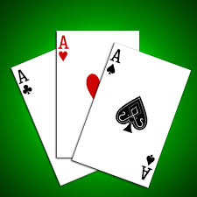

4.2 SYSTEM OVERVIEW

This system of game aims mainly about users entertainment. Card can be shuffled at any order so that each player will be allocated with three cards by which they can start the game.

After starting the game each player should give his card to their next one and if they have any possibility to win suggestions will be available and the players can make use of those suggestions or else they can decide by their own.

They cannot simply give any card to their next one because error message will be displayed. So if any one of the player who have same three cards will be the winner but it will announced at the end of that turn of the game.

4.3 MODULE DESCRIPTION

|  |  |
| --- | --- |
| **MODULE** | **DESCRIPTION** |
| MODULE 1 | CARD ALLOCATION |
| MODULE 2 | CARD REPLACEMENT |
| MODULE 3 | WINNER DECLARATION |

4.3.1 Card allocation

Describing the rules and allocating cards to the players.

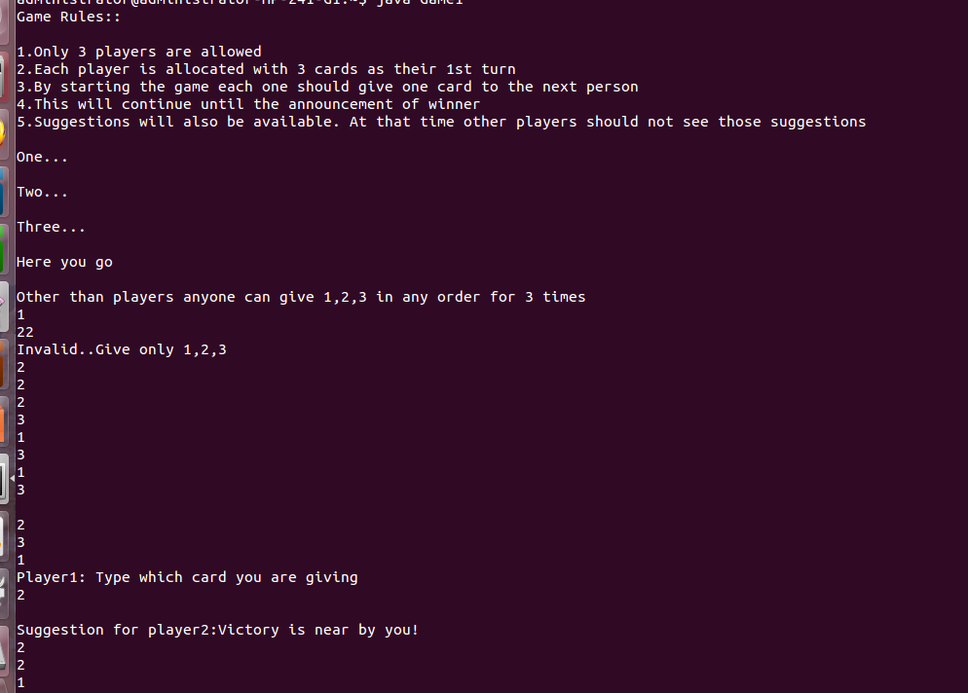

4.3.2Card replacement

Exchanging the cards between the players until anyone of the players having the same three cards.

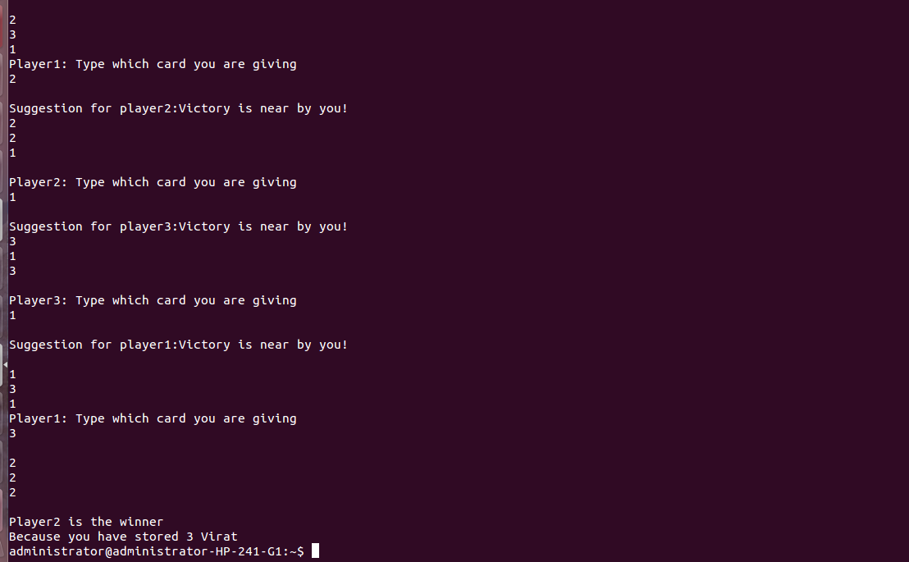

4.3.3Winner announcement

Each player’s card will be checked and the player who has the same three cards for the first time will be declared as winner after completion of that particular turn.

IMPLEMENTATION:

5.1LANGUAGE

This game is developed under programming language java. This game can be run in any platform as java is platform independent language. We have implements various concepts in this coding and it is simple because java is object oriented language. Program errors are known as bugs and the process of detecting these errors is called debugging. In other words debugging is the art of finding and correctness of detecting these errors in the system. Debugging is the consequence of successful testing. It is interpreted because line by line compilation is allowed and it makes to clear errors easily.

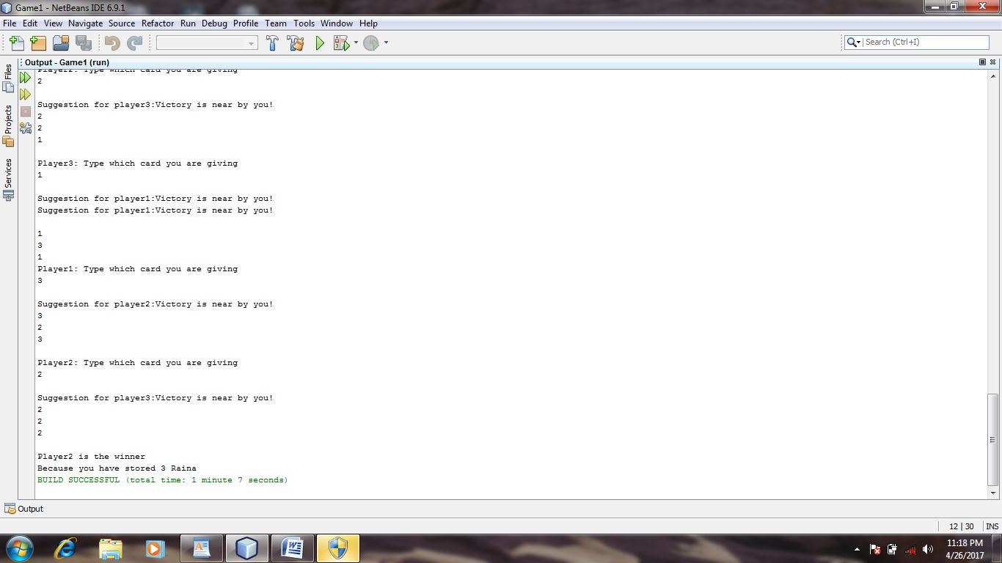

5.2. SOURCE CODE

import java.io.*;

import java.util.*;

class Game1

{

public static void main(String args[])

{

Scanner ob=new Scanner(System.in);

int a[]=new int[3];

int b[]=new int[3];

int c[]=new int[3];

int t[]=new int[10];

int g[]=new int[9];

int i,j,k,l,m,n,h,x,c1=0,c2=0,c3=0;

System.out.println("Game Rules::\n");

System.out.println("1.Only 3 players are allowed");

System.out.println("2.Each player is allocated with 3 cards as their 1st turn");

System.out.println("3.By starting the game each one should give one card to the next person");

System.out.println("4.This will continue until the announcement of winner");

System.out.println("5.Suggestions will also be available. At that time other players should not see those suggestions\n");

System.out.println("One...\n");

System.out.println("Two...\n");

System.out.println("Three...\n");

System.out.println("Here you go\n");

System.out.println("Other than players anyone can give 1,2,3 in any order for 3 times");

for(h=0;h<g.length;h++)

{

g[h]=ob.nextInt();

if(g[h]<=0||g[h]>3)

{

System.out.println("Invalid..Give only 1,2,3");

h--;

}

else

{

if(g[h]==1)

{

c1=c1+1;

if(c1>3)

{

System.out.println("One Not more than 3 times");

h--;

}

}

else if(g[h]==2)

{

c2=c2+1;

if(c2>3)

{

System.out.println("Two Not more than 3 times");

h--;

}

}

else if(g[h]==3)

{

c3=c3+1;

if(c3>3)

{

System.out.println("Three Not more than 3 times");

h--;

}

}

}

}

a[0]=g[2];

a[1]=g[8];

a[2]=g[5];

b[0]=g[1];

b[1]=g[3];

b[2]=g[0];

c[0]=g[4];

c[1]=g[7];

c[2]=g[6];

i=0;

j=1;

k=2;

while(!(a[i]==a[j]&&a[j]==a[k])||(b[i]==b[j]&&b[j]==b[k])||(c[i]==c[j]&&c[j]==c[k]))

{

System.out.println();

for(x=0;x<3;x++)

{

System.out.println(a[x]);

}

if(a[0]==a[1]&&a[1]==a[2])

break;

System.out.println("Player1: Type which card you are giving");

t[0]=ob.nextInt();

System.out.println();

while(t[0]<=0||t[0]>3)

{

System.out.println("Invalid.Please type another time");

t[0]=ob.nextInt();

System.out.println();

}

while(t[0]!=a[0]&&t[0]!=a[1]&&t[0]!=a[2])

{

System.out.println("Invalid.This is not your card.Please type another time");

t[0]=ob.nextInt();

System.out.println();

}

if(b[0]==t[0]||b[1]==t[0]||b[2]==t[0])

{

System.out.println("Suggestion for player2:Victory is near by you!");

}

for(x=0;x<3;x++)

{

System.out.println(b[x]);

}

System.out.println();

if(b[0]==b[1]&&b[1]==b[2])

break;

System.out.println("Player2: Type which card you are giving");

t[1]=ob.nextInt();

System.out.println();

while(t[1]<=0||t[1]>3)

{

System.out.println("Invalid.Please type another time");

t[1]=ob.nextInt();

System.out.println();

}

while(t[1]!=b[0]&&t[1]!=b[1]&&t[1]!=b[2])

{

System.out.println("Invalid.This is not your card.Please type another time");

t[1]=ob.nextInt();

System.out.println();

}

for(l=0;l<b.length;l++)

{

if(t[1]==b[l])

{

b[l]=t[0];

break;

}

}

if(c[0]==t[1]||c[1]==t[1]||c[2]==t[1])

{

System.out.println("Suggestion for player3:Victory is near by you!");

}

for(x=0;x<3;x++)

{

System.out.println(c[x]);

}

System.out.println();

if(c[0]==c[1]&&c[1]==c[2])

break;

System.out.println("Player3: Type which card you are giving");

t[2]=ob.nextInt();

System.out.println();

if(t[2]<=0||t[2]>3)

{

System.out.println("Invalid.Please type another time");

t[2]=ob.nextInt();

System.out.println();

}

while(t[2]!=c[0]&&t[2]!=c[1]&&t[2]!=c[2])

{

System.out.println("Invalid.This is not your card.Please type another time");

t[2]=ob.nextInt();

System.out.println();

}

for(n=0;n<c.length;n++)

{

if(t[2]==c[n])

{

c[n]=t[1];

break;

}

if(a[0]==t[2]||a[1]==t[2]||a[2]==t[2])

{

System.out.println("Suggestion for player1:Victory is near by you!");

}

for(x=0;x<a.length;x++)

{

if(t[0]==a[x])

{

a[x]=t[2];

break;

}

}

}

}

i=0;

j=1;

k=2;

if(a[i]==a[j]&&a[j]==a[k])

{

System.out.println("Player1 is the winner");

if(a[0]==1)

System.out.println("Because you have stored 3 Thala MSD");

else if(a[0]==2)

System.out.println("Because you have stored 3 Virat");

else

System.out.println("Because you have stored Raina");

}

else if(b[i]==b[j]&&b[j]==b[k])

{

System.out.println("Player2 is the winner");

if(b[0]==1)

System.out.println("Because you have stored 3 Thala MSD");

else if(b[0]==2)

System.out.println("Because you have stored 3 Virat");

else

System.out.println("Because you have stored 3 Raina");

}

else if(c[i]==c[j]&&c[j]==c[k])

{

System.out.println("Player3 is the winner");

if(c[0]==1)

System.out.println("Because you have stored 3 Thala MSD");

else if(c[0]==2)

System.out.println("Because you have stored 3 Virat");

else

System.out.println("Because you have stored 3 Raina");

}

}

}

5.3 RESULT

This game makes us to get entertained mostly and it is innovative than other online games. This will be preferred by many users since it can be played in the offline mode also.

CONCLUSION AND FUTURE ENHANCEMENTS:

* The project on cricketer casino has been working efficiently for every movement of game player and various facilities availed by them.
* One can easily play the game with user friendly environment.
* Works efficiently with available resources and produced results in minimum time span.
* Game is made very interactive.
* This game can be developed as an application and it can be played using mobile devices connecting via Bluetooth.

REFERENCES: