**EXPENSE TRACKER**

# Installation Instruction:

## Database Scripts:

/* The database credentials used are ‘**root**’ and no password in MySQL. In case the credentials are different please update the ‘**spring.datasource.username**’ and ‘**spring.datasource.password**’ properties in ‘**ExpenseTracker\src\main\resources\application.properties**’. */

create database expensetracker;

use expensetracker;

// TO CREATE USER ENTITY

CREATE TABLE `user` (

`active` boolean NOT NULL,

`role` varchar(255) NOT NULL,

`username` varchar(255) NOT NULL,

`password` varchar(255) NOT NULL,

`name` varchar(255) NOT NULL,

PRIMARY KEY (`username`)

);

// INSERT SAMPLE DATA

// Password for each user is ‘pass’ which is saved in encrypted format.

insert into user values(1,'ADMIN', 'nithya','$2a$10$veUEUIyBIVe9BZjAOr.ILOy.65hw8IYIxH8OZIyWQg9bdd2eH/m8C', 'nithya');

insert into user values(1,'USER', 'suprajkolluri','$2a$10$veUEUIyBIVe9BZjAOr.ILOy.65hw8IYIxH8OZIyWQg9bdd2eH/m8C', 'supraj');

insert into user values(1,'USER', 'kiran','$2a$10$veUEUIyBIVe9BZjAOr.ILOy.65hw8IYIxH8OZIyWQg9bdd2eH/m8C', 'kiran');

insert into user values(1,'ADMIN', 'giri','$2a$10$veUEUIyBIVe9BZjAOr.ILOy.65hw8IYIxH8OZIyWQg9bdd2eH/m8C', 'giri');

// CREATE ENTITY TO SAVE USER EXPENSES.

create table `expense` (

`id` int(11) NOT NULL AUTO_INCREMENT,

`username` varchar(255) NOT NULL,

`date` datetime NOT NULL,

`amount` double(10,2) NOT NULL,

`description` varchar(255) NOT NULL,

PRIMARY KEY (`id`),

FOREIGN KEY (`username`) REFERENCES `user` (`username`)

);

## Running the application:

mvn clean package

java -jar ExpenseTracker/target/ExpenseTracker-0.0.1-SNAPSHOT.jar

## Screenshots:

Login Page:

Eg: use ‘nithya’ as username and ‘pass’ as password for admin login

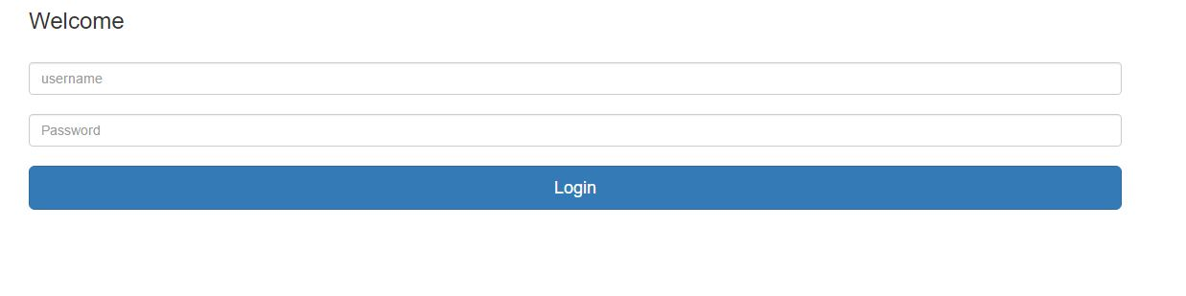

Expenses Page – Admin:

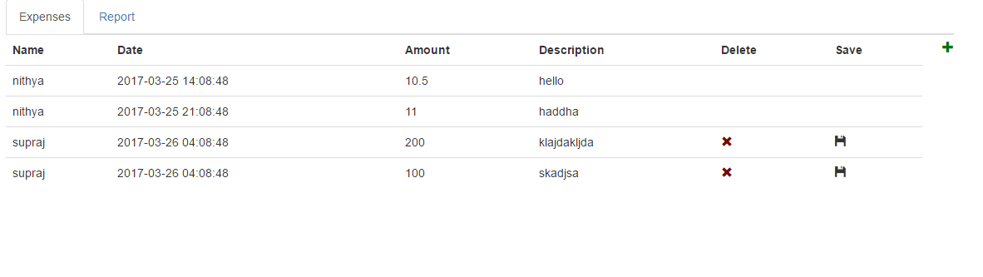

Only the expenses corresponding to the admin are editable. The expensed owned by other users are read only.

Please use the date format ‘YYYY-MM-DD hh:mm:ss’ in the date column

Expenses Page – User:

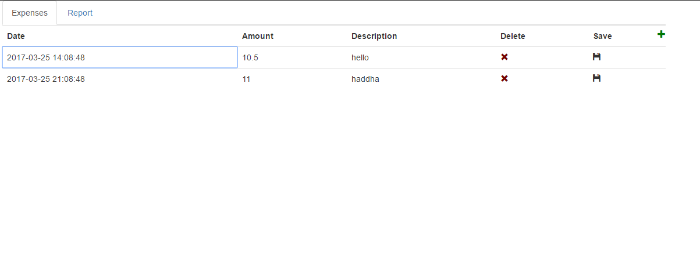

Report Screen:

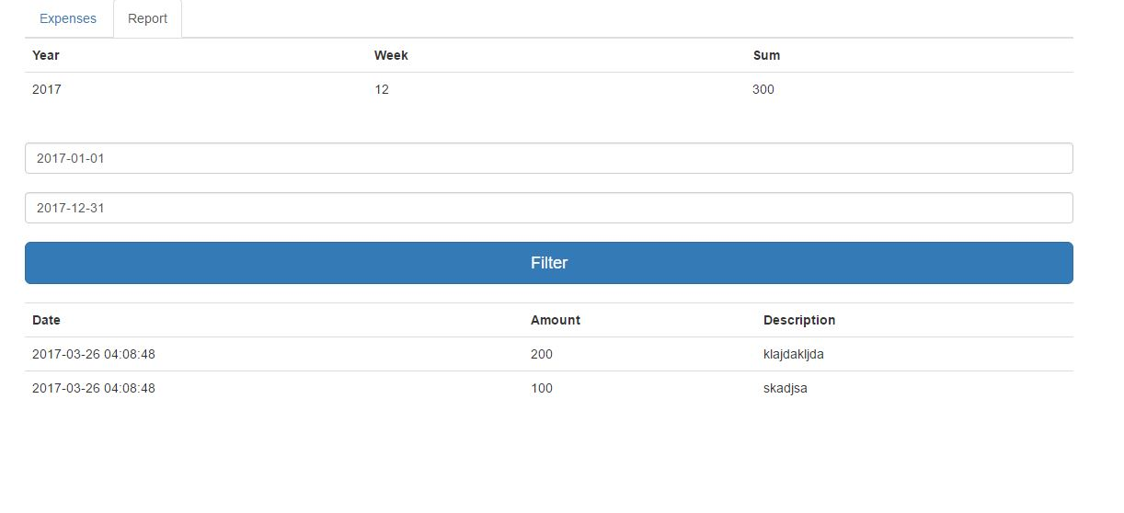

For the date filter fields please use the format – YYYY-MM-DD