GL:

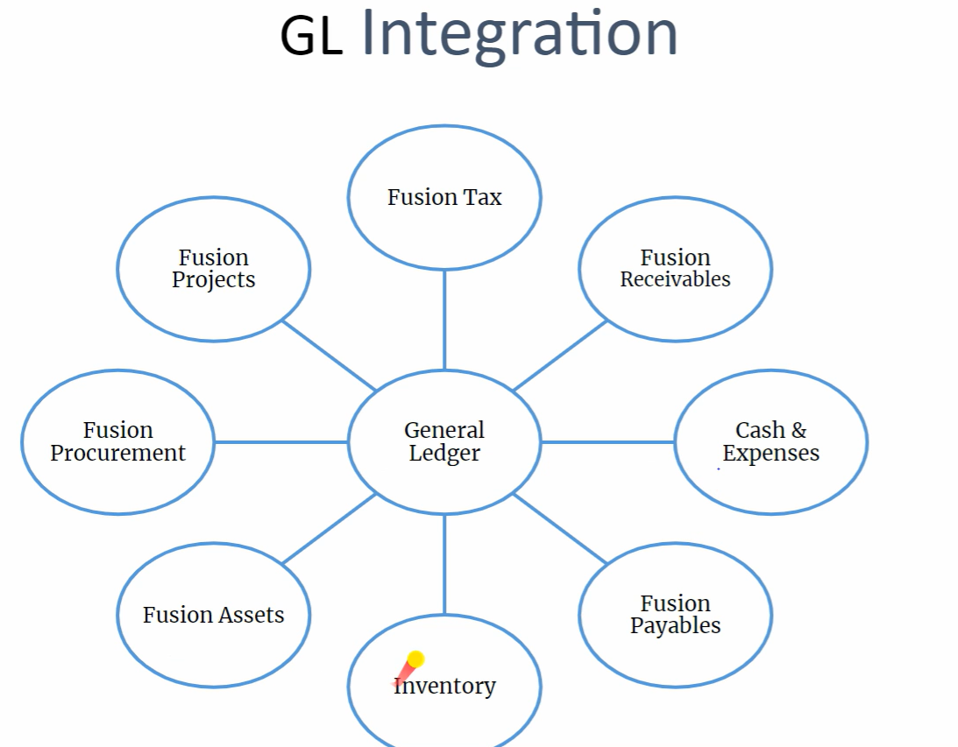

Calender:

Accounting Calender:

Transaction Calender:

Avg Balance Concept:

Chart of Accounts:

Creation of segment values:

FBDI:

