**PROJECT 1:Deploying website on AWS EC2 instances**

Amazon Web Services (AWS) is the world’s most comprehensive and broadly adopted cloud, offering over 200 fully featured services from data centers globally. Millions of customers—including the fastest-growing startups, largest enterprises, and leading government agencies—are using AWS to lower costs, become more agile, and innovate faster.

Most functionality

AWS has significantly more [services](https://aws.amazon.com/products/?pg=WIAWS-mstf), and more features within those services, than any other cloud provider–from infrastructure technologies like compute, storage, and databases–to emerging technologies, such as machine learning and artificial intelligence, data lakes and analytics, and Internet of Things. This makes it faster, easier, and more cost effective to move your existing applications to the cloud and build nearly anything you can imagine.

AWS also has the deepest functionality within those services. For example, AWS offers the widest variety of databases that are purpose-built for different types of applications so you can choose the right tool for the job to get the best cost and performance.

Step 1:We have to create VPC(virtual private cloud)

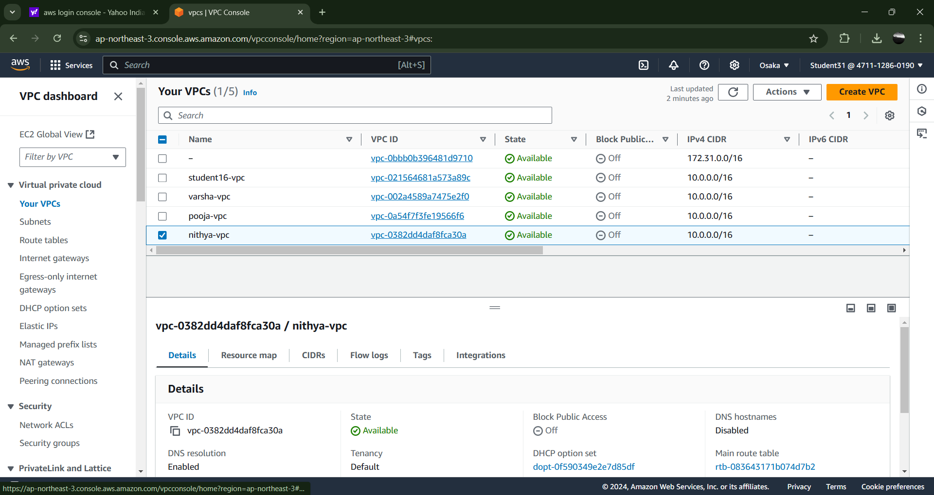

Step 2:

Next creating the internet gateway for the purpose of to make communication between the vpc and public network

After creating the igw then we have to connect to the vpc

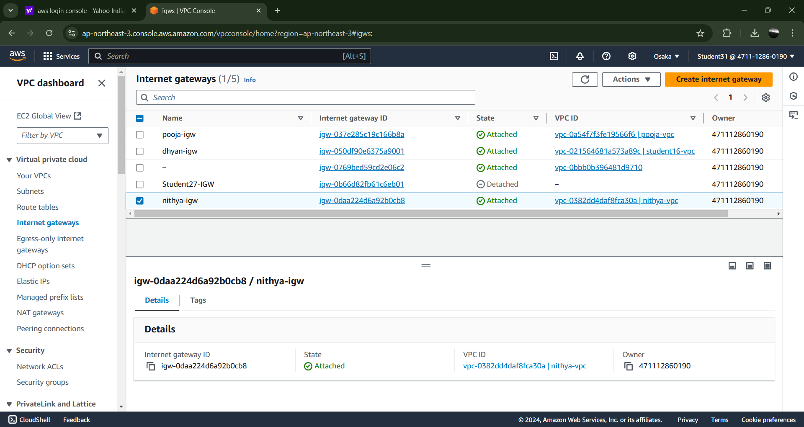

Step 3

After ,we are creating the route table for the purpose of direct network traffic based on the destination IP address then attach to the igw.

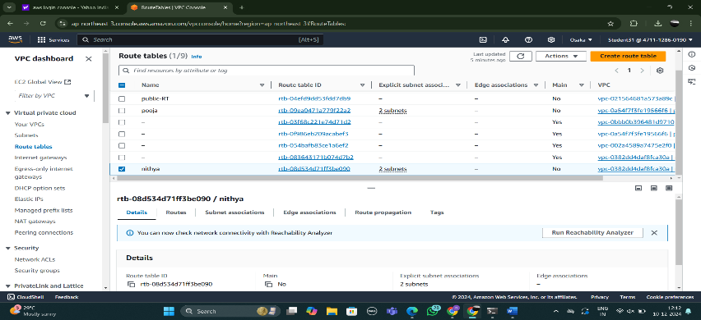

Step 4:

Then we are creating the two subnets and then we attach it to the route table

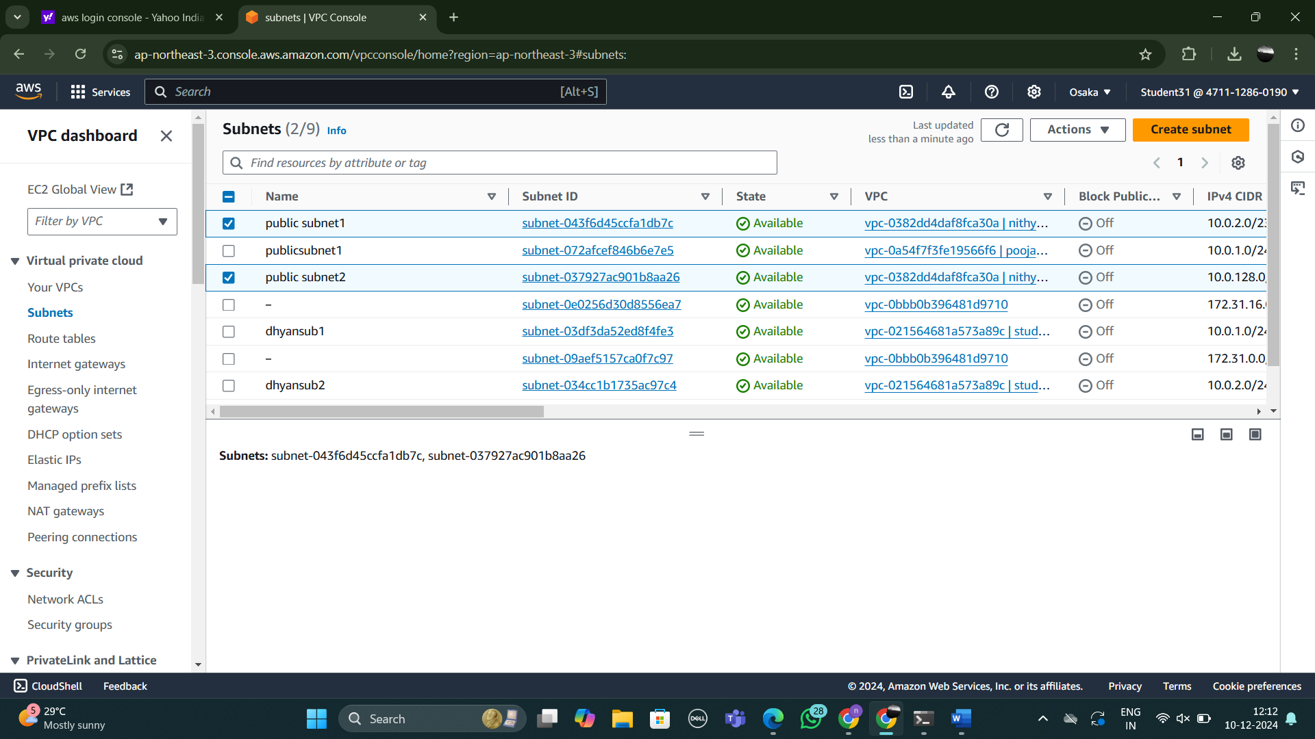

Step 5:

1. We are creating the instance from using the ec2 dashboard
2. then launch the instance give the name to the instances
3. select the os
4. create the key pair with unique name
5. make the vpc enable create security group
6. we have to change that and create more than 2 security groups
7. launch it and connect the instance.

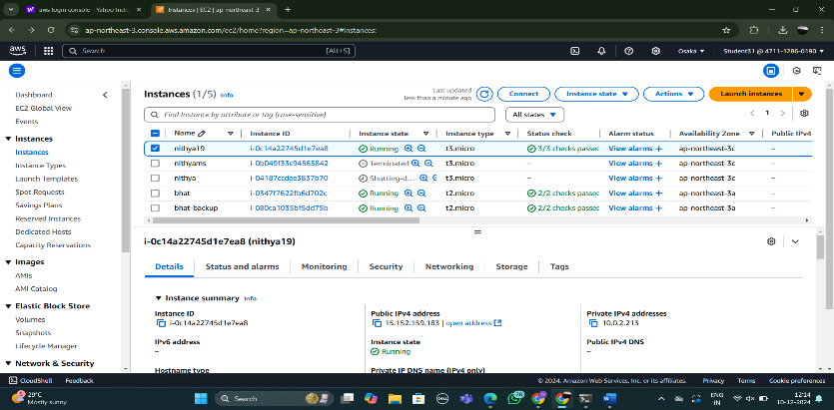

Step 6:

1. then we are use the command promt use below showing commands
2. cd downloads
3. paste the ssh link
4. sudo su
5. cd
6. yum install httpd -y(for installing the apache)
7. cd /var/www/html
8. vi index.html
9. cat index.html
10. systemctl start httpd
11. systemctl enable httpd
12. systemctl status httpd

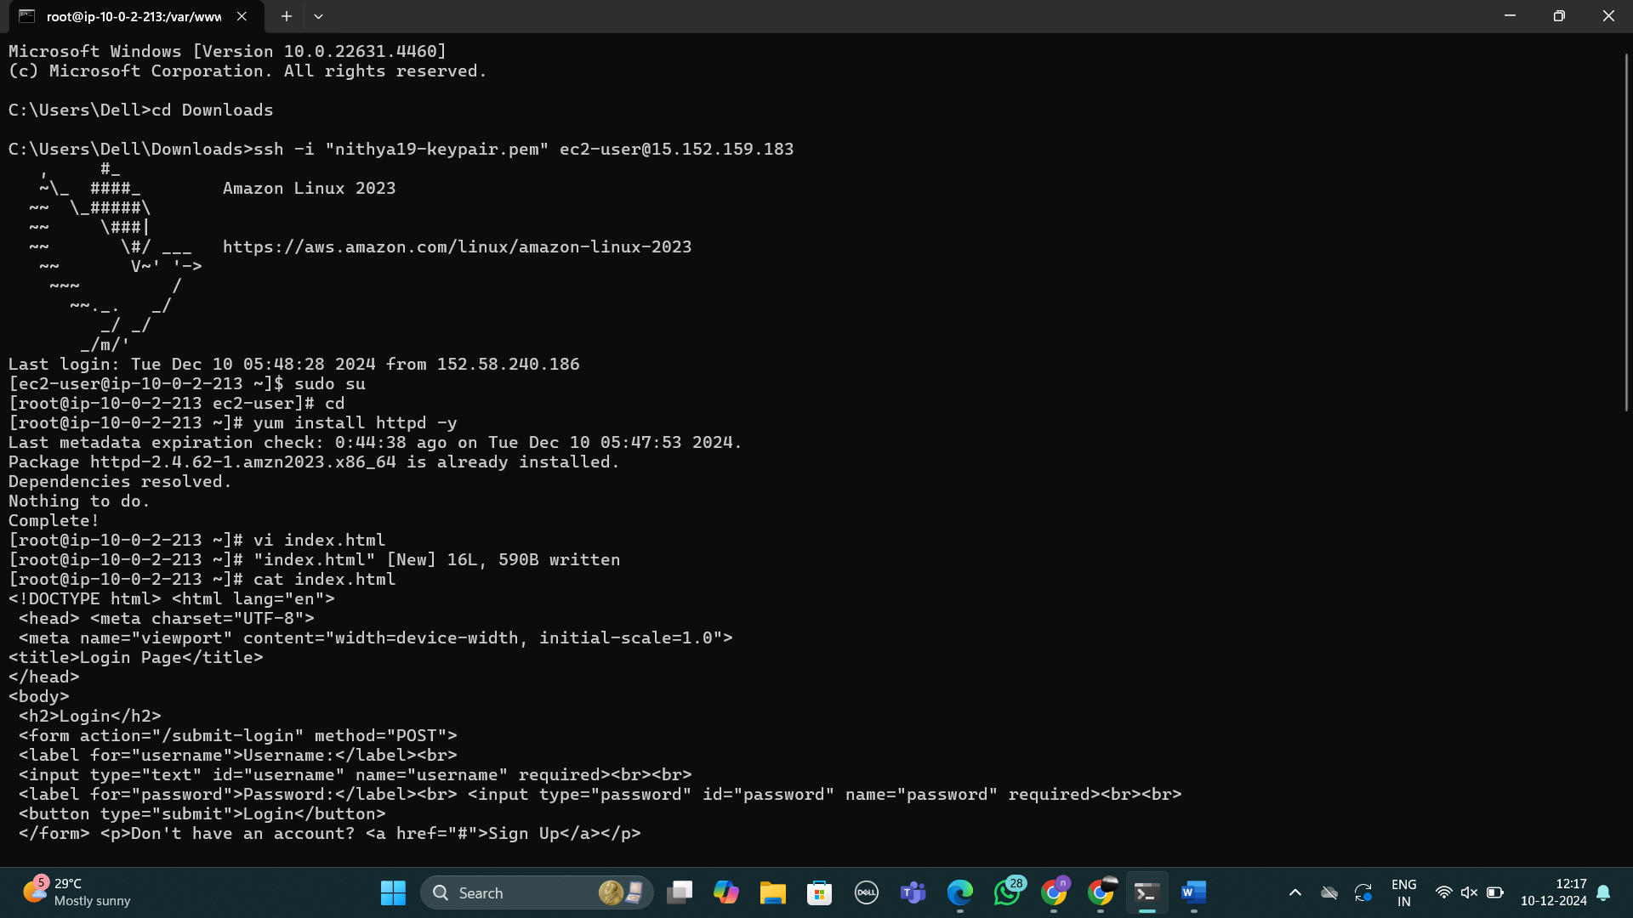

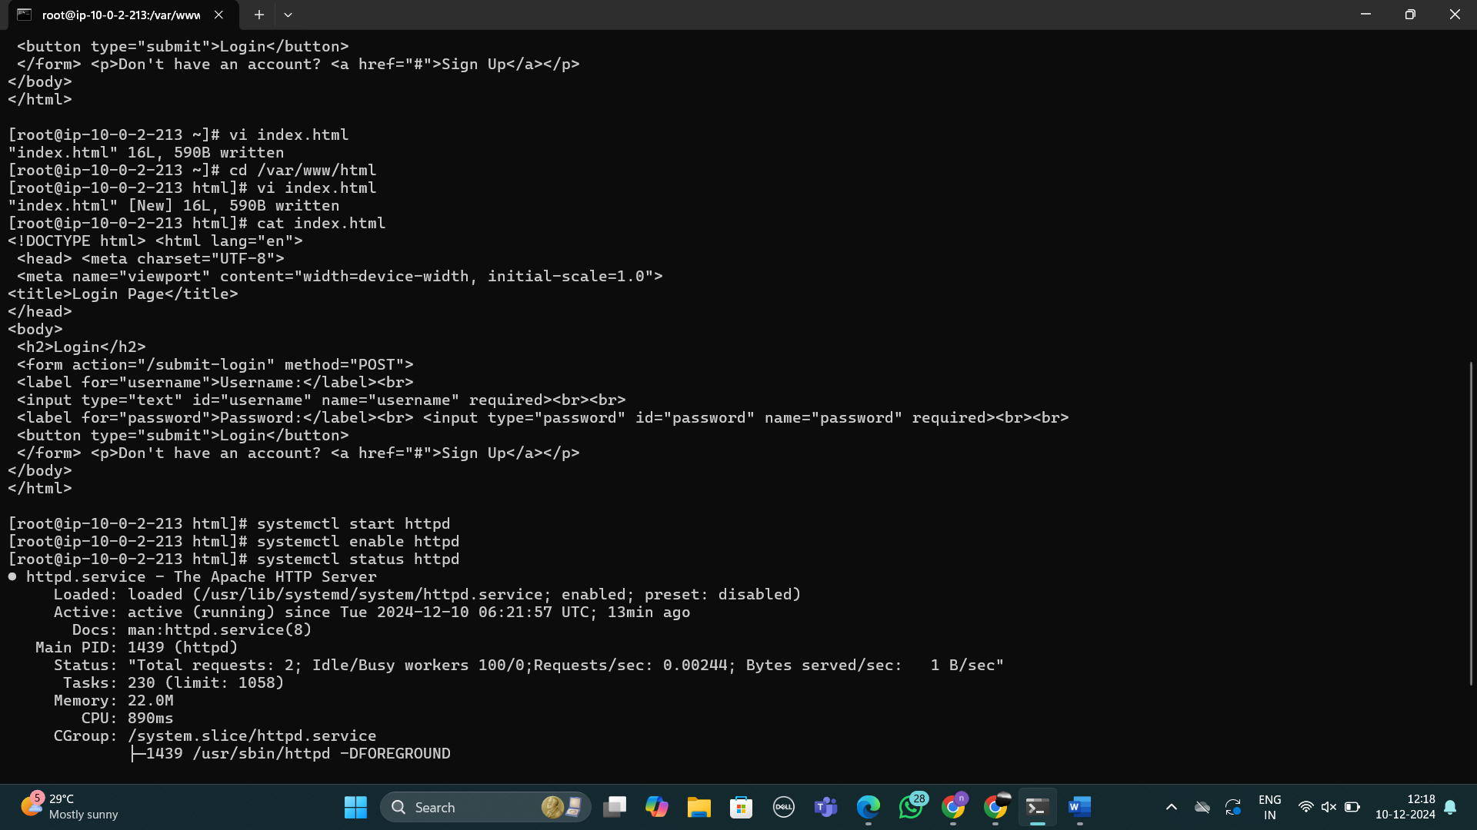

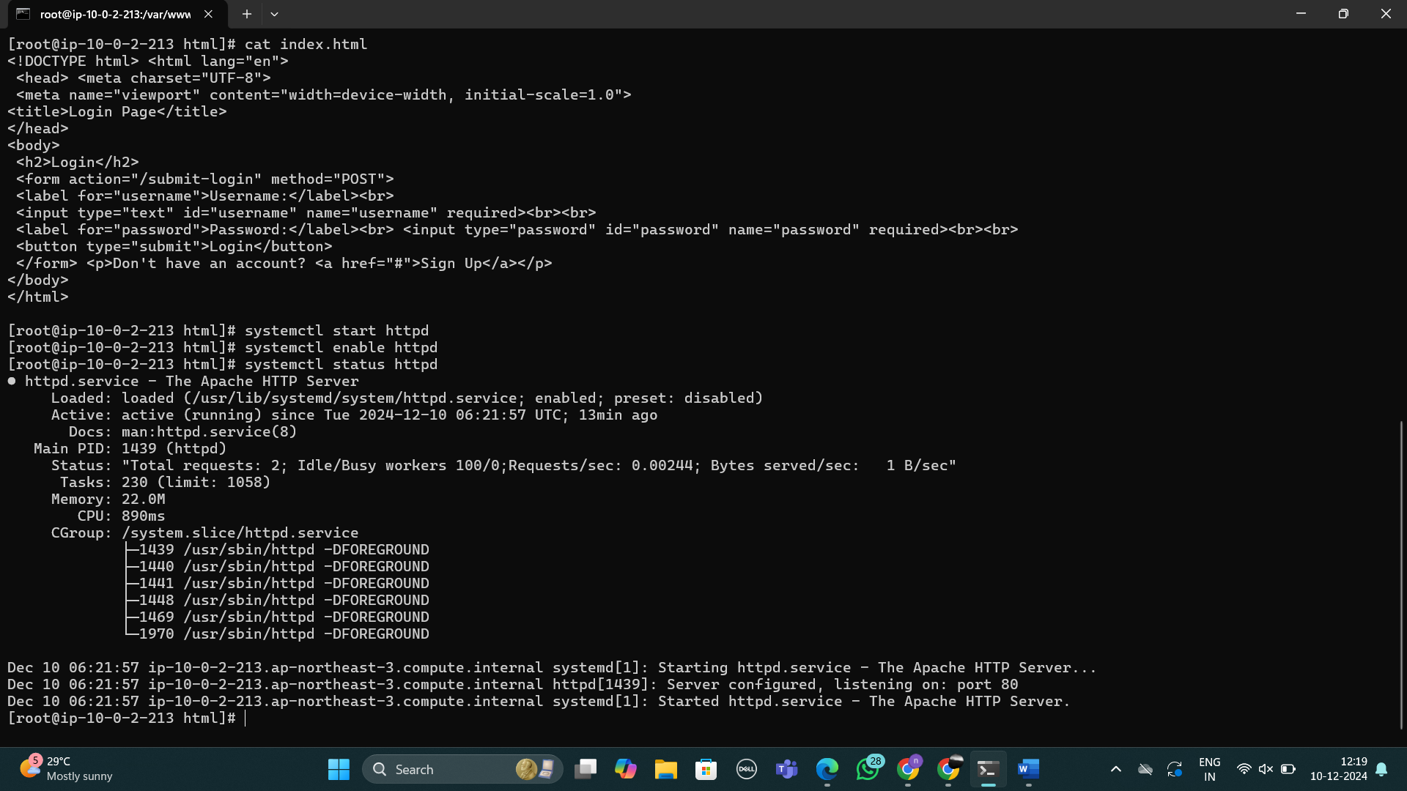

Step 7:

We are coping the ip address from instance run on any browser then you will get the output

