Ideation Phase
Brainstorm & Idea Prioritization Template

Date | 19 october 2023
Team ID | NM2023TMID01657
Project Name | Food tracking system
Maximum Marks | 4 Marks

Brainstorm & Idea Prioritization Template:

Safe food consumption is one of the main things to be considered for a healthy life. The World Health Organization (WHO) stated that 600 million people get sick and 420 thousand people die every year due to unsafe food products. The increase in accessible data and cases has also increased consumers’ awareness of safe food. Aware of the situation, states are working to ensure access to safe food with legal regulations and to ensure that food can be traced throughout the supply chain. While the increase in food destruction negatively affects health, it also causes serious economic losses. In order to prevent losses, companies have concentrated their studies on food safety in the light of technological developments.
The use of traceability technologies is the most effective way for consumers to access safe food. Food traceability covers defining the processes and products in the supply chain, recording them and sharing the recorded information if requested

Step-1: Team Gathering, Collaboration and Select the Problem Statement

Problem statement

Contains details about source of online food ordering system with modeling diagram

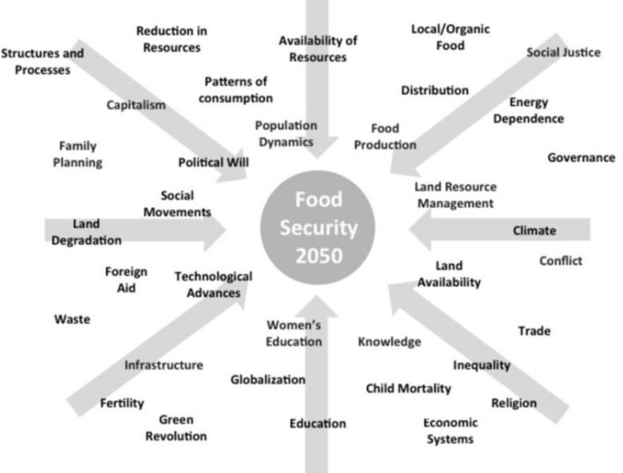
Step-2: Brainstorm, Idea Listing and Grouping

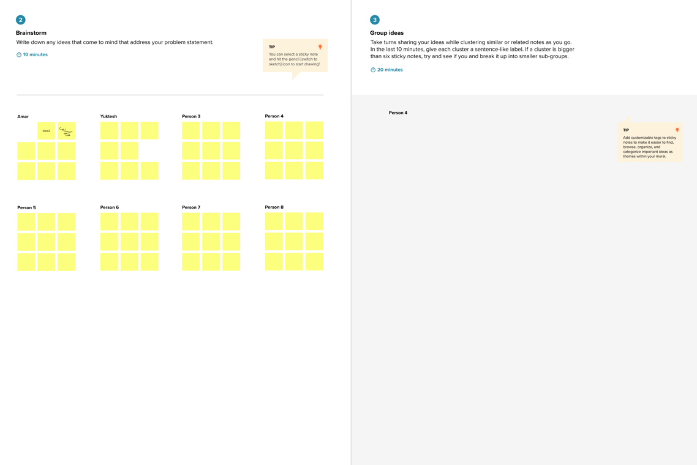

Step-3: Idea Prioritization

