EXP NO: 1.a Analyse the trend of data Science job postings over the last decade
AIM:
To analyse the trend of data science job postings over the last decade.

DESCRIPTION:
Use web scraping or APIs to gather the number of data science data on job postings each year. Use pandas for data manipulation and matplotlib/seaborn for visualization.

PROGRAM:
import pandas as pd
import matplotlib.pyplot as plt
data = {'Year': list(range(2013, 2024)),
'Job Postings': [120,180,250,310,370,440,490,510,570,600,630]}
df = pd.DataFrame(data)
plt.plot(df['Year'], df['Job Postings'], marker='o')
plt.title('Trend of Data Science Job Postings')
plt.xlabel('Year')
plt.ylabel('Number ofJob Postings')
plt.show()

OUTPUT: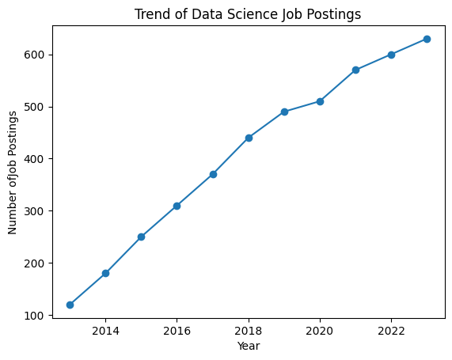

RESULT:
Hence the trend of job postings over the last decade has been analysed.

EXP NO: 1.b Analyze and visualize the distribution of various data science roles from a dataset
AIM:
To analyze and visualize the distribution of various data science roles from a dataset.

DESCRIPTION:
Use a dataset of job postings and categorize them into different roles. Visualize the distribution using pie chart or bar plots.

PROGRAM:
roles = ['Data Analyst', 'Data Engineer', 'Data Scientist', 'ML Engineer',
'Business Analyst']
total_count = [150,350,220,660,300]
index=[5,7,9,11,13]
plt.bar(index,total_count,tick_label=roles)
plt.title('Distribution of Data Science Roles')
plt.xlabel('Role')
plt.ylabel('Total_Count')
plt.show()

OUTPUT: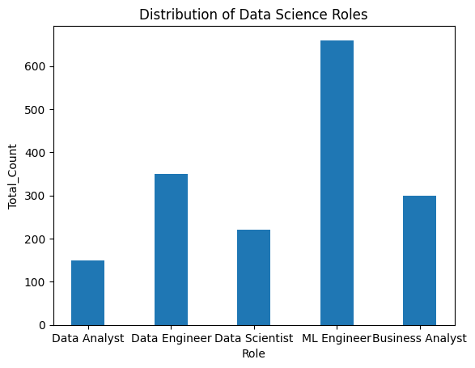

RESULT:
Hence the distribution of various data from a dataset is visualized and analyzed.

EXP NO: 1.c Conduct an experiment to differentiate structured, un-structural and semi structured data based on data sets given.

AIM:
To conduct an experiment to differentiate structured, un-structured and semi structured data based given on data sets given.

DESCRIPTION:
Create small datasets for each type an explain their characteristics.

PROGRAM:
import pandas as pd
df=pd.DataFrame({'Roll No':[101,102,103,104],
'Name':['Harini','Nivedha','Pooja','Poshitha'],
'Department':['CSE','CSE','IT','RA']})
print("Structured Data:\n",df)
print("\n")
unstructured_data="Unstructured data is information that does not have a predefined data model or organizational structure."
print("Unstructured Data:\n",unstructured_data)
print("\n")
semi_structured_data = {'Roll No': [1,2,3], 'Name': ['Prithika','Harini','Berlin'], 'Attributes': {'Height': [165,155,160], 'Weight': [68,55,56]}}
print("Semi-structured Data:\n", semi_structured_data)

OUTPUT:
Structured Data:
Roll No Name Department
0 101 Harini CSE
1 102 Nivedha CSE
2 103 Pooja IT
3 104 Poshitha RA

Unstructured Data:
Unstructured data is information that does not have a predefined data model or organizational structure.

Semi-structured Data:
{'Roll No': [1, 2, 3], 'Name': ['Prithika', 'Harini', 'Berlin'], 'Attributes': {'Height': [165, 155, 160], 'Weight': [68, 55, 56]}}

RESULT:
Hence an experiment to differentiate structured, un-structured and semi structured data based given on data sets given is done.

Exp No:1.d Conduct an experiment to encrypt and decrypt given sensitive data.

AIM:
To conduct an experiment to encrypt and decrypt given sensitive data.

DESCRIPTION:
Use the cryptography library to encrypt and decrypt a piece of data.

PROGRAM:
from cryptography.fernet import Fernet
key = Fernet.generate_key()
cipher = Fernet(key)
original_message = "Conduct an experiment to encrypt and decrypt given sensitive data."
data_bytes = original_message.encode()
encrypted_message = cipher.encrypt(data_bytes)
decrypted_bytes = cipher.decrypt(encrypted_message)
decrypted_message = decrypted_bytes.decode()
print("Original: ", original_message)
print("Encrypted:", encrypted_message.decode())
print("Decrypted:", decrypted_message)

OUTPUT:
Original: Conduct an experiment to encrypt and decrypt given sensitive data.
Encrypted: gAAAAABqgXSYzfJkn_R9tiQ0m3ddlwJHj7RACiTWkCfTfFDltof7v9BFwDuvu-VA_bl5XINETQtoN3JCQiFPJ2DB9C33Qb3Qhd6PGR7fHxQvt6mXw3vphdmR6OA-c6Z8z-Qj5n9UhqNO8AHbrmHp53M8mGyvOn7N733DKOlXFd3FidRYsQlh7_w=
Decrypted: Conduct an experiment to encrypt and decrypt given sensitive data.

RESULT:
Hence an experiment to encrypt and decrypt given sensitive data is done.

