Exp No:2 Upload and Analyze the data set given in csv format and perform data preprocessing and visualization.

AIM:
To upload and analyze the data set given in csv format and perform data
preprocessing and visualization.

DESCRIPTION:
Use sample data set sales-data.csv.

PROGRAM:
from google.colab import drive #mounting csv file to google colab
drive.mount('/content/drive')
import pandas as pd
import numpy as np
import matplotlib.pyplot as plt
df=pd.read_csv('/content/drive/MyDrive/SALES DATA.csv')
print(df.head()) #print the first few rows of data
print(df.isnull().sum())
df['Sales']=df['Sales'].fillna(df['Sales'].mean())
df.dropna(subset=['Product', 'Quantity', 'Region'], inplace=True)
print(df.describe())
prdt_summary=df.groupby('Product').agg({
'Sales':'sum',
'Quantity':'sum'
}).reset_index()
print(prdt_summary)
plt.figure(figsize=(10, 6))
plt.bar(prdt_summary['Product'], prdt_summary['Sales'])
plt.title('TOTAL SALES BY PRODUCT')
plt.xlabel('PRODUCT')
plt.ylabel('TOTAL SALES')
plt.show()
plt.figure(figsize=(10, 6))
plt.bar(prdt_summary['Product'], prdt_summary['Sales'])
plt.title('TOTAL SALES BY PRODUCT')
plt.xlabel('PRODUCT')
plt.ylabel('TOTAL SALES')
plt.show()
pivot_table = df.pivot_table(values='Sales', index='Region', columns='Product',
aggfunc=np.sum, fill_value=0)
print(pivot_table)
correlation_matrix = df[['Sales','Quantity']].corr()
print(correlation_matrix)
import seaborn as sns
plt.figure(figsize=(8, 6))
sns.heatmap(correlation_matrix, annot=True, cmap='coolwarm')
plt.title('Correlation Matrix')
plt.show()

OUTPUT:
Drive already mounted at /content/drive; to attempt to forcibly remount, call drive.mount("/content/drive", force_remount=True).
Date Product Sales Quantity Region
0 01-01-2023 Product A 200 4 North
1 02-01-2023 Product B 150 3 South
2 03-01-2023 Product A 220 5 North
3 04-01-2023 Product C 300 6 East
4 05-01-2023 Product B 180 4 West
Date 0
Product 0
Sales 0
Quantity 0
Region 0
dtype: int64
Sales Quantity
count 16.000000 16.000000
mean 237.500000 5.375000
std 64.031242 1.746425
min 150.000000 3.000000
25% 187.500000 4.000000
50% 225.000000 5.500000
75% 302.500000 7.000000
max 340.000000 8.000000

Product Sales Quantity
0 Product A 1350 33
1 Product B 850 17
2 Product C 1600 36
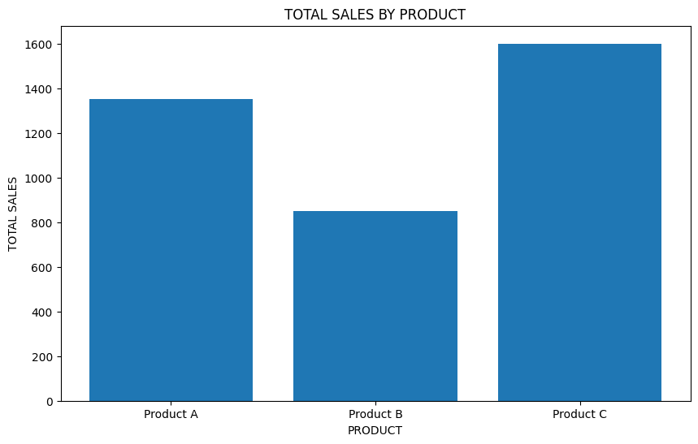

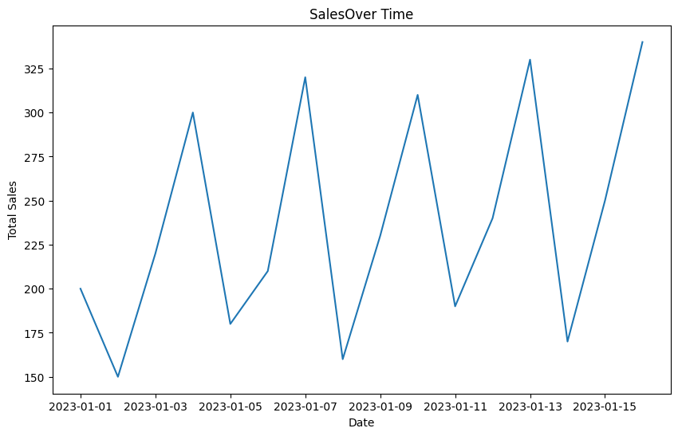
Product Product A Product B Product C
Region
East 0 0 1600
North 1350 0 0
South 0 480 0
West 0 370 0

Sales Quantity
Sales 1.000000 0.944922
Quantity 0.944922 1.000000

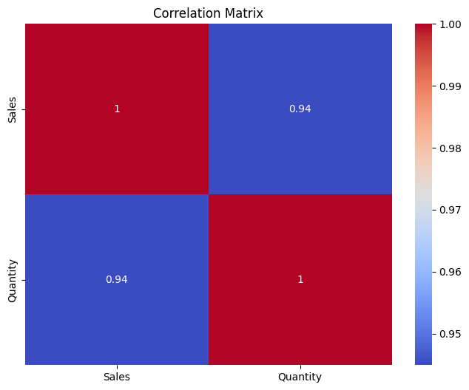

RESULT:
Hence the data set given in csv format and perform data preprocessing and visualization is uploaded and analyzed.

