Exp No:3.a Conduct an experiment to show data visualization using line plot

AIM:
To conduct an experiment to show data visualization using line plot.

DESCRIPTION:
Take any sample data either through csv file or data fetched directly through
code.

PROGRAM:
import matplotlib.pyplot as plt
Months = list(range(1, 11)) # Months 1 to 10
Company_A = [130, 135, 152, 138, 160, 165, 172, 180, 178, 200]
Company_B = [100, 108, 105, 115, 130, 138, 145, 140, 152, 170]
plt.plot(Months, Company_A, color="purple", label="Company A (Tech)")
plt.plot(Months, Company_B, color="blue", label="Company B (Auto)")
plt.title("Stock Price Trend Comparison")
plt.xlabel("Month")
plt.ylabel("Stock Price ($)")
plt.legend(loc="upper left")
plt.show()

OUTPUT: 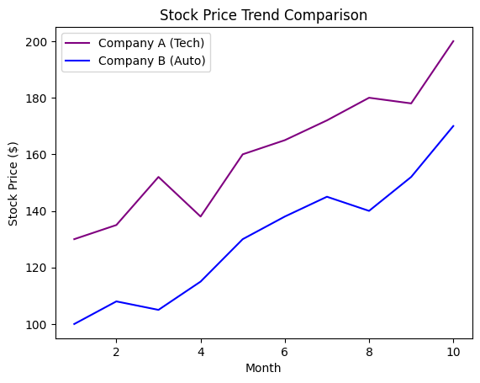

RESULT:
Hence an experiment to show data visualization using line plot is done.

Exp No:3.b Conduct an experiment to show data visualization using bar chart

AIM:
To conduct an experiment to show data visualization using bar chart.

DESCRIPTION:
Take any sample data either through csv file or data fetched directly through code.

PROGRAM:
import matplotlib.pyplot as plt
import numpy as np
Categories = ['ELECTRONICS', 'CLOTHING', 'HOME DECOR', 'BOOKS']
xaxis = np.arange(len(Categories))
Sales = [12500, 8400, 11000, 3100]
bars = plt.bar(Categories, Sales)
plt.xticks(xaxis, Categories, rotation=45)
plt.xlabel("Product Category", fontweight="bold")
plt.ylabel("Sales Revenue ($)", fontweight="bold")
plt.title("Monthly Revenue by Product Category", fontsize=16, color="purple", fontweight="bold")
plt.show()

OUTPUT:
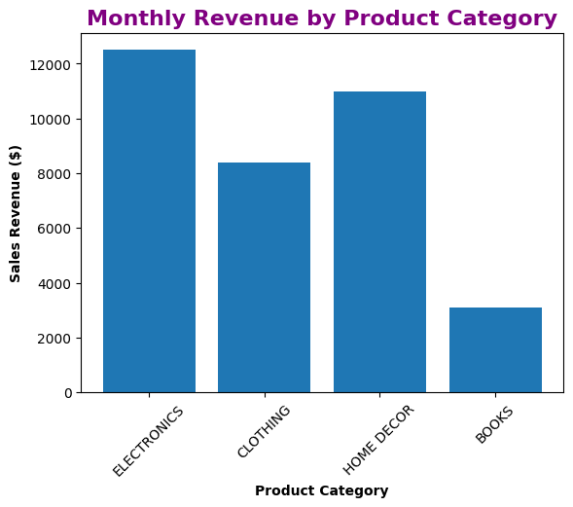

RESULT:
Hence an experiment to show data visualization using bar chart is done.

Exp No:3.c Conduct an experiment to show data visualization using pie chart

AIM:
To conduct an experiment to show data visualization using pie chart.

DESCRIPTION:
Take any sample data either through csv file or data fetched directly through code.

PROGRAM:
import matplotlib.pyplot as plt
labels = ['Android', 'iOS', 'Windows', 'Others']
shares = [70.5, 32.2, 15.5, 9.5]
colors = ['purple', 'skyblue', 'pink', 'darkblue']
explode = (0.2, 0, 0, 0) # Explode the leading slice (Android)
plt.pie(shares, labels=labels, colors=colors, explode=explode, autopct='%0.1f%%')
plt.title('Global Mobile OS Market Share', fontsize=14, fontweight='bold')
plt.show()

OUTPUT:
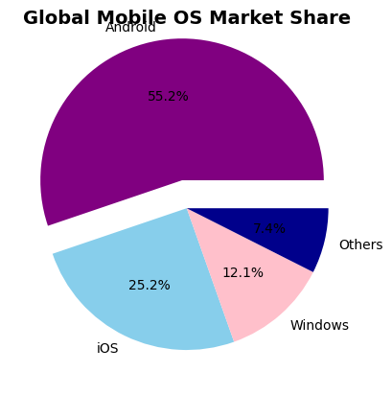

RESULT:
Hence an experiment to show data visualization using pie chart is done.

