Game Design Document

Fill up the Following document

1. Write the title of your project.

Bruise

1. What is the goal of the game?

It is to reach the end without getting bruised

1. Write a brief story of your game?

I wanted to reach a very difficult goal. I kept getting bruised. By the end of

it, I had almost died. I wanted people to experience what I have gone

through so they can get ready if they want to reach the same goal.

1. Which are the playing characters of this game?

* Playing characters are the ones which respond to the user based on the input from the user
* Cars, monkeys, dinos, wizards etc, are the playing characters in the game.

|  |  |  |
| --- | --- | --- |
| Number | Character Name | What can this character do? |
| 1 | Wanda | It can move up ,left, right or down. |
| 2 |  |  |
| 3 |  |  |
| 4 |  |  |
| 5 |  |  |
| 6 |  |  |
| 7 |  |  |
| 8 |  |  |

1. Which are the Non Playing Characters of this game?

* Non Playing characters are the ones which don't have an action or a behaviour when the user interacts with the game.
* Hurdles, stones, bananas, coins, etc are non playing characters in the game.

|  |  |  |
| --- | --- | --- |
| Number | Character Name | What can this character do? |
| 1 | bullets | They try and hit Wanda |
| 2 |  |  |
| 3 |  |  |
| 4 |  |  |
| 5 |  |  |
| 6 |  |  |
| 7 |  |  |
| 8 |  |  |

Draw your imagination of this game. What does this game look like?

* Draw the game either on your computer or on paper,
* Add images of scenes of the game to show each of the playing and non-playing characters at least once.

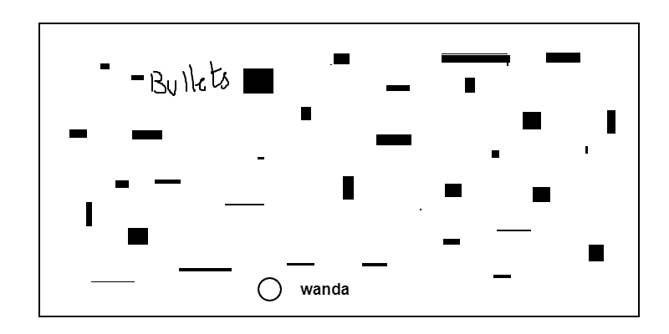



How do you plan to make your game engaging?

I would keep the bullets move at random points by the end of it. I would keep it simple but once they go past a limit it would get harder