TASK-3 DATA LOGGER : SENSOR -> SD CARD
CODE :
#include <SPI.h>
#include <SD.h>
#include <Wire.h>
#include <RTClib.h>
#include <DHT.h>

#define DHTPIN 4
#define DHTTYPE DHT11
#define LDR_PIN A0
#define SD_CS 10

DHT dht(DHTPIN, DHTTYPE);
RTC_DS3231 rtc;
File dataFile;

void setup() {
Serial.begin(9600);
delay(2000);

dht.begin();
Wire.begin();

if (!rtc.begin()) {
Serial.println("RTC not found");
while (1);
}

if (!SD.begin(SD_CS)) {
Serial.println("SD card failed");
while (1);
}

if (!SD.exists("data.csv")) {
dataFile = SD.open("data.csv", FILE_WRITE);
dataFile.println("Date,Time,Temperature,Humidity,Light");
dataFile.close();
}

Serial.println("System Ready");
}

void loop() {
logDataToSD();
readFileAndPrint();
delay(5000); // sampling rate
}

void logDataToSD() {
DateTime now = rtc.now();

float temp = dht.readTemperature();
float hum = dht.readHumidity();
int lightVal = analogRead(LDR_PIN);

if (isnan(temp) || isnan(hum)) {
Serial.println("DHT error");
return;
}

dataFile = SD.open("data.csv", FILE_WRITE);
if (dataFile) {
dataFile.print(now.year()); dataFile.print("-");
dataFile.print(now.month()); dataFile.print("-");
dataFile.print(now.day()); dataFile.print(",");

dataFile.print(now.hour()); dataFile.print(":");
dataFile.print(now.minute()); dataFile.print(":");
dataFile.print(now.second()); dataFile.print(",");

dataFile.print(temp); dataFile.print(",");
dataFile.print(hum); dataFile.print(",");
dataFile.println(lightVal);

dataFile.close();
Serial.println("Data logged to SD");
}
}

void readFileAndPrint() {
Serial.println("---- CSV FILE CONTENT ----");

dataFile = SD.open("data.csv");
if (dataFile) {
while (dataFile.available()) {
Serial.write(dataFile.read());
}
dataFile.close();
} else {
Serial.println("File open failed");
}

Serial.println("---- END OF FILE ----");
}
CSV FILE SNIPPET :
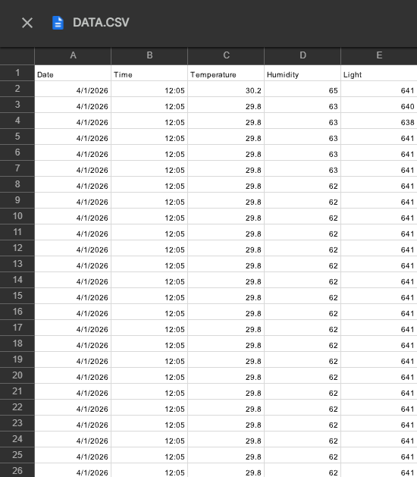

Sampling Rate Explanation
The sampling rate defines how frequently sensor data is collected and stored.
In this project:
- Sensor readings are taken at fixed time intervals
- The interval is controlled in the code using a delay / timing logic
- Each sampling cycle performs:
  - Sensor data acquisition
  - Timestamp retrieval from RTC
  - Writing data as a new row in the CSV file
Choosing an appropriate sampling rate is important because:
- High sampling rate → more data, higher power consumption
- Low sampling rate → reduced power usage and longer system life
For this application, a moderate sampling interval is selected to balance data resolution and power efficiency.

Power Consumption Considerations
Power efficiency is an important factor in embedded data logging systems.
The following measures help reduce power consumption:
- Sensors are read only during the sampling interval
- SD card is accessed only when writing data
- Continuous SD card access is avoided to reduce current draw
- Lower sampling frequency reduces:
  - Microcontroller active time
  - SD card write cycles
If deployed in battery-powered systems:
- Increasing the sampling interval significantly reduces power usage
- Sleep modes can be added to further optimize energy consumption

