**Tableau & Power BI Exam**

**Part I: Tableau**

**Q1. The major time slots when the demand is more**

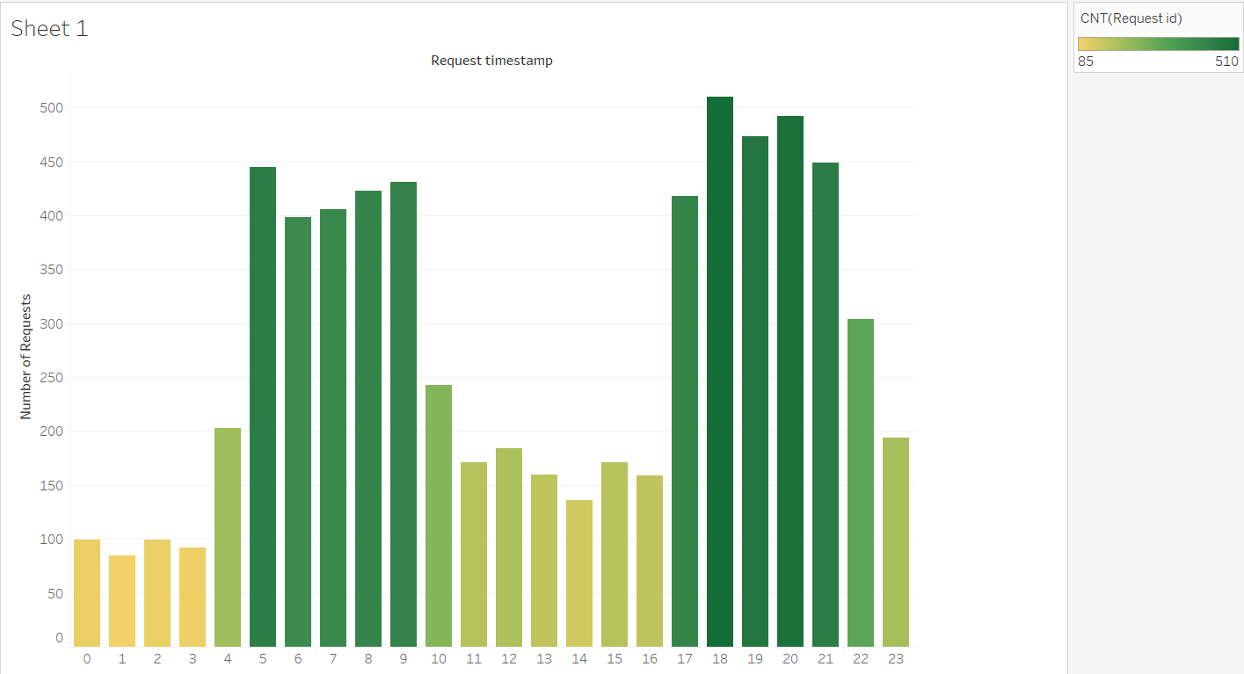

From the above graph we notice that the times between 5.00 A.M to 9.00 A.M and 5.00 P.M to 9.00 P.M have high demand. That is peak morning and peak evening.

---------------------------------------------------------------------------------

**Q2. Identify the factors that impact incomplete requests**

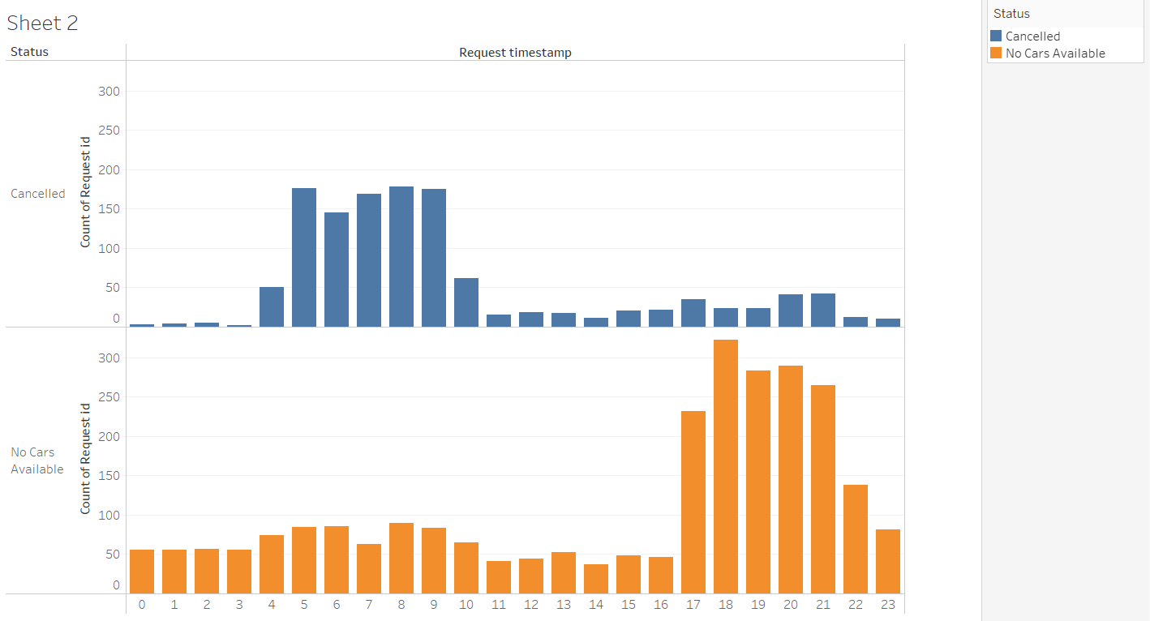

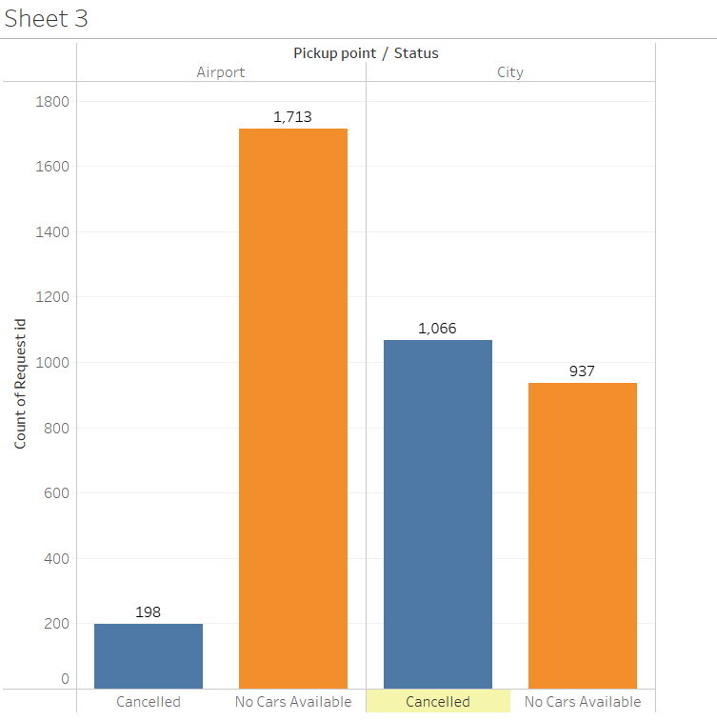

The factors that affect the incomplete requests are **Pickup Point** , **peak morning** and **peak evening** timeslots.

--------------------------------------------------------------------------------------------------------

**Q3. Highlight the supply - demand relationship**