**Tableau & Power BI Exam**

**Part I: Tableau**

**Q1. The major time slots when the demand is more**

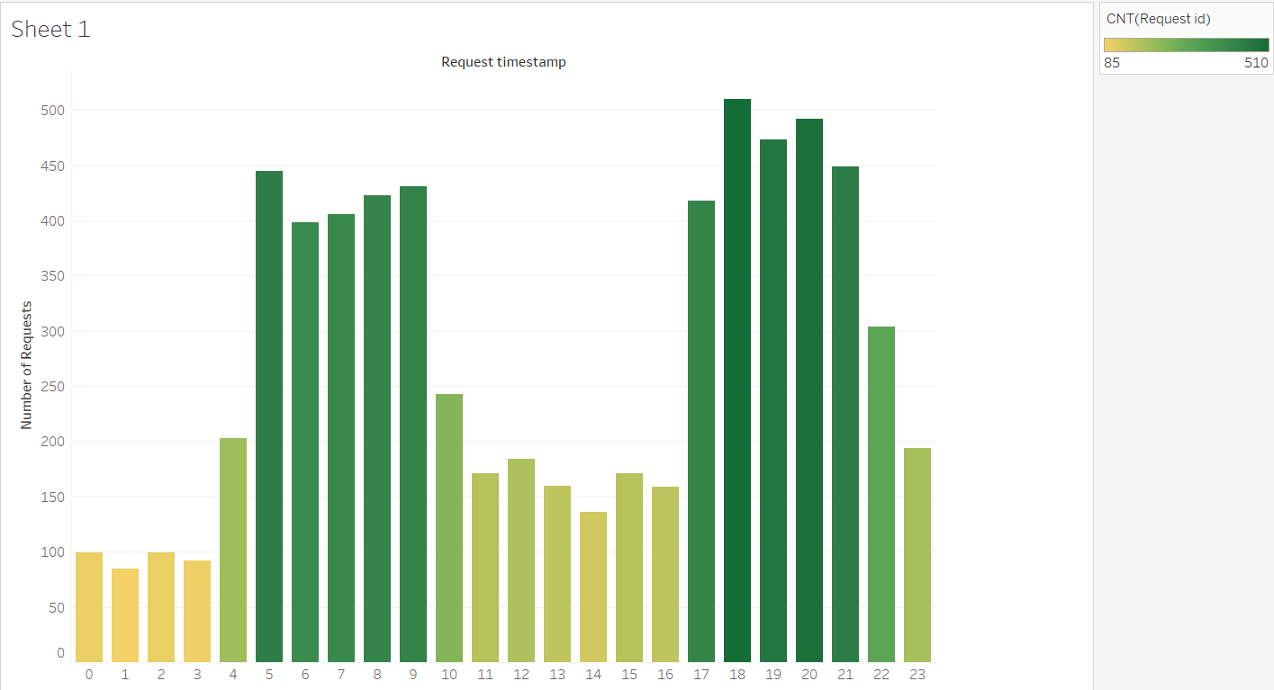

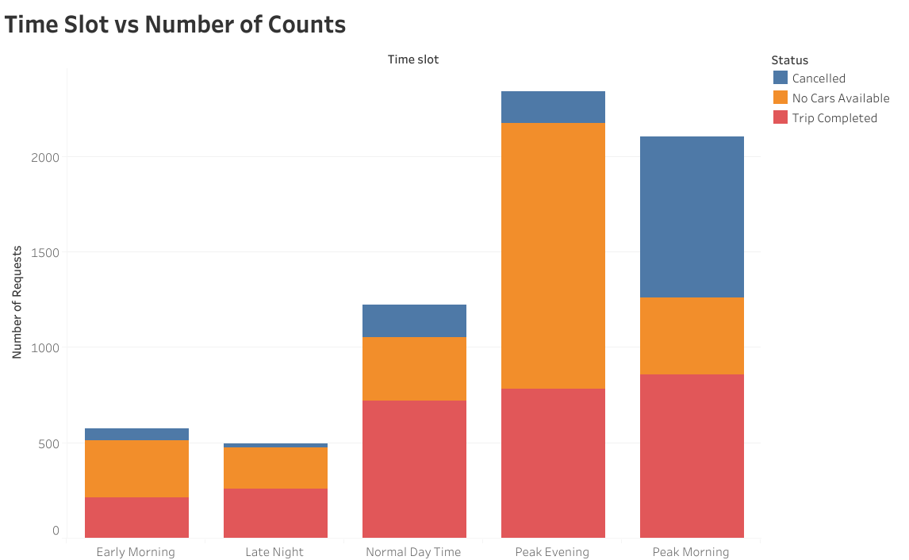

From the above graphS we notice that the times between 5.00 A.M to 9.00 A.M and 5.00 P.M to 9.00 P.M have high demand. That is at the peak morning and peak evening.

---------------------------------------------------------------------------------

**Q2. Identify the factors that impact incomplete requests**

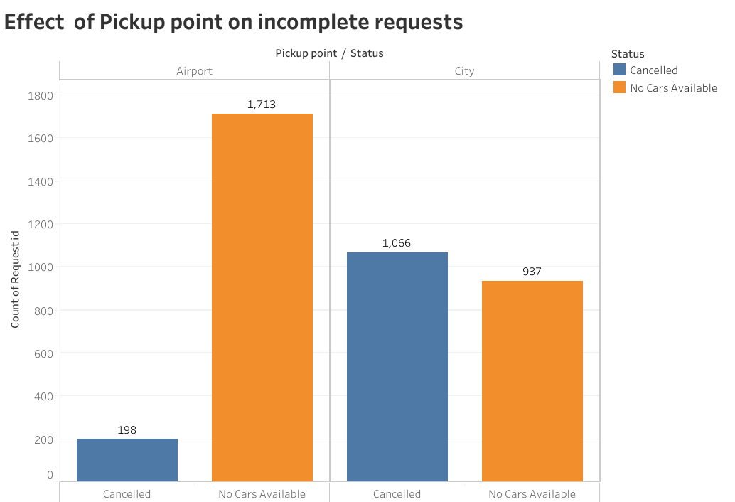

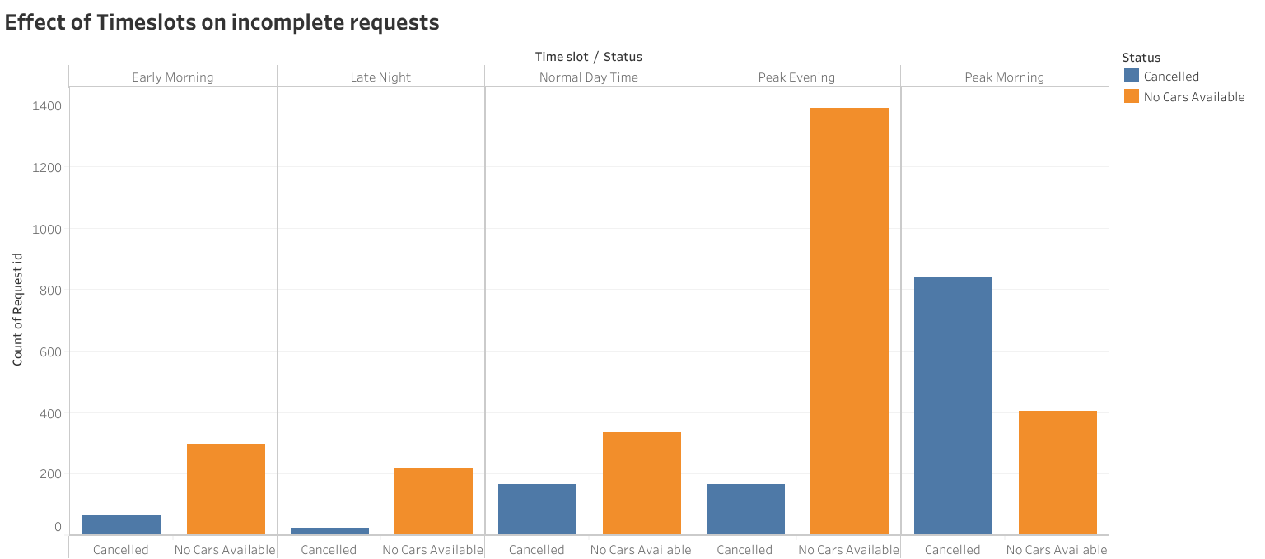

The factors that affect the incomplete requests are **Pickup Point** , **peak morning** and **peak evening** timeslots.

--------------------------------------------------------------------------------------------------------

**Q3. Highlight the supply - demand relationship**

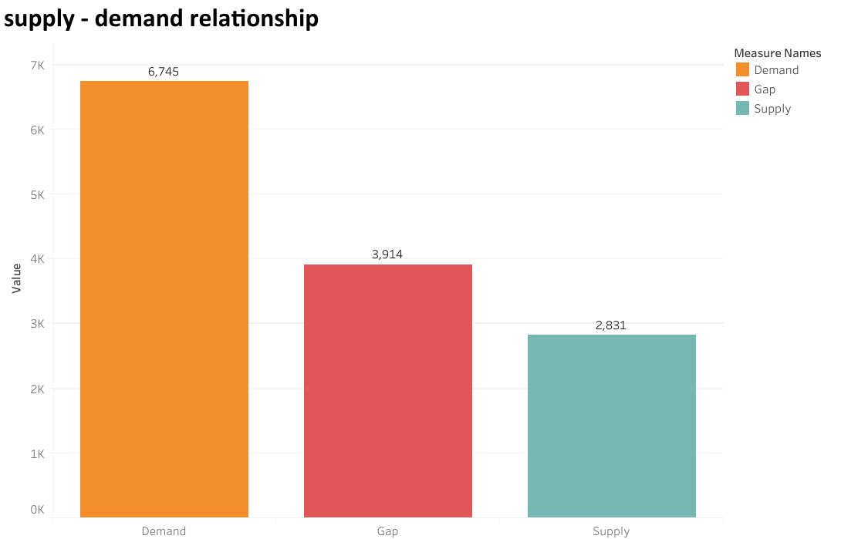

* The gap is about approx. 58%

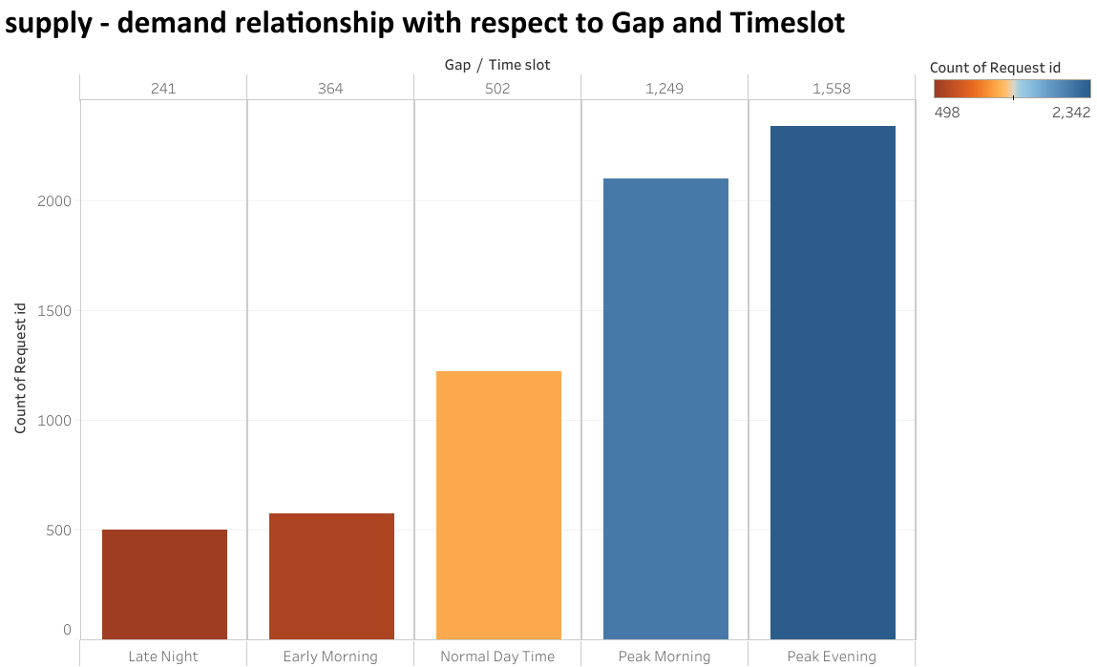

More gap is in the Peak morning and Peak evening

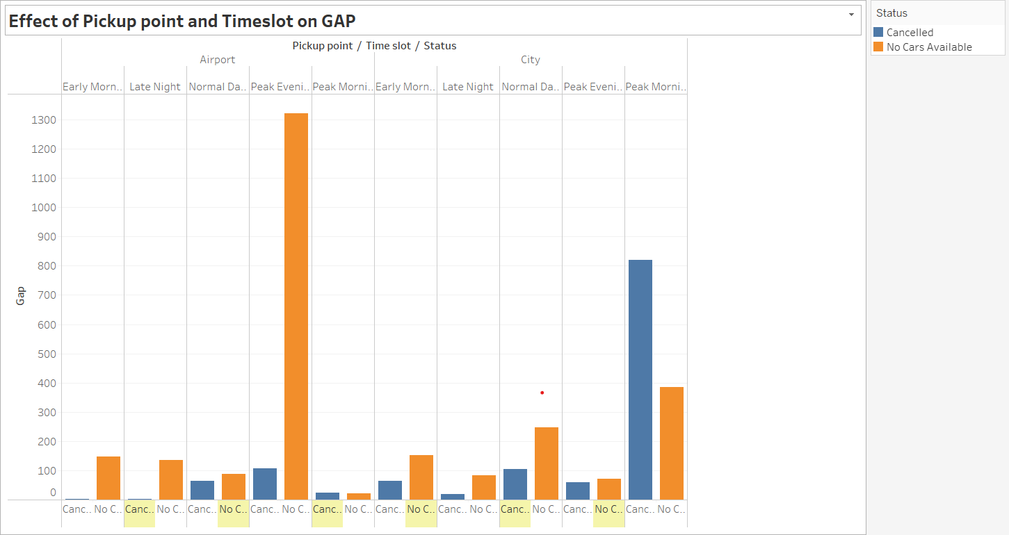

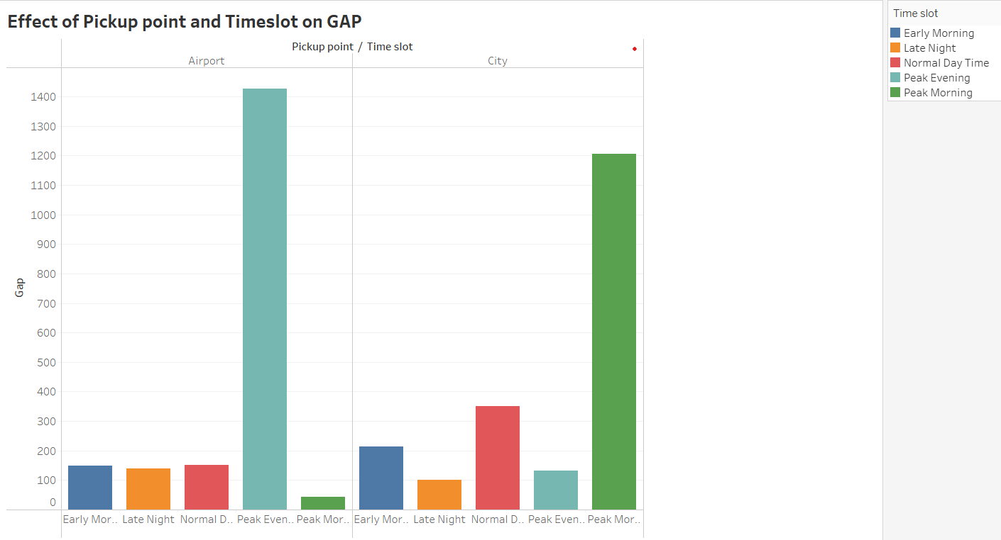

* From the above graphs we conclude that gap in the Peak morning is due to the cancellation at city
* The gap in the peak evening is due to the No car Availability in airport