1. Check if Git client is installed properly:

git --version



1. Check if the configuration is properly set

git config --global --list

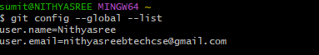

1. Integrate notepad++.exe to Git and make it a default editor

notepad++



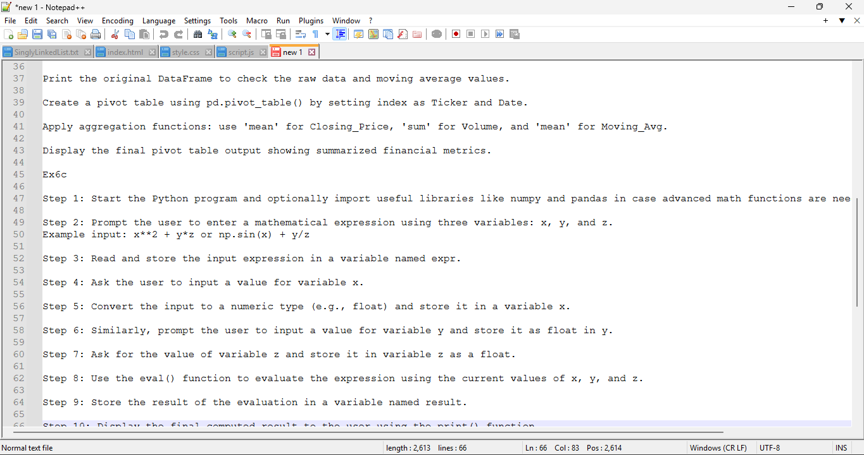

1. Configure the editor

git config –global core.editor “’D:/Notepad++/notepad++.exe’ -multiInst -nosession -noPlugin”



1. Verify git’s editor setting

git config –global --edit



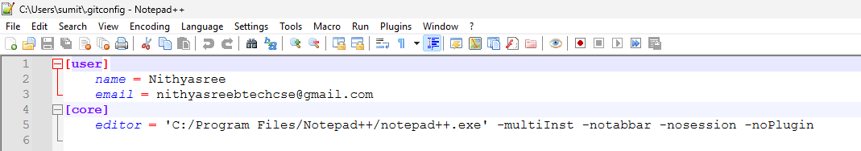

1. Create folder and initialize git repo

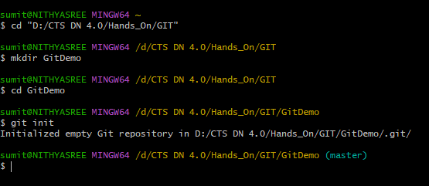

1. Verify .git folder exists

ls -al

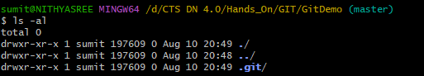

1. Create the file welcome.txt with content



1. Verify if the file “welcome.txt” is created

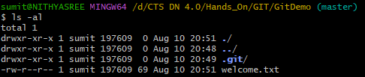

1. Verify contents of welcome.txt



1. See repository status

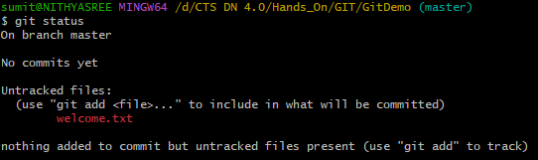

1. Start tracking the file



1. Add multi-line commit message using default editor

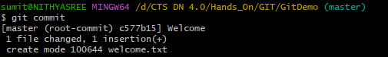

1. Check if local and “Working Directory” git repository are same

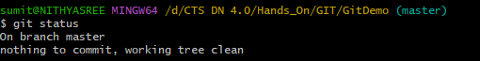

1. Connect to GitLab repo



1. Pull the remote repository

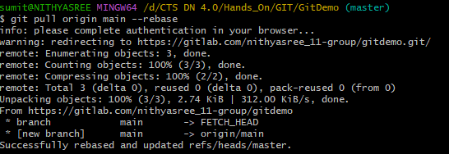

1. Push the local to remote repository

