Clean up and push back to remote Git

1. Verify master is in clean state

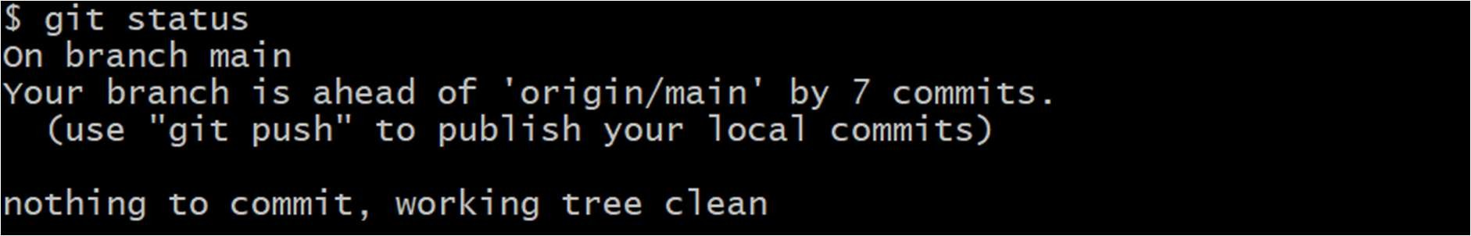

1. List all available branches



1. Pull the latest from remote into main

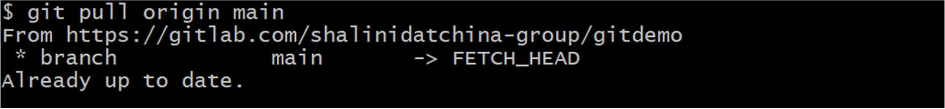

1. Push the changes to the remote Git repository

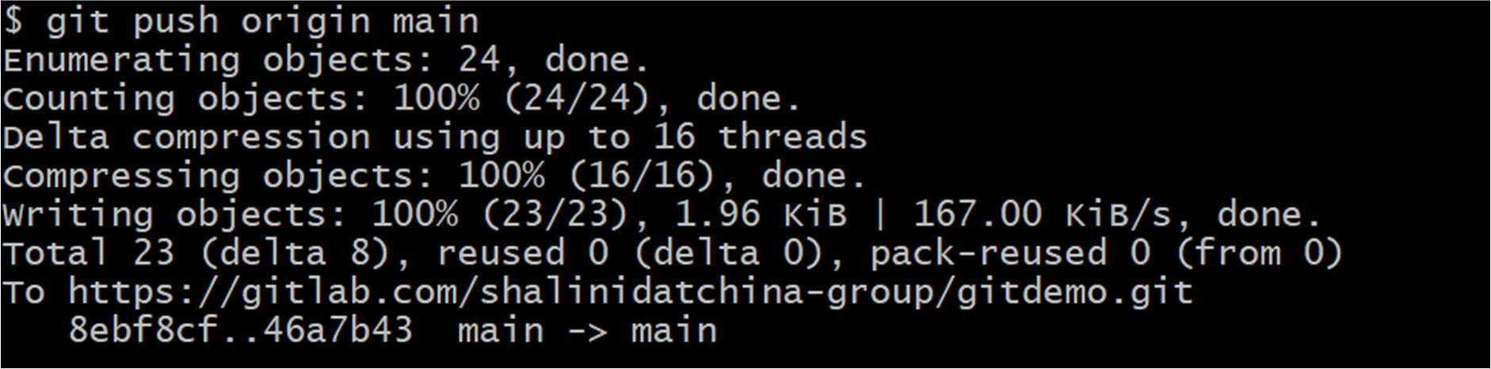

1. Verify changes on remote

