Experiment : 6

AIM: Creating Smart Contracts and performing transactions using Solidity and Remix IDE.

Theory:

Introduction to Smart Contracts
A Smart Contract is a self-executing digital program stored on a blockchain that automatically enforces rules and agreements when predefined conditions are met. These contracts eliminate the need for intermediaries, ensuring a secure and transparent system.
Smart contracts are commonly written in Solidity and executed on the Ethereum Virtual Machine, which is the runtime environment for blockchain-based applications.

Ethereum Blockchain Overview
The Ethereum blockchain is a decentralized platform that supports smart contracts and decentralized applications (DApps). It enables developers to build secure and automated systems without relying on central authorities.

Key Concepts

  - Solidity Programming Language
- A high-level, contract-oriented programming language.
- Used to write smart contracts for Ethereum.
- Syntax is similar to JavaScript and C++.

Ethereum Virtual Machine (EVM)
- Executes smart contracts on the blockchain.
- Ensures consistent execution across all nodes.
- Maintains the state of contracts.

Remix IDE
Remix IDE is a browser-based development tool used to:
- Write Solidity code
- Compile smart contracts
- Deploy and test contracts
- Interact with deployed contracts

Significance of Smart Contracts in Ethereum

- Automation

Smart contracts automatically execute predefined actions when conditions are met, reducing manual intervention.

Transparency
All contract code and transaction details are publicly visible on the blockchain.

Security
Once deployed, smart contracts are immutable and resistant to tampering.

Cost-Effectiveness
Eliminates intermediaries, reducing operational and transaction costs.

Trustless Environment
Participants can interact without needing to trust each other, as the code governs execution.

Role in Modern Applications
Smart contracts serve as the foundation for:

Decentralized Applications (DApps)
- Decentralized Finance (DeFi) systems
- Token creation and management
- Voting and governance systems

Performing Transactions using Smart Contracts
Transactions in smart contracts involve:
- Deployment Transaction → Deploying the contract to the blockchain
- State-Changing Transactions → Functions that modify data (require gas)
- View Transactions → Functions that only read data (no gas required)
All transactions are verified and recorded on the blockchain, ensuring reliability and traceability.
Implementation: Code:

AccessControl.sol

// SPDX-License-Identifier: MIT pragma solidity ^0.8.0;
tract AccessControl {

mapping(address => mapping(address => bool)) private accessList;
function grantAccess(address doctor) public { accessList[msg.sender][doctor] = true;
}
function revokeAccess(address doctor) public { accessList[msg.sender][doctor] = false;

accessControlAddress = _accessControlAddress;

}

truct Record { string data; uint timestamp;
}

}

function hasAccess(address patient, address doctor) public view returns (bool) {
return accessList[patient][doctor];

}

}

PatientRecord.sol

// SPDX-License-Identifier: MIT pragma solidity ^0.8.0;
interface IAccessControl {

function hasAccess(address patient, address doctor) external view returns (bool);
}

contract PatientRecord {

address public accessControlAddress; constructor(address _accessControlAddress) {
mapping(address => Record[]) private records; unction addRecord(string memory _data) public {
records[msg.sender].push(Record(_data, block.timestamp));
}

function getRecords(address patient) public view returns (Record[] memory) {
IAccessControl ac = IAccessControl(accessControlAddress);
require(

patient == msg.sender || ac.hasAccess(patient, msg.sender),
"Access Denied"

);

return records[patient];

}

Output:

First got error

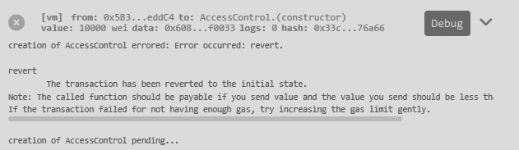
Got deployed first one:
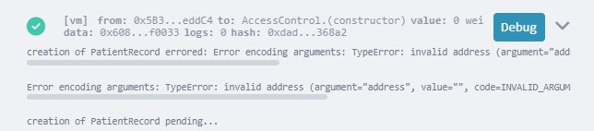

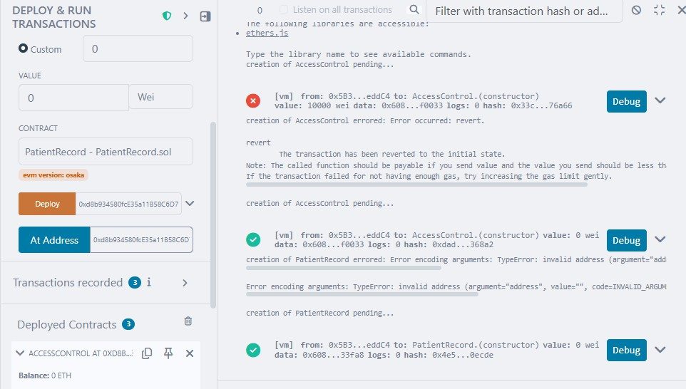
Second one deployed

Added the record

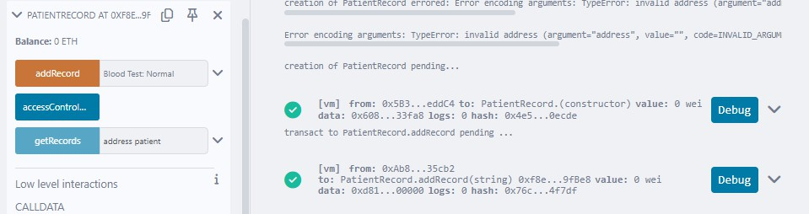
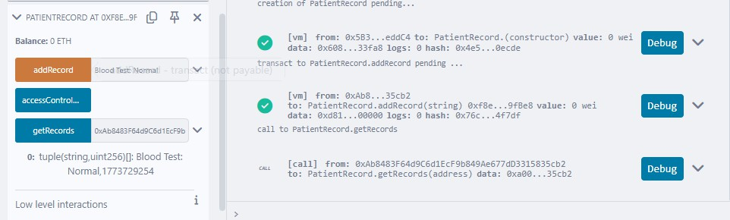
Get the record

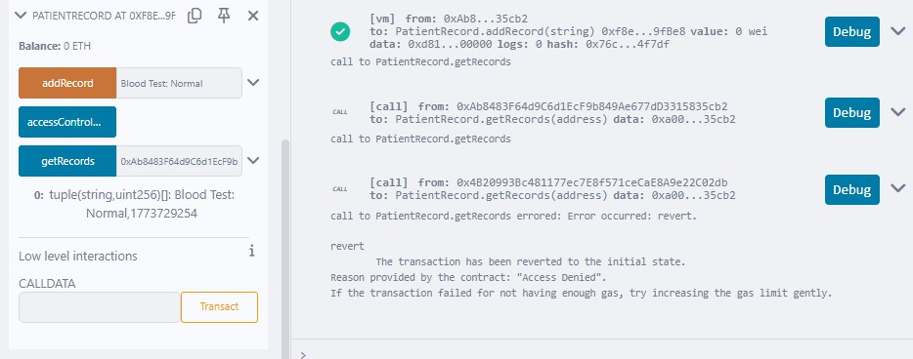
Doctor Tries to Access (FAIL CASE)

Patient Grants Access

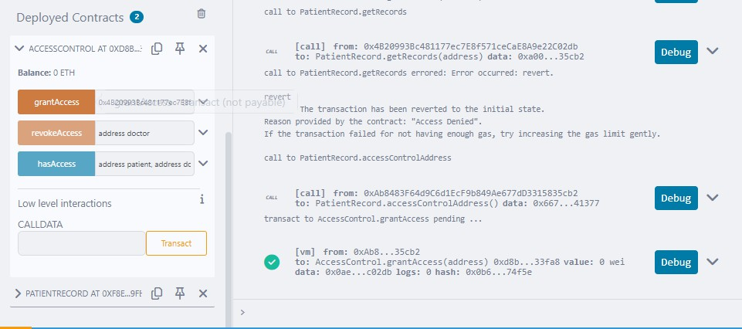
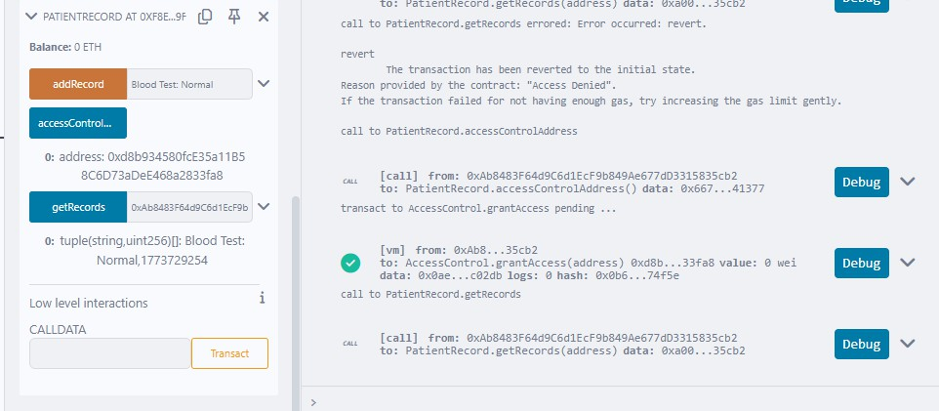
Doctor Access Again (SUCCESS CASE)
Access revoked

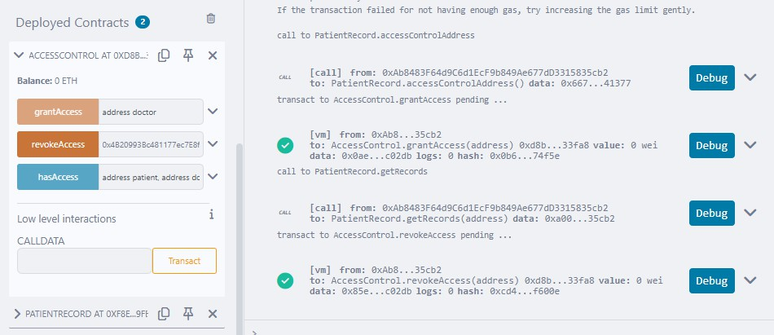
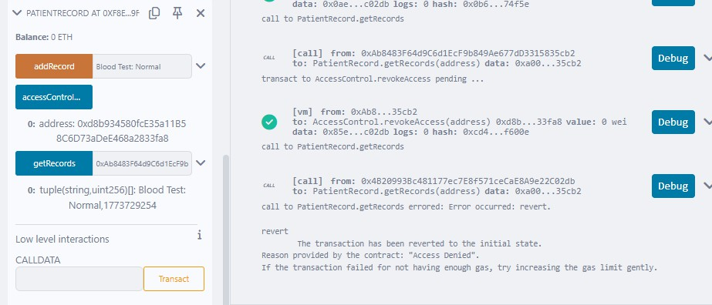
Again the access has been denied

Conclusion:

Smart contracts revolutionize digital agreements by enabling secure, automated, and transparent execution of logic on the blockchain. Using tools like Remix IDE and languages like Solidity, developers can efficiently create, deploy, and interact with blockchain-based applications.

