Blockchain Experiment No 6

Aim: Creating Smart Contracts and performing transactions using Solidity and Remix IDE

Theory:
A Smart Contract is a self-executing program stored on the blockchain that automatically enforces the terms of an agreement when predefined conditions are met. It eliminates the need for intermediaries, ensuring transparency, security, and trust between parties. Smart contracts are written in Solidity (for Ethereum-based systems) and executed on the Ethereum Virtual Machine (EVM).
Significance of Smart Contracts in the Ethereum Blockchain:
- Automation: Executes actions automatically when conditions are satisfied. ● Transparency: The contract code and transactions are visible on the blockchain. ● Security: Once deployed, contracts are immutable and tamper-proof.
- Cost-effective: Removes intermediaries and reduces transaction costs. ● Trustless System: Participants can interact without needing to trust each other directly. Smart contracts form the backbone of decentralized applications (DApps) and decentralized finance (DeFi) systems on Ethereum.

Code:\

// SPDX-License-Identifier: MIT pragma solidity ^0.8.0;

contract PharmaSupply {

address public manufacturer; address public pharmacy;

struct Medicine { string name; uint quantity; bool shipped; bool received;
}

Medicine public med;

constructor(address _pharmacy) { manufacturer = msg.sender; pharmacy = _pharmacy;
}

function addMedicine(string memory _name, uint _quantity) public { require(msg.sender == manufacturer, "Only manufacturer allowed"); med = Medicine(_name, _quantity, false, false);
}

function shipMedicine() public {
require(msg.sender == manufacturer, "Only manufacturer allowed"); med.shipped = true;
}

function receiveMedicine() public {
require(msg.sender == pharmacy, "Only pharmacy allowed"); require(med.shipped == true, "Not shipped yet"); med.received = true;
}

function getMedicine() public view returns (string memory, uint, bool, bool)
{ return (med.name, med.quantity, med.shipped, med.received);
}
}

Implementation:

Contract 1: PharmaSupply (Medicine flow) Contract code

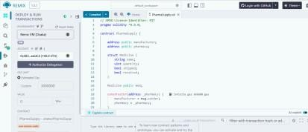

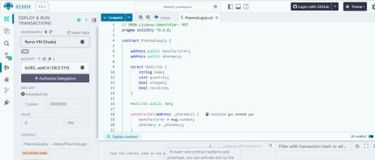

Transaction deployed successfully

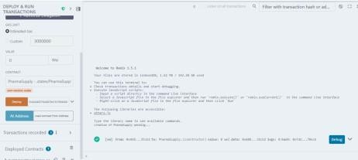

Deployed contract
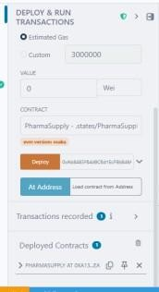
Manufacture adding medicine for shipping
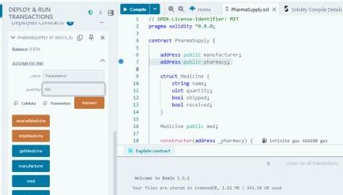

Manufacturer successfully added medicine
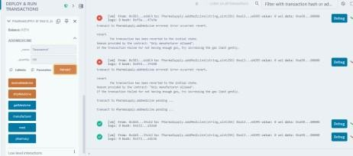

Manufacturer Shipping the medicine

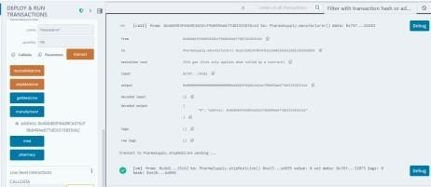

Medicine received by pharmacy successfully
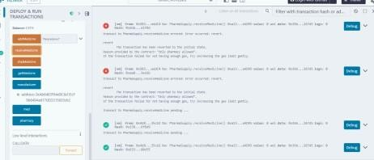

getmedicine() we are getting the values of added medicine

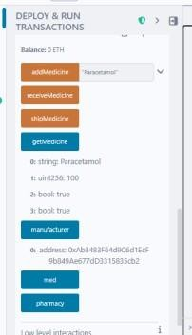

Contract 2: medicine quality verification While verifying:
“Here, the regulator verifies the medicine batch and stores its approval status on
blockchain.” While fetching:
“This function retrieves the verification report, ensuring transparency and immutability.”

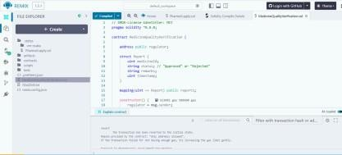

Contract deployed
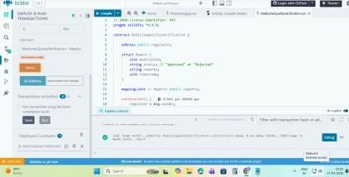

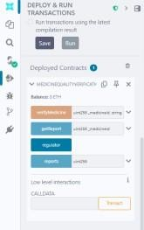

Regulator


Medicine verification done by regulator
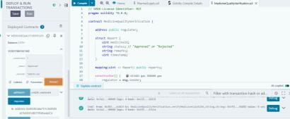

getreport
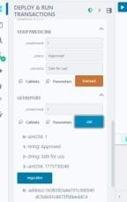

Conclusion:
The experiment was successfully completed using Remix IDE, where two Solidity smart contracts were deployed and tested on the Ethereum blockchain. Contract 1 (PharmaSupply) demonstrated the medicine flow from manufacturer to pharmacy, while Contract 2 (MedicineQualityVerification) allowed a regulator to verify and store quality reports on-chain. Role-based access control was enforced using require statements, and all transactions were recorded immutably. The experiment successfully demonstrated the use of smart contracts for transparent and trustless pharmaceutical supply chain management.

