Blockchain Experiment No: 7
AIM: Implement the embedding wallet (Metamask) and transaction using Solidity

Theory:
Blockchain is a decentralized and distributed digital ledger that records transactions securely across multiple systems. It ensures transparency, security, and immutability, meaning once data is recorded, it cannot be changed.
Ethereum is a popular blockchain platform that allows the execution of Smart Contracts. Smart contracts are self-executing programs written in Solidity that automatically perform actions when predefined conditions are met, eliminating the need for intermediaries.
MetaMask is a cryptocurrency wallet and browser extension used to interact with blockchain networks. It stores user accounts and private keys securely and allows users to send, receive, and sign transactions. It also acts as a bridge between Remix IDE and the blockchain network.
Testnets such as Sepolia and RSK Testnet are used for testing purposes. They provide free tokens, allowing developers to deploy and test smart contracts without using real cryptocurrency, reducing financial risk.
Remix IDE is a web-based development environment used to write, compile, deploy, and test smart contracts. It provides a user-friendly interface and supports direct integration with MetaMask for deploying contracts on blockchain networks.
The smart contract deployment process includes writing the contract in Solidity, compiling it to remove errors, connecting MetaMask to Remix, and deploying the contract on a testnet by paying gas fees using test tokens.
A blockchain transaction refers to any interaction with the network, such as deploying a contract or calling its functions. Each transaction requires authentication through a digital signature and is permanently recorded on the blockchain. These transactions can be verified using blockchain explorers.

Implementation

Step 1: Install MetaMask
Install MetaMask extension and create a wallet
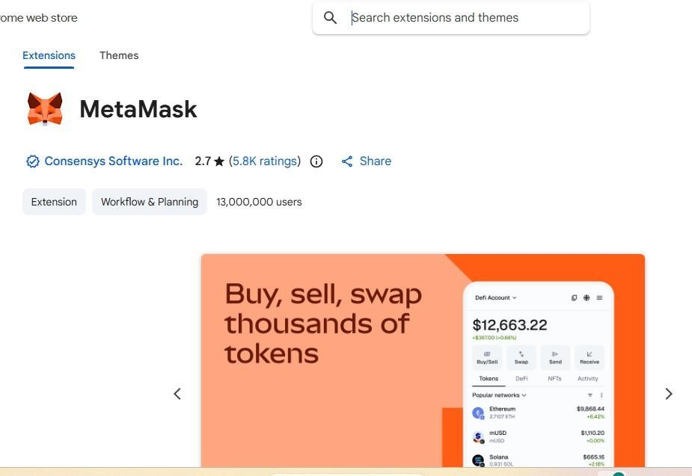
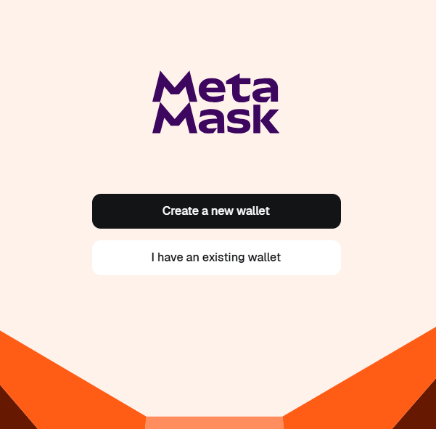

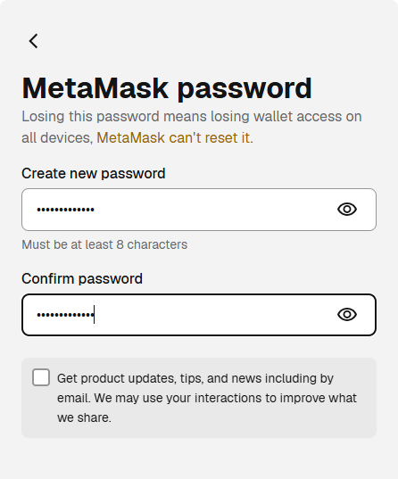
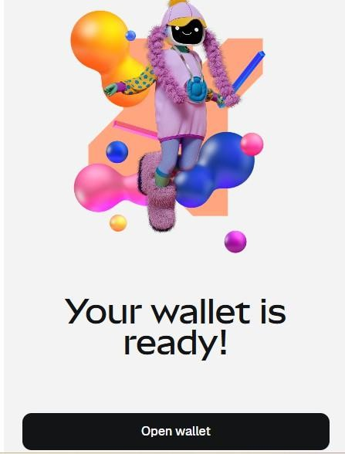

Step 2: Add Sepolia Testnet
Configure MetaMask to connect to Sepolia network.
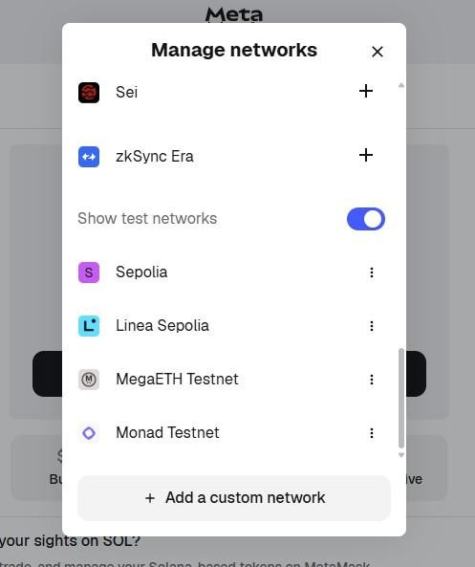
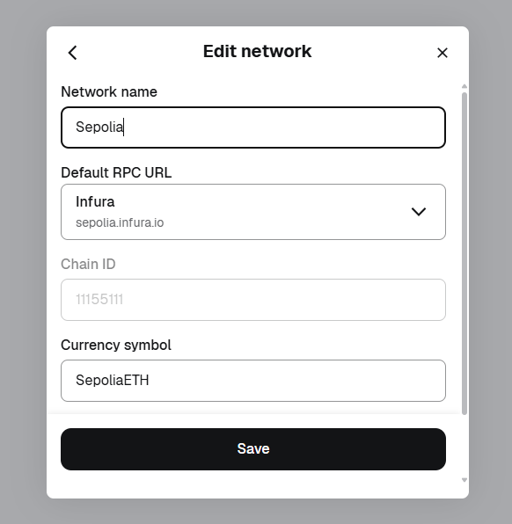

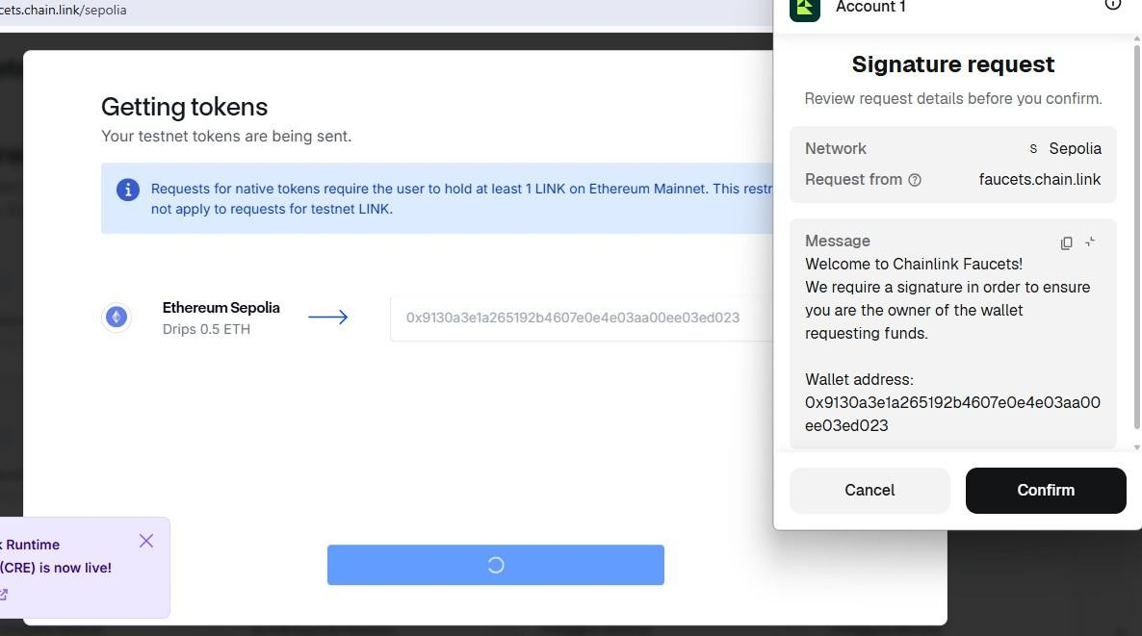
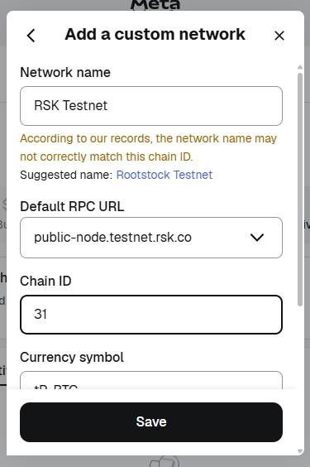
\

Step 3: Fund Wallet
Use faucet to get test ETH
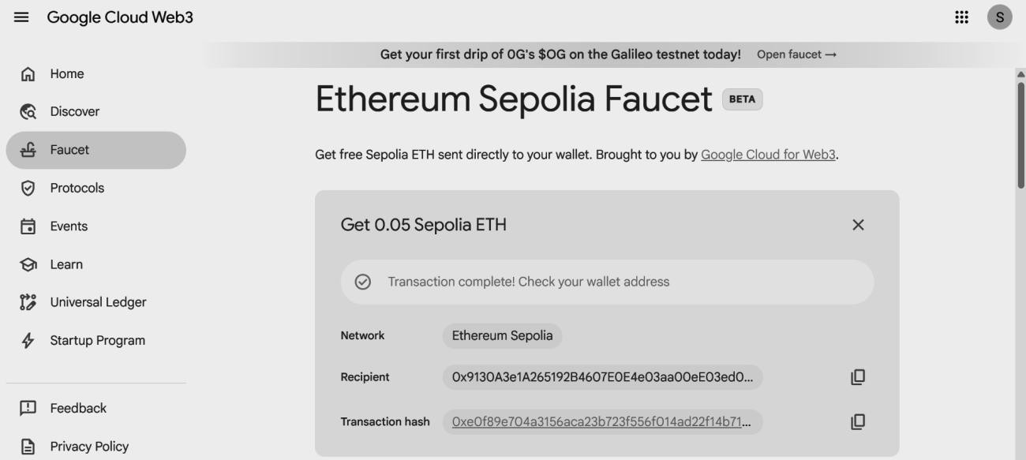

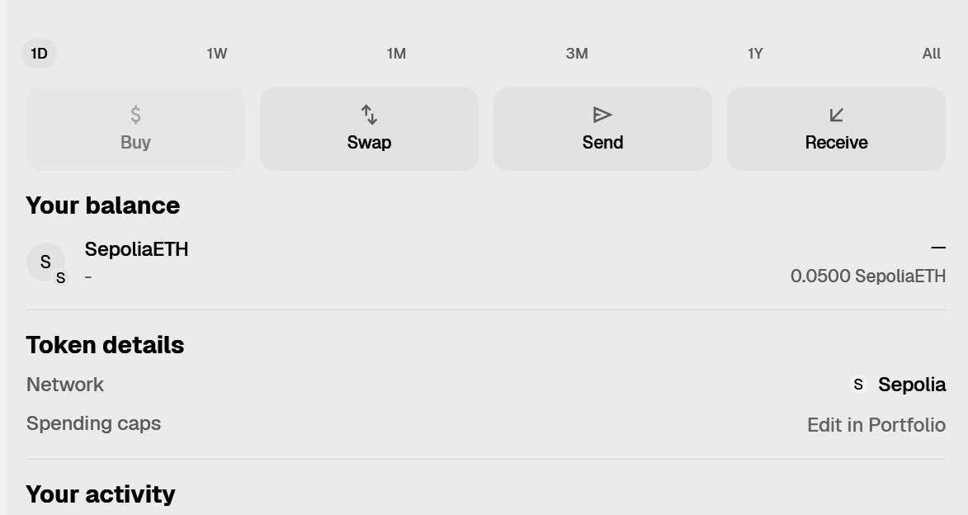

Step4: Connect the Sepolia Testnet / RSK Testnet to Remix IDE
1. In the Remix IDE, select the Environment as Injected Web3.
Note : Injected Web3 connects Remix with the active account in Metamask.

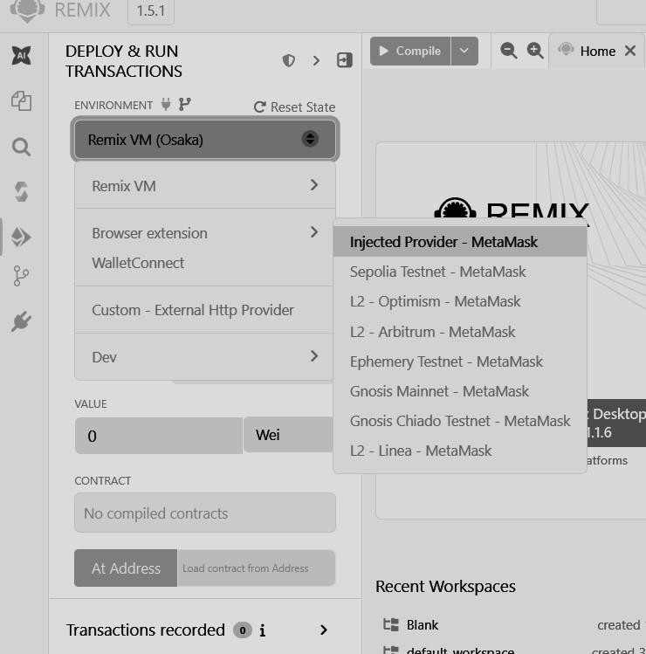
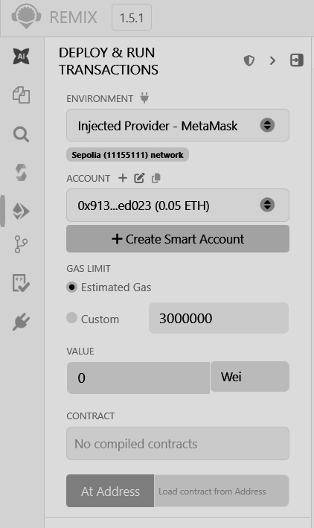

Compile the Contract

- Open Remix
- Paste your contract code
- Go to Solidity Compiler (left panel)
- Select version 0.8.x (match ^0.8.0)
- Click Compile PharmaSupply.sol

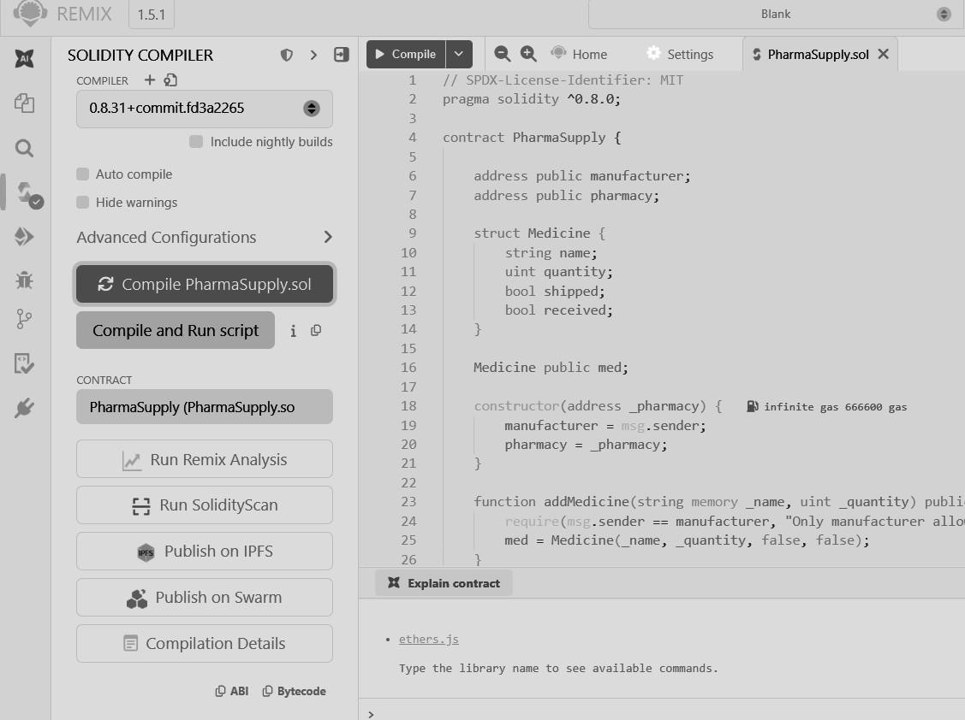

Connect MetaMask (Injected Provider)

- Go to Deploy & Run Transactions tab
- In Environment → select Injected Provider - MetaMask
- MetaMask popup will open → click Connect Make sure:
  - Network = Sepolia Test Network
  - You have 0.05 Sepolia ETH
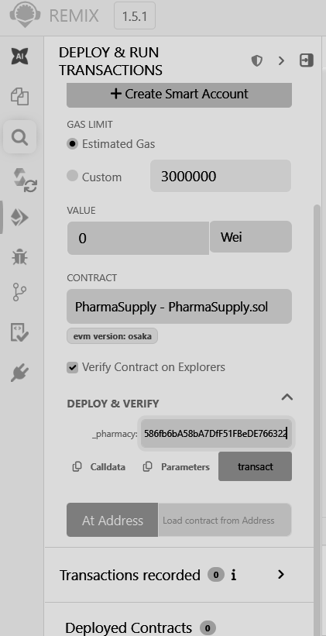

Deploy Contract

Your constructor needs a pharmacy address Steps:
- Copy your second MetaMask account address (pharmacy)
  - MetaMask → Account 2 → Copy address
- Paste that address in constructor field
- Click Deploy
- MetaMask will pop up → Confirm transaction Wait a few seconds…
After success → your contract appears under Deployed Contracts

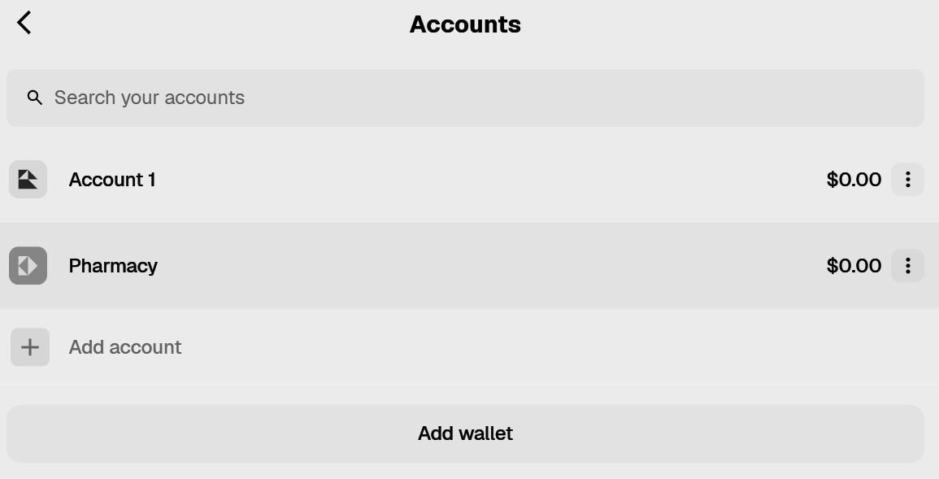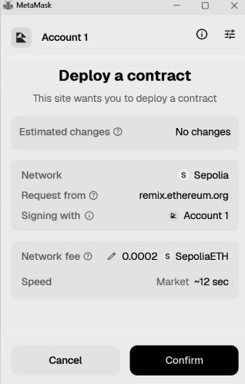
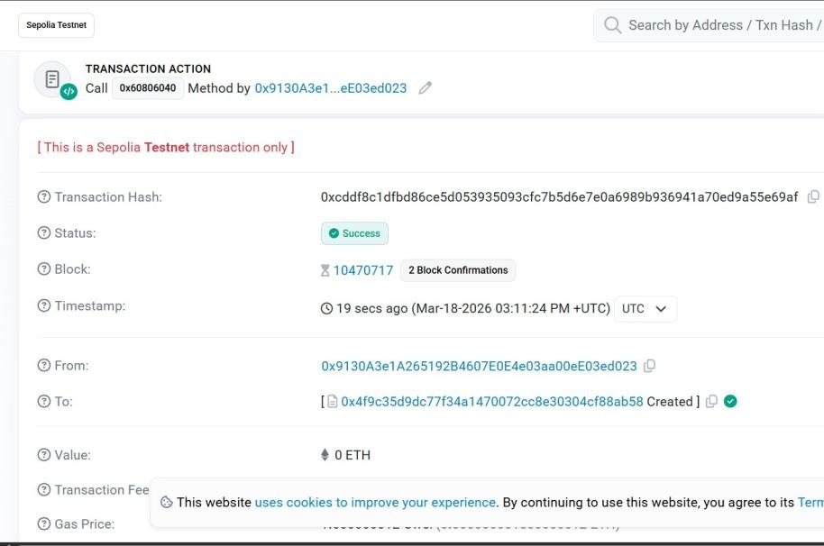

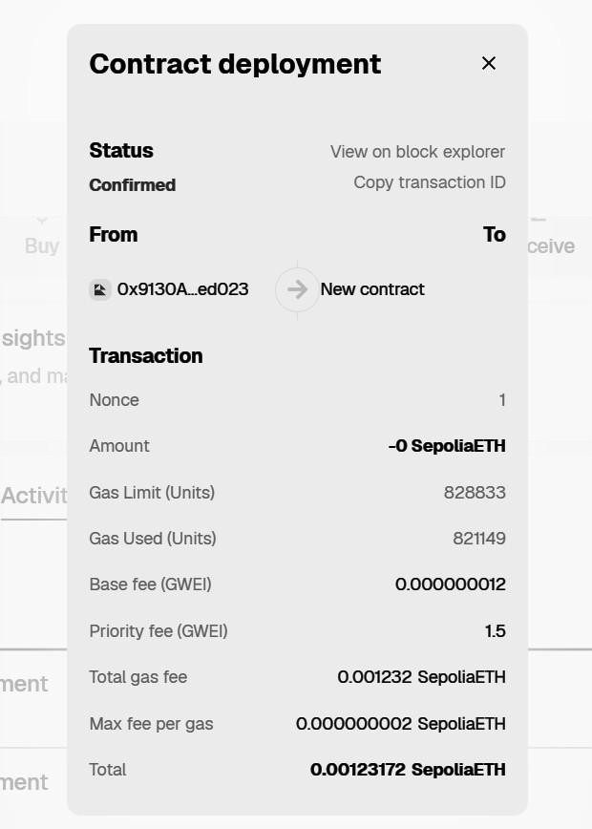
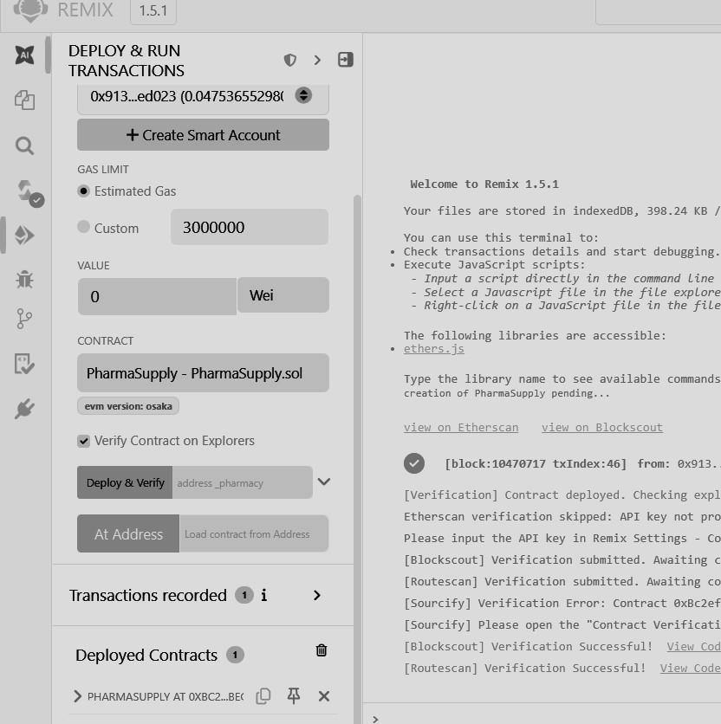
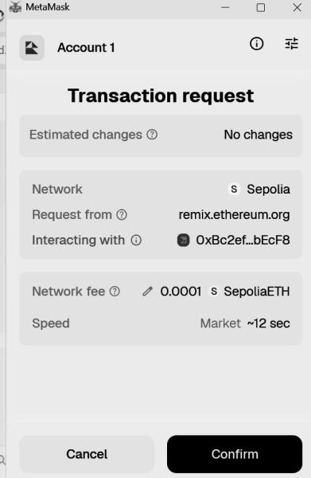

Interact with Contract

Step 1: Add Medicine (Manufacturer only)
- Make sure MetaMask is on Account 1 (manufacturer)
- In Remix:
  - Enter:
    - _name: "Paracetamol"
    - _quantity: 100
- Click addMedicine Confirm in MetaMask
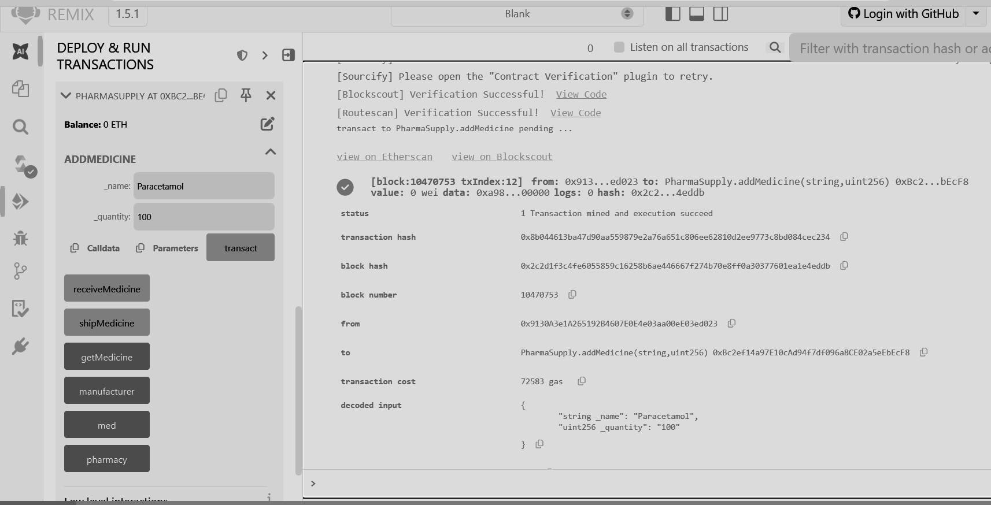

Step 2: Ship Medicine
- Still on Account 1
- Click shipMedicine
- Confirm transaction
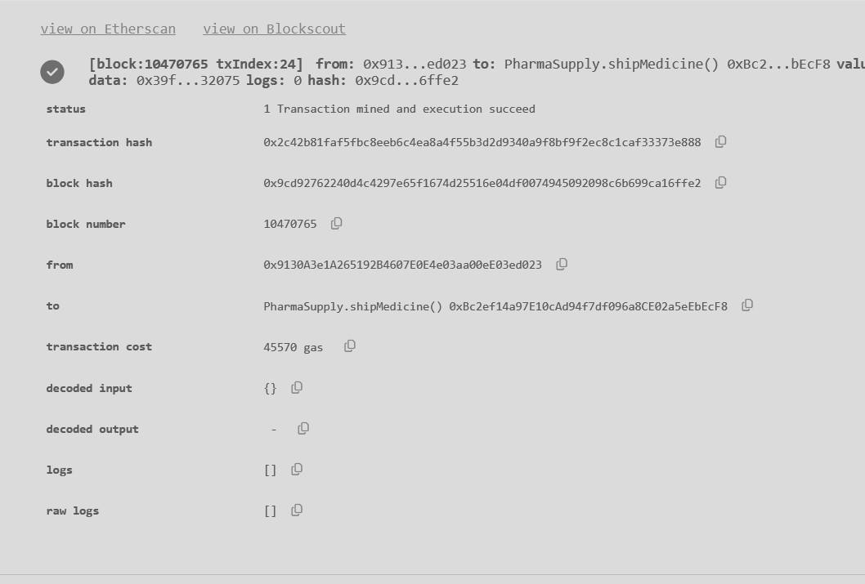
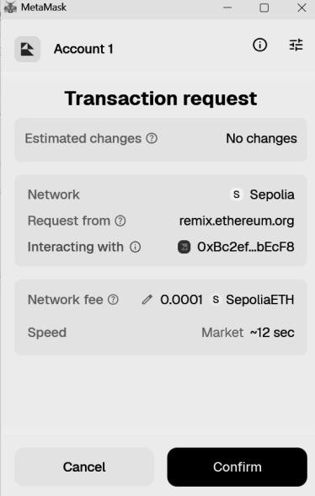
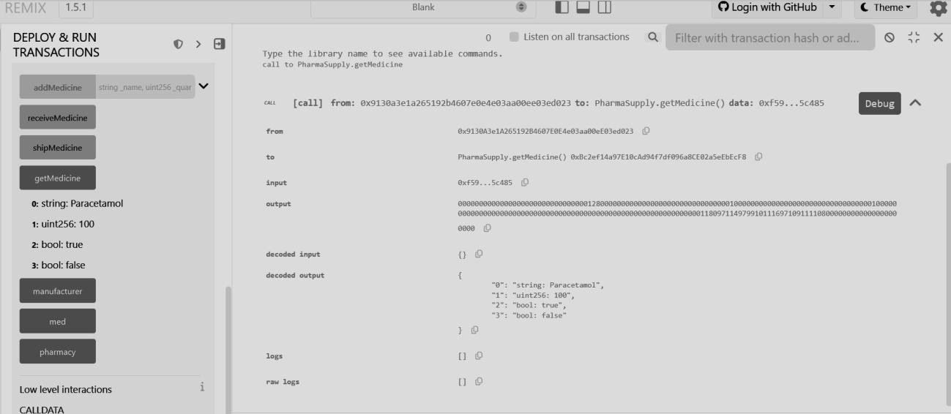

Step 3: Receive Medicine (Pharmacy)
- Switch MetaMask to Account 2 (pharmacy)
- Click receiveMedicine
- Confirm transaction
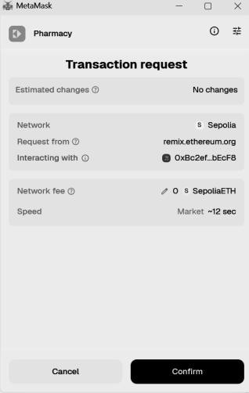
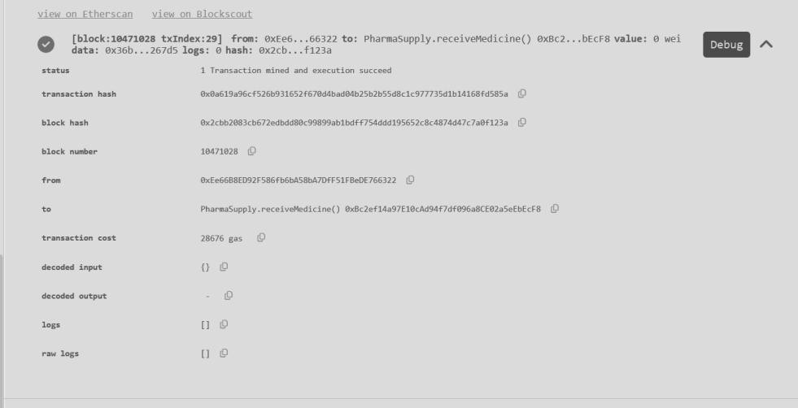

Step 4: Check Data
- Click getMedicine
Output will be like: "Paracetamol"
100
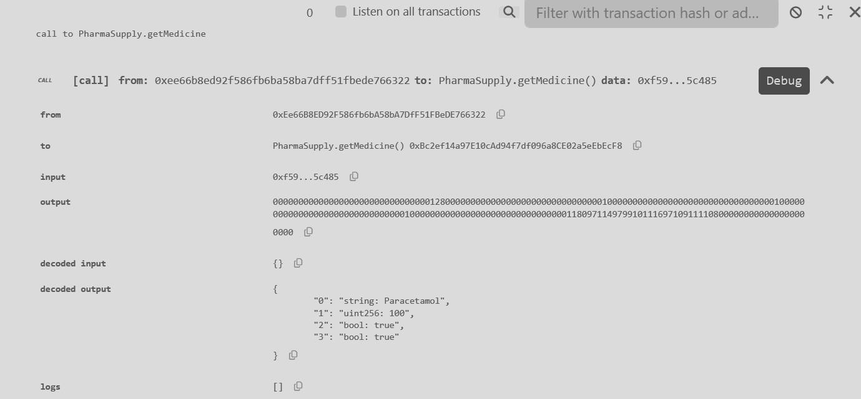
true (shipped) true (received)

Compiled PharmaSupply.sol

Copy contract address → paste in Etherscan (Sepolia) See all transactions + status
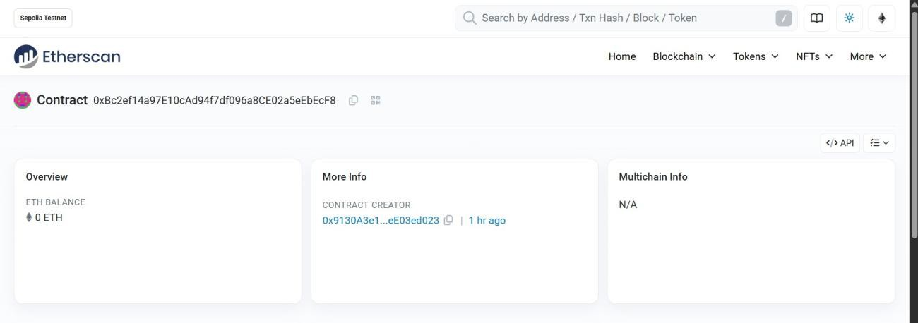
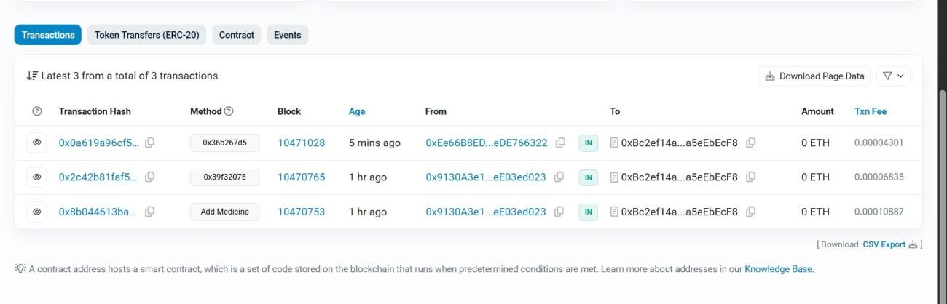

Conclusion

The experiment successfully demonstrated MetaMask integration with Remix IDE and execution of blockchain transactions. It provided hands-on experience with smart contracts, ensuring secure and transparent interactions on a testnet

