**SCREEN SHOTS**

1. This is the first output window.

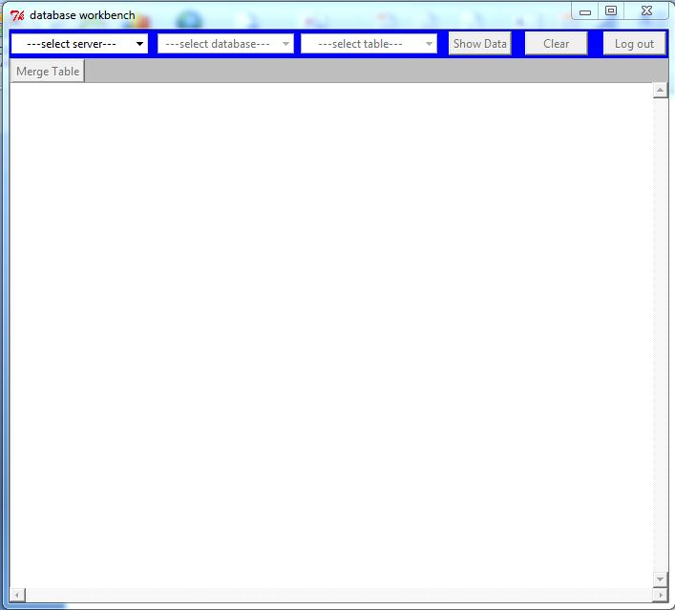

1. Select a database server from the drop down list.

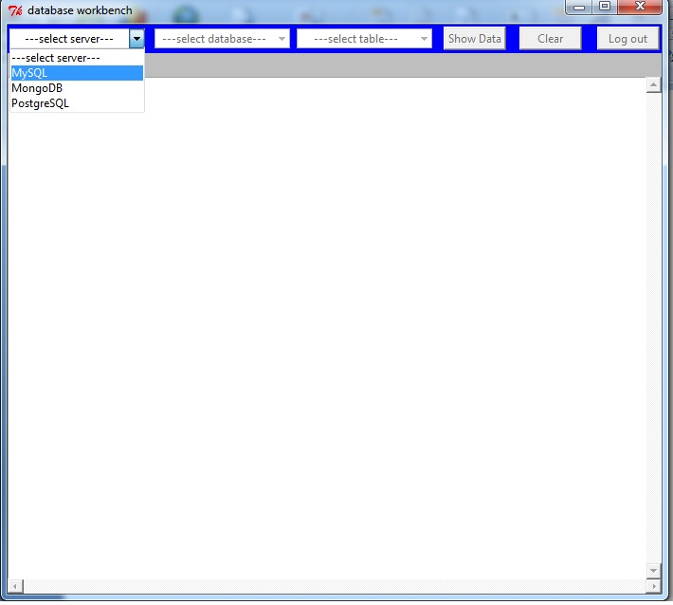

1. Login with your username and password of that database.

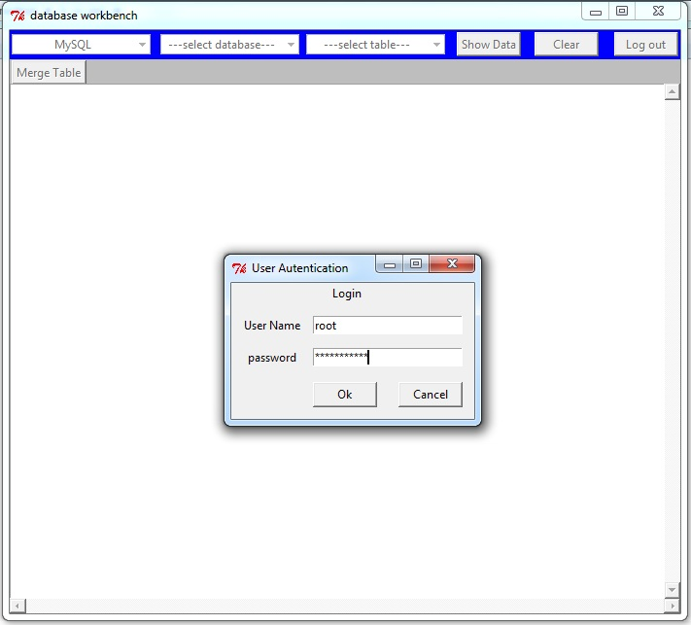

1. Select a database form the drop down list.

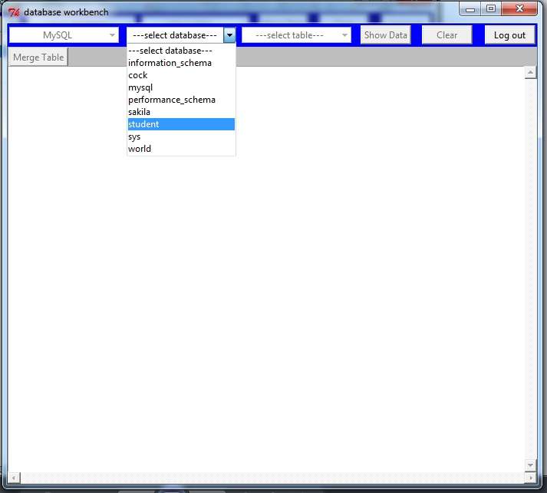

1. Select a table.

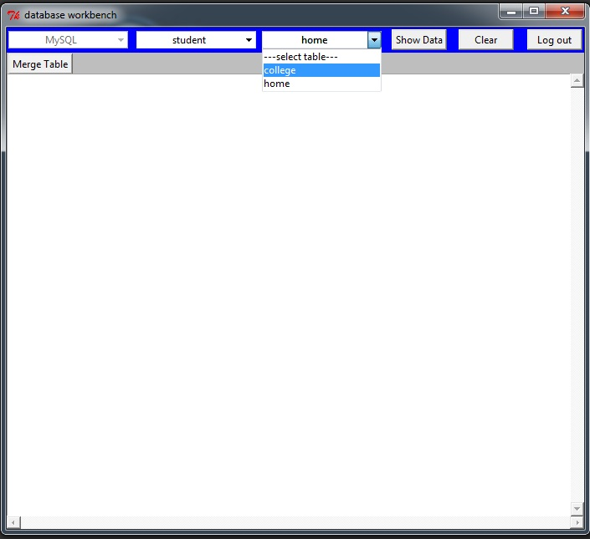

1. Click on “Show Data” button to show the data of that table.

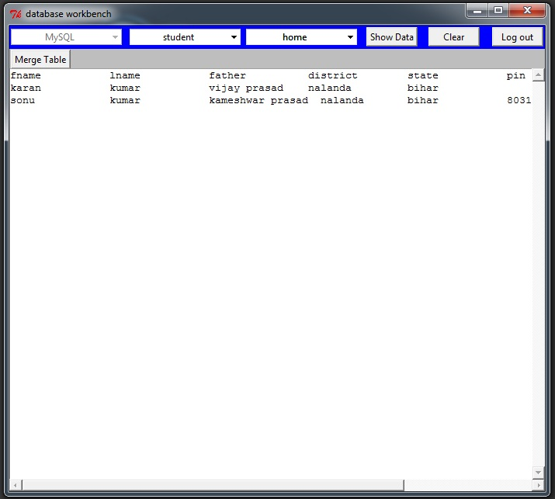

1. To merge two tables click on “Merge Table” button and select two tables and a joining field name then clicjk on “Merge and Show “ button to show the merged data.

