**Nitish Bhardwaj (B21AI056)**

**Results of the program code**

**Output of server 1**

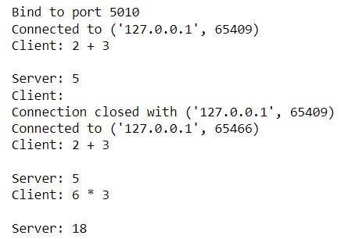

Here, we showed how the server binds to a port and connects to a single client .

**Output of server 2**

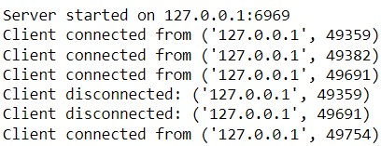

Here, we showed how the server binds to the port and connects to multiple clients.

**Output of client**

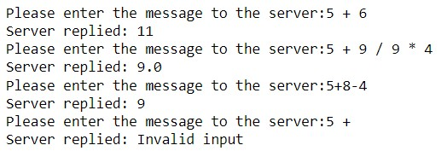

# Results of Tests Given

* **Testcase 1:** Passed (Evidence in above screenshots also shown)
* **Testcase 2:** Passed (Evidence in above screenshots also shown)
* **Test 3:** Passed ,When another client tries to send an expression for evaluation, it does “nothing”.Also the server1 doesn’t show its connection establishment as client1 is already connected. Evidence as screenshot given below. Better manually checked by the grader.

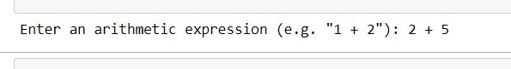

* **Test 4:** Passed (Evidence in above screenshots also shown)
* **Test 5:** Passed (Evidence in above screenshots also shown) ● **Test 6:** Passed, Need to be manually checked by grader.
* **Test 7:** Passed, Need to be manually checked by grader.
* **Additional Test:** It can be seen in the screenshot above that our server can handle any kind of mathematical expression and will give correct output if the expression is valid else gives message as “Invalid input” .