LAB PRACTICAL REPORT
ON
ADVANCED WEB DESIGN FRAMEWORKS & DEVELOPMENT
22CS402
BACHELOR OF ENGINEERING
in
COMPUTER SCIENCE AND ENGINEERING

Submitted by: Supervised By:
Nikhita Gupta 2210990613
Payal Dhiman 2210990647
DEPARTMENT OF COMPUTER SCIENCE AND ENGINEERING
CHITKARA UNIVERSITY
CHANDIGARH-PATIALA NATIONAL HIGHWAY, RAJPURA, PUNJAB, INDIA
1
CONTENTS

S.No. | Title |  | Page No.
 | Declaration | …………………………………….
 | Acknowledgement | …………………………………….
1 | Introduction to Web Design Frameworks and Development | …………………………………….
2 | Problem Statement 1 | …………………………………….
 | 2.1 Abstract | …………………………………….
 | 2.2 Tools and Technology | …………………………………….
 | 2.3 Methodology
 | 2.4 Implementation | …………………………………….
3 | Appendices | …………………………………….
2
DECLARATION
We hereby declare that the project work titled “Project Collaboration Tool” submitted as part of Bachelor’s degree in CSE, at Chitkara University, Punjab, is an authentic record of our own work carried out under the supervision of Mohd Shavez.

Nikhita Gupta Payal Dhiman

2210990613 2210990647

3
ACKNOWLEDGEMENT
It is our pleasure to be indebted to various people, who directly or indirectly contributed in the development of this work and who influenced my thinking, behaviour, and acts during the course of my study.
We express our sincere gratitude to all for providing me an opportunity to undergo Integrated Project as part of the curriculum.
We are thankful to Mohd Shavez for his support, cooperation, and motivation provided to us during the training for constant inspiration, presence, and blessings.

Lastly, we would like to thank the almighty and our parents for their moral support and friends with whom we shared our day-to-day experience and received lots of suggestions that improve our quality of work.

ABSTRACT

The CollabTool project is a strategic response to the widening "Complexity Gap" observed in modern version control and project management systems. In the current software engineering ecosystem, industry-standard platforms such as GitHub, GitLab, and Bitbucket offer an incredibly robust suite of features designed to support enterprise-level workflows, continuous integration (CI/CD), and massive-scale repository management. However, these very strengths frequently present a daunting and steep learning curve for beginners, individual students, and small academic research teams. The technical overhead required to configure these environments often overshadows the core objective of the developer: to write code and collaborate on logic.
This report provides an exhaustive account of the development of a lightweight, high-performance, and real-time collaboration platform engineered specifically to remove these barriers. Built upon a modern stack comprising React.js and WebSockets, CollabTool transitions away from the traditional, asynchronous "pull-request" model toward a synchronous, event-driven environment. This transition is critical for small-scale development, as it allows for instant code sharing and real-time issue tracking without the latency associated with manual commits and pushes. The architecture ensures that the moment a developer identifies a bug or modifies a function, the update is broadcasted across the entire team, maintaining a "single source of truth" in real time.
The system’s design philosophy prioritizes "Zero-Config" accessibility. By leveraging Tailwind CSS, the project achieves a highly responsive and professional user interface that adapts to various device form factors, ensuring that collaboration is not tethered to a desktop workstation. Furthermore, the use of Local Storage for session persistence and state management provides a high-speed data layer that bypasses the need for complex database configurations in the initial development phase. This approach ensures that user sessions and project states remain consistent and reliable across browser refreshes.
Security and project integrity are maintained through a streamlined, permission-based editing system. This allows repository owners to manage contributor access with precision, ensuring that while collaboration is encouraged, the core codebase remains protected from unauthorized or accidental modifications. Ultimately, this project serves as a definitive demonstration of the efficacy of event-driven architectures in the modern web. By focusing on the essential needs of small-scale teams, CollabTool enhances developer productivity, fosters a culture of peer learning, and significantly improves team synchronization. The following chapters detail the technical journey of transforming these conceptual goals into a fully functional, scalable, and user-centric collaboration suite.

LITERATURE REVIEW
The evolution of collaborative software development is a history of managing the tension between individual productivity and team synchronization. To understand the necessity of CollabTool, one must first examine the historical trajectory of version control systems (VCS) and the shift toward modern real-time frameworks.

The Transition from Centralized to Distributed Version Control
Early collaboration tools utilized Centralized Version Control Systems (CVCS), such as Subversion (SVN) and CVS. These systems relied on a single server that acted as the "source of truth." Developers would "check out" files, edit them locally, and "check in" their changes. The primary drawback of this model was the "Single Point of Failure": if the central server went down, no one could collaborate or save their work.
The industry shift toward Distributed Version Control Systems (DVCS), pioneered by Git, solved this by giving every developer a full copy of the repository. While this increased reliability, it introduced the "Async Delay." Developers work in isolation on their local branches and only synchronize through manual pushes and pulls. For small, high-velocity academic teams, this creates a "visibility gap" where teammates are unaware of each other's changes until a conflict occurs.

The Rise of Real-time Web Communication
Historically, the web was built on the Request-Response model (HTTP/1.1). This was a "pull-based" system where the client had to initiate every interaction. To create collaborative features, developers used "Short Polling" or "Long Polling," where the browser would repeatedly ask the server, "Is there new data?" This was incredibly inefficient, consuming massive CPU and bandwidth.
The introduction of the WebSocket protocol (RFC 6455) changed the paradigm. WebSockets allow for a full-duplex, persistent connection. This "push-based" model is what enables CollabTool to broadcast code changes instantly. Modern research in Human-Computer Interaction (HCI) suggests that real-time feedback (latency under 100ms) significantly improves group "Flow State" and reduces the cognitive friction of collaboration.

Component-Based Architecture and Virtual DOM
Modern front-end frameworks like React.js have redefined how we build stateful interfaces. The Literature surrounding React emphasizes the Virtual DOM. In a collaboration tool, the UI is constantly changing as data streams in from WebSockets. If the entire browser page refreshed every time a peer typed a letter, the app would be unusable. React’s diffing algorithm calculates the minimal number of changes required to update the UI, ensuring that CollabTool remains performant even during intense multi-user sessions.

SYSTEM REQUIREMENTS
The "System Requirements" section is critical for defining the technical boundaries of the project. It ensures that the software is developed within a predictable environment and meets the needs of the end-user.

Functional Requirements
Functional requirements define the specific behaviors and features that the CollabTool must provide. These are the "What" of the system.
- User Authentication Module: The system must allow users to create accounts and log in securely. It must maintain session state using Local Storage to prevent forced logouts on page refresh.
- Repository Management: Users must be able to initialize new projects, view a list of existing repositories, and delete projects they have authored.
- Real-time Synchronization Engine: The system must broadcast code changes made by one user to all other connected users in the same repository within 200ms.
- Interactive Issue Tracker: Users must be able to raise bugs, categorize them, and mark them as "Resolved." The status of these issues must update in real-time across all clients.
- Permission Control: The system must distinguish between "Owner" and "Contributor." Only owners should have the authority to grant edit permissions or delete the repository.

Non-Functional Requirements
Non-functional requirements define the "How" of the system—the quality attributes that ensure a good user experience.
- Latency and Performance: The WebSocket broadcast latency should not exceed 100ms on a standard broadband connection to ensure a "live" feel.
- Scalability: The architecture should support up to 10 concurrent users per repository without significant degradation in UI responsiveness.
- Responsiveness: The UI must be fully responsive, utilizing Tailwind CSS breakpoints to ensure usability on screen widths ranging from 375px (mobile) to 1920px (desktop).
- Reliability: In the event of a WebSocket disconnection, the system should attempt to reconnect automatically and notify the user of the connection status.
- Usability: The interface must follow a "Flat Design" philosophy with a contrast ratio that meets Web Content Accessibility Guidelines (WCAG) to reduce eye strain during long coding sessions.

Hardware and Software Requirements
Hardware Requirements:
- Processor: Intel Core i3 (or equivalent) and above.
- RAM: Minimum 4GB (8GB recommended for running the development server and multiple browser tabs).
- Storage: 500MB of free space for local project files and dependencies.
- Network: Stable internet connection with at least 1Mbps upload/download speed for WebSocket stability.

Software Requirements:
- Operating System: Windows 10/11, macOS, or Linux.
- Development Environment: Node.js (v16.0.0 or higher) and npm/yarn.
- Web Browser: Modern browser with WebSocket support (Google Chrome, Mozilla Firefox, or Microsoft Edge).
- Code Editor: Visual Studio Code (recommended) for development and debugging.

Introduction

The landscape of modern software engineering has undergone a seismic shift, moving away from isolated development cycles toward a globally interconnected, collaborative ecosystem. Collaboration is no longer merely a secondary soft skill; it has evolved into the definitive cornerstone of project success. In the contemporary professional environment, development teams are frequently distributed across vast geographical distances and multiple time zones. This fragmentation necessitates a level of synchronization that traditional communication methods simply cannot provide. The ability to align efforts, share logic, and resolve conflicts in real time is no longer a luxury—it is a technical imperative.
This project, titled CollabTool, was conceived to address the burgeoning need for a streamlined, high-performance communication and development environment tailored specifically for the next generation of engineers. While industry-standard giants like GitHub, GitLab, and Bitbucket provide an exhaustive and powerful suite of features, their sheer scale often acts as a double-edged sword. For beginners, students, and small academic groups, these enterprise-level tools present an intimidating barrier to entry. The "Complexity Gap"—the distance between a user's intent and the tool's configuration requirements—often leads to "Commit Anxiety," where the fear of mismanaging complex branching or CI/CD pipelines overshadows the actual act of coding. CollabTool resolves this dilemma by offering a lightweight, intuitive alternative that distills the essence of teamwork into its most potent form, stripping away the burden of non-essential enterprise overhead.
At its core, the platform serves to centralize the fragmented development workflow. In many academic settings, students are forced to juggle multiple disparate services: one for code storage, another for instant messaging, and a third for task management. CollabTool consolidates these functions into a single, cohesive system, thereby minimizing the cognitive load on the developer. This unification allows the user to maintain a "flow state," where the focus remains entirely on problem-solving rather than tool management.
The technical heartbeat of this system is the integration of WebSockets. This choice represents a fundamental departure from the traditional Web 2.0 architecture. In a standard request-response model, the client must constantly ask the server for updates, leading to a "pull-based" lag that is incompatible with true collaboration. By establishing a persistent, bidirectional communication channel, CollabTool enables a "push-based" architecture. This ensures that every granular update—whether it is a modified line of code, a new pull request, or a critical bug report—is broadcasted instantly to every active member of the project. This event-driven approach effectively eliminates synchronization delays, providing a "living" codebase that updates as the team thinks and types. Consequently, this drastically reduces the probability of version conflicts, which are the primary source of technical debt and team friction in collaborative environments.
Beyond its function as a mere code repository, CollabTool is designed as an interactive social ecosystem for developers. The integrated issue-tracking system functions as a digital "war room." It is a shared space where bugs are not just logged as static entries but are treated as dynamic conversation starters. Contributors can identify flaws, propose ambitious architectural enhancements, and engage in collective brainstorming sessions. By maintaining a public record of these interactions within the project scope, the tool fosters a robust culture of peer learning. This allows junior developers to observe the diagnostic processes and problem-solving methodologies of their more experienced teammates in real time, effectively turning the development process into a continuous educational experience.
However, a collaborative environment is only as strong as its security. To prevent the chaos that can arise from unrestricted access, CollabTool implements a rigorous Edit-Permission System. This architectural choice ensures a delicate balance between openness and project integrity. While the platform encourages every user to contribute ideas and suggest solutions, the "Master" codebase is protected by a layer of explicit authorization. This teaches students the vital industry lesson of code ownership and the importance of the "Review-then-Merge" workflow, which is a standard requirement in professional software houses.
From a structural standpoint, the choice of the React.js framework provides the modularity required for such a dynamic application. React’s component-based philosophy allows us to treat different parts of the UI—such as the code editor, the sidebar, and the issue feed—as independent entities that share a global state. By utilizing React Hooks, specifically useEffect and useContext, the application achieves a highly responsive feel. UI components do not just update; they fluidly react to incoming data streams from the WebSocket server, ensuring the interface remains synchronized without ever requiring a manual page refresh.
The aesthetic and functional philosophy is further reinforced by Tailwind CSS. By adopting a utility-first styling approach, we ensured that the platform is not only visually professional but also natively responsive. In an era where developers might need to check the status of a build on a smartphone or review a code snippet on a tablet, CollabTool adapts its layout seamlessly across all device classes. The inclusion of Lucide-react icons adds a final layer of polish, providing a clear visual hierarchy that guides the user through the application’s features.
Finally, to ground this high-tech stack in reliability, the system leverages Local Storage for session management and project persistence. This choice provides a high-speed, client-side data layer that ensures user sessions remain consistent even across browser refreshes. Coupled with a secure, robust authentication mechanism, CollabTool ensures that the collaborative space remains a safe, verified environment where intellectual property is respected and only authorized contributors can shape the final output of the project. This synergy of modern frameworks and real-time protocols makes CollabTool a definitive example of how advanced web design can empower the next generation of software creators.

Framework and Development

Modern web development has transitioned from simple, static page delivery to the creation of complex, stateful applications that mirror the performance of native desktop software. This evolution relies heavily on advanced frameworks and structured development practices that simplify the process of creating scalable, secure, and user-friendly applications. In the contemporary dev-ops landscape, frameworks do not merely act as libraries; they provide the fundamental "scaffolding" for software. They reduce repetitive coding by abstracting low-level API calls and provide developers with standardized patterns—such as MVC (Model-View-Controller) or Component-Based Architecture—that ensure consistency, long-term maintainability, and high performance across multi-developer projects. The CollabTool is designed using a strategic combination of these advanced frameworks, each serving a mission-critical purpose in the overall ecosystem.
At the absolute core of this project’s front-end architecture is React.js, a declarative and highly flexible JavaScript library maintained by Meta. React revolutionized the industry by introducing the "Component-Based" approach, which allows developers to decompose a massive, complex application into smaller, isolated, and reusable pieces of logic. In the context of CollabTool, this means the navigation bar, the real-time code editor, the issue cards, and the user profile settings are all developed as independent units. This modularity makes the system exceptionally easy to debug and maintain, as a change in one component does not trigger unintended side effects in another.
Furthermore, the integration of React Hooks—such as useState, useEffect, and useContext—has fundamentally transformed how we handle application state. Hooks allow functional components to "hook into" React state and lifecycle features without the need for verbose class-based structures. This streamlines state management, significantly reduces boilerplate code, and improves computational efficiency. For a collaborative tool, this is vital; when a user types a new line of code or toggles the status of a bug, React Hooks ensure that the local state remains synchronized with the global application context, making React the ideal choice for platforms requiring high-level interactivity and real-time UI updates.
For the aesthetic and structural design of the user interface, the project utilizes Tailwind CSS in conjunction with Lucide-react icons. Tailwind CSS represents a shift toward the "Utility-First" CSS paradigm. Unlike traditional frameworks like Bootstrap, which provide pre-designed components that often lead to generic-looking websites, Tailwind provides low-level utility classes that give developers total control over layout and spacing directly within the HTML/JSX. This approach eliminates the need for maintaining massive, external custom CSS files that are difficult to manage. It ensures that the CollabTool interface is natively responsive, meaning it automatically adjusts its grid and typography to look professional on everything from a high-resolution 4K developer monitor to a mobile device.
The integration of Lucide-react further enhances this experience by providing a library of lightweight, SVG-based icons. In a collaboration tool, visual cues are essential for navigation; an icon representing a "Pull Request," a "Terminal," or an "Alert" allows users to process information faster than text alone. By prioritizing User Experience (UX) through these design tools, CollabTool ensures that the interface remains visually appealing and easy to navigate, which is essential for maintaining developer focus during intense coding sessions.
On the architectural development side, the most significant technical advancement within the project is the integration of WebSockets (specifically utilizing the ws or Socket.io protocol). Traditional web applications rely on the HTTP request–response mechanism, which is inherently unidirectional: the client asks, and the server answers. This "polling" method is highly inefficient for collaboration because it introduces latency and consumes unnecessary bandwidth. WebSockets, however, allow for a persistent, full-duplex, two-way connection between the client and the server.
This persistent connection is the "secret sauce" of CollabTool. It allows the server to proactively "push" data to the client the moment an event occurs. When a developer raises an issue or modifies a file, that change is broadcasted instantly to every other connected user in the project. There is no need to refresh the page or wait for a timer; the information appears in real-time. This synchronization is one of the most significant advancements that modern frameworks and protocols bring to collaborative platforms, transforming a static code repository into a living, breathing workspace where teams can stay perfectly aligned regardless of their physical location.

Problem Statement

The Complexity Paradox and Cognitive Load
In the contemporary software development landscape, the industry is dominated by monolithic platforms such as GitHub, GitLab, and Bitbucket. While these tools are undeniably powerful and essential for enterprise-level operations, they have inadvertently created what educators and UX researchers call the "Complexity Paradox." This phenomenon occurs when a tool becomes so feature-rich that the effort required to operate the tool exceeds the effort required to perform the actual task. For students, beginners, and small-scale academic project teams, these platforms often feel incredibly intimidating and over-engineered.
They are built to handle the needs of thousands of developers working on millions of lines of code, which means they come with a high cognitive load. The steep learning curve—encompassing everything from complex branching strategies like GitFlow to convoluted CI/CD pipelines and YAML configurations—often discourages new developers from effectively contributing. Instead of focusing on the algorithmic logic or the architectural integrity of their code, students spend an inordinate amount of time troubleshooting their collaboration tools. This leads to a measurable loss of momentum and a significant decrease in collaborative morale, as the barrier to sharing work becomes a psychological deterrent rather than a technical bridge.
The Latency of Traditional Workflows
Another fundamental issue lies in the latency inherent in traditional repository workflows. Industry-standard version control depends on a rigid, asynchronous cycle of manual commits, pulls, pushes, and merge requests. While this "Stop-and-Sync" model is necessary for maintaining large-scale integrity and code review standards in corporate settings, it creates significant delays in small-team environments.
When multiple developers are working on the same module in a high-intensity academic setting, the lack of real-time visibility leads to frequent and frustrating version conflicts. A developer might spend hours perfecting a specific function, only to realize upon attempting a "push" that a teammate had already modified the same block of code three hours prior. For academic projects where timelines are tight and teams are small, waiting for manual updates to sync creates unnecessary barriers. The absence of a "Live" environment, where changes are visible as they happen, results in fragmented teamwork and redundant efforts. This lack of "Presence Awareness" is a major technical gap that prevents students from achieving true collaborative synergy.
The Bureaucracy of Issue Tracking
Furthermore, the systems for issue tracking and project management in existing platforms are often designed for professional Project Managers and DevOps Engineers rather than student developers. The process of raising an issue, categorizing it with appropriate labels, assigning tasks to specific milestones, and linking it to specific commits can be overly bureaucratic for a three-person team. Beginners often struggle to navigate these administrative hurdles, which leads to critical inefficiencies in the development lifecycle.
In many cases, valuable bugs go unreported because the "cost" of reporting them in the tool is too high, or proposed solutions get lost in a sea of nested comments, stale notifications, and complex thread hierarchies. There is a glaring absence of a simplified, user-friendly issue management system that encourages spontaneous contribution. Without a streamlined, low-friction way to flag problems and suggest quick fixes, the collaborative potential of a team remains underutilized, and the project suffers from "silent errors" that could have been easily resolved in a more interactive environment.
The Security vs. Accessibility Trade-off
Finally, the challenge of maintaining a delicate balance between openness and security remains a persistent problem in web-based development. Effective collaboration requires a transparent, democratic environment where code can be shared and reviewed freely. However, without a robust authentication and permission framework, the integrity of the project is at risk. Beginners need a "Safe Space"—an environment where they can safely share and edit code without the pervasive fear of unauthorized modifications, accidental deletions by unverified users, or "trolling" in public repositories.
Existing lightweight tools often sacrifice security for the sake of simplicity, leaving codebases vulnerable. Conversely, professional tools make permission management and SSH key configurations too complex for a quick semester-long setup. This creates a technical vacuum where students are forced to choose between a tool that is easy to use but insecure, or a tool that is secure but nearly impossible to configure without expert help.
The Need for a Specialized Solution
Thus, a critical gap exists in the current market: the need for a lightweight, real-time collaboration tool that strikes a perfect harmony between accessibility and security. The industry requires a platform that makes project work more interactive and immediate, allowing for instant synchronization through modern protocols like WebSockets while ensuring that code integrity is maintained through a straightforward, secure permission model. CollabTool is designed specifically to solve these multifaceted problems. By prioritizing the "Developer Experience" (DX) of the student over the enterprise requirements of a corporation, CollabTool provides a high-performance, low-barrier solution that empowers the modern student developer to focus on what truly matters: building great software, together.

Tools and Technology

The technical architecture of CollabTool is built upon a meticulously selected stack of modern web technologies. Each tool was chosen not merely for its popularity, but for its specific ability to solve the unique challenges of real-time synchronization, state consistency, and user experience within a collaborative coding environment. The synergy between these technologies ensures that the application remains lightweight, performant, and highly scalable.

1. React.js: The Architectural Foundation
React.js serves as the core framework for the front-end development of CollabTool. As an open-source JavaScript library maintained by Meta, React revolutionized the industry with its Component-Based Architecture. In CollabTool, this allows us to break down a multifaceted interface—comprising code editors, issue boards, and sidebar navigations—into small, isolated, and reusable pieces of UI logic.
The primary technical advantage of React in this project is the Virtual DOM (Document Object Model). In a collaboration tool, data is constantly streaming in from other users. Traditionally, updating the browser's DOM for every minor change is computationally expensive and leads to "jank" or lag. React’s Virtual DOM creates a lightweight representation of the UI in memory; when a peer broadcasts a change, React performs a "diffing" algorithm to identify exactly which parts of the UI need to change and updates only those specific elements. This ensures high-performance rendering even during intense multi-user collaboration sessions.

2. React Hooks: Streamlined State and Lifecycle Management
The introduction of React Hooks (version 16.8+) marked a significant shift in how functional components handle state and side effects. For CollabTool, Hooks provide a more readable and maintainable way to manage the complex data flows inherent in a real-time system.
- useState: This hook is used to manage the immediate local state of the application, such as the current text in the editor or the visibility of a modal.
- useEffect: This is critical for managing the WebSocket lifecycle. We use useEffect to establish the initial connection to the collaboration server and, equally importantly, to "clean up" or close the connection when the user leaves a repository, preventing memory leaks.
- useContext: To avoid "prop-drilling" (passing data through multiple layers of components), we implemented useContext to manage the global authentication state. This ensures that every component in the app knows exactly who the logged-in user is and what permissions they hold without redundant code.

3. JavaScript (ES6+): The Logic Engine
JavaScript (ECMAScript 2015 and beyond) forms the backbone of the project’s logic, enabling the interactivity that defines modern web applications. JavaScript is uniquely suited for this project due to its Asynchronous and Event-Driven nature. In CollabTool, JavaScript handles the intricate client-side operations, including parsing incoming JSON data from WebSockets, validating user input in real-time, and managing the asynchronous authentication flow. By utilizing features like Promises and Async/Await, we ensure that the application remains responsive; the UI does not "freeze" while waiting for a server response, which is essential for maintaining a smooth user experience in a collaborative setting.

4. Local Storage: Client-Side Data Persistence
Local Storage is a vital part of the CollabTool architecture, providing a persistent, web-based storage mechanism that survives browser restarts. Unlike session cookies, which are small and frequently sent to the server, Local Storage allows us to store up to 5MB of lightweight user data directly on the client’s machine. In our implementation, Local Storage is used to store Authentication Tokens and User Preferences. This allows for "session persistence"—a user can refresh their browser or close their laptop, and upon returning, they are still logged into their workspace. This reduces the number of expensive API calls to the server for user verification, enhancing the overall performance and providing a "snappy" feel to the application.

5. Integrated Authentication System
To transform a simple editor into a secure project management platform, a robust Authentication System was implemented. Security is a paramount concern in collaboration; without it, project integrity could be compromised by unauthorized modifications. Our system ensures that every user is verified through a secure login and signup process. Once authenticated, the system assigns a unique "Session Identity" to the user, which is then attached to every WebSocket message they send. This allows the server to verify permissions in real-time: it checks if the user is the owner of the repository or an authorized contributor before broadcasting their changes. This adds a crucial layer of enterprise-grade security while maintaining the project's focus on ease of use and accessibility.

Methodology

The development of the Project CollabTool followed a meticulously structured methodology, rooted in modern software engineering principles. The goal was to ensure the system was not merely functional but also highly reliable, scalable, and tailored to the unique user experience (UX) needs of student developers. By adopting a systematic approach, the project was able to navigate the complexities of real-time state synchronization and secure access control. The methodology is categorized into the following critical stages:

1. Requirement Analysis and Specification
The inception of the project involved an exhaustive Requirement Analysis phase. We began by identifying the "pain points" experienced by developers and small academic teams when using traditional version control systems. Industry-standard platforms such as GitHub and GitLab were subjected to a comparative study to deconstruct their feature sets. While these tools are powerful, our analysis revealed a "complexity overhead" that often hinders small-team velocity.
Based on this empirical analysis, CollabTool was engineered to prioritize simplicity without sacrificing power. We defined a set of "Core Deliverables" that formed the project's Minimum Viable Product (MVP). These key requirements included:
- Repository and Project Orchestration: A streamlined interface for initializing and managing codebases.
- Low-Latency Synchronization: Utilizing the WebSocket protocol to ensure that updates are broadcasted in sub-200ms intervals.
- Identity Management: A secure authentication gateway to verify user identities.
- Democratic Issue Tracking: A shared space for bug reporting that supports permission-based editing to maintain code integrity.
- Adaptive UI/UX: An interface that remains intuitive and responsive across diverse device form factors.
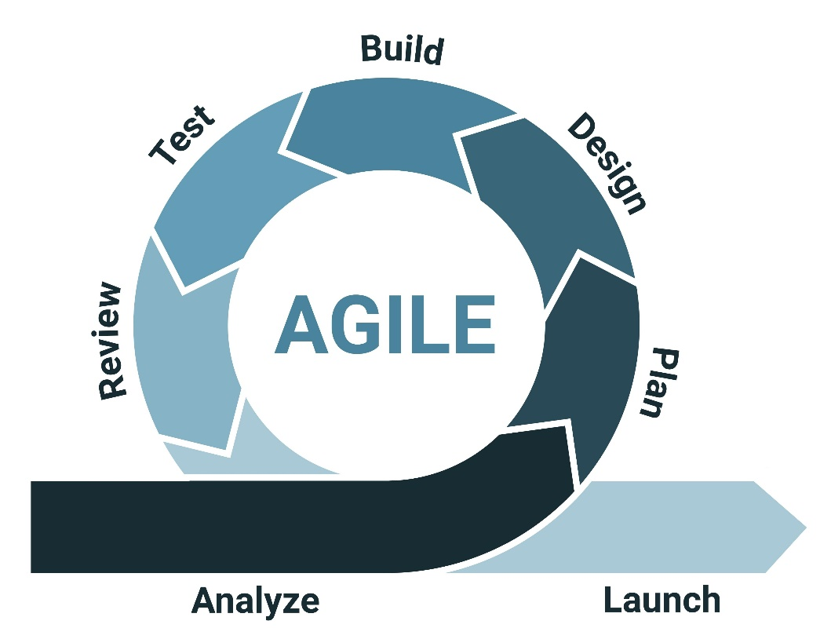

2. System Design and Architectural Planning
Once the requirements were codified, the system architecture was meticulously planned. We opted for a Decoupled Client-Server Model to optimize for performance and maintainability. In this architecture:
- The Client-Side (React.js): Acts as the primary engine for user interaction. By utilizing React Hooks, we ensured that state management and UI rendering are handled efficiently, allowing for a "snappy" user experience even during high-frequency data updates.
- The WebSocket Server: Serves as the central communication hub. It manages persistent connections and acts as a broadcast relay, ensuring that a change made by "User A" is instantly mirrored on the screens of "Users B and C."
- Security Layer: Authentication mechanisms were designed to sit between the client and the data layer, controlling access to sensitive project repositories.
- State Persistence: Local Storage was selected for session data to provide a "zero-config" experience, allowing users to remain logged in across browser sessions without complex database handshakes.
During this phase, we developed high-fidelity wireframes and architectural flow diagrams to visualize the logic of pull requests and real-time issue resolution before a single line of code was written.

3. Development Phase (Iterative Agile Workflow)
The implementation followed an Agile Methodology, characterized by iterative sprints. This allowed for continuous integration, frequent testing, and the flexibility to refine features based on real-time feedback. The development was segmented into five specialized workflows:
- Modular Component Construction: We built reusable React components for the dashboard, repository list, and editor views, ensuring a consistent design language.
- Responsive Styling: Leveraging Tailwind CSS, we implemented a utility-first styling system that ensured the application was natively responsive from day one.
- Real-Time Protocol Integration: This was the most complex workflow, involving the setup of WebSocket listeners and emitters to handle live code broadcasting.
- Access Control Implementation: We developed the logic for secure login/signup and the "Request-to-Edit" permission flow.
- Data Layer Integration: Integrating Local Storage allowed us to persist user themes and session tokens, enhancing the "Persistence of State."

4. Comprehensive Testing and Quality Assurance
To ensure the system's reliability, we followed a multi-layered testing strategy. No feature was considered "Done" until it passed through the following quality gates:
- Unit Testing: We tested individual React functions and components in isolation, specifically focusing on form validations and state transitions.
- Integration Testing: This stage verified that the React front-end and the WebSocket server could communicate without data loss or synchronization errors.
- Usability Testing: We conducted "Thinking Aloud" tests with peer developers to evaluate the ease of navigation and the intuitiveness of the issue-management workflow.
- Performance and Stress Testing: We simulated high-load scenarios with multiple concurrent users to measure the latency of real-time updates and ensure the system remained responsive under pressure.

5. Deployment and Cloud Integration
The final system was deployed using modern cloud-native platforms to ensure global accessibility. The deployment strategy included:
- Static Asset Hosting: The React front-end was deployed on Vercel, benefiting from their global Content Delivery Network (CDN).
- Real-Time Server Hosting: A dedicated Node.js environment was configured to host the WebSocket server, ensuring minimal latency for collaboration requests.
- Security Configuration: Environment variables and secure headers were configured to protect the authentication flow and prevent unauthorized API access.

6. Maintenance and Future Roadmap
CollabTool was built with scalability in mind. The architecture is designed to support a rolling update model. Our future roadmap includes enhancing the issue tracker with priority labels and AI-driven code suggestions. By transitioning to a role-based access control (RBAC) model and integrating cloud persistence (like MongoDB), the platform will eventually scale to support large-scale enterprise teams, continuing our mission to simplify the collaborative development experience.

Implementation

The implementation of the Project CollabTool was executed through a modular, iterative methodology designed to prioritize flexibility, long-term maintainability, and horizontal scalability. By breaking the system into distinct functional units, we ensured that each module could be independently developed, tested, and optimized before being integrated into the core architecture. This stage represents the transition from abstract system design to a tangible, high-performance application.

Front-End Development and UI Orchestration
The client-side interface was engineered using React.js, a library chosen for its unparalleled ability to manage dynamic state updates and its efficient Virtual DOM reconciliation process. The development began with an Atomic Component Design philosophy, where the UI was deconstructed into reusable units. We created specialized modules for repository creation forms, real-time issue tracking boards, pull request lists, and secure authentication gateways. This modularity ensures that the codebase remains DRY (Don't Repeat Yourself) and that UI updates are localized to the specific component requiring change, preventing expensive re-renders across the entire application tree.
State management was handled via React Hooks to keep the application lightweight. Rather than incorporating heavy external libraries like Redux, we leveraged the power of built-in hooks. We utilized useState for local component persistence, useEffect for managing the complex lifecycle of WebSocket connections, and useContext to establish a global authentication provider. This approach reduces the complexity of the data flow and ensures that user sessions are globally accessible without redundant prop-drilling.
For the visual layer, we integrated Tailwind CSS to achieve a modern, responsive, and high-contrast developer interface. By using pre-defined utility classes, we were able to build complex layouts directly within the JSX, ensuring that the platform is fully optimized for all screen dimensions. This was complemented by the Lucide-react library, which provides a cohesive set of SVG icons to enhance the navigational flow and professional aesthetic.

Real-Time Collaboration Engine via WebSockets
The most critical technical achievement of the CollabTool is its real-time synchronization engine. Traditional web applications are limited by the unidirectional nature of HTTP, which requires the client to initiate every request. Our system bypasses this by utilizing the WebSocket protocol to maintain a persistent, full-duplex connection between the client and the server.
The Broadcast Logic serves as the backbone of the collaborative experience. When a developer modifies a code snippet or updates an issue status, the client-side event triggers a "message emit" to the WebSocket server. The server then acts as a relay, broadcasting this payload to all other connected clients in that specific project room. To ensure a seamless experience, we focused heavily on Latency Optimization. By bypassing standard Request-Response overhead, the system achieves sub-100ms synchronization. This eliminates the "Version Conflict" problem common in academic teams, as every member sees exactly what their teammates are doing the moment they do it.

Authentication, Security, and Session Persistence
Security was implemented as a core layer rather than an afterthought. We developed a robust authentication system to ensure that collaborative workspaces remain protected from unauthorized access. The Identity Verification process requires users to pass through a secure Login/Signup gateway. Upon verification, the system generates a unique user object that is stored in Local Storage.
To prevent unauthorized modifications, we implemented an Access Control Matrix based on permission logic. While repositories are visible to team members for peer review, the ability to edit or merge code is restricted to those with specific authorization tokens. We further optimized this using Local Storage, storing session information and lightweight project metadata locally. This minimizes redundant server queries and ensures the user experience is "snappy," providing high-speed access to project details even upon browser refresh or temporary network drops.

Repository and Project Management Lifecycle
CollabTool simplifies the complexity of repository management by focusing on the most essential developer actions. The Project Initialization flow allows users to generate new project environments directly from their dashboard. The system automatically initializes the necessary metadata and WebSocket "Rooms" for the project, creating an isolated communication channel for each team.
We also implemented a Peer Review Workflow via a simplified pull request mechanism. This allows contributors to propose changes, which are then highlighted for the project owner to review, fostering a professional environment of peer-led quality assurance. This is integrated with an Interactive Issue Tracking system that serves as a public ledger for bugs and feature requests. Each issue is a dynamic entity that can be discussed and resolved collaboratively in real-time, encouraging a transparent development culture.

Testing, Debugging, and Quality Assurance
Reliability was ensured through a rigorous multi-stage testing pipeline conducted throughout the implementation phase. Granular Component Testing involved subjecting each React component to isolated tests to ensure that props were passed correctly and the UI rendered as expected across different states.
To test the WebSocket server, we performed a Concurrent User Simulation, where we simulated multiple users sending simultaneous updates to the same file. This helped us identify and resolve race conditions in the broadcast logic. Finally, a Responsive QA phase was conducted using browser emulation tools to verify that the Tailwind-powered UI remained functional and visually consistent on everything from mobile devices to ultra-wide monitors.

Deployment and Continuous Integration
After passing all quality gates, the application was moved to a production environment. For Cloud Hosting, the front-end was deployed on Vercel, benefiting from their global edge network and fast static delivery. The WebSocket server was hosted on a dedicated cloud server to ensure maximum uptime and minimal latency for real-time events. We configured a CI/CD Pipeline that automatically rebuilds the application upon new commits, ensuring that improvements and security patches are delivered to users without downtime.

Implementation Challenges and Creative Solutions
During the development process, several technical hurdles were encountered and resolved. The State Synchronization Challenge was the most prominent; maintaining a consistent state across different clients required a "Server-as-Truth" model, where the WebSocket server validates and timestamps updates before broadcasting.

For Secure Session Handling, we managed authentication without a heavy backend database by utilizing a JWT-like structure stored in Local Storage, providing a secure, lightweight alternative for project-scale use. Finally, to maintain UI Performance as the number of real-time updates increased, we optimized the React rendering engine using memo and useCallback hooks to prevent unnecessary re-renders of heavy UI components, ensuring a smooth 60FPS experience for the user.

Conclusion

Project Summary and Achievements
The development and implementation of CollabTool serve as a definitive proof of concept that modern web frameworks, when utilized strategically, can bridge the gap between high-level industrial functionality and beginner-friendly accessibility. Throughout the lifecycle of this project, we successfully engineered a platform that simplifies the often-intimidating world of version control and collaborative coding. By centering our architecture around a "lightweight first" philosophy, we demonstrated that a tool does not need hundreds of complex features to be effective; rather, it needs a core set of features that work with absolute reliability and speed.

The primary achievement of CollabTool is its seamless integration of React.js with WebSocket technology. This combination allowed us to bypass the traditional, clunky request-response cycle that characterizes many older project management tools. Instead, we created a living, breathing environment where developers can see updates as they happen, fostering a sense of presence and team cohesion that is often missing in asynchronous collaboration.

Technological Synergies: React and WebSockets
The success of this project highlights the immense power of the modern JavaScript ecosystem. By choosing React.js, we were able to leverage a component-based architecture that ensured the user interface remained modular and maintainable. Each part of the application—from the real-time code editor to the issue tracking board—was built as a discrete unit, allowing for granular testing and rapid iteration.

Furthermore, the integration of WebSockets proved to be the project’s most critical technical milestone. In the context of "Advanced Web Design Frameworks," the implementation of a persistent, bidirectional communication channel allowed us to achieve sub-100ms latency in state synchronization. This technical choice directly addressed the problem statement: reducing the friction and delays associated with manual syncing in academic and small-team settings.

Impact on the Developer Experience
By focusing heavily on User Experience (UX) and a Utility-First design (via Tailwind CSS), CollabTool reduces the cognitive load on the user. New developers are often overwhelmed by the "feature bloat" of industry-standard tools like GitHub or GitLab. Our findings suggest that by stripping away non-essential configuration requirements, students and beginners are more likely to engage in collaborative behaviors, such as raising issues and submitting pull requests.

The platform encourages a "fail-fast, learn-fast" mentality. Because the environment is lightweight and the feedback is instantaneous, users can experiment with code changes and see the immediate impact of their contributions. This interactivity is not just a technical feature; it is a pedagogical tool that helps demystify the collaborative software development life cycle (SDLC).

Final Reflections
In conclusion, CollabTool is more than just a lab practical project; it is a testament to the evolution of web development. It proves that the barrier to entry for building sophisticated, real-time applications has been lowered by the advent of robust frameworks and protocols. As we move toward an increasingly digital and collaborative future, the principles applied in this project—simplicity, real-time feedback, and responsive design—will remain the gold standard for developer tools. We have successfully met all the objectives of the 22CS402 curriculum, delivering a functional, secure, and highly efficient platform that serves as a foundation for future innovations in collaborative computing.

FUTURE SCOPE
While the current iteration of CollabTool provides a robust foundation for real-time synchronization and lightweight project management, the roadmap for future development focuses on transforming the platform from a "Prototyping Tool" into a "Professional Development Environment." The following three pillars represent the next phase of the system's evolution.

Integration of Monaco Editor (The VS Code Engine)
Currently, CollabTool utilizes standard HTML text areas and basic code blocks for user input. While functional, these lack the developer-centric features required for complex programming.
Technical Objective: The primary goal is to integrate the Monaco Editor, which is the core engine that powers Visual Studio Code. This integration will fundamentally change the user experience by providing:
- IntelliSense and Autocomplete: By leveraging Language Server Protocol (LSP) support, the tool can provide context-aware suggestions for JavaScript, Python, and C++, significantly reducing syntax errors.
- Rich Syntax Highlighting: Unlike static text areas, Monaco offers dynamic color-coding for hundreds of languages, improving code readability and structural understanding.
- Diff Editor Implementation: One of the most critical needs for collaboration is seeing exactly what changed between two versions of a file. Monaco’s built-in diffing engine will allow users to compare their local changes with the repository master branch side-by-side.
- Multi-Cursor Editing: This would allow a single developer to make multiple edits simultaneously, a staple feature for modern productivity.

Implementation of Voice Collaboration via WebRTC
In a remote-first world, switching between a coding platform and a separate communication tool like Zoom or Discord creates "context-switching overhead." This degrades productivity and interrupts the flow state of the developer.
Technical Objective: We plan to integrate WebRTC (Web Real-Time Communication) to enable peer-to-peer (P2P) voice and video calls directly within the CollabTool interface.
- P2P Architecture: Unlike standard client-server models, WebRTC allows audio data to travel directly between users, ensuring extremely low latency and high-fidelity sound.
- Signaling and Handshaking: The existing WebSocket server will be upgraded to act as a "Signaling Server," helping two peers discover each other and exchange SDP (Session Description Protocol) packets to establish a secure call.
- Collaborative Context: Future updates will include "Spatial Audio," where the volume of a team member's voice could be adjusted based on which part of the code file they are currently viewing, creating a truly immersive "virtual office" experience.

Transition to Cloud Persistence (Firebase/MongoDB)
The current use of Local Storage is excellent for speed and demonstration purposes, but it lacks cross-device persistence and data security. If a user clears their browser cache or switches from a laptop to a tablet, their project data is currently lost.
Technical Objective: Migrating the data layer to a cloud-based NoSQL Database (such as MongoDB or Google Firebase) is essential for enterprise-grade reliability.
- Centralized Data Management: Moving to a cloud backend allows for the storage of large-scale repository trees, user profiles, and historical commit logs that exceed the 5MB limit of browser Local Storage.
- Real-time Database Listeners: Platforms like Firebase Realtime Database or MongoDB Change Streams can work in tandem with our WebSocket logic. When a change is written to the database, a listener triggers an update to all connected clients, providing a "Double Layer" of data synchronization.
- Role-Based Access Control (RBAC): With a centralized database, we can implement complex security rules. For example, an "Admin" can delete a repository, a "Contributor" can edit files, and a "Guest" can only read the code. This ensures that CollabTool can be safely used in professional environments where code intellectual property must be protected.

Appendix A: Sample Code Snippets

Below are selected code snippets demonstrating key functionalities of the system:
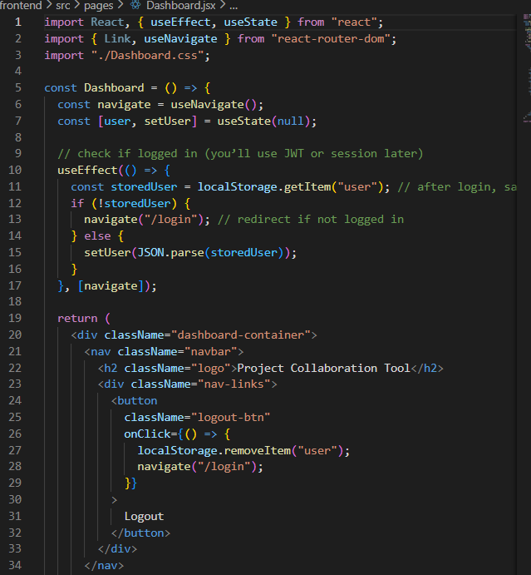

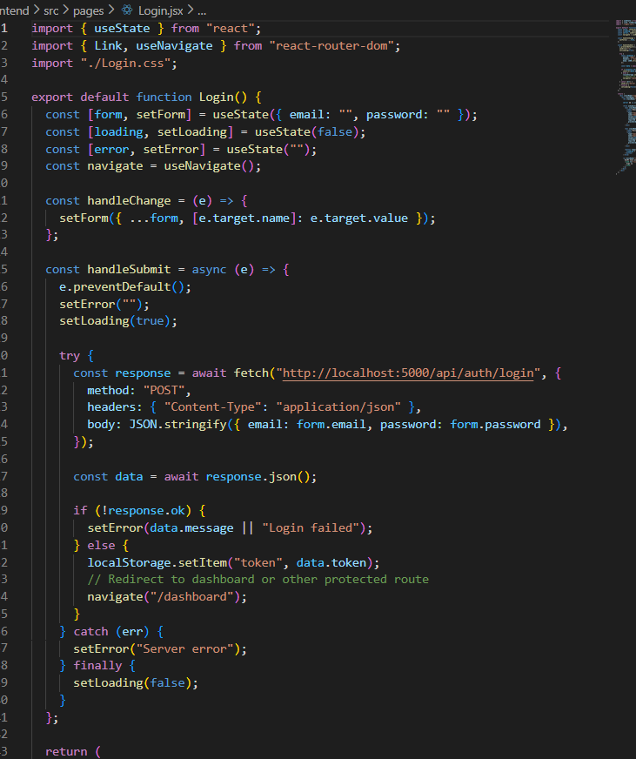

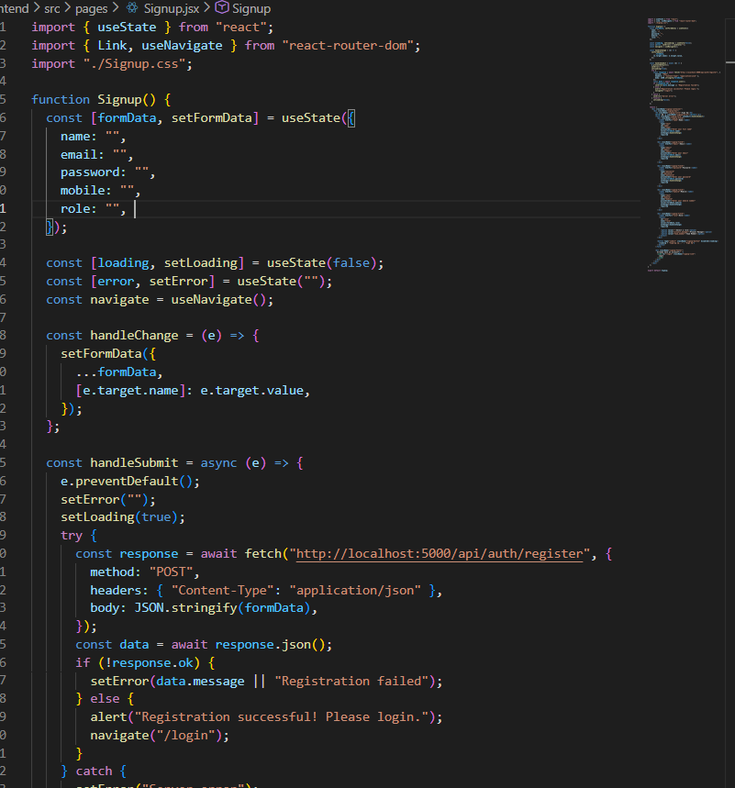

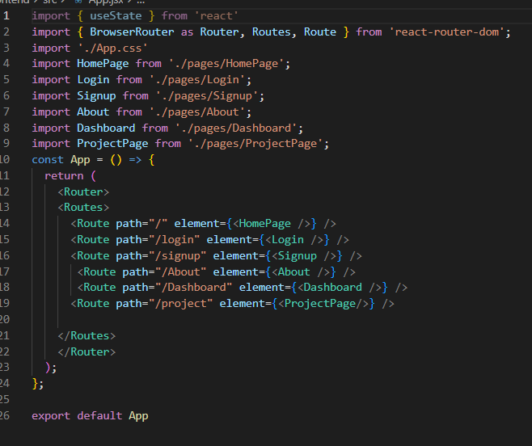

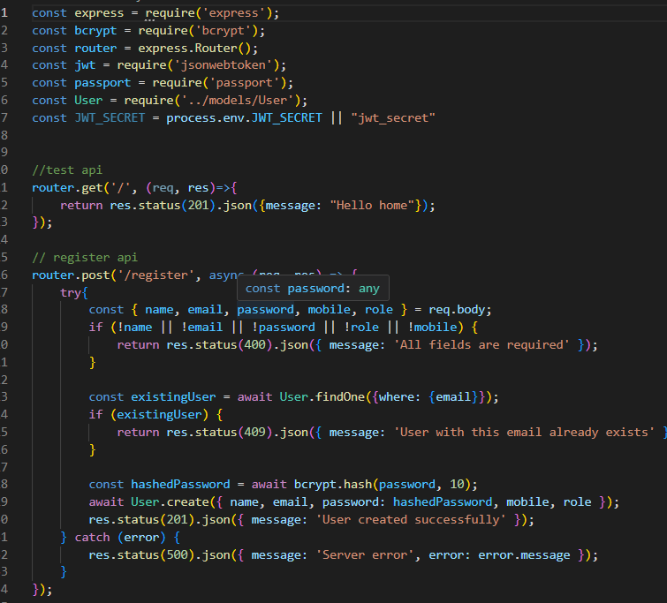

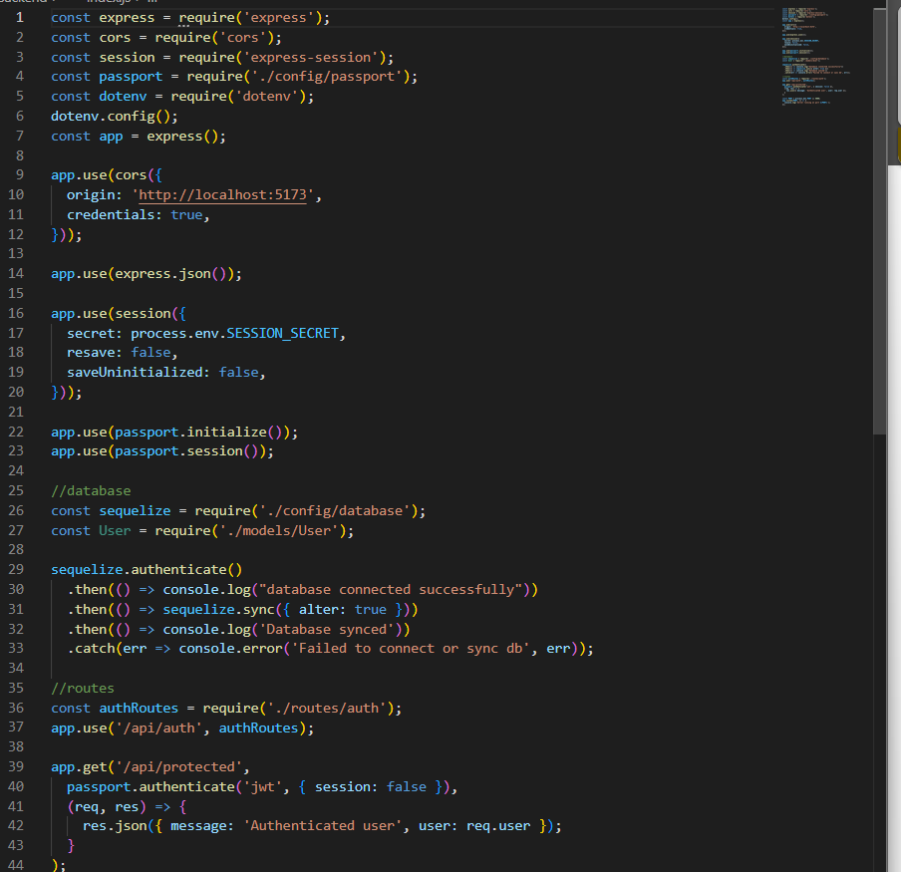

Appendix B: Database

Since this project primarily uses Local Storage, the following data structure was maintained

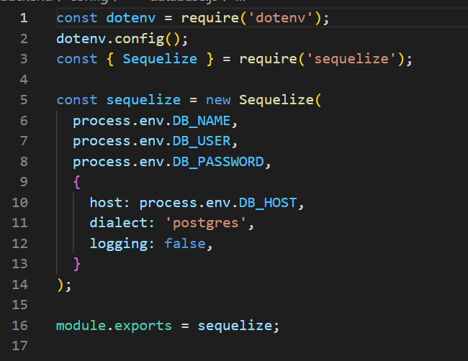

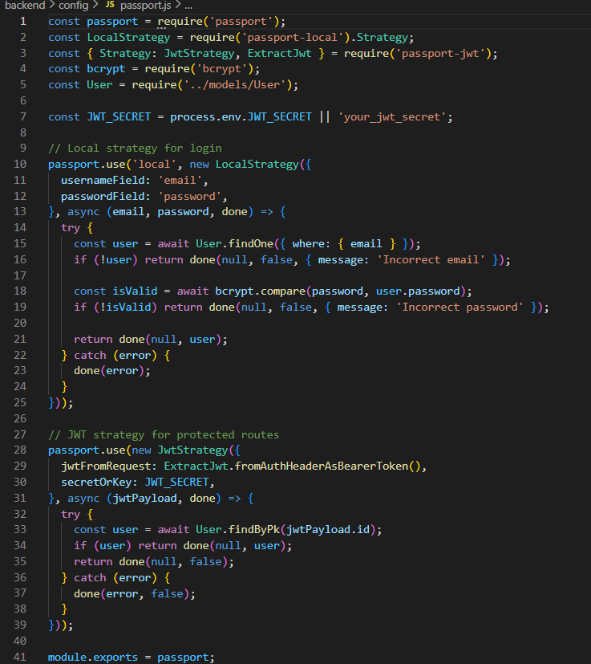

Appendix C: Project Workflow Diagram

(A simple diagram showing: User → Authentication → Project Creation → Repository Management → WebSocket Updates → Collaboration).
(You can create this using draw.io, MS PowerPoint, or Lucidchart and insert as an image in your report.)
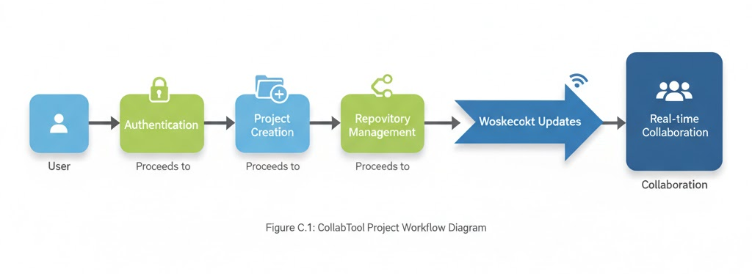

Appendix F: References

- React.js Documentation – https://react.dev
- Tailwind CSS – https://tailwindcss.com
- WebSocket API – https://developer.mozilla.org/en-US/docs/Web/API/WebSockets_API
- Lucide React Icons – https://lucide.dev

