Advanced Computer Networks – PCS223
Assignment 1
Name – Nitin kumar
Subgroup – CS3
Roll No. – 8025320064
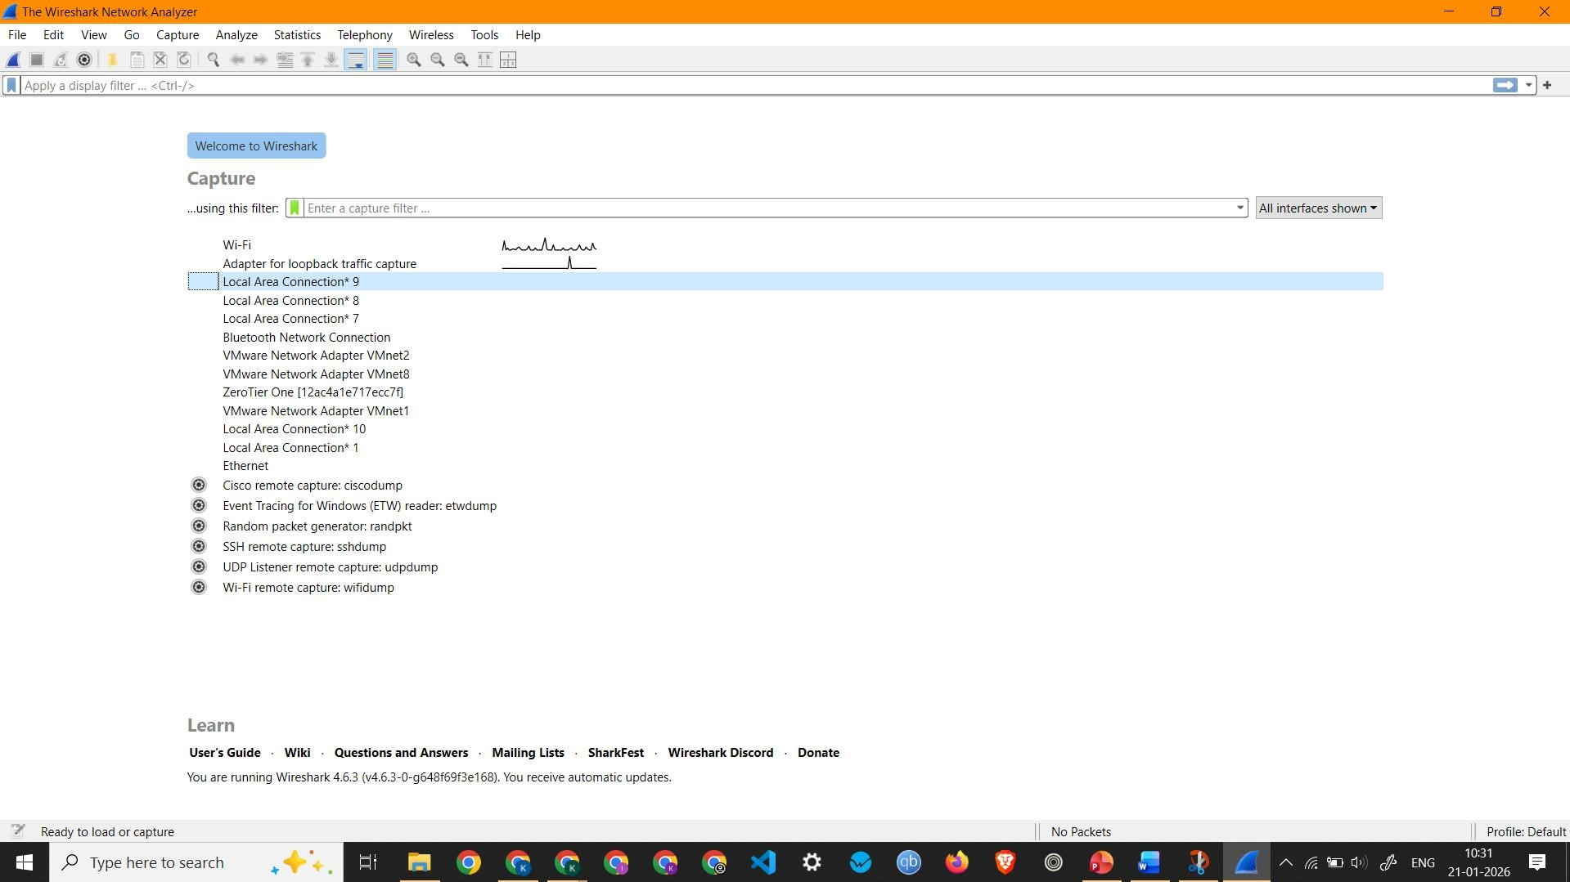
Screenshot showing Wireshark Home screen showing all interfaces and the active interface (Wi-Fi)
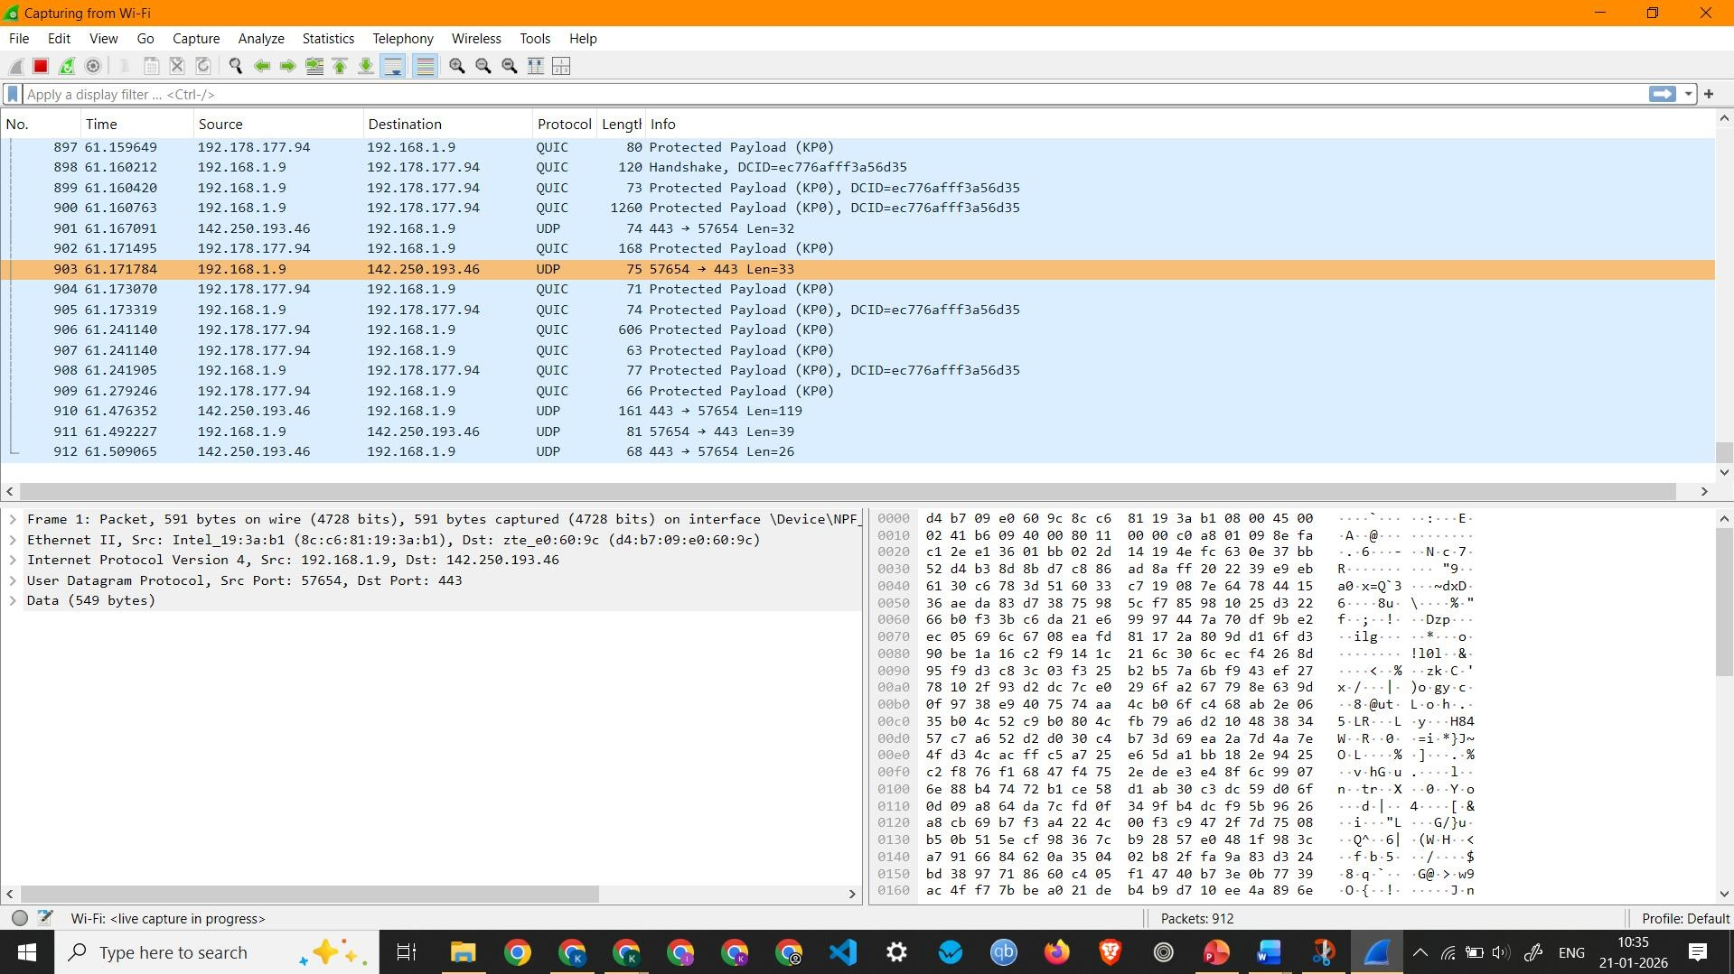
Showing Live Packet Capture on Wi-Fi
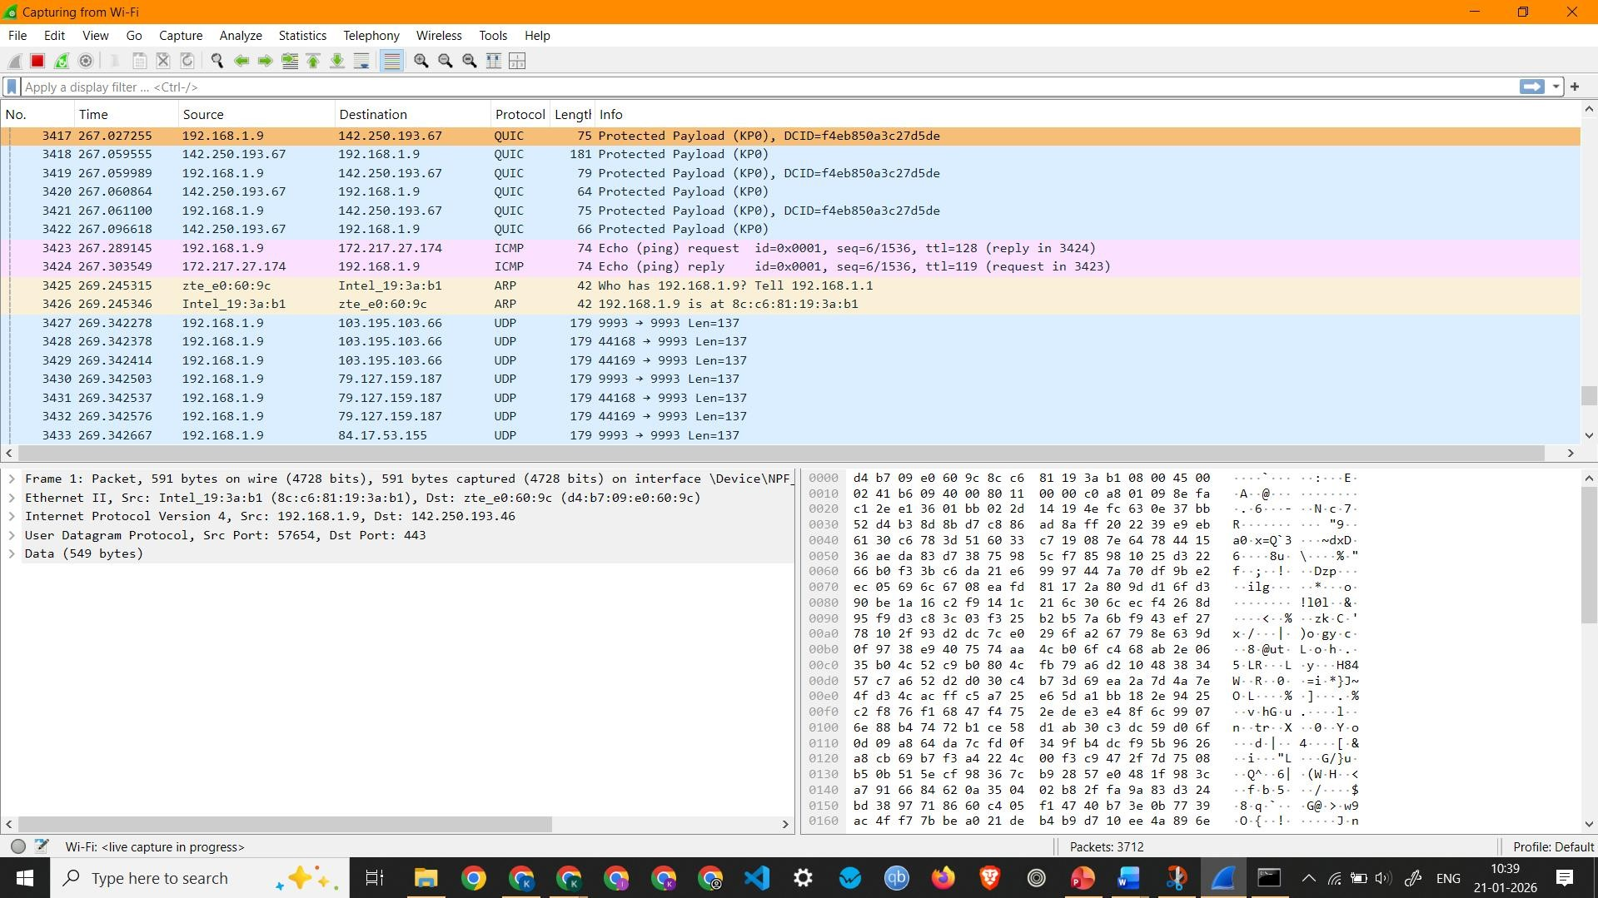
Screenshot showing ICMP Packets Captured by pinging google.com
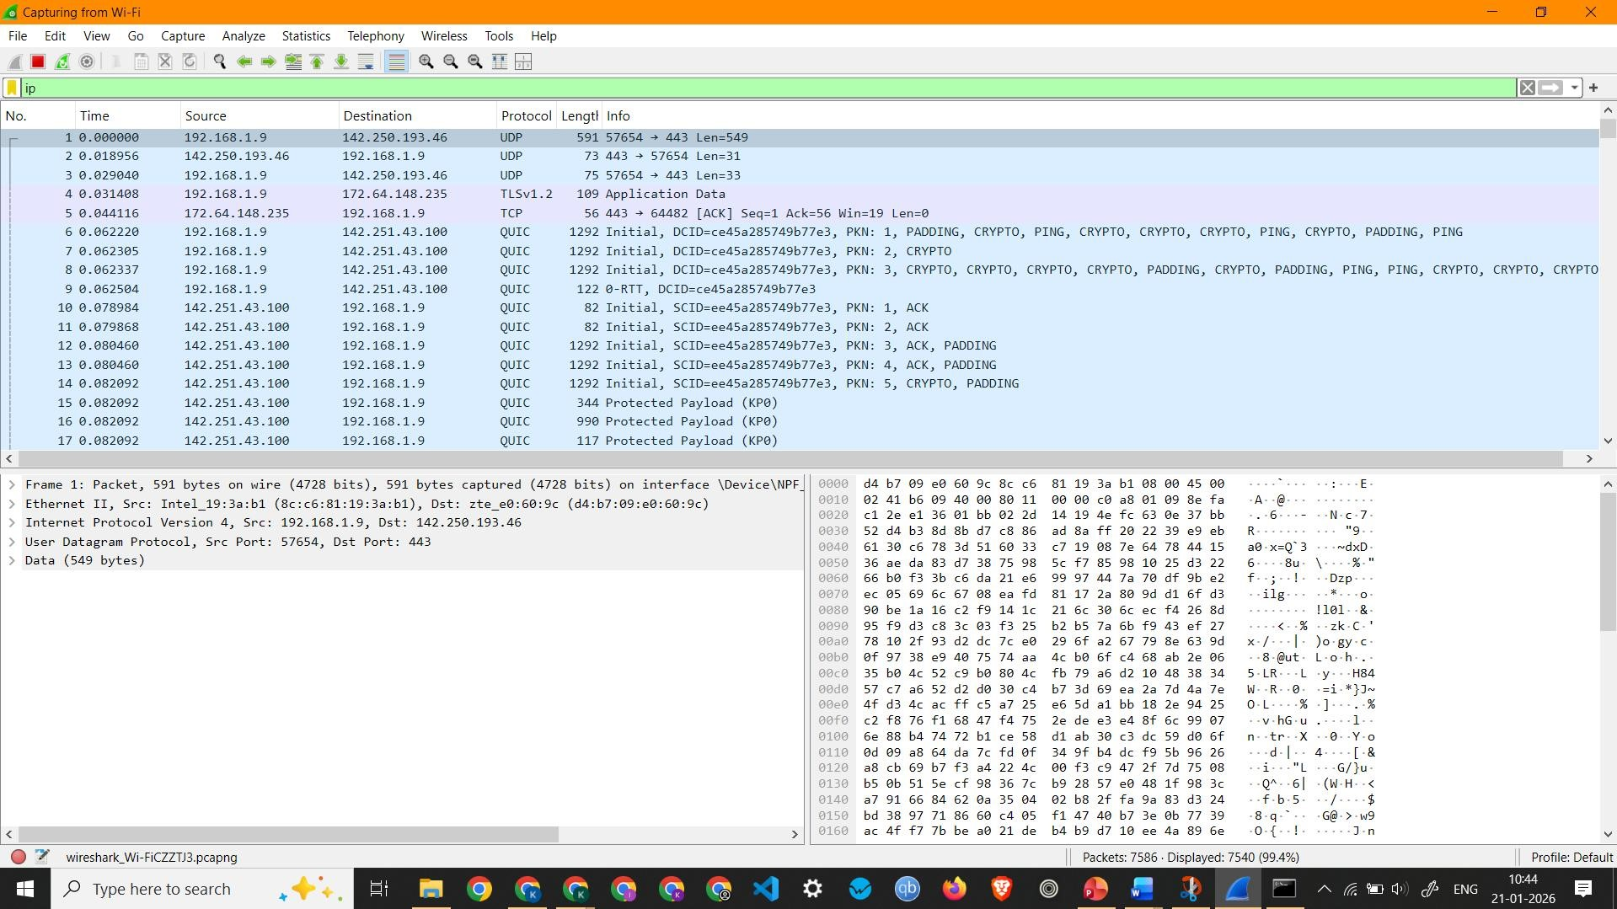
Screenshot showing IP Packets
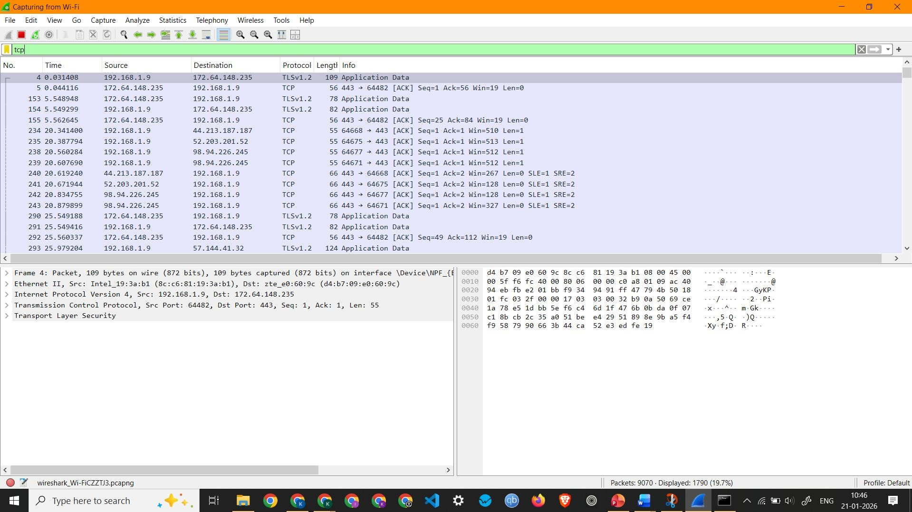
Screenshot showing TCP Packets Capture
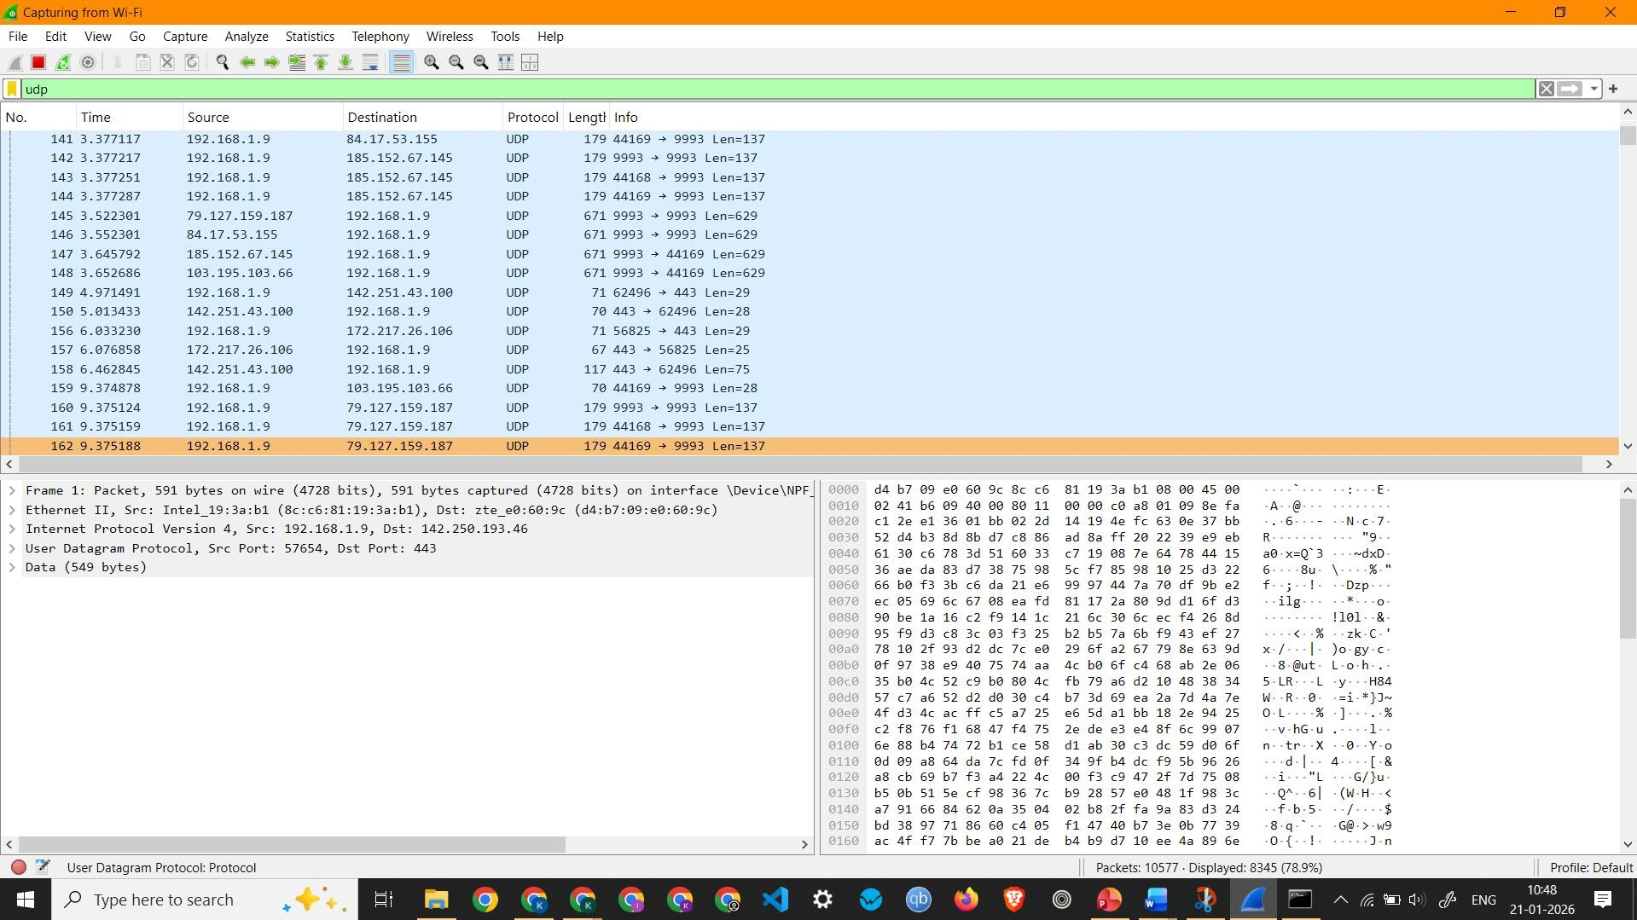
Screenshot showing UDP Packets Capture
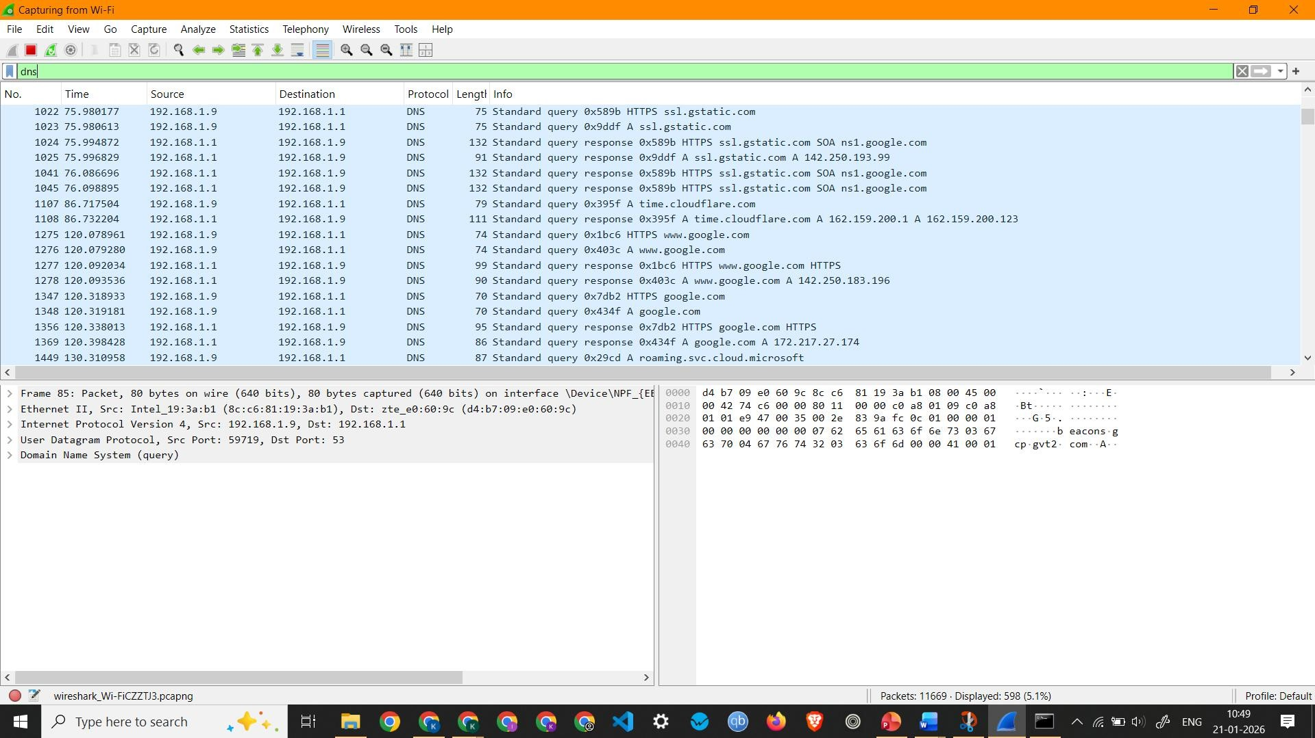
Screenshot showing DNS Packets Capture
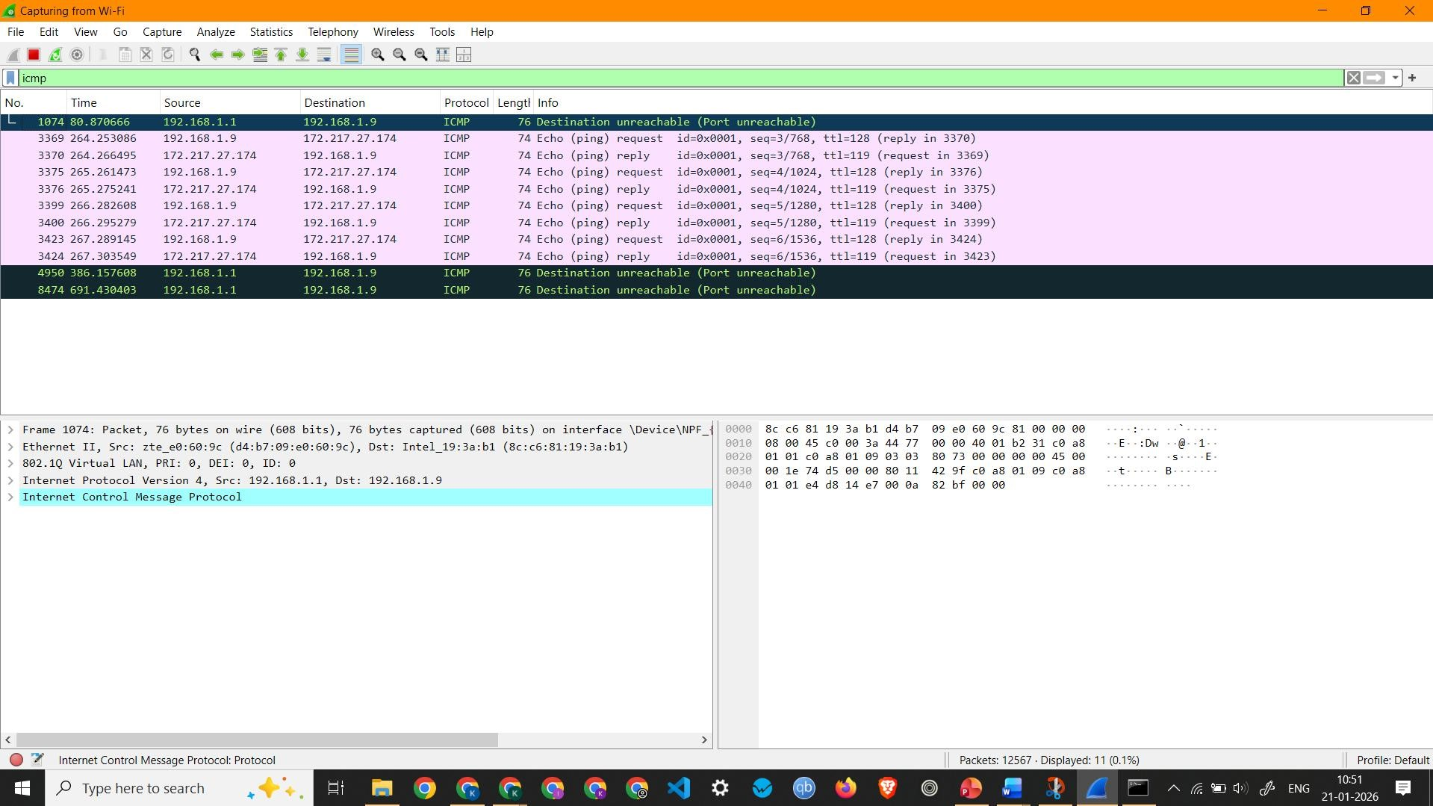
Screenshot showing ICMP Packets Capture
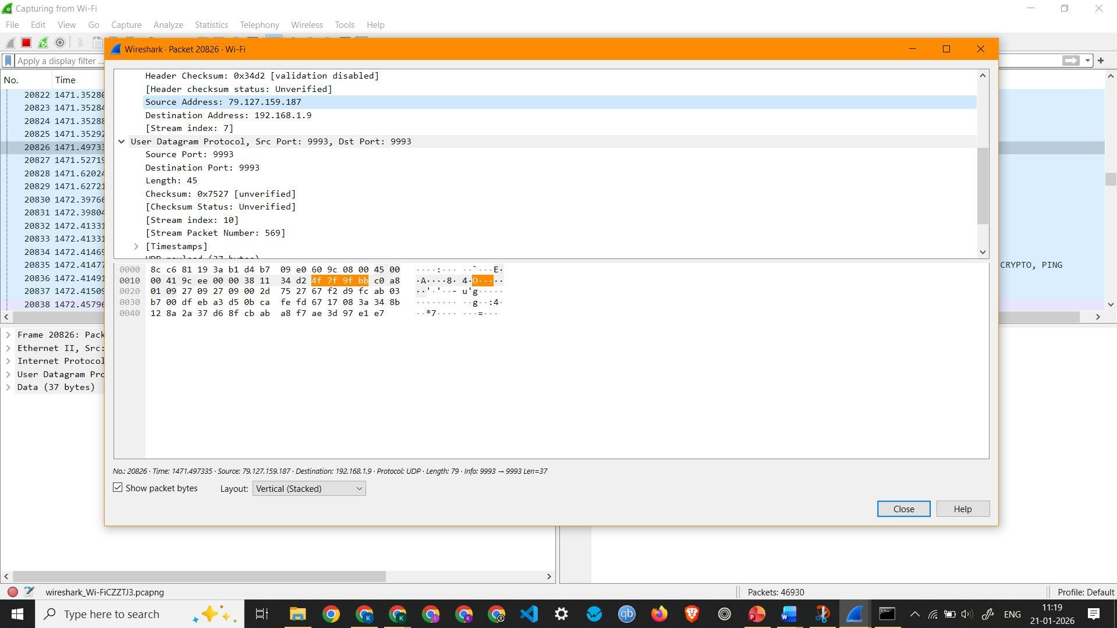
Screenshot showing details of a UDP Packet Observation: UDP Packet 20826 –
- Interface Used: Wi-Fi
- Protocols Observed: Ethernet II, Internet Protocol Version 4, and User Datagram Protocol
- Source IP Address: 79.127.159.187
- Destination IP Address: 192.168.1.9
- Packet Length: 79 Bytes

