Assignment 4

Configuration of DHCP Server on Router using Cisco Packet Tracer

Given Requirements
- DHCP pool name: xyz
- Network: 192.168.10.0/24
- DNS Server: 1.2.3.4
- Lease time: 3 hours
- Router should not respond to BOOTP
- Clients should obtain IP automatically

Topology Description
A router is connected to a switch, and two PCs are connected to the switch.
The router acts as a DHCP server, assigning IP addresses to the PCs.

Connections
- Router → Switch (Straight cable)
- PC1 → Switch (Straight cable)
- PC2 → Switch (Straight cable)

IP Addressing Plan
Device | IP Address
Router | 192.168.10.1
PC1 | DHCP
PC2 | DHCP

Configuration Steps

Step 1: Configure Router Interface
enable
conf t
interface g0/0
ip address 192.168.10.1 255.255.255.0
no shutdown
exit

Step 2: Configure DHCP Server
ip dhcp excluded-address 192.168.10.1
ip dhcp pool xyz
network 192.168.10.0 255.255.255.0
default-router 192.168.10.1
dns-server 1.2.3.4
👉 (Note: Lease command may not work in Packet Tracer, but theoretically it is 3 hours)

Step 3: Configure Clients
- Go to PC → Desktop → IP Configuration
- Select DHCP

Verification

Check IP on PC
ipconfig

Test Connectivity
ping 192.168.10.1

Check DHCP Binding on Router
show ip dhcp binding

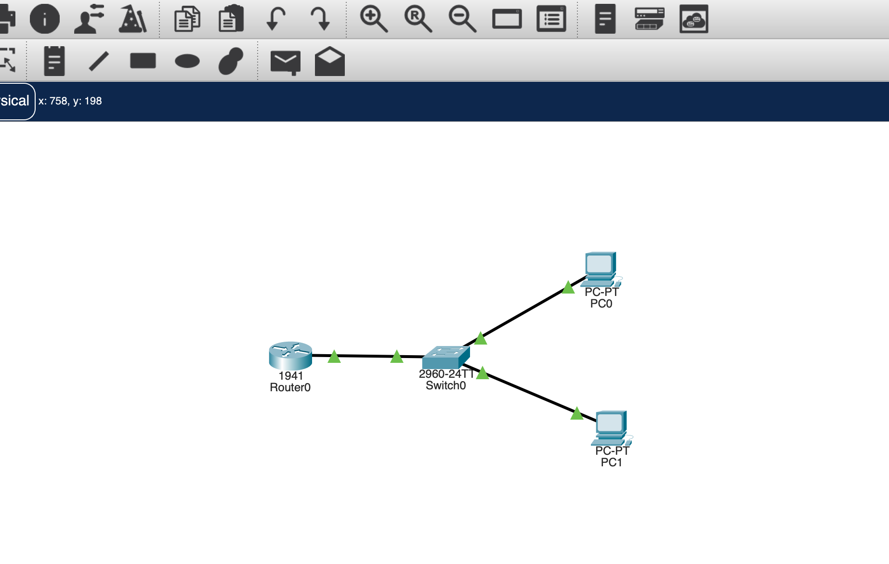
Topology

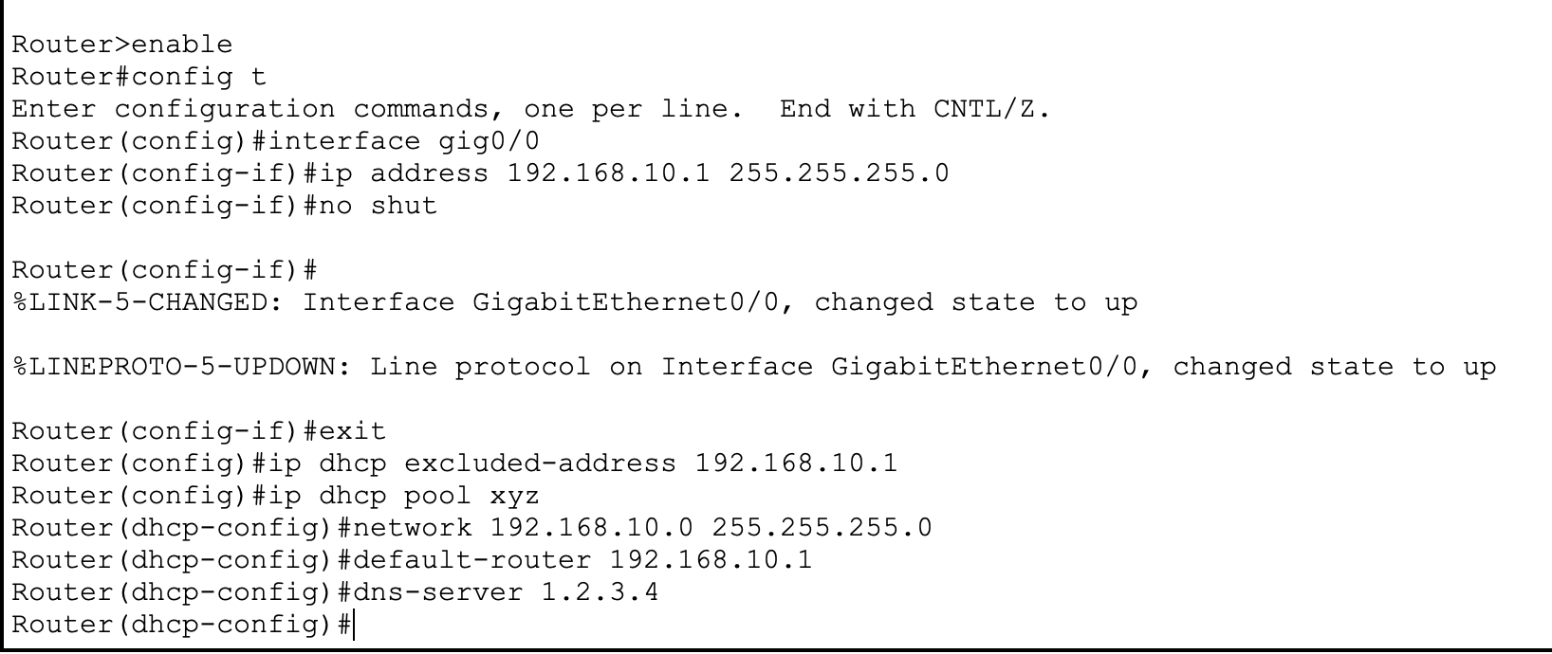
Commands to setup dhcp

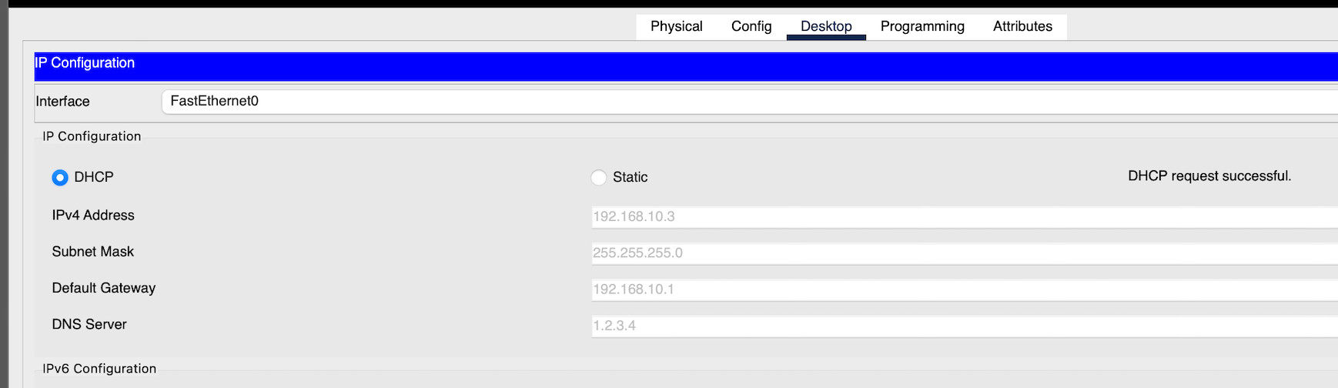
Automatically assigning the ip address using dhcp.
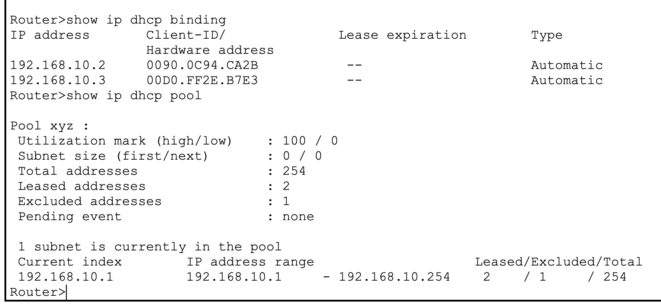

Checking dhcp binding and dhcp pool

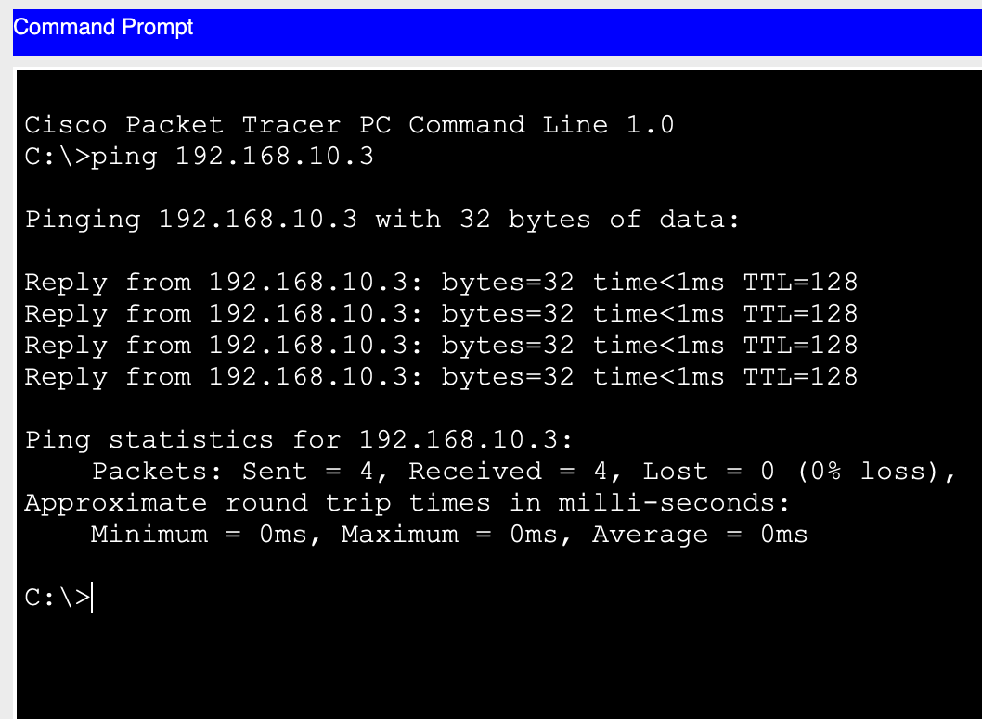

Pinging from one pc to another.

