Assignment 5

Ques 1:

STEP 0: What you are building
👉 2 networks:
- Left: 192.168.1.0/24
- Right: 172.16.0.0/16
- Connected using 2 routers via serial cable

STEP 1: Add Components

🎯 What to drag
From bottom panel:
- 2 Routers → (2811)
- 2 Switches → (2960)
- 2 PCs
👉 What you will see:
- Devices appear in workspace
- Names like: Router0, Router1, PC0, PC1

STEP 2: Connections (VERY IMPORTANT)

1️⃣ PC1 → Switch1
- Click ⚡ (Connections)
- Select Copper Straight
- Click:
  - PC1 → FastEthernet0
  - Switch1 → Fa0/1
👉 What you see:
- Cable appears
- Orange → Green light (after few seconds)

2️⃣ Switch1 → Router1
- Straight cable
- Switch1 Fa0/2 → Router1 Fa0/0

3️⃣ PC2 → Switch2
- Straight cable
- PC2 Fa0 → Switch2 Fa0/1

4️⃣ Switch2 → Router2
- Straight cable
- Switch2 Fa0/2 → Router2 Fa0/0

5️⃣ Router1 ↔ Router2 (MOST IMPORTANT)
- Select Serial DCE cable
- Click:
  - Router1 → Serial1/0
  - Router2 → Serial1/0
👉 What you see:
- One side shows clock icon ⏰ (DCE)

STEP 3: Configure Router R1
👉 Click Router1 → CLI
👉 You will see:
Would you like to enter initial configuration dialog? [yes/no]
👉 Type:
no

Enter commands:
enable
conf t
interface fa0/0
ip address 192.168.1.1 255.255.255.0
no shutdown
exit
👉 What you see:
%LINK-5-CHANGED: Interface FastEthernet0/0, changed state to up

Serial config:
interface s1/0
ip address 10.0.0.1 255.255.255.252
clock rate 64000
no shutdown
exit
👉 What you see:
- Interface becomes up

STEP 4: Configure Router R2
👉 Same process:
enable
conf t
interface s1/0
ip address 10.0.0.2 255.255.255.252
no shutdown
exit
interface fa0/0
ip address 172.16.0.1 255.255.0.0
no shutdown
exit

STEP 5: Verify Interfaces
show ip interface brief

👉 What you see:
Fa0/0 up up
Serial1/0 up up
✔ If not → check cables or no shutdown

STEP 6: Check Routing Table (Before)
show ip route
👉 You will see:
- Only directly connected networks

STEP 7: Configure Static Routing

On R1:
ip route 172.16.0.0 255.255.0.0 10.0.0.2
👉 Meaning:
- To reach 172 network → go via R2

On R2:
ip route 192.168.1.0 255.255.255.0 10.0.0.1

STEP 8: Verify Static Route
show ip route
👉 What you see:
S 172.16.0.0 [1/0] via 10.0.0.2
✔ S = Static route

STEP 9: Configure PCs

PC1:
- Desktop → IP Configuration
Fill:
- IP: 192.168.1.100
- Mask: 255.255.255.0
- Gateway: 192.168.1.1

PC2:
- IP: 172.16.0.100
- Mask: 255.255.0.0
- Gateway: 172.16.0.1

👉 What you see:
- No error
- IP shown in fields

STEP 10: TEST (MOST IMPORTANT)

From PC1:
ping 172.16.0.100
👉 First few:
Request timed out
👉 Then:
Reply from 172.16.0.100
✔ Means working

Q.1 Objective: Configure Static Route in Cisco packet tracer

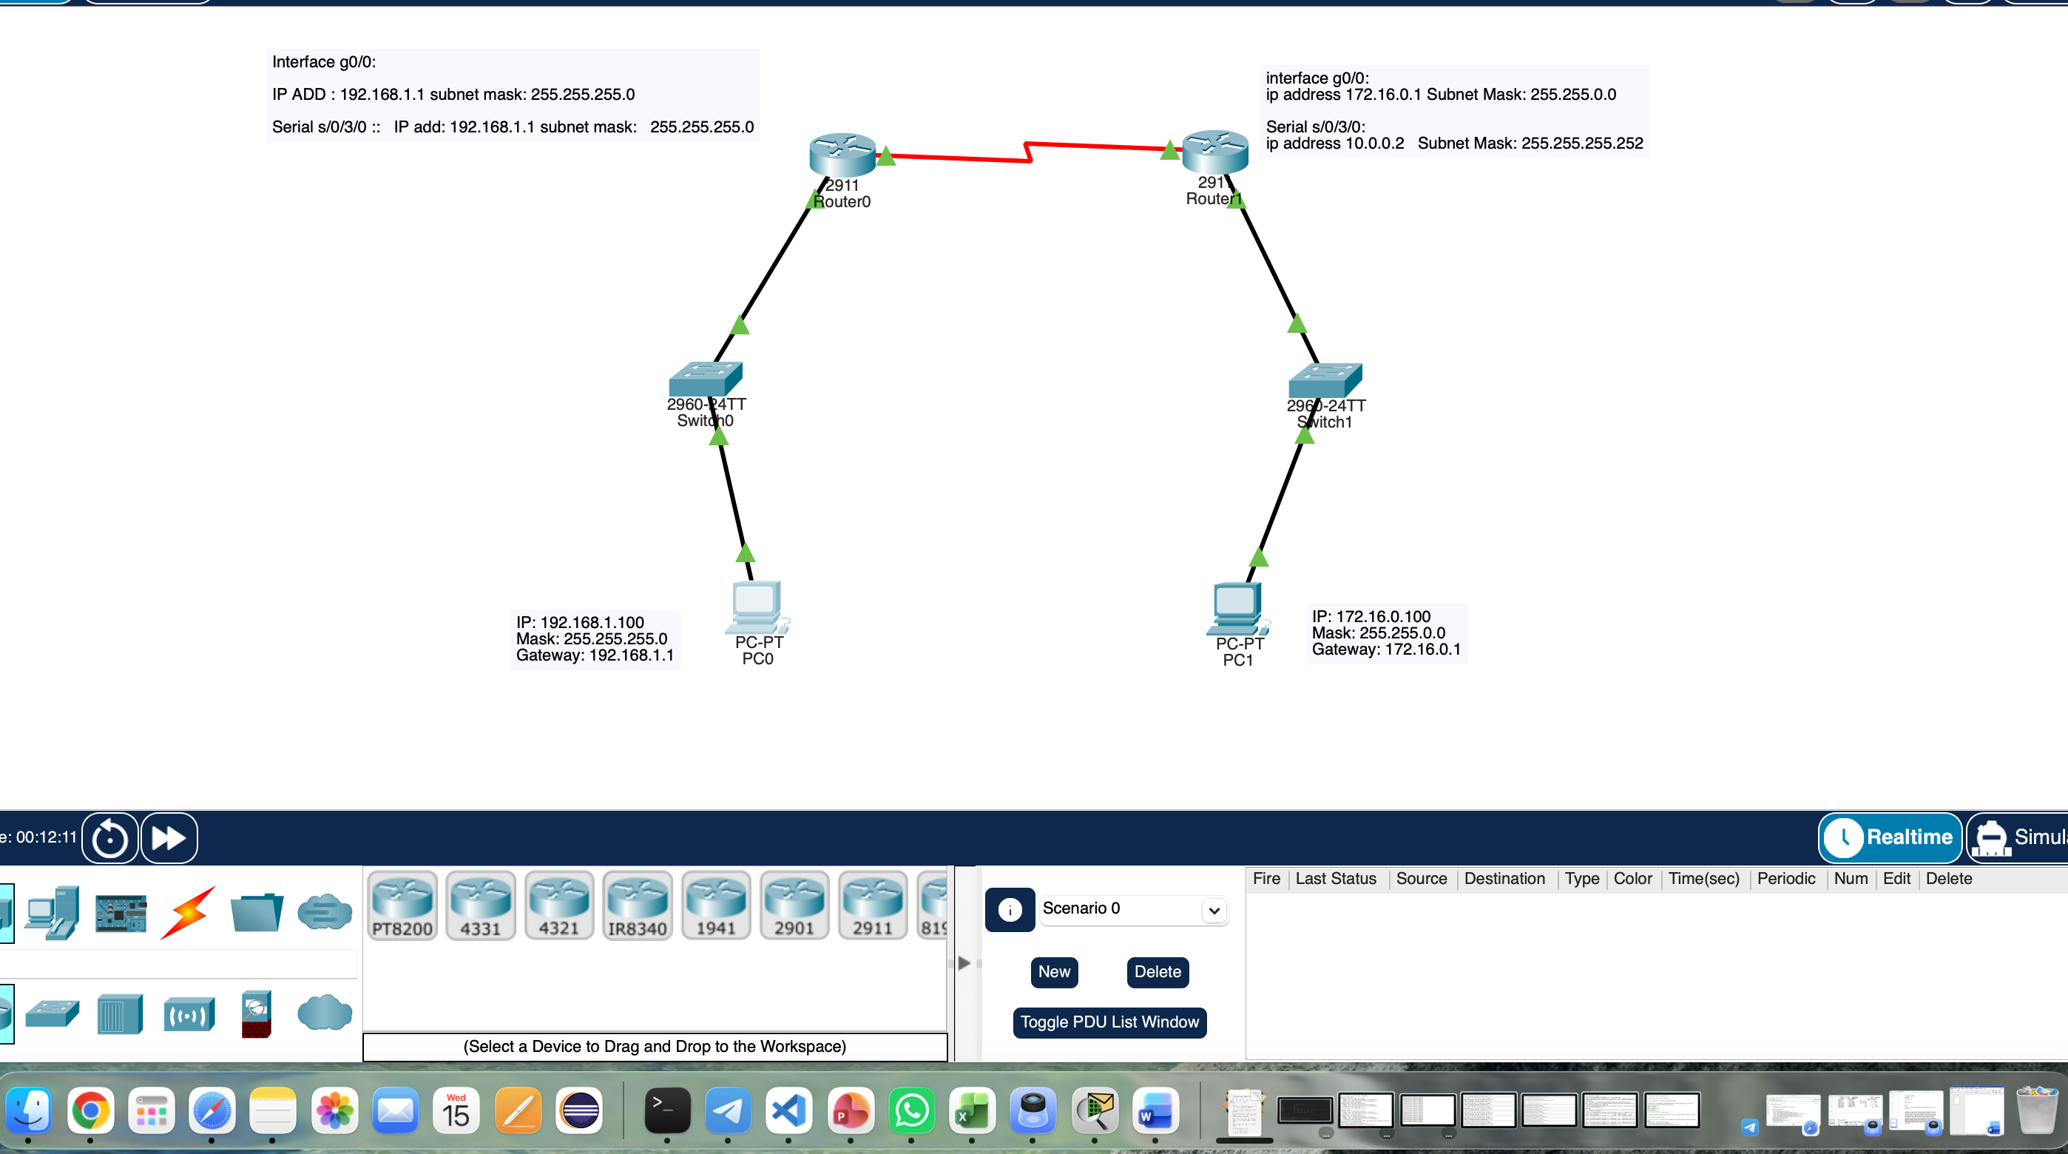
Topology

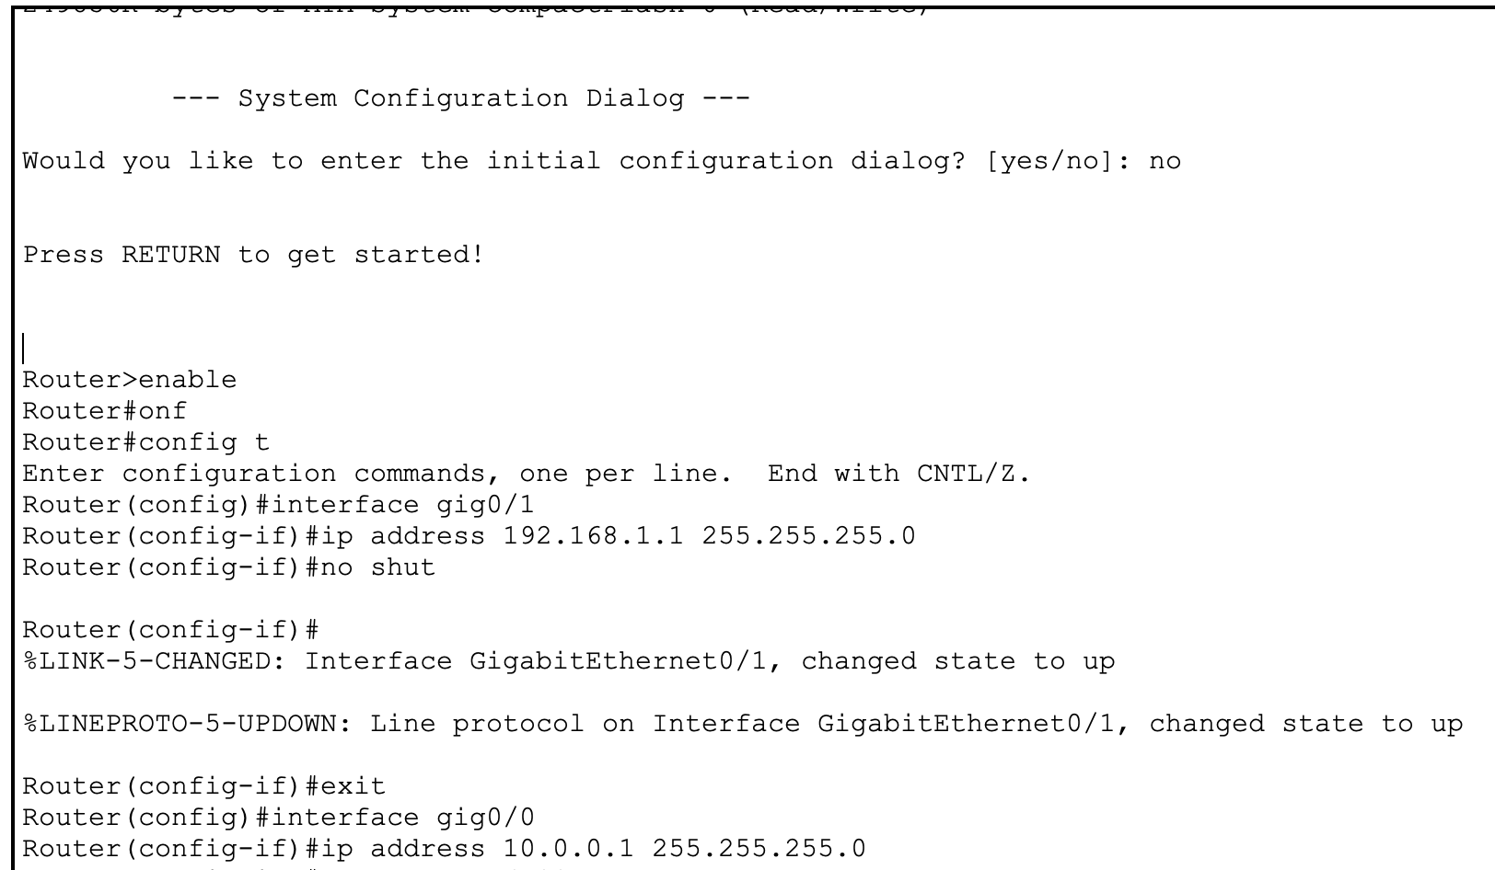
Router configurations

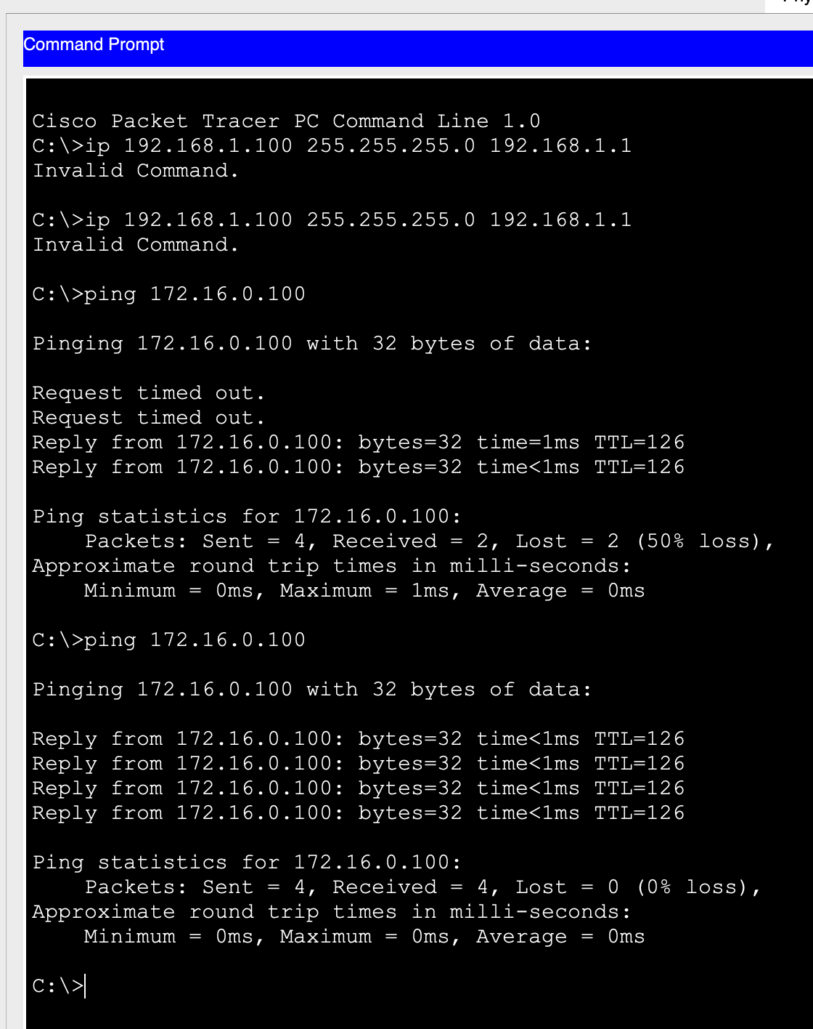

Pinging pc1 to pc2

Q2
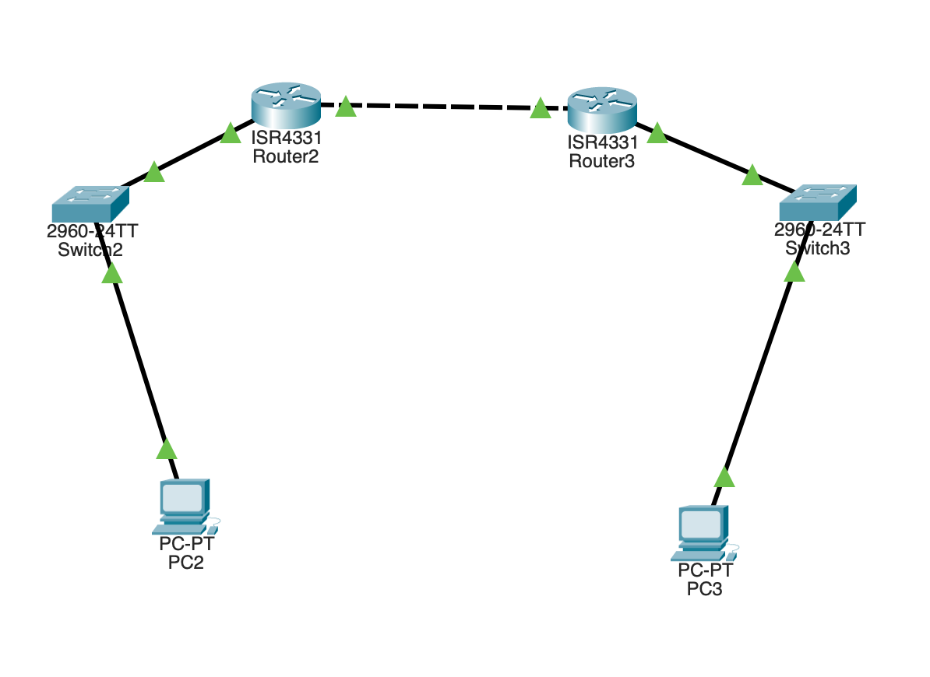
Router 1 Commands
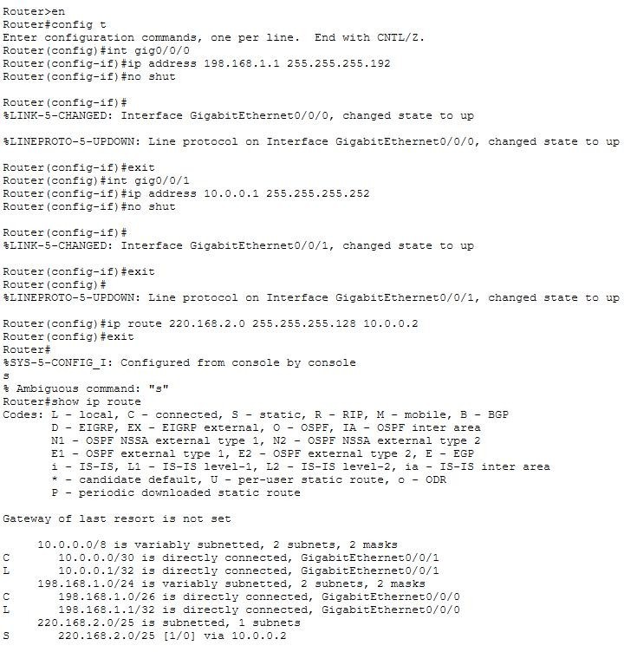

Router 2 Commands
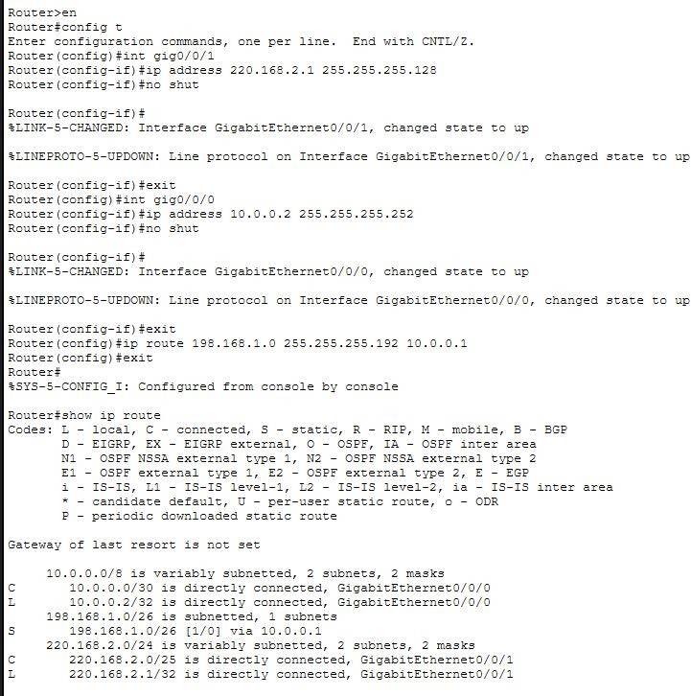

Ping from Pc 1 to Pc 2
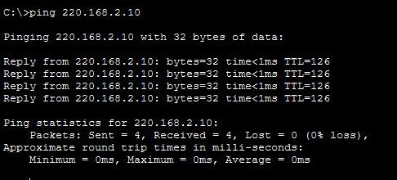

Question 3:
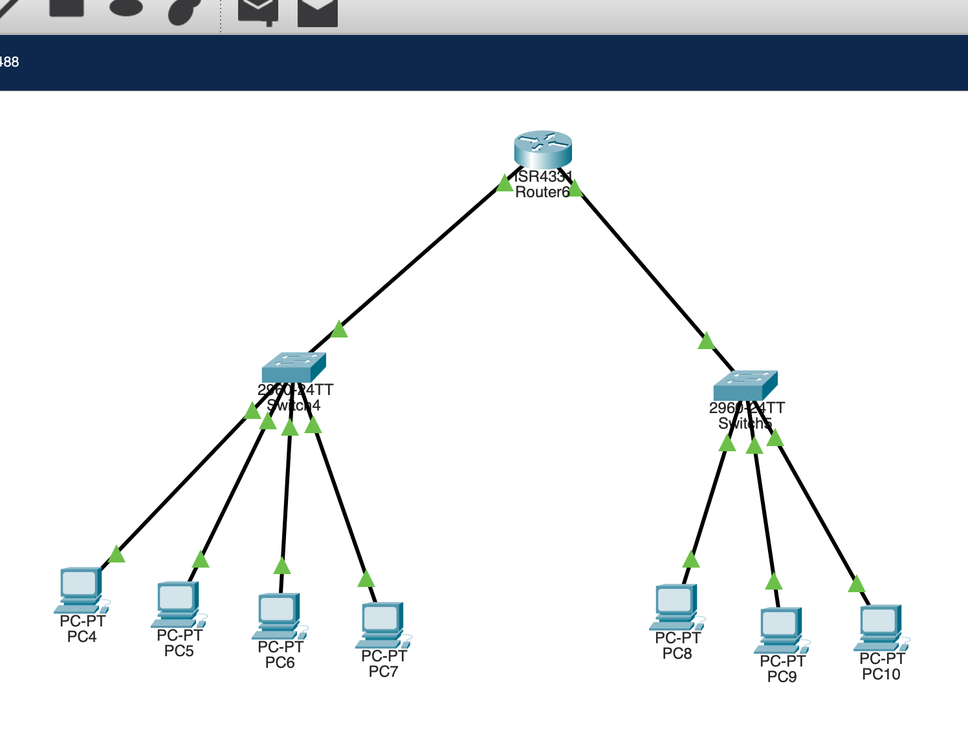

Router Commands
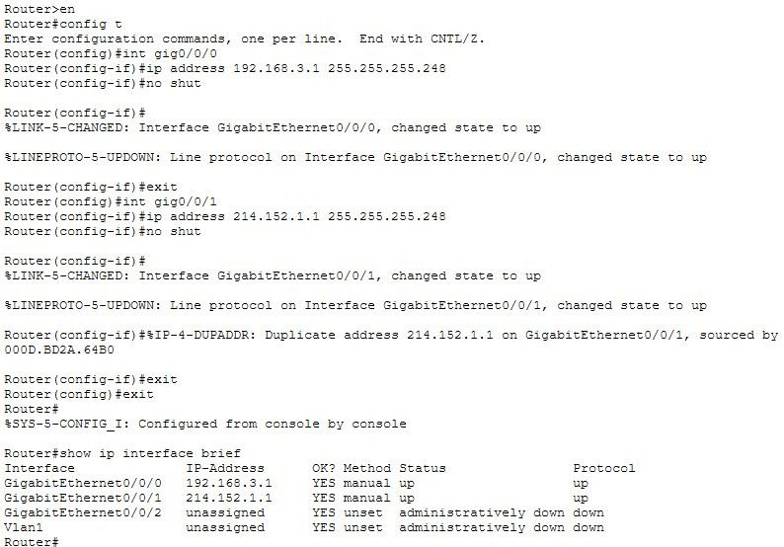

Ping from 1st network’s PC
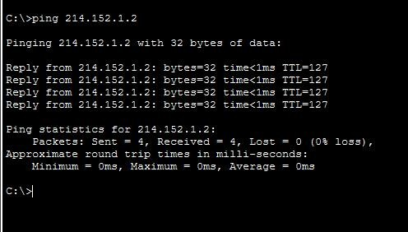

Ping from 2nd network’s PC
