ASSGNMENT 6: To configure and verify routing using RIP Version 2 and version 1 protocol in a network.

🟦 🔰 STEP 0: What you are building
👉 3 Routers:
- R1 (center)
- R2 (left LAN)
- R3 (right LAN)
👉 Networks:
- R1 ↔ R2 → 100.1.1.0
- R1 ↔ R3 → 20.1.1.0
- Left LAN → 172.16.2.0
- Right LAN → 10.2.2.0
👉 Goal:
✔ Use RIP v2 routing
✔ All networks should communicate

🟦 🔌 STEP 1: Add Components
👉 Drag:
- 3 Routers (2811 / 2911)
- 2 Switches (2960)
- 2 PCs
👉 What you see:
- Router0, Router1, Router2
- PC0, PC1

🟦 🔌 STEP 2: Connections (VERY IMPORTANT)

🔹 Left side
- PC1 → Switch1 (Straight)
- Switch1 → Router2 (g0/0)

🔹 Right side
- PC2 → Switch2 (Straight)
- Switch2 → Router3 (g0/0)

🔹 Router connections
- R1 ↔ R2 → Serial DCE
- R1 ↔ R3 → Serial DCE
👉 What you see:
- Red → turns Green after config
- One side shows ⏰ (DCE)

🟦 ⚙️ STEP 3: Configure Router R1
👉 CLI:
enable
conf t

Interface 1:
interface s0/0/0
ip address 100.1.1.2 255.255.255.0
clock rate 64000
no shutdown
👉 What you see:
%LINK-5-CHANGED

Interface 2:
interface s0/0/1
ip address 20.1.1.1 255.255.255.0
no shutdown

Enable RIP:
router rip
version 2
no auto-summary
network 100.1.1.0
network 20.1.1.0
👉 What happens:
✔ R1 starts sharing routes

🟦 ⚙️ STEP 4: Configure Router R2
enable
conf t

Serial:
interface s0/0/0
ip address 100.1.1.1 255.255.255.0
no shutdown

LAN:
interface g0/0
ip address 172.16.2.1 255.255.0.0
no shutdown

RIP:
router rip
version 2
no auto-summary
network 100.1.1.0
network 172.16.0.0

🟦 ⚙️ STEP 5: Configure Router R3
enable
conf t

Serial:
interface s0/0/1
ip address 20.1.1.2 255.255.255.0
no shutdown

LAN:
interface g0/0
ip address 10.2.2.1 255.255.255.0
no shutdown

RIP:
router rip
version 2
no auto-summary
network 20.1.1.0
network 10.2.2.0

🟦 💻 STEP 6: Configure PCs

PC1:
- IP: 172.16.2.10
- Mask: 255.255.0.0
- Gateway: 172.16.2.1

PC2:
- IP: 10.2.2.20
- Mask: 255.255.255.0
- Gateway: 10.2.2.1

🟦 🔍 STEP 7: Verify Interfaces
show ip interface brief
👉 You should see:
up up

🟦 🔍 STEP 8: Verify RIP Routing
show ip route
👉 You will see:
R 172.16.0.0
R 10.2.2.0
✔ R = RIP learned route

🟦 📡 STEP 9: Test Connectivity

From PC1:
ping 10.2.2.20
👉 First few:
Request timed out
👉 Then:
Reply from 10.2.2.20
✔ Success

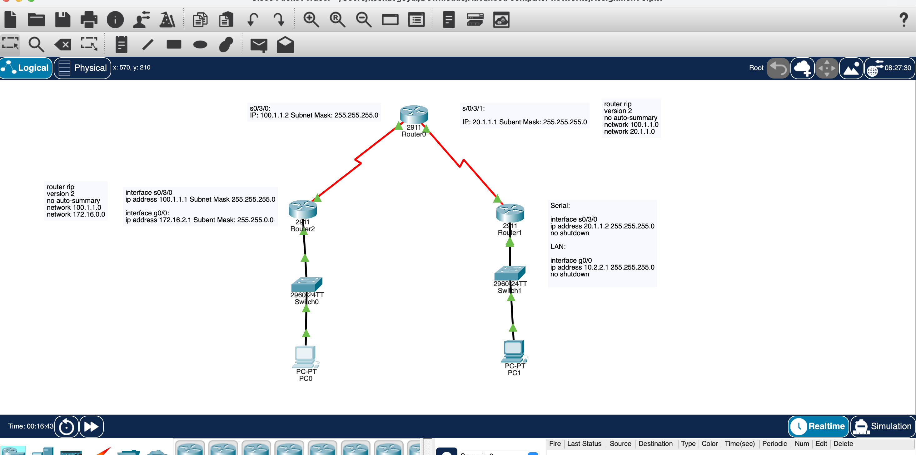
Topology
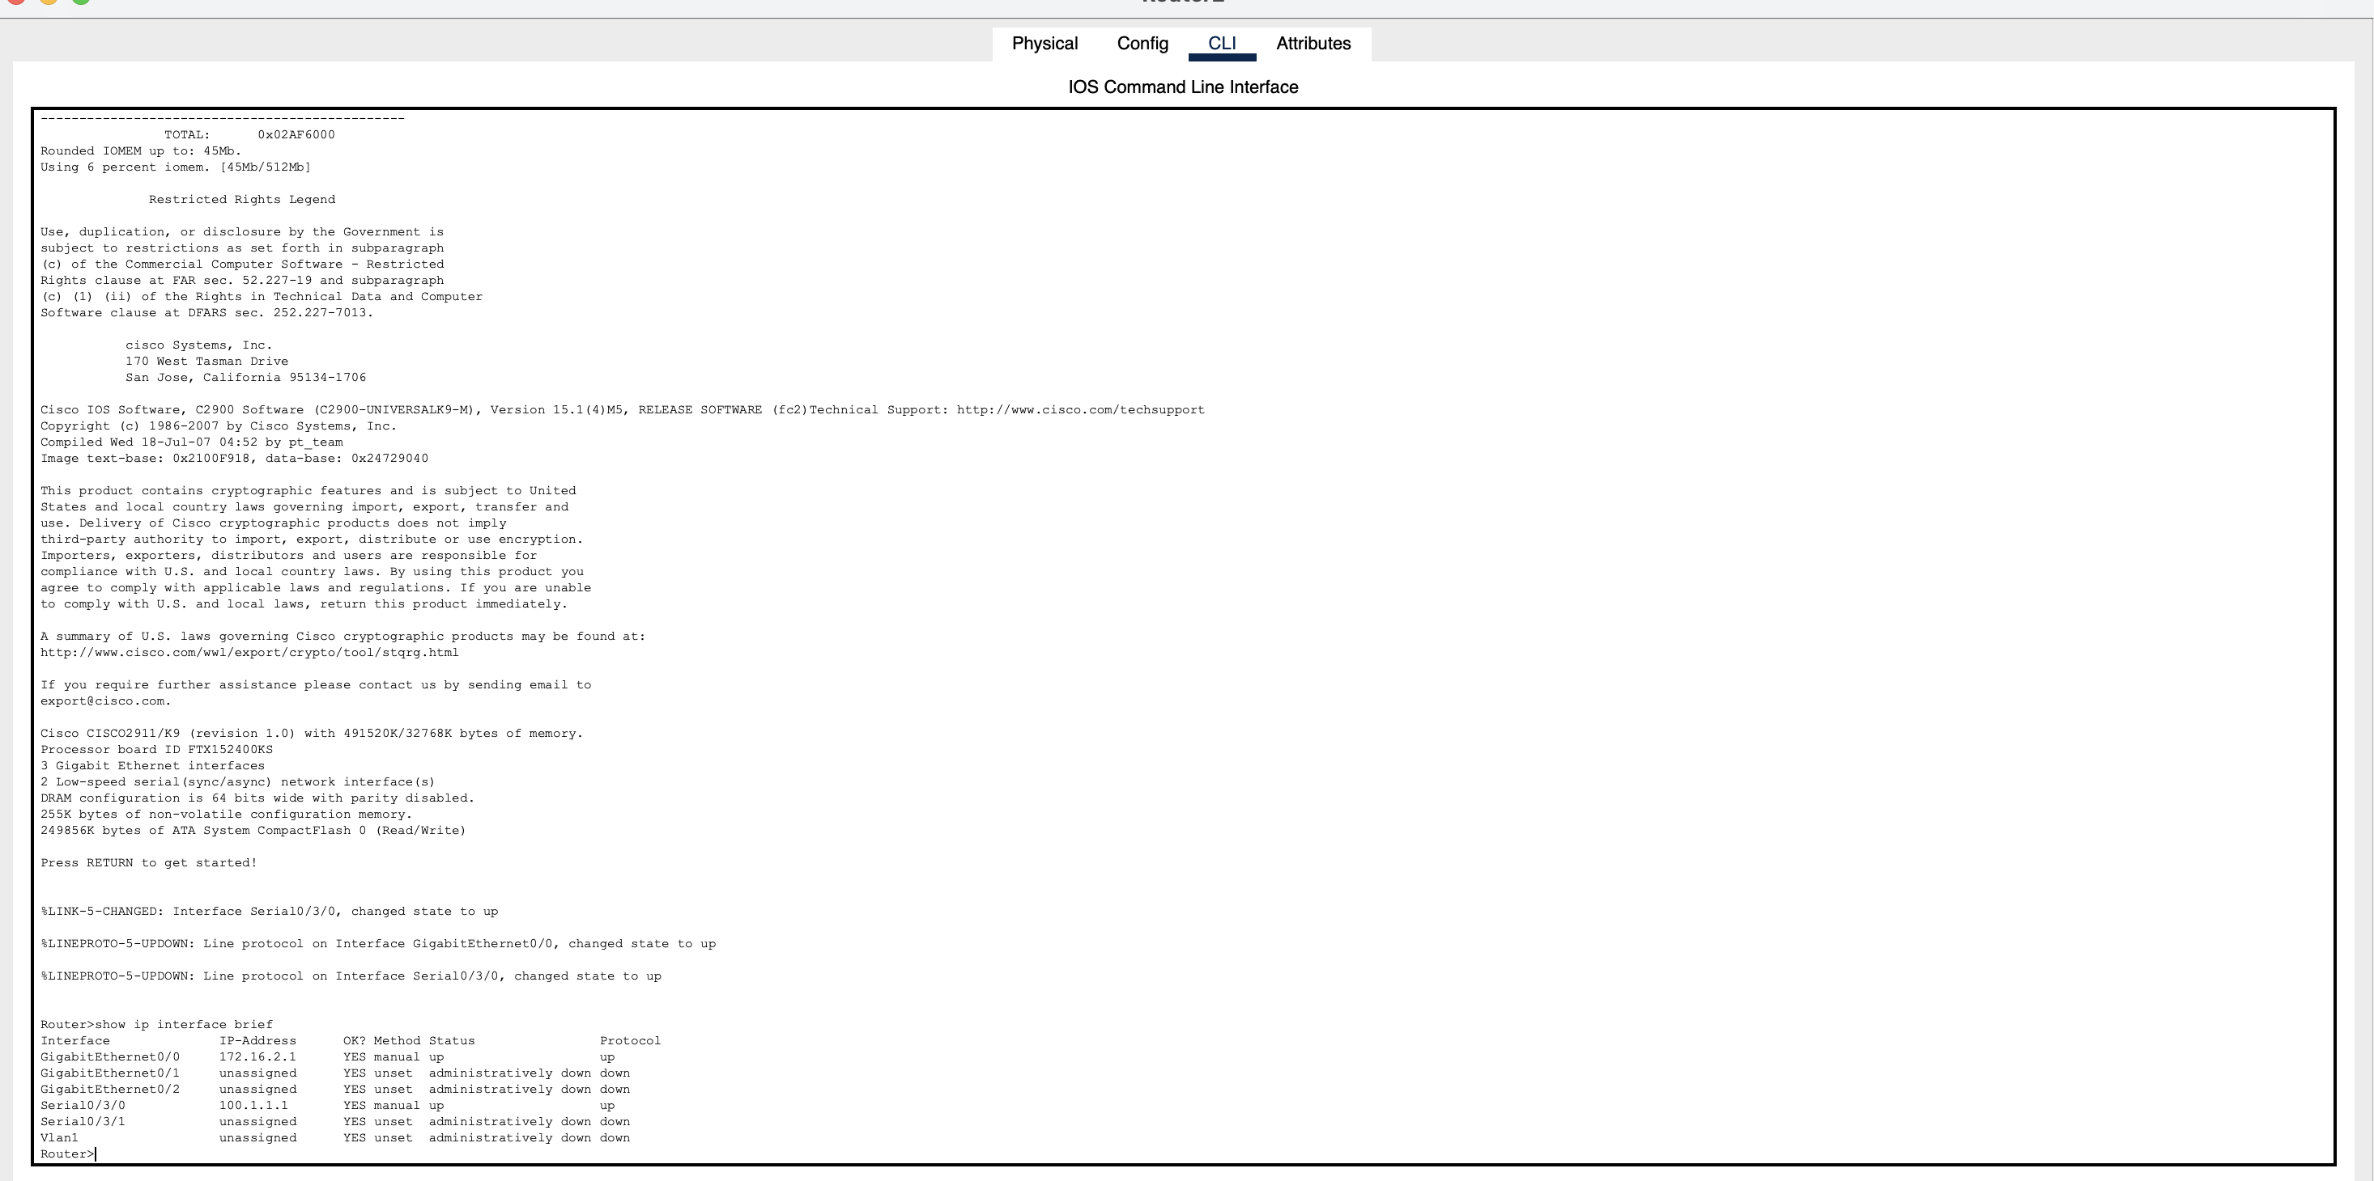
Comands

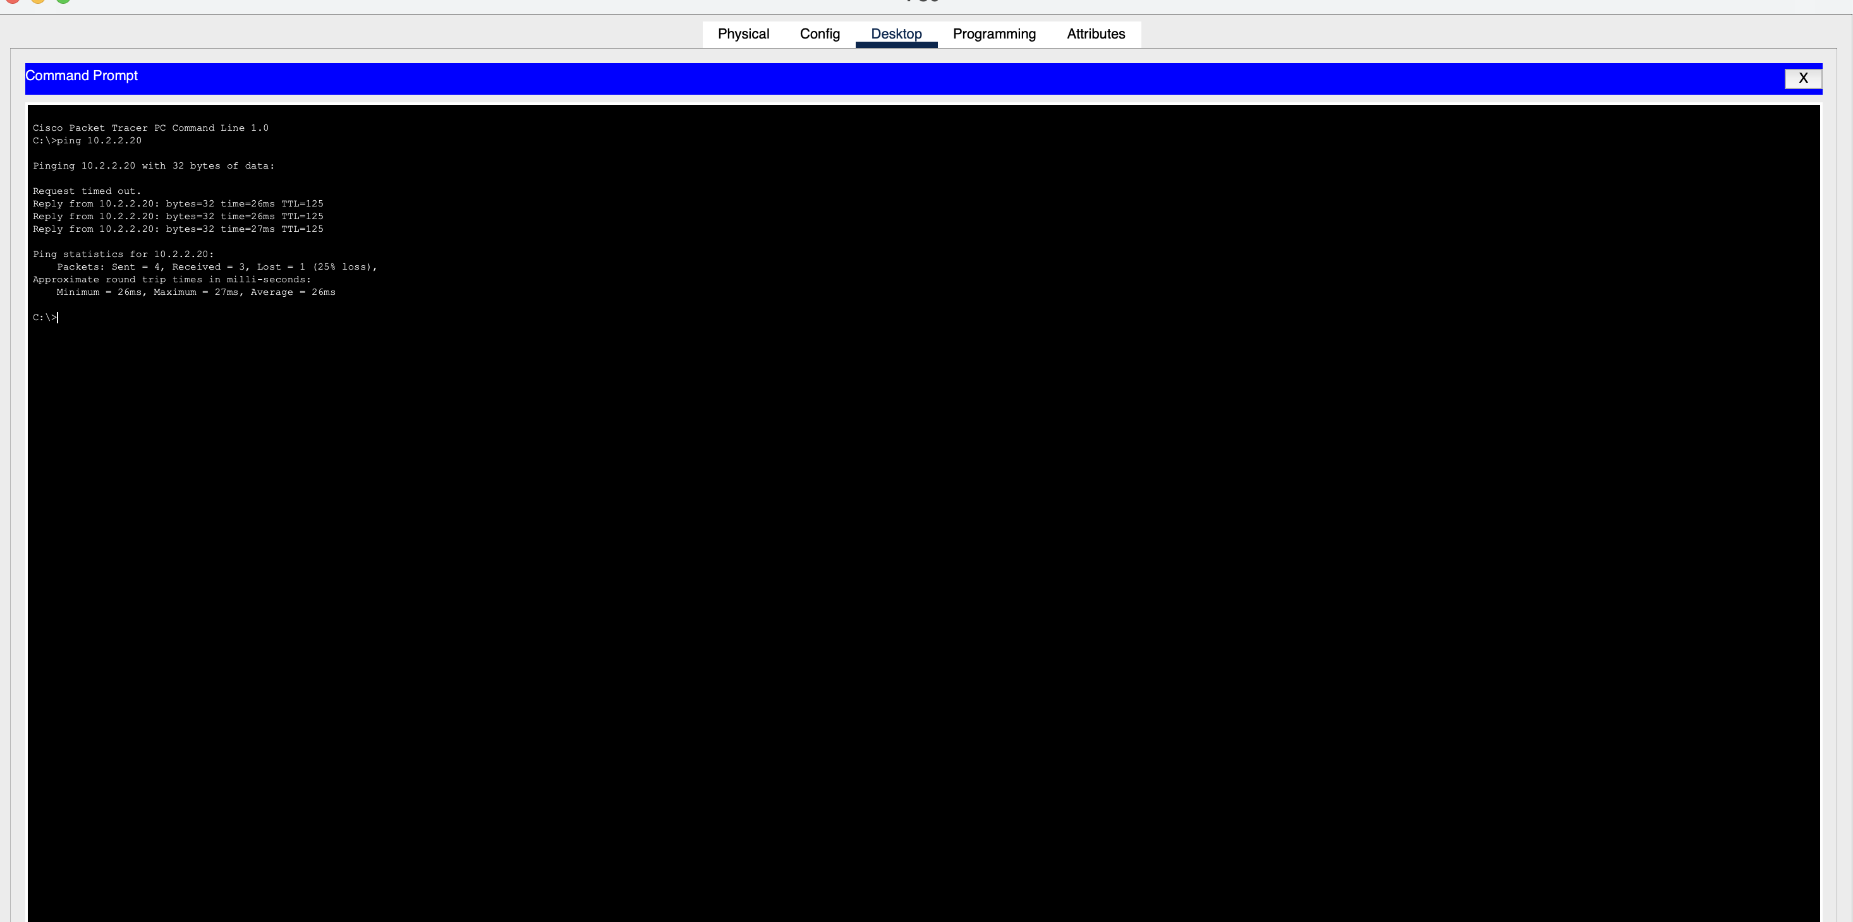
Pinging

