Assignment 8

Border Gateway Protocol

🧩 STEP 1: DEVICES REQUIRED
- 🟦 3 Routers → R1, R2, R3
- 🟩 3 Switches (optional but recommended)
- 💻 3 PCs (one per LAN)

🔌 STEP 2: CONNECTIONS (VERY IMPORTANT)

✅ 1. PC ↔ Switch
- Cable: Copper Straight-Through
PC → FastEthernet0
Switch → FastEthernet0/1

✅ 2. Switch ↔ Router
- Cable: Copper Straight-Through
Switch → Router G0/0

✅ 3. Router ↔ Router
👉 Use Copper Cross-Over OR Straight (auto works in PT)
R1 G0/1 ↔ R2 G0/0
R2 G0/1 ↔ R3 G0/0

🌐 STEP 3: IP ADDRESSING (FROM PDF)

🟦 R1
G0/0 → 192.168.1.1 /24
G0/1 → 10.0.0.1 /30

🟦 R2
G0/0 → 10.0.0.2 /30
G0/1 → 10.0.0.5 /30

🟦 R3
G0/0 → 10.0.0.6 /30
G0/1 → 192.168.3.1 /24

💻 PC CONFIGURATION

PC1 (R1 LAN)
IP: 192.168.1.2
Mask: 255.255.255.0
Gateway: 192.168.1.1

PC2 (R2 LAN – optional)
IP: 10.0.0.10
Mask: 255.255.255.252
Gateway: 10.0.0.2

PC3 (R3 LAN)
IP: 192.168.3.2
Mask: 255.255.255.0
Gateway: 192.168.3.1

⚙️ STEP 4: ROUTER CONFIGURATION

🟦 R1 CONFIG (AS 100)
enable
conf t
int g0/0
ip add 192.168.1.1 255.255.255.0
no shut
int g0/1
ip add 10.0.0.1 255.255.255.252
no shut

🟦 R2 CONFIG (AS 200)
enable
conf t
int g0/0
ip add 10.0.0.2 255.255.255.252
no shut
int g0/1
ip add 10.0.0.5 255.255.255.252
no shut

🟦 R3 CONFIG (AS 300)
enable
conf t
int g0/0
ip add 10.0.0.6 255.255.255.252
no shut
int g0/1
ip add 192.168.3.1 255.255.255.0
no shut

🌍 STEP 5: BGP CONFIGURATION
(From your PDF page 3)

🔹 R1 (AS 100)
router bgp 100
neighbor 10.0.0.2 remote-as 200
network 192.168.1.0 mask 255.255.255.0

🔹 R2 (AS 200)
router bgp 200
neighbor 10.0.0.1 remote-as 100
neighbor 10.0.0.6 remote-as 300
network 10.0.0.0 mask 255.255.255.252

🔹 R3 (AS 300)
router bgp 300
neighbor 10.0.0.5 remote-as 200
network 192.168.3.0 mask 255.255.255.0

✅ STEP 6: VERIFICATION

🔍 Check BGP neighbors
show ip bgp summary
✔ Should show Established

🔍 Check routes
show ip route
✔ Look for:
B 192.168.3.0
B 192.168.1.0

🔍 Ping test
From PC1:
ping 192.168.3.2
✔ Should work ✅

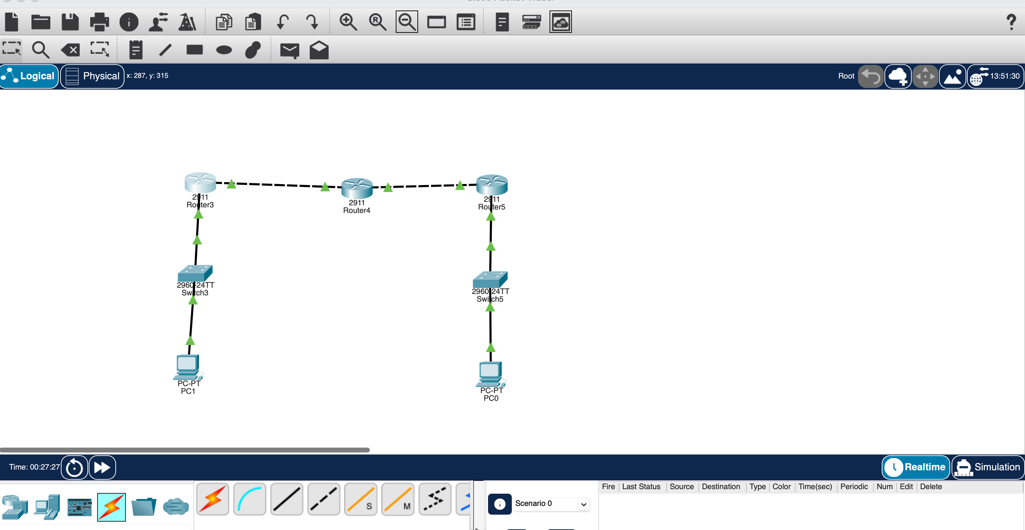

Topology

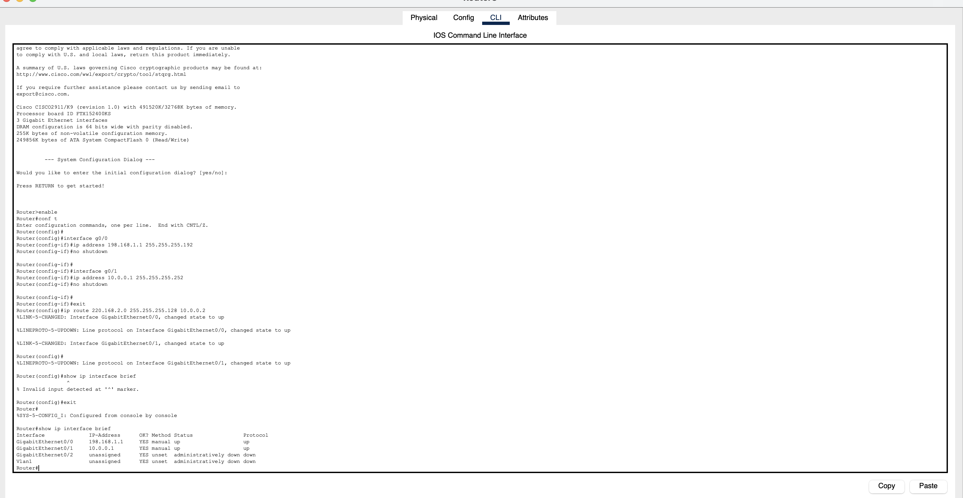
Commands

