SOP
Project Title: Offline 3D Industry Model Viewer with STL to GLB Conversion
Developer: Nitin C
Platform: Electron.js with Three.js and bundled Blender support
1. System Requirements
Item | Minimum Requirement
Operating System | Windows 10/11
RAM | 8 GB (recommended)
Disk Space | 3 GB free
Other Software | Node.js, VSCode, Blender (pre-bundled if packaged)

2. Software Downloads (One-Time Setup)
2.1 Download and Install Node.js
- Visit https://nodejs.org ( or I have attached the installer for node.js in /extras folder )
- Download the LTS (Long-Term Support) version.
- Run the installer and follow the on-screen instructions.
- After installation, verify by opening Command Prompt and typing:
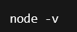
It should show a version like v18.17.1.
2.2 (Optional) Download VS Code
Visual Studio Code is helpful if you want to edit code or inspect files, but not mandatory.
- Visit https://code.visualstudio.com ( or I have attached the installer for vscode in /extras folder )
- Click Download for Windows and install it.
- After installation, right-click your project folder → choose "Open with Code".

3. Project Folder Structure
Your main folder will look like this:
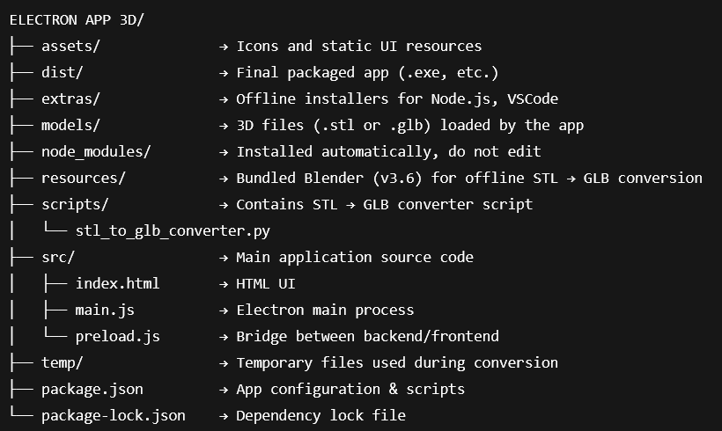
4. Running the App in Development Mode
Step-by-Step:
- Open Folder in Terminal
  - Shift + Right Click in the project folder → Select “Open PowerShell/Terminal window here”
- Install Project Dependencies
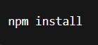

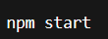

App window will open. Now you're ready to test models!
5. Adding & Viewing Models
To Add a .stl File:
- Copy your .stl file into the /models/ folder.
- Open the app and click "Open Model".
- Select your .stl file.
  - It will auto-convert to .glb
  - Load for viewing
  - Also saved in the same folder
To Add .glb File:
- Place the .glb model in /models/
- Use "Open Model" to select and view
6. Building a .exe Installer
- Run:
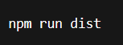

- Open /dist/
- You’ll find 3D Model Viewer Setup.exe (installer)
- Or win-unpacked/ (standalone app folder)
You can now copy to another offline PC.

7. Troubleshooting
Issue | Solution
.exe shows .dll not found | Don’t move just the .exe. Use installer or full folder
STL doesn't convert | Ensure Blender is installed or bundled properly
Terminal shows errors | Run npm install again
Model not loading | Check file format and rename if too long

8. How to Edit the Code Using Visual Studio Code (VS Code)

Step 1: Open the Project in VS Code
- Install VS Code using the file extras/VSCode-Setup.exe (if not already installed).
- After installation:
  - Go to the folder ELECTRON APP 3D
  - Right-click anywhere inside the folder
  - Select “Open with Code”
This will launch VS Code with your project opened.

Step 2: Understand the Main Files You’ll See
Once open in VS Code, look on the left sidebar (Explorer panel):

File / Folder | Purpose
main.js | Controls the Electron app's startup, window, menu & model conversion logic
preload.js | Connects the backend (main.js) with frontend (index.html)
index.html | The interface (UI) of the 3D Viewer you see on screen
scripts/stl_to_glb_converter.py | Python script used to convert .stl files into .glb using Blender
models/ | Folder containing .stl and .glb files for loading/viewing
package.json | File that defines the app’s configuration, commands, dependencies etc.

9. Contact for Support
Developer: Nitin C
Institute: VIT Chennai
For Support: cnitin2005@gmail.com

