**Wireframe and Mockup**

1. **Design the below like wireframe structure. Use your own creativity.**

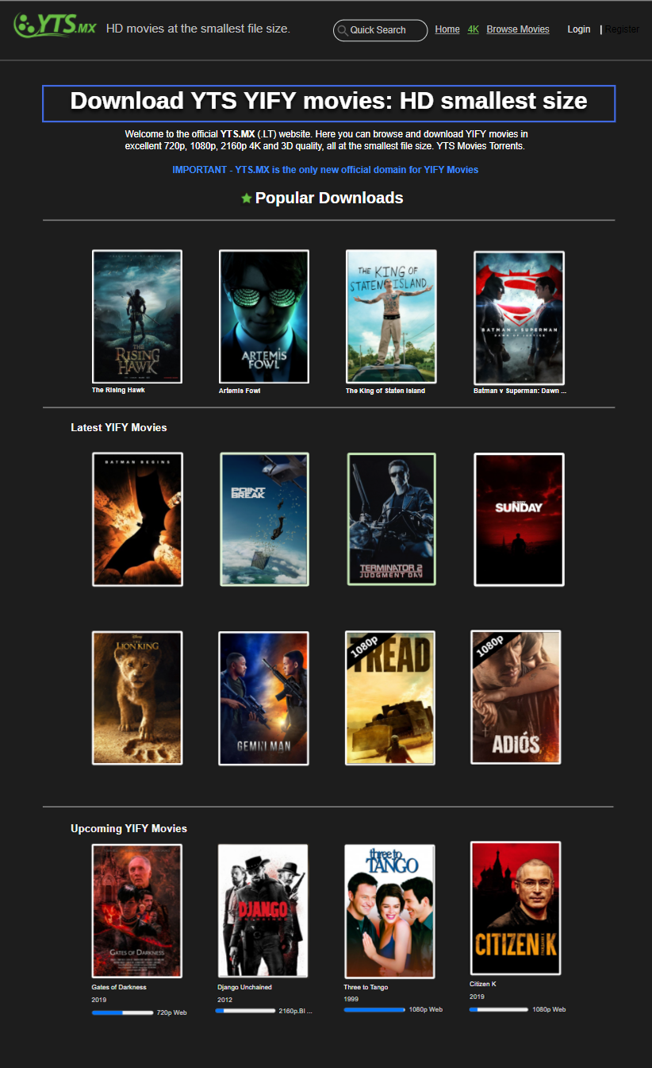

Link = *https://app.moqups.com/OVFBwGyJ97/edit/page/ad64222d5*

2. **Create a mockup design like your college website’s contact us page. Use your own creativity for this design.**

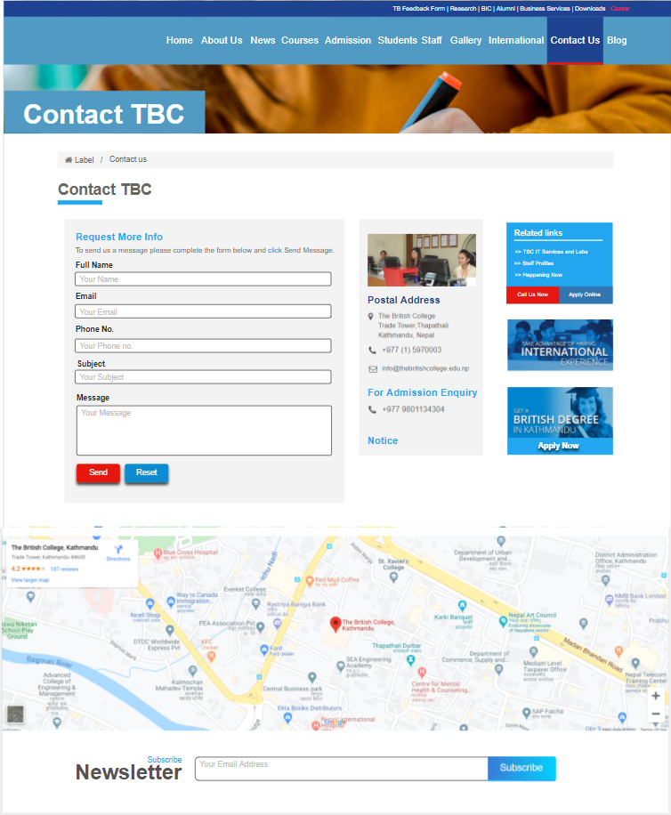

Link = *https://app.moqups.com/OVFBwGyJ97/edit/page/a33d8d677*