**Name: Nitin Jibhau Aher**

**Assignment No: 4**

**Array and Structure coding practice**

**Q1. Largest / Smallest Array Values**  
Write a program that lets the user enter ten values into an array. The program should then  
display the largest and smallest values stored in the array.

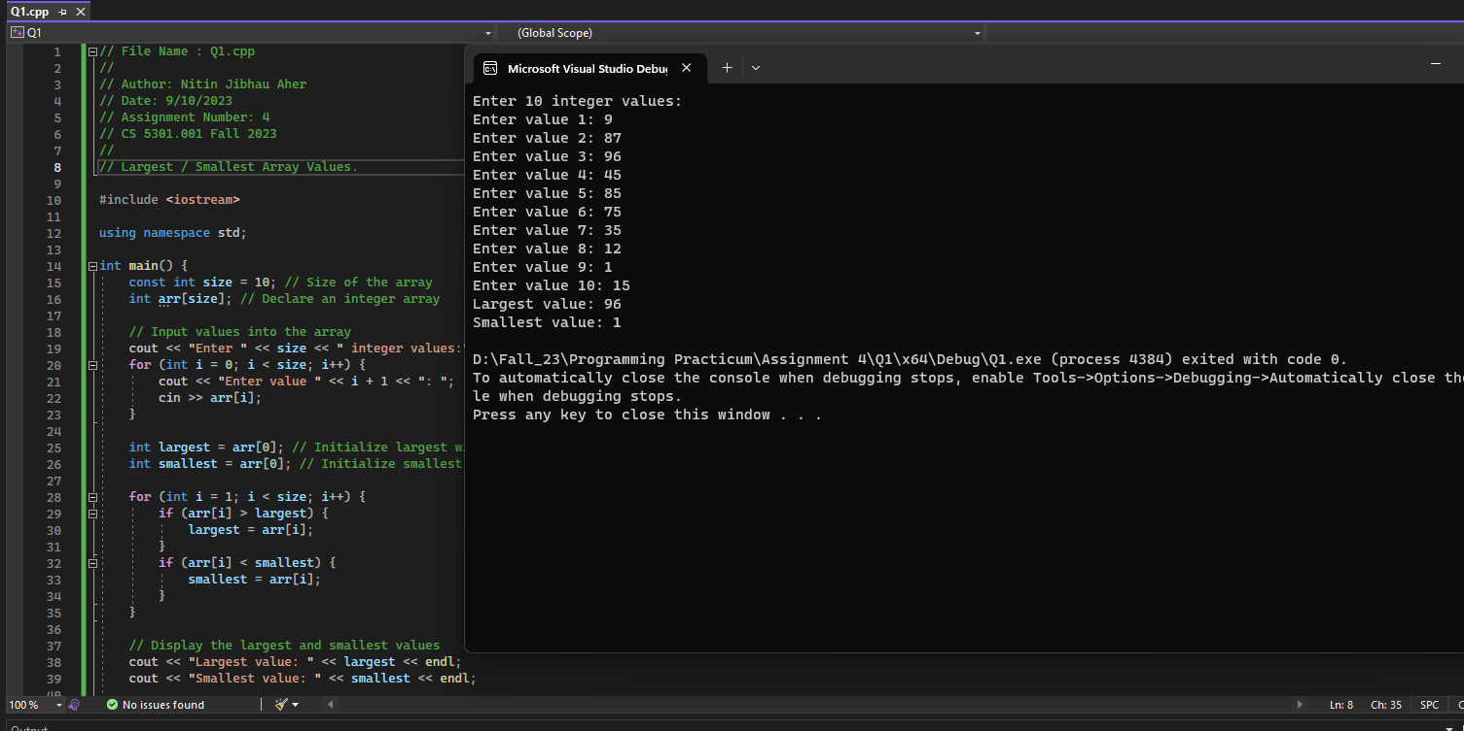

**Q2. Larger than n**  
In a program, write a function that accepts three arguments: an array, the size of the array, and  
a number n. Assume the array contains integers. The function should display all of the numbers  
in the array that are greater than the number n.

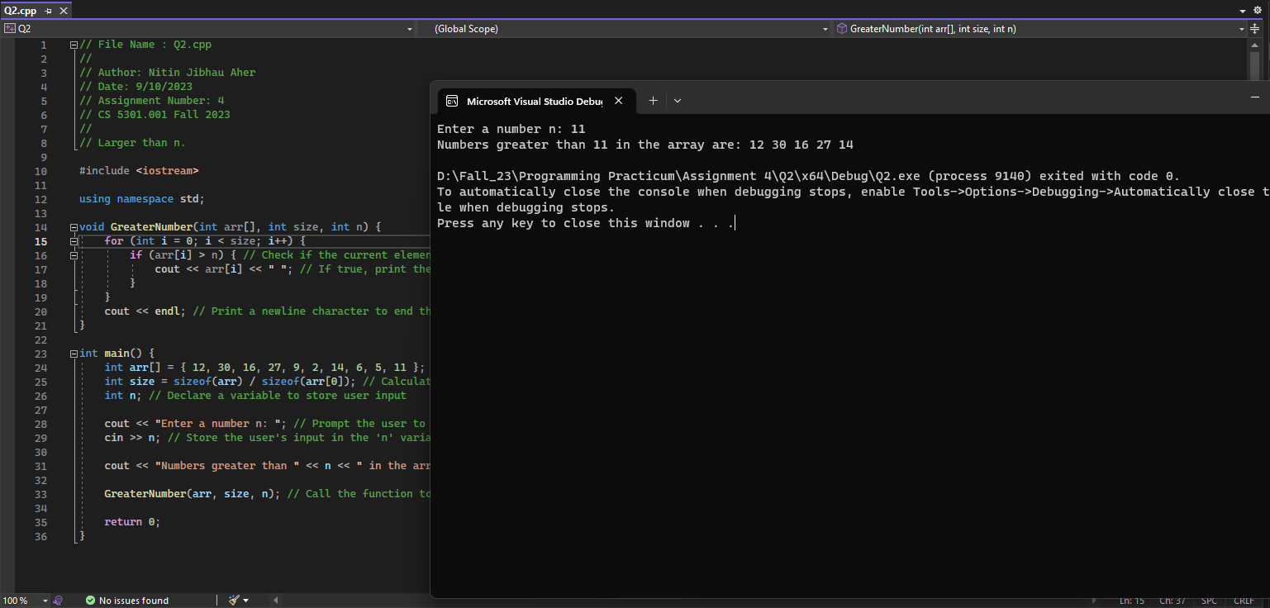

**Q3. Monkey Business**  
A local zoo wants to keep track of how many pounds of food each of its three monkeys eats  
each day during a typical week. Write a program that stores this information in a two-  
dimensional 3x5 array, where each row represents a different monkey, and each column  
represents a different day of the week. The program should first have the user input the data  
for each monkey. Then, it should create a report that includes the following information:  
(1) Average amount of food eaten per day by the whole family of monkeys.  
(2) The least amount of food eaten during the week by any one monkey.  
(3) The greatest amount of food eaten during the week by any one monkey.  
*Input validation: Do not accept negative numbers for pounds of food eaten.

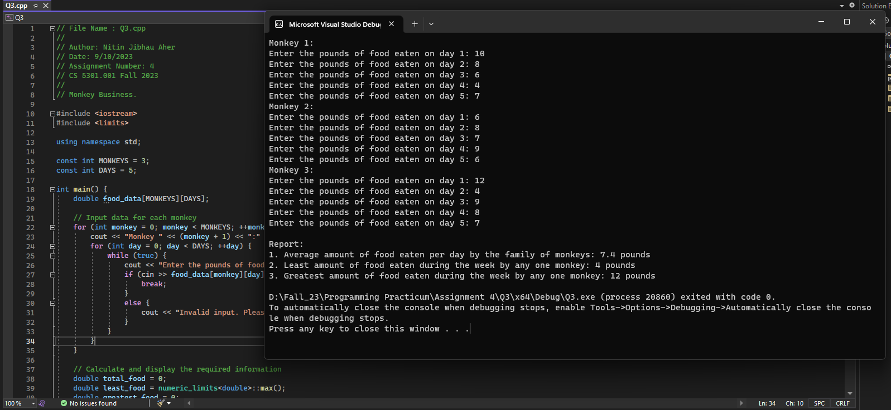

**Q4. Structure Car**

The structure Car is declared as follows:

struct Car

{

string carMake;  
string carModel;  
int yearModel;  
double cost;

};

**(1)** Write a definition statement that defines a Car structure variable initialized with the  
following data:  
a. Make: Ford  
b. Model: Mustang  
c. Year Model: 1968  
d. Cost: $20,000

**Answer:**

Car fordMustang = {"Ford", "Mustang", 1968, 20000};

**(2)** Define an array of 25 of the Car structure variables.

**Answer:**

Car carArray[25];

**(3)** Define an array of 35 of the Car structure variables. Initialize the first three elements  
with the following data:  
Make Model Year Cost

Ford Taurus 1997 $21,000  
Honda Accord 1992 $11,000  
Lamborghini Countach 1997 $200,000

**Answer:**

Car carArray[35];

carArray[0] = {"Ford", "Taurus", 1997, 21000};

carArray[1] = {"Honda", "Accord", 1992, 11000};

carArray[2] = {"Lamborghini", "Countach", 1997, 200000};

**(4)** Write a loop that will step through the array you defined in (3), displaying the contents of each element.

**Answer:**

for (int i = 0; i < 35; i++) {

cout << "Car " << (i + 1) << ":";

cout << "Make: " << carArray[i].carMake << endl;

cout << "Model: " << carArray[i].carModel << endl;

cout << "Year Model: " << carArray[i].yearModel << endl;

cout << "Cost: $" << carArray[i].cost << endl;

}

**Q5. Monthly Budget**  
A student has established the following monthly budget:  
Housing $500.00  
Utilities $150.00  
Household Expenses $65.00  
Transportation $50.00  
Food $250.00  
Medical $30.00  
Insurance $100.00  
Entertainment $150.00  
Clothing $75.00  
Miscellaneous $50.00  
Write a program that has a MonthlyBudget structure designed to hold each of these expense  
categories. The program should pass the structure to a function that asks the user to enter the  
amounts spent in each budget category during a month. The program should then pass the  
structure to a function that displays a report indicating the amount over or under in each  
category, as well as the amount over or under for the entire monthly budget.

