**25-01-22 9 progrms**

//1C++ prm To Swap 2 numbr using C++

#include <iostream>

using namespace std;

int main()

{

    int a = 5, b = 10, temp;

    cout << "Before swapping." << endl;

    cout << "a = " << a << ", b = " << b << endl;

    temp = a;

    a = b;

    b = temp;

    cout << "\nAfter swapping." << endl;

    cout << "a = " << a << ", b = " << b << endl;

    return 0;

}

//2using 3rd variable C++

#include <iostream>

using namespace std;

int main()

{

    int a = 5, b = 10;

    cout << "Before swapping." << endl;

    cout << "a = " << a << ", b = " << b << endl;

    a = a + b;

    b = a - b;

    a = a - b;

    cout << "\nAfter swapping." << endl;

    cout << "a = " << a << ", b = " << b << endl;

    return 0;

}

//3C++ program to calculate area of the circle

#include <iostream>

using namespace std;

 int main() {

   float radius, area_circle;

   // take radius as input

   cout << "Enter the radius of circle: ";

   cin >> radius;

   area_circle = 3.14 * radius * radius;

   cout << "Area of circle: " << area_circle << endl;

   return 0;

}

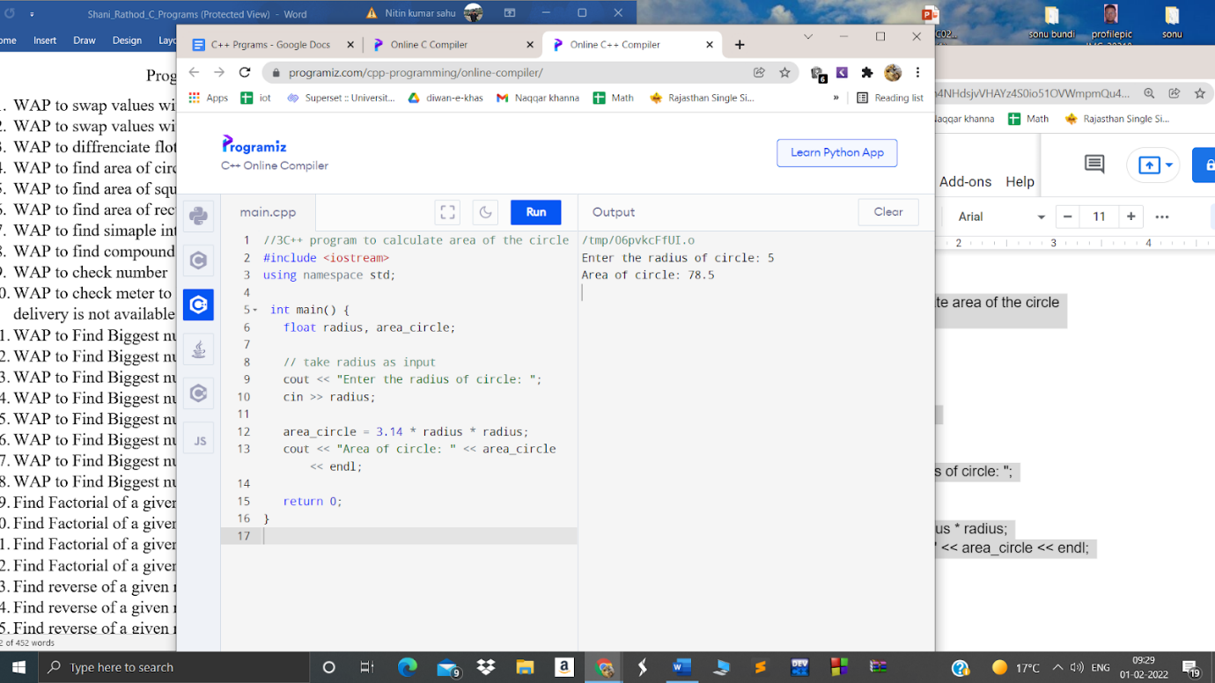

//3WAP to differentiate float and int from number

//number 3.14

#include<iostream>

Using namespace std;

float number,f,int n;

cin>>number;

//4C++ program to calculate area of the circle

#include <iostream>

using namespace std;

 int main() {

   float radius, area_circle;

   // take radius as input

   cout << "Enter the radius of circle: ";

   cin >> radius;

   area_circle = 3.14 * radius * radius;

   cout << "Area of circle: " << area_circle << endl;

   return 0;

}

Enter the radius of Circle : 2.0

Area of Circle : 6.14

5-/* program to calculate the area of square */

#include <iostream>

using namespace std;

int main() //function main begins program execution

{

   int square_area, square_side;

   cout << "Enter the side of square:";

   cin >> square_side;

   square_area = square_side * square_side;

   cout << "Area of Square: " << square_area << endl;

   return 0;

} // end main

Output:

Enter the Length of Side : 4

Area of Square : 16

//5 Area of Rectangle using C++

#include<iostream>

using namespace std;

int main()

{

    float len, bre, area;

    cout<<"Enter Length of Rectangle: ";

    cin>>len;

    cout<<"Enter Breadth of Rectangle: ";

    cin>>bre;

    area = len*bre;

    cout<<"\nArea = "<<area;

    cout<<endl;

    return 0;

}

//7 prgm to calculate Simple interest using C++

#include<iostream>

using namespace std;

int main()

{

int p,r,t,i;

cout << "\n\n Calculate the Simple Interest :\n";

cout << " -----------------------------------\n";

cout<<" Input the Principle: ";

cin>>p;

cout<<" Input the Rate of Interest: ";

cin>>r;

cout<<" Input the Time: ";

cin>>t;

i=(p*r*t)/100;

cout<<" The Simple interest for the amount "<<p<<" for "<<t<<" years @ "<<r<<" % is: "<<i;

        cout << endl;

return 0;

}

OUTPUT:

 Input the Principle:

 5

 Input the Rate of Interest: 2

 Input the Time: 3

//8 C++ prgm to calculate Compund Interest

#include<iostream>

#include<math.h>

using namespace std;

int main()

{

float p,r,t,ci;

cout<<"Enter Principle, Rate and Time:\n";

cin>>p>>r>>t;

ci=p*pow((1+r/100),t);

cout<<"\nCompound Interest = "<<ci;

return 0;

}

**Output**

*Enter Principle, Rate and Time: 2000*

*2*

*3*

*Bank Loans Compound Interest = 2122.415771*

//9 EVEN/odd

#include <iostream>

using namespace std;

int main()

{

int num;

cout<<"Enter an integer number: ";

cin>>num;

if(num%2==0)

cout<<num<<" is an EVEN number."<<endl;

else

cout<<num<<" is an ODD number."<<endl;

return 0;

}

// 10 1.      WAP to check meter to kilometer and if it is greater then 5 then print “Home delivery is not available “ else  print “Home delivery is available”.

#include<stdio.h>

#include<conio.h>

int main()

{

int a;

float b;

scanf("%d",&a);

b = a/1000;

if(b>5)

printf("Home delivery is Available");

else

printf("not available");

getch();

}

OUTPUT:

Home Delievery

//11 C++ prgm to find Biggest no out of 3

#include <iostream>

using namespace std;

int main() {

    float n1, n2, n3;

    cout << "Enter three numbers: ";

    cin >> n1 >> n2 >> n3;

    if(n1 >= n2 && n1 >= n3)

        cout << "Largest number: " << n1;

    if(n2 >= n1 && n2 >= n3)

        cout << "Largest number: " << n2;

    if(n3 >= n1 && n3 >= n2)

        cout << "Largest number: " << n3;

    return 0;

}

OUTPUT:

4 7 9

//12C++ to find greatest of 4 number

#include <bitsstdc++.h>

1. **using** **namespace** std;
2. **void** find_greatest(**int** a, **int** b, **int** c, **int** d)
3. {
4. **if** (a > b) {
5. **if** (a > c) {
6. **if** (a > d) {
7. cout << "a is greatest";
8. }
9. **else** {
10. cout << "d is greatest";
11. }
12. }
13. }
14. **else** **if** (b > c) {
15. **if** (b > d) {
16. cout << "b is greatest";
17. }
18. **else** {
19. cout << "d is greatest";
20. }
21. }
22. **else** **if** (c > d) {
23. cout << "c is greatest";
24. }
25. **else** {
26. cout << "d is greatest";
27. }
28. }

OUTPUT:

Enter four number:1 4 7 9

Largest Number:9

//13 prgm: To find greatest among 5

#include <stdio.h>

#include <conio.h>

void main()

{

int a, b, c, d, e;

clrscr();

printf("\nGreater Out of 5>> \n");

printf("Enter 5 Numbers >\n");

scanf("%d", &a);

scanf("%d", &b);

scanf("%d", &c);

scanf("%d", &d);

scanf("%d", &e);

printf("Greter is ");

if (a > e)

if (a > d)

if (a > c)

if (a > b)

printf("%d",a);

else

printf("%d",b);

else

if (c > b)

printf("%d",c);

else

printf("%d",b);

else

if (d > c)

if (d > b)

printf("%d",d);

else

printf("%d",b);

else

if (c > b)

printf("%d",c);

else

printf("%d",b);

else

if (e > d)

if (e > c)

if (e > b)

printf("%d",e);

else

printf("%d",b);

else

if (c > b)

printf("%d",c);

else

printf("%d",b);

else

if (d > c)

if (d > b)

printf("%d",d);

else

printf("%d",b);

else

if (c > b)

printf("%d",c);

else

printf("%d",b);

getch();

}

OUTPUT:

Enter the number:1,4,2,8,9

Largest number:9

//13C++ to find biggest out of 6

#include <iostream>

Using namespace std;

void main()

{

int a, b, c, d, e, f;

clrscr();

cout<<Greater Out of 6;

cout<<Enter 6 Numbers ;

cin>>a>>b>>c>>d>>e>>f;

cout<<Greter is ;

if (a > f)

if (a > e)

if (a > d)

if (a > c)

if (a > b)

printf("%d",a);

else

printf("%d",b);

else

if (c > b)

printf("%d",c);

else

printf("%d",b);

else

if (d > c)

if (d > b)

printf("%d",d);

else

printf("%d",b);

else

if (c > b)

printf("%d",c);

else

printf("%d",b);

else

if (e > d)

if (e > c)

if (e > b)

printf("%d",e);

else

printf("%d",b);

else

if (c > b)

printf("%d",c);

else

printf("%d",b);

else

if (d > c)

if (d > b)

printf("%d",d);

else

printf("%d",b);

else

if (c > b)

printf("%d",c);

else

printf("%d",b);

else

if (f > e)

if (f > d)

if (f > c)

if (f > b)

printf("%d",f);

else

printf("%d",b);

else

if (c > b)

printf("%d",c);

else

printf("%d",b);

else

if (d > c)

if (d > b)

printf("%d",d);

else

printf("%d",b);

else

if (c > b)

printf("%d",c);

else

printf("%d",b);

else

if (e > d)

if (e > c)

if (e > b)

printf("%d",e);

else

printf("%d",b);

else

if (c > b)

printf("%d",c);

else

printf("%d",b);

else

if (d > c)

if (d > b)

printf("%d",d);

else

printf("%d",b);

else

if (c > b)

printf("%d",c);

else

printf("%d",b);

getch();

}

Ouptut

Enter the number:23,1,2,5,7,8

Largest Number:23

//14C++ to find greatest among 7

#include <iostream>

Using namespace std;

void main()

{

int a, b, c, d, e, f, g;

clrscr();

cout<<Greater Out of 7;

cout<<Enter 7 Numbers ;

cin>>a>>b>>c>>d>>e>>f>>g;

printf("Greter is ");

if (a > g)

if (a > f)

if (a > e)

if (a > d)

if (a > c)

if (a > b)

printf("%d",a);

else

printf("%d",b);

else

if (c > b)

printf("%d",c);

else

printf("%d",b);

else

if (d > c)

if (d > b)

printf("%d",d);

else

printf("%d",b);

else

if (c > b)

printf("%d",c);

else

printf("%d",b);

else

if (e > d)

if (e > c)

if (e > b)

printf("%d",e);

else

printf("%d",b);

else

if (c > b)

printf("%d",c);

else

printf("%d",b);

else

if (d > c)

if (d > b)

printf("%d",d);

else

printf("%d",b);

else

if (c > b)

printf("%d",c);

else

printf("%d",b);

else

if (f > e)

if (f > d)

if (f > c)

if (f > b)

printf("%d",f);

else

printf("%d",b);

else

if (c > b)

printf("%d",c);

else

printf("%d",b);

else

if (d > c)

if (d > b)

printf("%d",d);

else

printf("%d",b);

else

if (c > b)

printf("%d",c);

else

printf("%d",b);

else

if (e > d)

if (e > c)

if (e > b)

printf("%d",e);

else

printf("%d",b);

else

if (c > b)

printf("%d",c);

else

printf("%d",b);

else

if (d > c)

if (d > b)

printf("%d",d);

else

printf("%d",b);

else

if (c > b)

printf("%d",c);

else

printf("%d",b);

else

if (g > f)

if (g > e)

if (g > d)

if (g > c)

if (g > b)

printf("%d",g);

else

printf("%d",b);

else

if (c > b)

printf("%d",c);

else

printf("%d",b);

else

if (d > c)

if (d > b)

printf("%d",d);

else

printf("%d",b);

else

if (c > b)

printf("%d",c);

else

printf("%d",b);

else

if (e > d)

if (e > c)

if (e > b)

printf("%d",e);

else

printf("%d",b);

else

if (c > b)

printf("%d",c);

else

printf("%d",b);

else

if (d > c)

if (d > b)

printf("%d",d);

else

printf("%d",b);

else

if (c > b)

printf("%d",c);

else

printf("%d",b);

else

if (f > e)

if (f > d)

if (f > c)

if (f > b)

printf("%d",f);

else

printf("%d",b);

else

if (c > b)

printf("%d",c);

else

printf("%d",b);

else

if (d > c)

if (d > b)

printf("%d",d);

else

printf("%d",b);

else

if (c > b)

printf("%d",c);

else

printf("%d",b);

else

if (e > d)

if (e > c)

if (e > b)

printf("%d",e);

else

printf("%d",b);

else

if (c > b)

printf("%d",c);

else

printf("%d",b);

else

if (d > c)

if (d > b)

printf("%d",d);

else

printf("%d",b);

else

if (c > b)

printf("%d",c);

else

printf("%d",b);

getch();

}

Output:1,3,5,7,9,0,11

Largerst:11

//15      WAP to Find Biggest number out of 8 numbers.

 C++

#include <iostream>

Using namespace std;

void main()

{

int a, b, c, d, e, f, g, h;

clrscr();

cout<<Greater Out of 8;

cout<<Enter 8 Numbers ;

cin>>a>>b>>c>>d>>e>>f>>g>>h;

printf("Greter is ");

if (a > h)

if (a > g)

if (a > f)

if (a > e)

if (a > d)

if (a > c)

if (a > b)

printf("%d",a);

else

printf("%d",b);

else

if (c > b)

printf("%d",c);

else

printf("%d",b);

else

if (d > c)

if (d > b)

printf("%d",d);

else

printf("%d",b);

else

if (c > b)

printf("%d",c);

else

printf("%d",b);

else

if (e > d)

if (e > c)

if (e > b)

printf("%d",e);

else

printf("%d",b);

else

if (c > b)

printf("%d",c);

else

printf("%d",b);

else

if (d > c)

if (d > b)

printf("%d",d);

else

printf("%d",b);

else

if (c > b)

printf("%d",c);

else

printf("%d",b);

else

if (f > e)

if (f > d)

if (f > c)

if (f > b)

printf("%d",f);

else

printf("%d",b);

else

if (c > b)

printf("%d",c);

else

printf("%d",b);

else

if (d > c)

if (d > b)

printf("%d",d);

else

printf("%d",b);

else

if (c > b)

printf("%d",c);

else

printf("%d",b);

else

if (e > d)

if (e > c)

if (e > b)

printf("%d",e);

else

printf("%d",b);

else

if (c > b)

printf("%d",c);

else

printf("%d",b);

else

if (d > c)

if (d > b)

printf("%d",d);

else

printf("%d",b);

else

if (c > b)

printf("%d",c);

else

printf("%d",b);

else

if (g > f)

if (g > e)

if (g > d)

if (g > c)

if (g > b)

printf("%d",g);

else

printf("%d",b);

else

if (c > b)

printf("%d",c);

else

printf("%d",b);

else

if (d > c)

if (d > b)

printf("%d",d);

else

printf("%d",b);

else

if (c > b)

printf("%d",c);

else

printf("%d",b);

else

if (e > d)

if (e > c)

if (e > b)

printf("%d",e);

else

printf("%d",b);

else

if (c > b)

printf("%d",c);

else

printf("%d",b);

else

if (d > c)

if (d > b)

printf("%d",d);

else

printf("%d",b);

else

if (c > b)

printf("%d",c);

else

printf("%d",b);

else

if (f > e)

if (f > d)

if (f > c)

if (f > b)

printf("%d",f);

else

printf("%d",b);

else

if (c > b)

printf("%d",c);

else

printf("%d",b);

else

if (d > c)

if (d > b)

printf("%d",d);

else

printf("%d",b);

else

if (c > b)

printf("%d",c);

else

printf("%d",b);

else

if (e > d)

if (e > c)

if (e > b)

printf("%d",e);

else

printf("%d",b);

else

if (c > b)

printf("%d",c);

else

printf("%d",b);

else

if (d > c)

if (d > b)

printf("%d",d);

else

printf("%d",b);

else

if (c > b)

printf("%d",c);

else

printf("%d",b);

else

if (h > g)

if (h > f)

if (h > e)

if (h > d)

if (h > c)

if (h > b)

printf("%d",h);

else

printf("%d",b);

else

if (c > b)

printf("%d",c);

else

printf("%d",b);

else

if (d > c)

if (d > b)

printf("%d",d);

else

printf("%d",b);

else

if (c > b)

printf("%d",c);

else

printf("%d",b);

else

if (e > d)

if (e > c)

if (e > b)

printf("%d",e);

else

printf("%d",b);

else

if (c > b)

printf("%d",c);

else

printf("%d",b);

else

if (d > c)

if (d > b)

printf("%d",d);

else

printf("%d",b);

else

if (c > b)

printf("%d",c);

else

printf("%d",b);

else

if (f > e)

if (f > d)

if (f > c)

if (f > b)

printf("%d",f);

else

printf("%d",b);

else

if (c > b)

printf("%d",c);

else

printf("%d",b);

else

if (d > c)

if (d > b)

printf("%d",d);

else

printf("%d",b);

else

if (c > b)

printf("%d",c);

else

printf("%d",b);

else

if (e > d)

if (e > c)

if (e > b)

printf("%d",e);

else

printf("%d",b);

else

if (c > b)

printf("%d",c);

else

printf("%d",b);

else

if (d > c)

if (d > b)

printf("%d",d);

else

printf("%d",b);

else

if (c > b)

printf("%d",c);

else

printf("%d",b);

else

if (g > f)

if (g > e)

if (g > d)

if (g > c)

if (g > b)

printf("%d",g);

else

printf("%d",b);

else

if (c > b)

printf("%d",c);

else

printf("%d",b);

else

if (d > c)

if (d > b)

printf("%d",d);

else

printf("%d",b);

else

if (c > b)

printf("%d",c);

else

printf("%d",b);

else

if (e > d)

if (e > c)

if (e > b)

printf("%d",e);

else

printf("%d",b);

else

if (c > b)

printf("%d",c);

else

printf("%d",b);

else

if (d > c)

if (d > b)

printf("%d",d);

else

printf("%d",b);

else

if (c > b)

printf("%d",c);

else

printf("%d",b);

else

if (f > e)

if (f > d)

if (f > c)

if (f > b)

printf("%d",f);

else

printf("%d",b);

else

if (c > b)

printf("%d",c);

else

printf("%d",b);

else

if (d > c)

if (d > b)

printf("%d",d);

else

printf("%d",b);

else

if (c > b)

printf("%d",c);

else

printf("%d",b);

else

if (e > d)

if (e > c)

if (e > b)

printf("%d",e);

else

printf("%d",b);

else

if (c > b)

printf("%d",c);

else

printf("%d",b);

else

if (d > c)

if (d > b)

printf("%d",d);

else

printf("%d",b);

else

if (c > b)

printf("%d",c);

else

printf("%d",b);

getch();

}

OUTPUT:2,4,6,8,10,12,14,18

Largest:18

//16 C++ to find among 9

#include <iostream>

Using namespace std;

void main()

{

int a, b, c, d, e, f, g, h, i, j;

clrscr();

printf("\nGreater Out of 9>> \n");

printf("Enter 9 Numbers >\n");

scanf("%d", &a);

scanf("%d", &b);

scanf("%d", &c);

scanf("%d", &d);

scanf("%d", &e);

scanf("%d", &f);

scanf("%d", &g);

scanf("%d", &h);

scanf("%d", &i);

printf("Greter is ");

if (a > i)

if (a > h)

if (a > g)

if (a > f)

if (a > e)

if (a > d)

if (a > c)

if (a > b)

printf("%d",a);

else

printf("%d",b);

else

if (c > b)

printf("%d",c);

else

printf("%d",b);

else

if (d > c)

if (d > b)

printf("%d",d);

else

printf("%d",b);

else

if (c > b)

printf("%d",c);

else

printf("%d",b);

else

if (e > d)

if (e > c)

if (e > b)

printf("%d",e);

else

printf("%d",b);

else

if (c > b)

printf("%d",c);

else

printf("%d",b);

else

if (d > c)

if (d > b)

printf("%d",d);

else

printf("%d",b);

else

if (c > b)

printf("%d",c);

else

printf("%d",b);

else

if (f > e)

if (f > d)

if (f > c)

if (f > b)

printf("%d",f);

else

printf("%d",b);

else

if (c > b)

printf("%d",c);

else

printf("%d",b);

else

if (d > c)

if (d > b)

printf("%d",d);

else

printf("%d",b);

else

if (c > b)

printf("%d",c);

else

printf("%d",b);

else

if (e > d)

if (e > c)

if (e > b)

printf("%d",e);

else

printf("%d",b);

else

if (c > b)

printf("%d",c);

else

printf("%d",b);

else

if (d > c)

if (d > b)

printf("%d",d);

else

printf("%d",b);

else

if (c > b)

printf("%d",c);

else

printf("%d",b);

else

if (g > f)

if (g > e)

if (g > d)

if (g > c)

if (g > b)

printf("%d",g);

else

printf("%d",b);

else

if (c > b)

printf("%d",c);

else

printf("%d",b);

else

if (d > c)

if (d > b)

printf("%d",d);

else

printf("%d",b);

else

if (c > b)

printf("%d",c);

else

printf("%d",b);

else

if (e > d)

if (e > c)

if (e > b)

printf("%d",e);

else

printf("%d",b);

else

if (c > b)

printf("%d",c);

else

printf("%d",b);

else

if (d > c)

if (d > b)

printf("%d",d);

else

printf("%d",b);

else

if (c > b)

printf("%d",c);

else

printf("%d",b);

else

if (f > e)

if (f > d)

if (f > c)

if (f > b)

printf("%d",f);

else

printf("%d",b);

else

if (c > b)

printf("%d",c);

else

printf("%d",b);

else

if (d > c)

if (d > b)

printf("%d",d);

else

printf("%d",b);

else

if (c > b)

printf("%d",c);

else

printf("%d",b);

else

if (e > d)

if (e > c)

if (e > b)

printf("%d",e);

else

printf("%d",b);

else

if (c > b)

printf("%d",c);

else

printf("%d",b);

else

if (d > c)

if (d > b)

printf("%d",d);

else

printf("%d",b);

else

if (c > b)

printf("%d",c);

else

printf("%d",b);

else

if (h > g)

if (h > f)

if (h > e)

if (h > d)

if (h > c)

if (h > b)

printf("%d",h);

else

printf("%d",b);

else

if (c > b)

printf("%d",c);

else

printf("%d",b);

else

if (d > c)

if (d > b)

printf("%d",d);

else

printf("%d",b);

else

if (c > b)

printf("%d",c);

else

printf("%d",b);

else

if (e > d)

if (e > c)

if (e > b)

printf("%d",e);

else

printf("%d",b);

else

if (c > b)

printf("%d",c);

else

printf("%d",b);

else

if (d > c)

if (d > b)

printf("%d",d);

else

printf("%d",b);

else

if (c > b)

printf("%d",c);

else

printf("%d",b);

else

if (f > e)

if (f > d)

if (f > c)

if (f > b)

printf("%d",f);

else

printf("%d",b);

else

if (c > b)

printf("%d",c);

else

printf("%d",b);

else

if (d > c)

if (d > b)

printf("%d",d);

else

printf("%d",b);

else

if (c > b)

printf("%d",c);

else

printf("%d",b);

else

if (e > d)

if (e > c)

if (e > b)

printf("%d",e);

else

printf("%d",b);

else

if (c > b)

printf("%d",c);

else

printf("%d",b);

else

if (d > c)

if (d > b)

printf("%d",d);

else

printf("%d",b);

else

if (c > b)

printf("%d",c);

else

printf("%d",b);

else

if (g > f)

if (g > e)

if (g > d)

if (g > c)

if (g > b)

printf("%d",g);

else

printf("%d",b);

else

if (c > b)

printf("%d",c);

else

printf("%d",b);

else

if (d > c)

if (d > b)

printf("%d",d);

else

printf("%d",b);

else

if (c > b)

printf("%d",c);

else

printf("%d",b);

else

if (e > d)

if (e > c)

if (e > b)

printf("%d",e);

else

printf("%d",b);

else

if (c > b)

printf("%d",c);

else

printf("%d",b);

else

if (d > c)

if (d > b)

printf("%d",d);

else

printf("%d",b);

else

if (c > b)

printf("%d",c);

else

printf("%d",b);

else

if (f > e)

if (f > d)

if (f > c)

if (f > b)

printf("%d",f);

else

printf("%d",b);

else

if (c > b)

printf("%d",c);

else

printf("%d",b);

else

if (d > c)

if (d > b)

printf("%d",d);

else

printf("%d",b);

else

if (c > b)

printf("%d",c);

else

printf("%d",b);

else

if (e > d)

if (e > c)

if (e > b)

printf("%d",e);

else

printf("%d",b);

else

if (c > b)

printf("%d",c);

else

printf("%d",b);

else

if (d > c)

if (d > b)

printf("%d",d);

else

printf("%d",b);

else

if (c > b)

printf("%d",c);

else

printf("%d",b);

else

if (i > h)

if (i > g)

if (i > f)

if (i > e)

if (i > d)

if (i > c)

if (i > b)

printf("%d",i);

else

printf("%d",b);

else

if (c > b)

printf("%d",c);

else

printf("%d",b);

else

if (d > c)

if (d > b)

printf("%d",d);

else

printf("%d",b);

else

if (c > b)

printf("%d",c);

else

printf("%d",b);

else

if (e > d)

if (e > c)

if (e > b)

printf("%d",e);

else

printf("%d",b);

else

if (c > b)

printf("%d",c);

else

printf("%d",b);

else

if (d > c)

if (d > b)

printf("%d",d);

else

printf("%d",b);

else

if (c > b)

printf("%d",c);

else

printf("%d",b);

else

if (f > e)

if (f > d)

if (f > c)

if (f > b)

printf("%d",f);

else

printf("%d",b);

else

if (c > b)

printf("%d",c);

else

printf("%d",b);

else

if (d > c)

if (d > b)

printf("%d",d);

else

printf("%d",b);

else

if (c > b)

printf("%d",c);

else

printf("%d",b);

else

if (e > d)

if (e > c)

if (e > b)

printf("%d",e);

else

printf("%d",b);

else

if (c > b)

printf("%d",c);

else

printf("%d",b);

else

if (d > c)

if (d > b)

printf("%d",d);

else

printf("%d",b);

else

if (c > b)

printf("%d",c);

else

printf("%d",b);

else

if (g > f)

if (g > e)

if (g > d)

if (g > c)

if (g > b)

printf("%d",g);

else

printf("%d",b);

else

if (c > b)

printf("%d",c);

else

printf("%d",b);

else

if (d > c)

if (d > b)

printf("%d",d);

else

printf("%d",b);

else

if (c > b)

printf("%d",c);

else

printf("%d",b);

else

if (e > d)

if (e > c)

if (e > b)

printf("%d",e);

else

printf("%d",b);

else

if (c > b)

printf("%d",c);

else

printf("%d",b);

else

if (d > c)

if (d > b)

printf("%d",d);

else

printf("%d",b);

else

if (c > b)

printf("%d",c);

else

printf("%d",b);

else

if (f > e)

if (f > d)

if (f > c)

if (f > b)

printf("%d",f);

else

printf("%d",b);

else

if (c > b)

printf("%d",c);

else

printf("%d",b);

else

if (d > c)

if (d > b)

printf("%d",d);

else

printf("%d",b);

else

if (c > b)

printf("%d",c);

else

printf("%d",b);

else

if (e > d)

if (e > c)

if (e > b)

printf("%d",e);

else

printf("%d",b);

else

if (c > b)

printf("%d",c);

else

printf("%d",b);

else

if (d > c)

if (d > b)

printf("%d",d);

else

printf("%d",b);

else

if (c > b)

printf("%d",c);

else

printf("%d",b);

else

if (h > g)

if (h > f)

if (h > e)

if (h > d)

if (h > c)

if (h > b)

printf("%d",h);

else

printf("%d",b);

else

if (c > b)

printf("%d",c);

else

printf("%d",b);

else

if (d > c)

if (d > b)

printf("%d",d);

else

printf("%d",b);

else

if (c > b)

printf("%d",c);

else

printf("%d",b);

else

if (e > d)

if (e > c)

if (e > b)

printf("%d",e);

else

printf("%d",b);

else

if (c > b)

printf("%d",c);

else

printf("%d",b);

else

if (d > c)

if (d > b)

printf("%d",d);

else

printf("%d",b);

else

if (c > b)

printf("%d",c);

else

printf("%d",b);

else

if (f > e)

if (f > d)

if (f > c)

if (f > b)

printf("%d",f);

else

printf("%d",b);

else

if (c > b)

printf("%d",c);

else

printf("%d",b);

else

if (d > c)

if (d > b)

printf("%d",d);

else

printf("%d",b);

else

if (c > b)

printf("%d",c);

else

printf("%d",b);

else

if (e > d)

if (e > c)

if (e > b)

printf("%d",e);

else

printf("%d",b);

else

if (c > b)

printf("%d",c);

else

printf("%d",b);

else

if (d > c)

if (d > b)

printf("%d",d);

else

printf("%d",b);

else

if (c > b)

printf("%d",c);

else

printf("%d",b);

else

if (g > f)

if (g > e)

if (g > d)

if (g > c)

if (g > b)

printf("%d",g);

else

printf("%d",b);

else

if (c > b)

printf("%d",c);

else

printf("%d",b);

else

if (d > c)

if (d > b)

printf("%d",d);

else

printf("%d",b);

else

if (c > b)

printf("%d",c);

else

printf("%d",b);

else

if (e > d)

if (e > c)

if (e > b)

printf("%d",e);

else

printf("%d",b);

else

if (c > b)

printf("%d",c);

else

printf("%d",b);

else

if (d > c)

if (d > b)

printf("%d",d);

else

printf("%d",b);

else

if (c > b)

printf("%d",c);

else

printf("%d",b);

else

if (f > e)

if (f > d)

if (f > c)

if (f > b)

printf("%d",f);

else

printf("%d",b);

else

if (c > b)

printf("%d",c);

else

printf("%d",b);

else

if (d > c)

if (d > b)

printf("%d",d);

else

printf("%d",b);

else

if (c > b)

printf("%d",c);

else

printf("%d",b);

else

if (e > d)

if (e > c)

if (e > b)

printf("%d",e);

else

printf("%d",b);

else

if (c > b)

printf("%d",c);

else

printf("%d",b);

else

if (d > c)

if (d > b)

printf("%d",d);

else

printf("%d",b);

else

if (c > b)

printf("%d",c);

else

printf("%d",b);

getch();

}

OUTPUT=1,2,4,6,8,10,12,14,16

largest:16

//17 C++ to find greatest among 10

#include <iostream>

Using namespace std;

void main()

{

int a, b, c, d, e, f, g, h, i, j;

clrscr();

cout<<”Greater Out of 10”;

cout<Enter 10 Numbers >\n");

in>>a>>b>>c>>d>>e>>f>>g>>h>>i>>j;

printf("Greter is ");

if (a > j)

if (a > i)

if (a > h)

if (a > g)

if (a > f)

if (a > e)

if (a > d)

if (a > c)

if (a > b)

printf("%d",a);

else

printf("%d",b);

else

if (c > b)

printf("%d",c);

else

printf("%d",b);

else

if (d > c)

if (d > b)

printf("%d",d);

else

printf("%d",b);

else

if (c > b)

printf("%d",c);

else

printf("%d",b);

else

if (e > d)

if (e > c)

if (e > b)

printf("%d",e);

else

printf("%d",b);

else

if (c > b)

printf("%d",c);

else

printf("%d",b);

else

if (d > c)

if (d > b)

printf("%d",d);

else

printf("%d",b);

else

if (c > b)

printf("%d",c);

else

printf("%d",b);

else

if (f > e)

if (f > d)

if (f > c)

if (f > b)

printf("%d",f);

else

printf("%d",b);

else

if (c > b)

printf("%d",c);

else

printf("%d",b);

else

if (d > c)

if (d > b)

printf("%d",d);

else

printf("%d",b);

else

if (c > b)

printf("%d",c);

else

printf("%d",b);

else

if (e > d)

if (e > c)

if (e > b)

printf("%d",e);

else

printf("%d",b);

else

if (c > b)

printf("%d",c);

else

printf("%d",b);

else

if (d > c)

if (d > b)

printf("%d",d);

else

printf("%d",b);

else

if (c > b)

printf("%d",c);

else

printf("%d",b);

else

if (g > f)

if (g > e)

if (g > d)

if (g > c)

if (g > b)

printf("%d",g);

else

printf("%d",b);

else

if (c > b)

printf("%d",c);

else

printf("%d",b);

else

if (d > c)

if (d > b)

printf("%d",d);

else

printf("%d",b);

else

if (c > b)

printf("%d",c);

else

printf("%d",b);

else

if (e > d)

if (e > c)

if (e > b)

printf("%d",e);

else

printf("%d",b);

else

if (c > b)

printf("%d",c);

else

printf("%d",b);

else

if (d > c)

if (d > b)

printf("%d",d);

else

printf("%d",b);

else

if (c > b)

printf("%d",c);

else

printf("%d",b);

else

if (f > e)

if (f > d)

if (f > c)

if (f > b)

printf("%d",f);

else

printf("%d",b);

else

if (c > b)

printf("%d",c);

else

printf("%d",b);

else

if (d > c)

if (d > b)

printf("%d",d);

else

printf("%d",b);

else

if (c > b)

printf("%d",c);

else

printf("%d",b);

else

if (e > d)

if (e > c)

if (e > b)

printf("%d",e);

else

printf("%d",b);

else

if (c > b)

printf("%d",c);

else

printf("%d",b);

else

if (d > c)

if (d > b)

printf("%d",d);

else

printf("%d",b);

else

if (c > b)

printf("%d",c);

else

printf("%d",b);

else

if (h > g)

if (h > f)

if (h > e)

if (h > d)

if (h > c)

if (h > b)

printf("%d",h);

else

printf("%d",b);

else

if (c > b)

printf("%d",c);

else

printf("%d",b);

else

if (d > c)

if (d > b)

printf("%d",d);

else

printf("%d",b);

else

if (c > b)

printf("%d",c);

else

printf("%d",b);

else

if (e > d)

if (e > c)

if (e > b)

printf("%d",e);

else

printf("%d",b);

else

if (c > b)

printf("%d",c);

else

printf("%d",b);

else

if (d > c)

if (d > b)

printf("%d",d);

else

printf("%d",b);

else

if (c > b)

printf("%d",c);

else

printf("%d",b);

else

if (f > e)

if (f > d)

if (f > c)

if (f > b)

printf("%d",f);

else

printf("%d",b);

else

if (c > b)

printf("%d",c);

else

printf("%d",b);

else

if (d > c)

if (d > b)

printf("%d",d);

else

printf("%d",b);

else

if (c > b)

printf("%d",c);

else

printf("%d",b);

else

if (e > d)

if (e > c)

if (e > b)

printf("%d",e);

else

printf("%d",b);

else

if (c > b)

printf("%d",c);

else

printf("%d",b);

else

if (d > c)

if (d > b)

printf("%d",d);

else

printf("%d",b);

else

if (c > b)

printf("%d",c);

else

printf("%d",b);

else

if (g > f)

if (g > e)

if (g > d)

if (g > c)

if (g > b)

printf("%d",g);

else

printf("%d",b);

else

if (c > b)

printf("%d",c);

else

printf("%d",b);

else

if (d > c)

if (d > b)

printf("%d",d);

else

printf("%d",b);

else

if (c > b)

printf("%d",c);

else

printf("%d",b);

else

if (e > d)

if (e > c)

if (e > b)

printf("%d",e);

else

printf("%d",b);

else

if (c > b)

printf("%d",c);

else

printf("%d",b);

else

if (d > c)

if (d > b)

printf("%d",d);

else

printf("%d",b);

else

if (c > b)

printf("%d",c);

else

printf("%d",b);

else

if (f > e)

if (f > d)

if (f > c)

if (f > b)

printf("%d",f);

else

printf("%d",b);

else

if (c > b)

printf("%d",c);

else

printf("%d",b);

else

if (d > c)

if (d > b)

printf("%d",d);

else

printf("%d",b);

else

if (c > b)

printf("%d",c);

else

printf("%d",b);

else

if (e > d)

if (e > c)

if (e > b)

printf("%d",e);

else

printf("%d",b);

else

if (c > b)

printf("%d",c);

else

printf("%d",b);

else

if (d > c)

if (d > b)

printf("%d",d);

else

printf("%d",b);

else

if (c > b)

printf("%d",c);

else

printf("%d",b);

else

if (i > h)

if (i > g)

if (i > f)

if (i > e)

if (i > d)

if (i > c)

if (i > b)

printf("%d",i);

else

printf("%d",b);

else

if (c > b)

printf("%d",c);

else

printf("%d",b);

else

if (d > c)

if (d > b)

printf("%d",d);

else

printf("%d",b);

else

if (c > b)

printf("%d",c);

else

printf("%d",b);

else

if (e > d)

if (e > c)

if (e > b)

printf("%d",e);

else

printf("%d",b);

else

if (c > b)

printf("%d",c);

else

printf("%d",b);

else

if (d > c)

if (d > b)

printf("%d",d);

else

printf("%d",b);

else

if (c > b)

printf("%d",c);

else

printf("%d",b);

else

if (f > e)

if (f > d)

if (f > c)

if (f > b)

printf("%d",f);

else

printf("%d",b);

else

if (c > b)

printf("%d",c);

else

printf("%d",b);

else

if (d > c)

if (d > b)

printf("%d",d);

else

printf("%d",b);

else

if (c > b)

printf("%d",c);

else

printf("%d",b);

else

if (e > d)

if (e > c)

if (e > b)

printf("%d",e);

else

printf("%d",b);

else

if (c > b)

printf("%d",c);

else

printf("%d",b);

else

if (d > c)

if (d > b)

printf("%d",d);

else

printf("%d",b);

else

if (c > b)

printf("%d",c);

else

printf("%d",b);

else

if (g > f)

if (g > e)

if (g > d)

if (g > c)

if (g > b)

printf("%d",g);

else

printf("%d",b);

else

if (c > b)

printf("%d",c);

else

printf("%d",b);

else

if (d > c)

if (d > b)

printf("%d",d);

else

printf("%d",b);

else

if (c > b)

printf("%d",c);

else

printf("%d",b);

else

if (e > d)

if (e > c)

if (e > b)

printf("%d",e);

else

printf("%d",b);

else

if (c > b)

printf("%d",c);

else

printf("%d",b);

else

if (d > c)

if (d > b)

printf("%d",d);

else

printf("%d",b);

else

if (c > b)

printf("%d",c);

else

printf("%d",b);

else

if (f > e)

if (f > d)

if (f > c)

if (f > b)

printf("%d",f);

else

printf("%d",b);

else

if (c > b)

printf("%d",c);

else

printf("%d",b);

else

if (d > c)

if (d > b)

printf("%d",d);

else

printf("%d",b);

else

if (c > b)

printf("%d",c);

else

printf("%d",b);

else

if (e > d)

if (e > c)

if (e > b)

printf("%d",e);

else

printf("%d",b);

else

if (c > b)

printf("%d",c);

else

printf("%d",b);

else

if (d > c)

if (d > b)

printf("%d",d);

else

printf("%d",b);

else

if (c > b)

printf("%d",c);

else

printf("%d",b);

else

if (h > g)

if (h > f)

if (h > e)

if (h > d)

if (h > c)

if (h > b)

printf("%d",h);

else

printf("%d",b);

else

if (c > b)

printf("%d",c);

else

printf("%d",b);

else

if (d > c)

if (d > b)

printf("%d",d);

else

printf("%d",b);

else

if (c > b)

printf("%d",c);

else

printf("%d",b);

else

if (e > d)

if (e > c)

if (e > b)

printf("%d",e);

else

printf("%d",b);

else

if (c > b)

printf("%d",c);

else

printf("%d",b);

else

if (d > c)

if (d > b)

printf("%d",d);

else

printf("%d",b);

else

if (c > b)

printf("%d",c);

else

printf("%d",b);

else

if (f > e)

if (f > d)

if (f > c)

if (f > b)

printf("%d",f);

else

printf("%d",b);

else

if (c > b)

printf("%d",c);

else

printf("%d",b);

else

if (d > c)

if (d > b)

printf("%d",d);

else

printf("%d",b);

else

if (c > b)

printf("%d",c);

else

printf("%d",b);

else

if (e > d)

if (e > c)

if (e > b)

printf("%d",e);

else

printf("%d",b);

else

if (c > b)

printf("%d",c);

else

printf("%d",b);

else

if (d > c)

if (d > b)

printf("%d",d);

else

printf("%d",b);

else

if (c > b)

printf("%d",c);

else

printf("%d",b);

else

if (g > f)

if (g > e)

if (g > d)

if (g > c)

if (g > b)

printf("%d",g);

else

printf("%d",b);

else

if (c > b)

printf("%d",c);

else

printf("%d",b);

else

if (d > c)

if (d > b)

printf("%d",d);

else

printf("%d",b);

else

if (c > b)

printf("%d",c);

else

printf("%d",b);

else

if (e > d)

if (e > c)

if (e > b)

printf("%d",e);

else

printf("%d",b);

else

if (c > b)

printf("%d",c);

else

printf("%d",b);

else

if (d > c)

if (d > b)

printf("%d",d);

else

printf("%d",b);

else

if (c > b)

printf("%d",c);

else

printf("%d",b);

else

if (f > e)

if (f > d)

if (f > c)

if (f > b)

printf("%d",f);

else

printf("%d",b);

else

if (c > b)

printf("%d",c);

else

printf("%d",b);

else

if (d > c)

if (d > b)

printf("%d",d);

else

printf("%d",b);

else

if (c > b)

printf("%d",c);

else

printf("%d",b);

else

if (e > d)

if (e > c)

if (e > b)

printf("%d",e);

else

printf("%d",b);

else

if (c > b)

printf("%d",c);

else

printf("%d",b);

else

if (d > c)

if (d > b)

printf("%d",d);

else

printf("%d",b);

else

if (c > b)

printf("%d",c);

else

printf("%d",b);

else

if (j > i)

if (j > h)

if (j > g)

if (j > f)

if (j > e)

if (j > d)

if (j > c)

if (j > b)

printf("%d",j);

else

printf("%d",b);

else

if (c > b)

printf("%d",c);

else

printf("%d",b);

else

if (d > c)

if (d > b)

printf("%d",d);

else

printf("%d",b);

else

if (c > b)

printf("%d",c);

else

printf("%d",b);

else

if (e > d)

if (e > c)

if (e > b)

printf("%d",e);

else

printf("%d",b);

else

if (c > b)

printf("%d",c);

else

printf("%d",b);

else

if (d > c)

if (d > b)

printf("%d",d);

else

printf("%d",b);

else

if (c > b)

printf("%d",c);

else

printf("%d",b);

else

if (f > e)

if (f > d)

if (f > c)

if (f > b)

printf("%d",f);

else

printf("%d",b);

else

if (c > b)

printf("%d",c);

else

printf("%d",b);

else

if (d > c)

if (d > b)

printf("%d",d);

else

printf("%d",b);

else

if (c > b)

printf("%d",c);

else

printf("%d",b);

else

if (e > d)

if (e > c)

if (e > b)

printf("%d",e);

else

printf("%d",b);

else

if (c > b)

printf("%d",c);

else

printf("%d",b);

else

if (d > c)

if (d > b)

printf("%d",d);

else

printf("%d",b);

else

if (c > b)

printf("%d",c);

else

printf("%d",b);

else

if (g > f)

if (g > e)

if (g > d)

if (g > c)

if (g > b)

printf("%d",g);

else

printf("%d",b);

else

if (c > b)

printf("%d",c);

else

printf("%d",b);

else

if (d > c)

if (d > b)

printf("%d",d);

else

printf("%d",b);

else

if (c > b)

printf("%d",c);

else

printf("%d",b);

else

if (e > d)

if (e > c)

if (e > b)

printf("%d",e);

else

printf("%d",b);

else

if (c > b)

printf("%d",c);

else

printf("%d",b);

else

if (d > c)

if (d > b)

printf("%d",d);

else

printf("%d",b);

else

if (c > b)

printf("%d",c);

else

printf("%d",b);

else

if (f > e)

if (f > d)

if (f > c)

if (f > b)

printf("%d",f);

else

printf("%d",b);

else

if (c > b)

printf("%d",c);

else

printf("%d",b);

else

if (d > c)

if (d > b)

printf("%d",d);

else

printf("%d",b);

else

if (c > b)

printf("%d",c);

else

printf("%d",b);

else

if (e > d)

if (e > c)

if (e > b)

printf("%d",e);

else

printf("%d",b);

else

if (c > b)

printf("%d",c);

else

printf("%d",b);

else

if (d > c)

if (d > b)

printf("%d",d);

else

printf("%d",b);

else

if (c > b)

printf("%d",c);

else

printf("%d",b);

else

if (h > g)

if (h > f)

if (h > e)

if (h > d)

if (h > c)

if (h > b)

printf("%d",h);

else

printf("%d",b);

else

if (c > b)

printf("%d",c);

else

printf("%d",b);

else

if (d > c)

if (d > b)

printf("%d",d);

else

printf("%d",b);

else

if (c > b)

printf("%d",c);

else

printf("%d",b);

else

if (e > d)

if (e > c)

if (e > b)

printf("%d",e);

else

printf("%d",b);

else

if (c > b)

printf("%d",c);

else

printf("%d",b);

else

if (d > c)

if (d > b)

printf("%d",d);

else

printf("%d",b);

else

if (c > b)

printf("%d",c);

else

printf("%d",b);

else

if (f > e)

if (f > d)

if (f > c)

if (f > b)

printf("%d",f);

else

printf("%d",b);

else

if (c > b)

printf("%d",c);

else

printf("%d",b);

else

if (d > c)

if (d > b)

printf("%d",d);

else

printf("%d",b);

else

if (c > b)

printf("%d",c);

else

printf("%d",b);

else

if (e > d)

if (e > c)

if (e > b)

printf("%d",e);

else

printf("%d",b);

else

if (c > b)

printf("%d",c);

else

printf("%d",b);

else

if (d > c)

if (d > b)

printf("%d",d);

else

printf("%d",b);

else

if (c > b)

printf("%d",c);

else

printf("%d",b);

else

if (g > f)

if (g > e)

if (g > d)

if (g > c)

if (g > b)

printf("%d",g);

else

printf("%d",b);

else

if (c > b)

printf("%d",c);

else

printf("%d",b);

else

if (d > c)

if (d > b)

printf("%d",d);

else

printf("%d",b);

else

if (c > b)

printf("%d",c);

else

printf("%d",b);

else

if (e > d)

if (e > c)

if (e > b)

printf("%d",e);

else

printf("%d",b);

else

if (c > b)

printf("%d",c);

else

printf("%d",b);

else

if (d > c)

if (d > b)

printf("%d",d);

else

printf("%d",b);

else

if (c > b)

printf("%d",c);

else

printf("%d",b);

else

if (f > e)

if (f > d)

if (f > c)

if (f > b)

printf("%d",f);

else

printf("%d",b);

else

if (c > b)

printf("%d",c);

else

printf("%d",b);

else

if (d > c)

if (d > b)

printf("%d",d);

else

printf("%d",b);

else

if (c > b)

printf("%d",c);

else

printf("%d",b);

else

if (e > d)

if (e > c)

if (e > b)

printf("%d",e);

else

printf("%d",b);

else

if (c > b)

printf("%d",c);

else

printf("%d",b);

else

if (d > c)

if (d > b)

printf("%d",d);

else

printf("%d",b);

else

if (c > b)

printf("%d",c);

else

printf("%d",b);

else

if (i > h)

if (i > g)

if (i > f)

if (i > e)

if (i > d)

if (i > c)

if (i > b)

printf("%d",i);

else

printf("%d",b);

else

if (c > b)

printf("%d",c);

else

printf("%d",b);

else

if (d > c)

if (d > b)

printf("%d",d);

else

printf("%d",b);

else

if (c > b)

printf("%d",c);

else

printf("%d",b);

else

if (e > d)

if (e > c)

if (e > b)

printf("%d",e);

else

printf("%d",b);

else

if (c > b)

printf("%d",c);

else

printf("%d",b);

else

if (d > c)

if (d > b)

printf("%d",d);

else

printf("%d",b);

else

if (c > b)

printf("%d",c);

else

printf("%d",b);

else

if (f > e)

if (f > d)

if (f > c)

if (f > b)

printf("%d",f);

else

printf("%d",b);

else

if (c > b)

printf("%d",c);

else

printf("%d",b);

else

if (d > c)

if (d > b)

printf("%d",d);

else

printf("%d",b);

else

if (c > b)

printf("%d",c);

else

printf("%d",b);

else

if (e > d)

if (e > c)

if (e > b)

printf("%d",e);

else

printf("%d",b);

else

if (c > b)

printf("%d",c);

else

printf("%d",b);

else

if (d > c)

if (d > b)

printf("%d",d);

else

printf("%d",b);

else

if (c > b)

printf("%d",c);

else

printf("%d",b);

else

if (g > f)

if (g > e)

if (g > d)

if (g > c)

if (g > b)

printf("%d",g);

else

printf("%d",b);

else

if (c > b)

printf("%d",c);

else

printf("%d",b);

else

if (d > c)

if (d > b)

printf("%d",d);

else

printf("%d",b);

else

if (c > b)

printf("%d",c);

else

printf("%d",b);

else

if (e > d)

if (e > c)

if (e > b)

printf("%d",e);

else

printf("%d",b);

else

if (c > b)

printf("%d",c);

else

printf("%d",b);

else

if (d > c)

if (d > b)

printf("%d",d);

else

printf("%d",b);

else

if (c > b)

printf("%d",c);

else

printf("%d",b);

else

if (f > e)

if (f > d)

if (f > c)

if (f > b)

printf("%d",f);

else

printf("%d",b);

else

if (c > b)

printf("%d",c);

else

printf("%d",b);

else

if (d > c)

if (d > b)

printf("%d",d);

else

printf("%d",b);

else

if (c > b)

printf("%d",c);

else

printf("%d",b);

else

if (e > d)

if (e > c)

if (e > b)

printf("%d",e);

else

printf("%d",b);

else

if (c > b)

printf("%d",c);

else

printf("%d",b);

else

if (d > c)

if (d > b)

printf("%d",d);

else

printf("%d",b);

else

if (c > b)

printf("%d",c);

else

printf("%d",b);

else

if (h > g)

if (h > f)

if (h > e)

if (h > d)

if (h > c)

if (h > b)

printf("%d",h);

else

printf("%d",b);

else

if (c > b)

printf("%d",c);

else

printf("%d",b);

else

if (d > c)

if (d > b)

printf("%d",d);

else

printf("%d",b);

else

if (c > b)

printf("%d",c);

else

printf("%d",b);

else

if (e > d)

if (e > c)

if (e > b)

printf("%d",e);

else

printf("%d",b);

else

if (c > b)

printf("%d",c);

else

printf("%d",b);

else

if (d > c)

if (d > b)

printf("%d",d);

else

printf("%d",b);

else

if (c > b)

printf("%d",c);

else

printf("%d",b);

else

if (f > e)

if (f > d)

if (f > c)

if (f > b)

printf("%d",f);

else

printf("%d",b);

else

if (c > b)

printf("%d",c);

else

printf("%d",b);

else

if (d > c)

if (d > b)

printf("%d",d);

else

printf("%d",b);

else

if (c > b)

printf("%d",c);

else

printf("%d",b);

else

if (e > d)

if (e > c)

if (e > b)

printf("%d",e);

else

printf("%d",b);

else

if (c > b)

printf("%d",c);

else

printf("%d",b);

else

if (d > c)

if (d > b)

printf("%d",d);

else

printf("%d",b);

else

if (c > b)

printf("%d",c);

else

printf("%d",b);

else

if (g > f)

if (g > e)

if (g > d)

if (g > c)

if (g > b)

printf("%d",g);

else

printf("%d",b);

else

if (c > b)

printf("%d",c);

else

printf("%d",b);

else

if (d > c)

if (d > b)

printf("%d",d);

else

printf("%d",b);

else

if (c > b)

printf("%d",c);

else

printf("%d",b);

else

if (e > d)

if (e > c)

if (e > b)

printf("%d",e);

else

printf("%d",b);

else

if (c > b)

printf("%d",c);

else

printf("%d",b);

else

if (d > c)

if (d > b)

printf("%d",d);

else

printf("%d",b);

else

if (c > b)

printf("%d",c);

else

printf("%d",b);

else

if (f > e)

if (f > d)

if (f > c)

if (f > b)

printf("%d",f);

else

printf("%d",b);

else

if (c > b)

printf("%d",c);

else

printf("%d",b);

else

if (d > c)

if (d > b)

printf("%d",d);

else

printf("%d",b);

else

if (c > b)

printf("%d",c);

else

printf("%d",b);

else

if (e > d)

if (e > c)

if (e > b)

printf("%d",e);

else

printf("%d",b);

else

if (c > b)

printf("%d",c);

else

printf("%d",b);

else

if (d > c)

if (d > b)

printf("%d",d);

else

printf("%d",b);

else

if (c > b)

printf("%d",c);

else

printf("%d",b);

getch();

}

OUTPUT:1,2,,4,5,6,7,8,910

Largest:10

**28/01/2022 3*3=9 progrms**

//18 C++ to find factorial of for loop1

#include <iostream>

using namespace std;

int main() {

    int n;

    long double factorial = 1.0;

    cout << "Enter a positive integer: ";

    cin >> n;

    if (n < 0)

        cout << "Error! Factorial of a negative number doesn't exist.";

    else {

        for(int i = 1; i <= n; ++i) {

            factorial *= i;

        }

        cout << "Factorial of " << n << " = " << factorial;

    }

    return 0;

}

Output:

Enter number :5

Factorial is :120

//19  C++ prgm to find factorial for loop2

  #include<stdio.h>

#include<conio.h>

int main()

{

int number=5,res=1,i;

int t=number;

for(i=0;i<t;)

{

res=number*res;

number=number-1;

i++;

}

cout<<res;

}

Output

Enter number :5

Factorial 120

//20 Find Factorial of a given number (whileloop).

#include<iostream.h>

#include<conio.h>

void main()

{

    int n,f=1,i=1;

    clrscr();

    cout<<"\n Enter The Number:";

    cin>>n;

    //LOOP TO CALCULATE THE FACTORIAL OF A NUMBER

    while(i<=n)

    {

        f=f*i;

        i++;

    }

    cout<<"\n The Factorial of "<<n<<" is "<<f;

    getch();

}

Output:

Enter the no :5

Factorial is :120

//21 Find reverse of a given number (for loop1)

#include <iostream>

using namespace std;

int main()

{

int n, reverse=0, rem;

cout<<"Enter a number: ";

cin>>n;

while(n!=0)

{

rem=n%10;

reverse=reverse*10+rem;

n/=10;

}

cout<<"Reversed Number: "<<reverse<<endl;

return 0;

}

OUTPUT: Enter a number:123

Reverse of number:321

22:C++ prm to Print reverse of a Number using for loop 2

#include<iostream>

Using namespace std;

int main()

{

int remainder,res=0,i;

int number,t;

printf("enter the number");

cin>>t;

}

printf("Reverse of number:%d",res);

}

"%d",&number);

t=number;

for(i=0;number!='\0';)

{

remainder =number%10;

res=res*10+remainder;

number=number/10;

i++;

}

OUTPUT: Enter a number:123

Reverse of numb er:321

23:Prgm:C++ prm to Print reverse of a Number using while loop

#include <iostream>

using namespace std;

int main() {

    int n, reversedNumber = 0, remainder;

    cout << "Enter an integer: ";

    cin >> n;

    while(n != 0) {

        remainder = n%10;

        reversedNumber = reversedNumber*10 + remainder;

        n /= 10;

    }

    cout << "Reversed Number = " << reversedNumber;

    return 0;

}

OUTPUT: Enter a number:123

Reverse of number:321

// 24 Prgm:C++ prm to count Digits of a Number using for loop1

#include<iostream>

using namespace std;

int main()

{

   int num, tot=0;

   cout<<"Enter the Number: ";

   cin>>num;

   while(num>0)

   {

      tot++;

      num = num/10;

   }

   cout<<"\nTotal Digits = "<<tot;

   cout<<endl;

   return 0;

}

//25 Prgm:C++ prm to count Digits of a Number using for loop2

#include <iostream>

using namespace std;

int main() {

    int num, temp;

    int count = 0;

    // Take input from user

    cout << "Enter any number : ";

    cin >> num;

    // Store to temporary variable.

    temp = num;

    for(i=0;number!='\0';)

{

 remainder =number%10;

count++;

number=number/10

i++;

}

    cout << endl << "Total digits in " << num << " : "  << count;

    return 0;

}

Output:

Enter number:234

Digits of number:3

//26  Prgm:C++ prm to count Digits of a Number using while loop

#include <iostream>

using namespace std;

int main() {

    int num, temp;

    int count = 0;

    // Take input from user

    cout << "Enter any number : ";

    cin >> num;

    // Store to temporary variable.

    temp = num;

    while(temp != 0) {

        // Increment counter

        count++;

        // Remove last digit of 'temp'

        temp /= 10;

    }

    cout << endl << "Total digits in " << num << " : "  << count;

    return 0;

}

Output:

Enter number:234

Digits of number:3

//30   Count digits from a given number (dowhileloop).

#include <iostream>

using namespace std;

int main()

{

    cout << "\n\nWelcome to Studytonight :-)\n\n\n";

    cout << " =====  Program to count the number of digits in a given number ===== \n\n";

    //variable declaration

    int n, n1, num = 0;

    //taking input from the command line (user)

    cout << " Enter a positive integer :  ";

    cin >> n;

    n1 = n; //storing the original number

    //Logic to count the number of digits in a given number

    while (n != 0)

    {

        n /= 10; //to get the number except the last digit.

        num++; //when divided by 10, updated the count of the digits

    }

    cout << "\n\nThe number of digits in the entered number: " << n1 << " is " << num;

    cout << "\n\n\n";

    return 0;

}

//31 Find sum digits from a given number (forloop1).

#include <stdio.h>

/* Function to get sum of digits */

int getSum(int n)

{

    int sum,i;

    /* Single line that calculates sum */

    for (i = 0; n > ;i++);

sum += n % 10 ;

 n /= 10;;

    return sum;

}

// Driver code

int main()

{

    int n = 687;

    cout<<getsum(n);

    return 0;

}

//32Find sum digits from a given number (forloop2).

#include <stdio.h>

/* Function to get sum of digits */

int getSum(int n)

{

    int sum,i;

    /* Single line that calculates sum */

    for (i = 0; n > ;i++);

sum += n % 10 ;,

 n /= 10;;

    return sum;

}

// Driver code

int main()

{

    int n = 687;

    cout<<getsum(n);

    return 0;

}

// 33 Find sum of digits of given number using while  loop

#include <iostream>

using namespace std;

int main()

{

    int num1, num2, r, sum=0;

    cout << "\n\n Find the sum of digits of a given number:\n";

    cout << "----------------------------------------------\n";

    cout << " Input a number: ";

    cin >> num1;

    num2 = num1;

    while (num1 > 0)

    {

        r = num1 % 10;

        num1 = num1 / 10;

        sum = sum + r;

    }

    cout << " The sum of digits of " << num2 << " is: " << sum << endl;

}

output:

Find the sum of digits of a given number:

----------------------------------------------

 Input a number: 1234

 The sum of digits of 1234 is: 10

//34 C++ Find sum of digits from a given number (do while).

#include<stdio.h>

int main(){

   int n,a,s=0;

   printf("Enter a number: ");

   scanf("%d",&n);

   do{

       a=n%10;

       s+=a;

       n=n/10;

   }while(n>0)

   cout<< Sum is<<s;

   return 0;

}

OUTPUT:

246

Sum is:12

//44  Program to count factorial numbers in given range using for loop2

//45 Program to count factorial numbers in given range using while loop

#include <iostream>

using namespace std;

int countFact(int low, int high)

{

    // Find the first factorial number 'fact' greater than or

    // equal to 'low'

    int fact = 1, x = 1;

    while (fact < low)

    {

        fact = fact*x;

        x++;

    }

    // Count factorial numbers in range [low, high]

    int res = 0;

    while (fact <= high)

    {

        res++;

        fact = fact*x;

        x++;

    }

    // Return the count

    return res;

}

// Driver program to test above function

int main()

{

    cout << "Count is " << countFact(2, 720);

    return 0;

}

|  |
| --- |
| // Program to count factorial numbers in given range  #include <iostream>  using namespace std;    int countFact(int low, int high)  {      // Find the first factorial number 'fact' greater than or      // equal to 'low'      int fact = 1, x = 1;      while (fact < low)      {          fact = fact*x;          x++;      }        // Count factorial numbers in range [low, high]      int res = 0;      while (fact <= high)      {          res++;          fact = fact*x;          x++;      }        // Return the count      return res;  }    // Driver program to test above function  int main()  {      cout << "Count is " << countFact(2, 720);      return 0;  } |

//46WAP to find factorial of numbers in given range(downwhileloop)

**01/02/2022 Switch Case 5 prgms**

P46 Minium and maximum of entered number using for loop1

P47 Minium and maximum of entered number using for loop2

P48 Minium and maximum of entered number using for while loop

P49 Minium and maximum of entered number using do while loop

P50.1 Menu program with integer as input

**//4/2/2022**

2D Array ,4 Programs

P1=Wap to print 2d Array.

P2=Wap to print prime numbers in 2d Array

P3=Wap to print Pallindrome numbers in 2d Array

P4= Wap to print Armstrong numbers in 2d Array

P1=Wap to print 2d arry

P2=Wap to print prime numbers in 2d Array

// Online C compiler to run C program online

#include <iostream>

#include<cstdio>

void prime(int a1)

{

int temp,flag,k;

temp=a1;

// printf("value of temp is %d\n",temp);

if(a1==1 || a1==2)

{

printf("%d is prime\t",a1);

}

for(k=2;k<a1;k++)

{

{

if( (temp%k) ==0)

{

// printf("\n %d is not prime",a1);

}

else

{

printf("%d is prime\t",a1);

}

}

break;

}

}

int main() {

// Write C code here

int arr[3][3],i,j,a;

for(i=0;i<3;i++)

{

for(j=0;j<3;j++)

{

printf("\nEnter the number of position arr[%d] arr[%d] ",i,j);

scanf("%d",&arr[i][j]);

}

}

printf("\nThe Elements are \n");

for(i=0;i<3;i++)

{

for(j=0;j<3;j++)

{

a=arr[i][j];

prime(a);

}

printf("\n");

}

return 0;

}

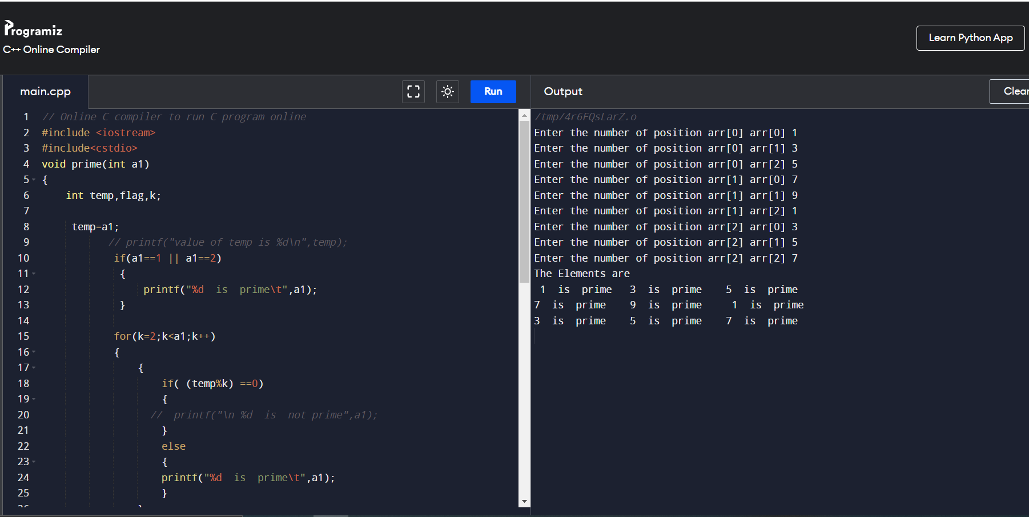

//3 write a program to check Pallindrome numbers in 2D Array

// Online C compiler to run C program online

#include <iostream>

#include<cstdio>

using namespace std;

void pallindrome(int a)

{

int temp,sum=0,rem;

temp=a;

//printf("value of temp is %d\n",temp);

do

{

rem = temp%10;

sum = (sum*10) + rem;

temp=temp/10;

}while(temp!=0);

if (sum == a)

{

printf("%d is pallindrome\n",a);

}

}

int main() {

// Write C code here

int arr[3][3],i,j,a;

for(i=0;i<3;i++)

{

for(j=0;j<3;j++)

{

printf("\nEnter the number of array at position arr[%d] and a arr[%d]",i,j);

cin>>arr[i][j];

}

}

cout<<"\nThe Elements are \n";

for(i=0;i<3;i++)

{

for(j=0;j<3;j++)

{

a=arr[i][j];

pallindrome(a);

}

cout<<("\n");

}

return 0;

}

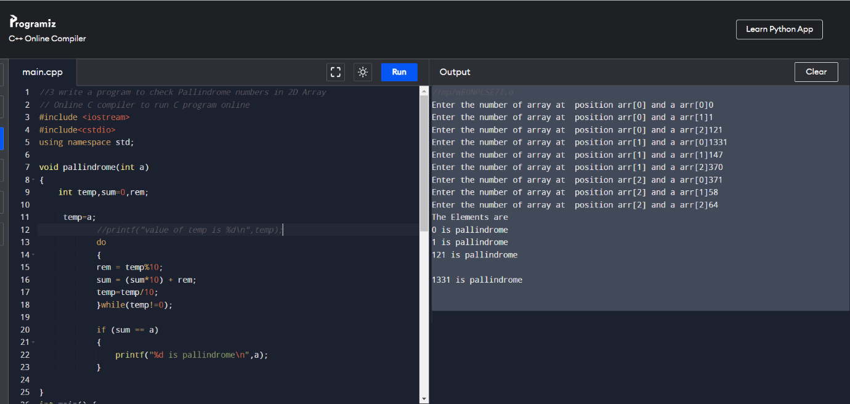

P4= Wap to print Armstrong numbers in 2d Array

// Online C compiler to run C program online

#include<iostream>

using namespace std;

void pallindrome(int a1)

{

int temp,sum=0,rem;

temp=a1;

while(temp!=0)

{

rem=temp%10;

sum=( sum + (rem*rem*rem) );

temp=temp/10;

}

if (sum == a1)

{

cout<<a1<<"is Armstrong \n";

}

}

int main() {

// Write C code here

int arr[3][3],i,j,a;

for(i=0;i<3;i++)

{

for(j=0;j<3;j++)

{

cout<<"\nEnter the number of 2d array";

cin>>arr[i][j];

}

}

cout<<"The Elements of Matrix\n";

for(i=0;i<3;i++)

{

for(j=0;j<3;j++)

{

a=arr[i][j];

pallindrome(a);

}

cout<<"\n";

}

return 0;

}

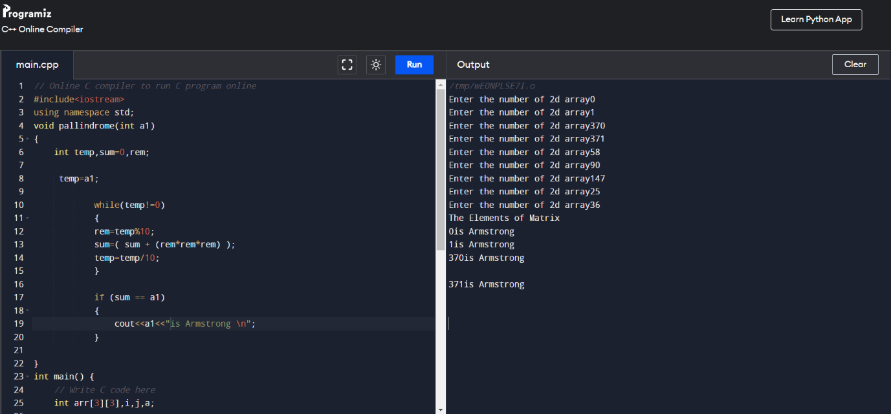

**07-02-2022 Functions**

//100C++ prgrm to swap two variable using function no argumnt no return type

//input 1,2

//expected output=2,1

#include<iostream>

#include<cstdio>

void swap();

int main()

{

swap();

}

void swap()

{

int a,b,c;

a=1;

b=2;

printf("Value before swap:%d %d",a,b);

c=b;

b=a;

a=c;

printf("using function no argumnt no return type Value after swap:%d %d",a,b);

}

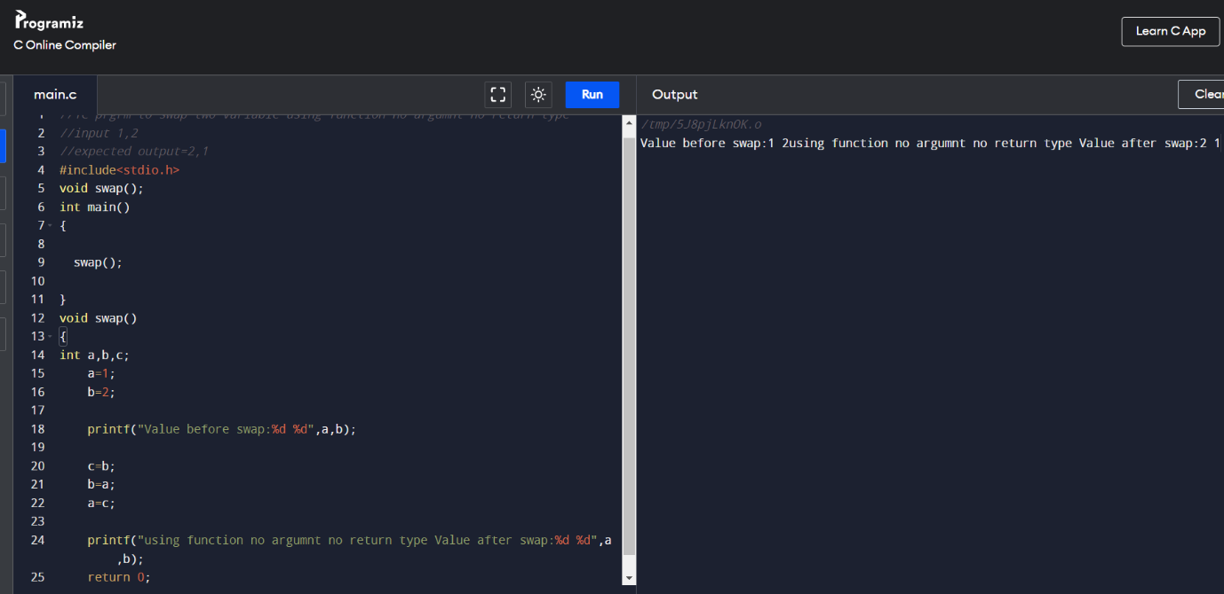

//2Diffrentiate between integer and float

//prgm to print integer and float values of no

//using no argmnt ,no return type of function

//input=5.6

//output= int=5 , float=.6

#include<iostream>

#include<cstdio>

void diff();

int main()

{

diff();

}

void diff()

{

float x;

int y;

float z;

printf("Enter the number: ");

scanf("%f",&x);

y= x;

z=x-y;

printf("Int is: %d, Float is: %f ",y,z);

}

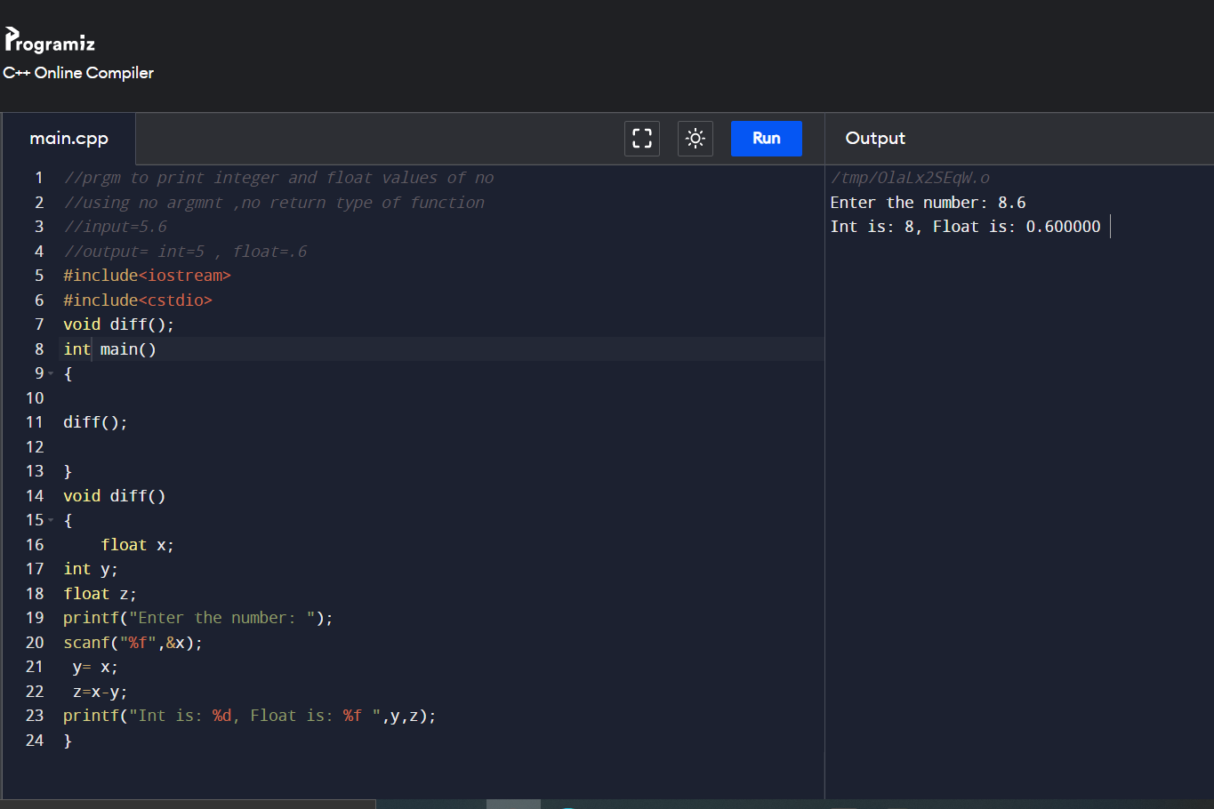

//103 Wap to find area of circle.

//using no argmnt ,no return type of function

//input=5

//output= 3.14*5*5

#include<iostream>

#include<cstdio>

void area();

int main()

{

area();

}

void area()

{

float area;

int radius;

printf("\nEnter the radius of Circle : ");

scanf("%d",&radius);

printf("\nRadiusof Circle : %d",radius);

area = 3.14 * radius * radius;

printf("\nArea of Circle : %f", area);

}

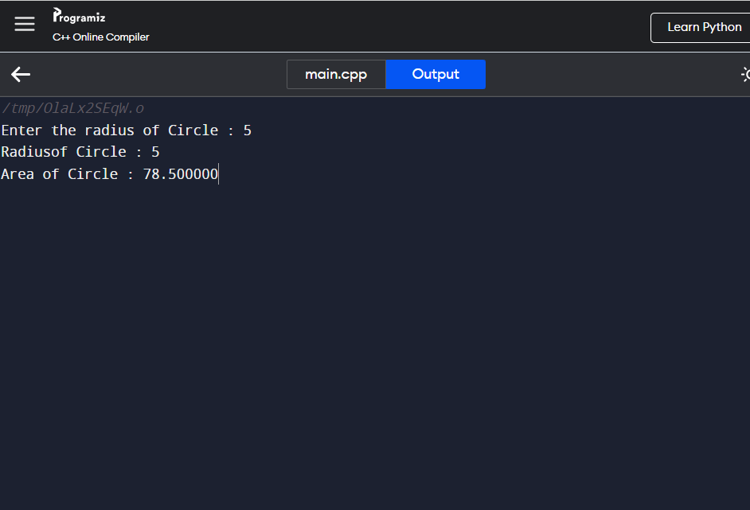

//104 To print area of rectangle

//prgm to print integer and float values of no

//using no argmnt ,no return type of function

//input=5 6

//output= 30

#include<iostream>

#include<cstdio>

void area();

int main()

{

area();

}

void area()

{

int width=5;

int height=10;

int area=width*height;

printf("Area of the rectangle=%d",area);

}

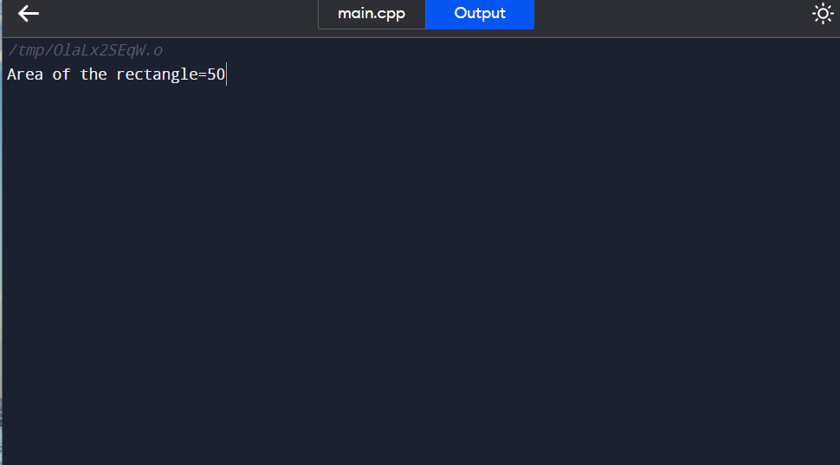

//105 Calculate simple interest

#include <stdio.h>

float value(void);

void main()

{

float f=value();

printf(" The total amount is %f:", f);

}

float value(void)

{

int year = 1, period = 5, amount = 5000, inrate = 0.12;

float sum;

sum = amount;

while (year <= period) {

sum = sum * (1 + inrate);

year = year + 1;

}

return sum;

}

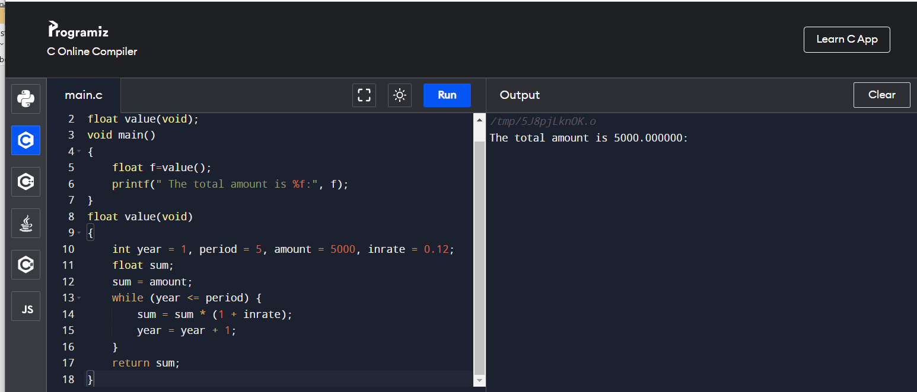

.

08-02-2022

**Call by Reference**

P1 Write a program to print prime number by passing address of variable as argument

P2 Smallest and largest number by passing address of variable as argument

P3 For loop programs

P4 While loop programs

P5 Do while loop programs

#include <iostream>

using namespace std;

//function to check number is prime or not

//function will return 1 if number is prime

int isPrime(int *num)

{

int i; //loop counter

//it will be 1 when number is not prime

int flag=0;

//loop to check number is prime or not

//we will check, if number is divisible

//by any number from 2 to num/2, then it

//will not be prime

for(i=2; i<*num/2; i++)

{

if(*num%i ==0)

{

flag =1;

break;

}

}

//flag is 1, if number is not prime

if(flag==1)

return 0;

else

return 1;

}

int main()

{

int loop; //loop counter

//declaring array with prime and not prime numbers

int arr[]={100, 200, 31, 13, 97, 10, 20, 11};

//calculate length of the array

int len = sizeof(arr)/sizeof(arr[0]);

//print array elements with message

//"prime" or "Not prime"

for(loop=0; loop<len; loop++)

{

if(isPrime(&arr[loop]))

cout<<arr[loop]<<"is prime"<<"\n";

else

cout<<arr[loop]<<"is not prime"<<"\n";

}

printf("\n");

return 0;

}

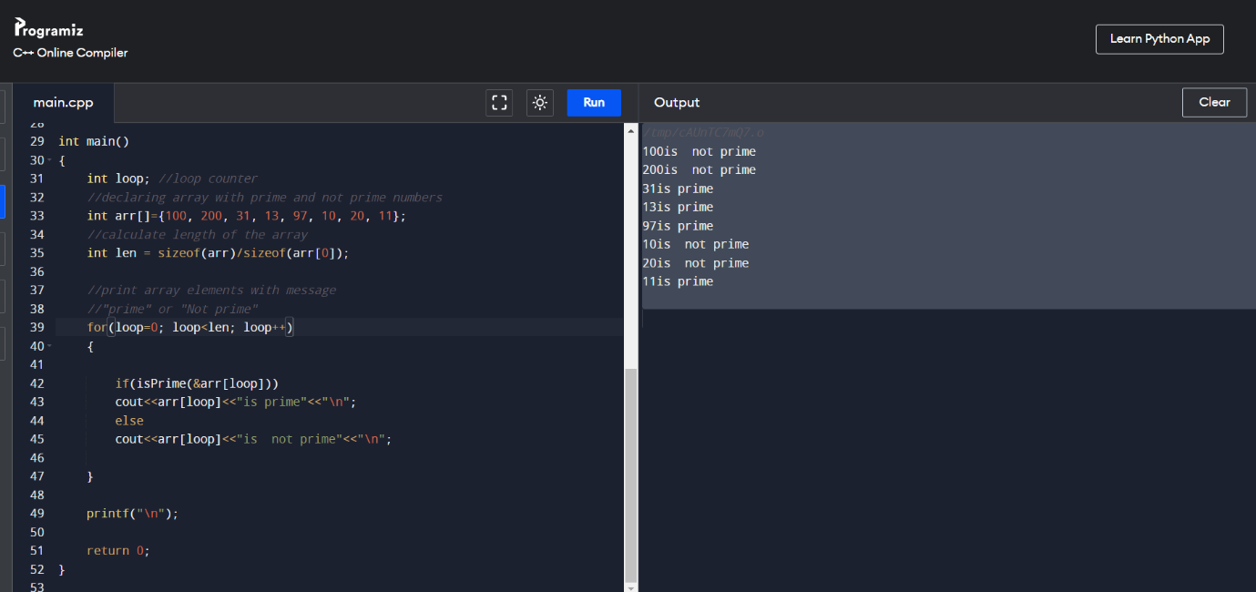

//2 Smallest and largest integer using call by reference

//inpput: 1,2,

//Expected output min=1, max=5

#include <iostream>

using namespace std;

void min_max(int *a,int *b)

{

int min,max,i;

min=max=0;

i=1;

if(min>*a)

{

min=*a;

max=*b;

}

else

{min=*b;

max=*a;}

printf("minimum number is : %d",min);

printf("\nmaximum number is : %d",max);

}

int main()

{

int i,a,b;

cout<<("Enter two elements : ");

cin>>a>>b;

min_max(&a,&b);

return 0;

}

..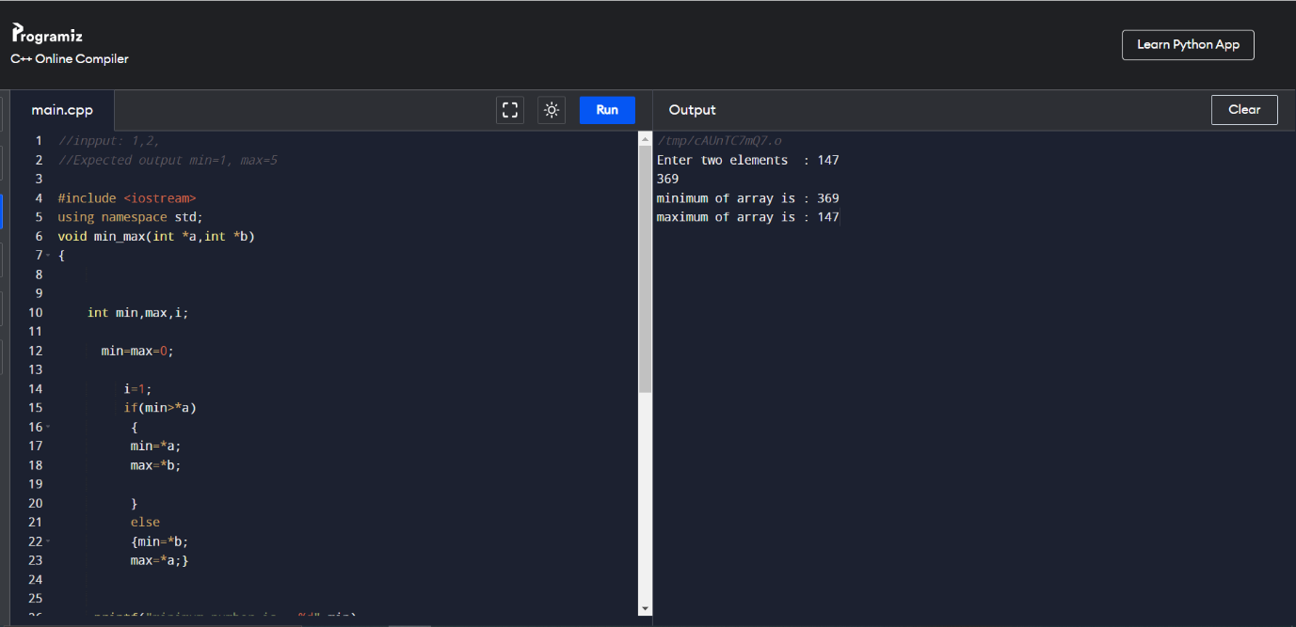

For loop programs

C++

//108 To print wheter a program is even or not

#include<iostream>

#include<cstdio>

void fun();

int main()

{

fun();

}

void fun()

{

int num;

printf("Enter an integer: ");

cin>>num;

if(num % 2 == 0)

printf("%d is even.", num);

else

printf("%d is odd.", num);

return 0;

}

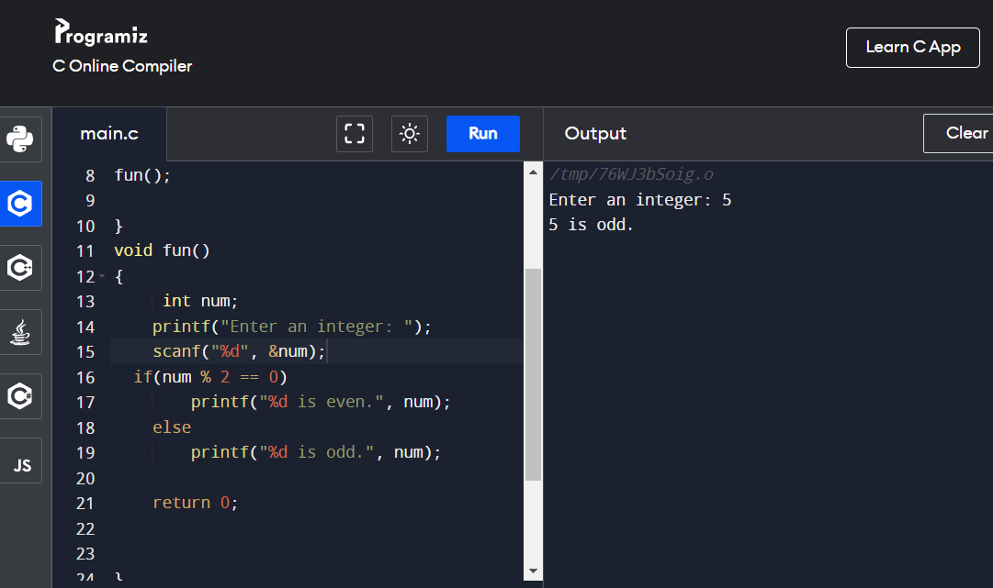

//108//input= 6000m

//output =6km , greater thn 5 home delivery available

#include <stdio.h>

void fun();

int main()

{

fun();

}

void fun()

{

int a;

float b;

printf("enter the number");

scanf("%d",&a);

b = a/1000;

if(b>5)

printf("Home delivery is Available");

else

printf("not available");

}

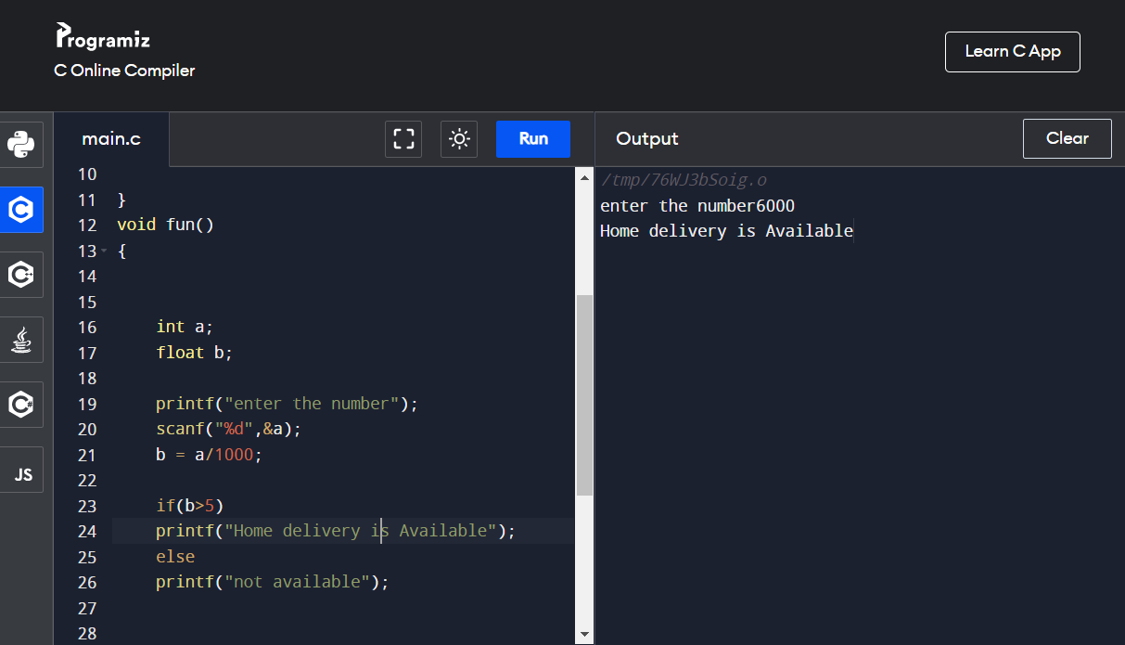

//109 Program to print factorial of number

//input= 5

//expected output =factorial is 120 ,

#include <stdio.h>

void fun();

int main()

{

fun();

}

void fun()

{

int number,res=1,i;

printf("enter number");

scanf("%d",&number);

int t=number;

for(i=1;i<=t;i++)

{

res = res*number;

number=number-1;

}

printf("factorial of number is:%d",res);

}

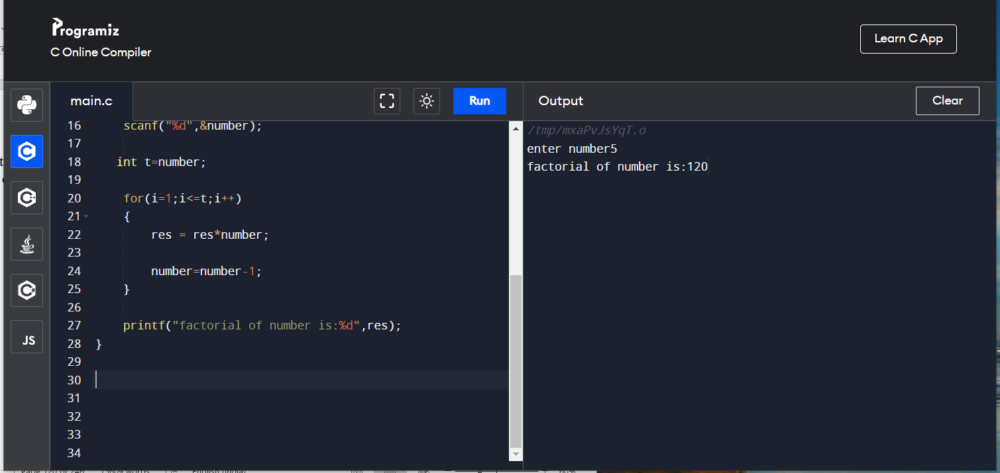

//110 Write a Program to reverse a number

//input= 123

//expected output = reverse is 321

#include <iostream>

Using namespace std;

void fun();

int main()

{

fun();

}

void fun()

{

int remainder,res=0,i;

int number,t;

printf("enter the number");

scanf("%d",&number);

t=number;

for(i=0;number!='\0';i++)

{

remainder =number%10;

res=res*10+remainder;

number=number/10;

}

printf("Reverse of number:%d",res);

}

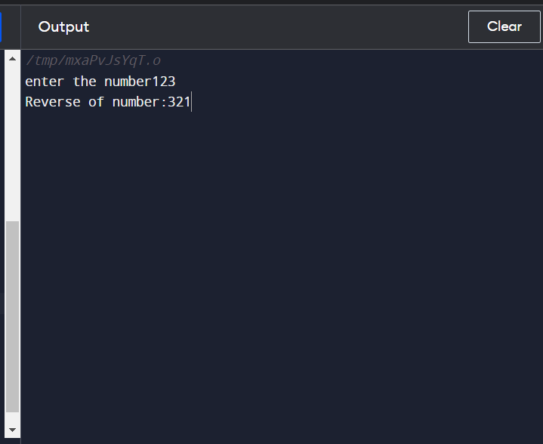

//111 Write a program to count digits of a number

//input= 123

//expected output = digit is 3

#include <iostream>

#include<cstdio>

Using namespace std;

void fun();

int main()

{

fun();

}

void fun()

{

int remainder,res=0,i;

int number,t,count=0;

printf("enter the number");

scanf("%d",&number);

for(i=0;number!='\0';i++)

{

remainder =number%10;

count++;

number=number/10;

}

printf("Digits of number:%d",count);

}

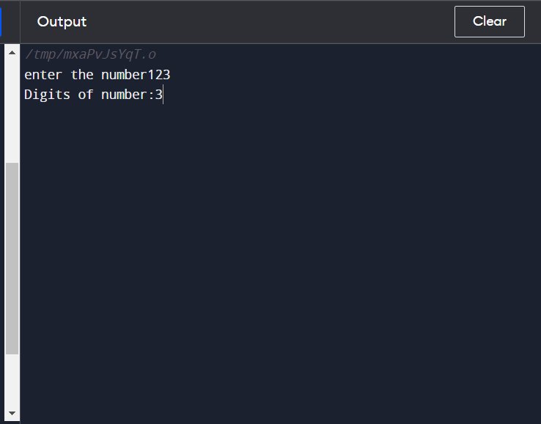

//112 To print sum of digit

//input= 123

//expected output = sum of digit is 6

#include <stdio.h>

void fun();

int main()

{

fun();

}

void fun()

{

int n,a,s=0;

printf("Enter a number: ");

scanf("%d",&n);

while(n>0){

a=n%10;

s+=a;

n=n/10;

}

printf("\nSum is: %d", s);

return 0;

}

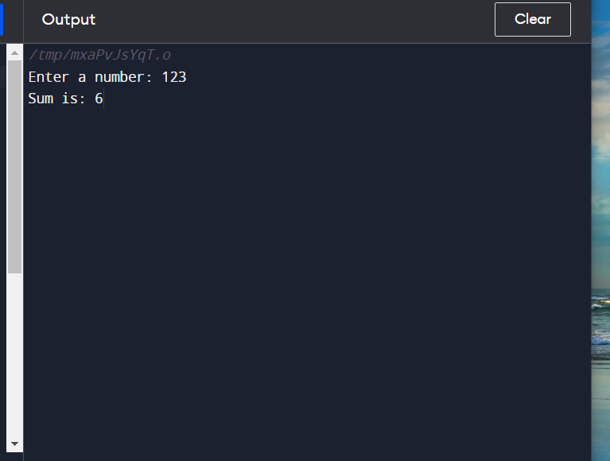

//113 to check program is palindrome or not

//input= 121

//expected output = no is pallindrome

#include <stdio.h>

void fun();

int main()

{

fun();

}

void fun()

{

int i,n,r,s=0;

printf("\n Enter The Number:");

scanf("%d",&n);

//LOOP TO FIND REVERSE OF A NUMBER

for(i=n;i>0; )

{

r=i%10;

s=s*10+r;

i=i/10;

}

/* CHECKING IF THE NUMBER ENTERED AND THE REVERSE NUMBER IS EQUAL OR NOT */

if(s==n)

{

printf("\n %d is a Palindrome Number",n);

}

else

{

printf("\n %d is not a Palindrome Number",n);

}

}

114 Write a program to check a Armstrong number

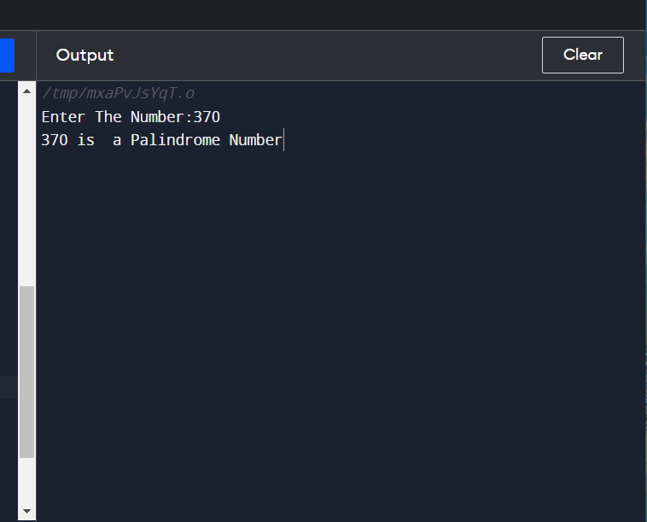

//input= 370

//expected output = no is armstrong 27+

#include <stdio.h>

void fun();

int main()

{

fun();

}

void fun()

{

int i,n,r,s=0;

printf("\n Enter The Number:");

scanf("%d",&n);

//LOOP TO FIND REVERSE OF A NUMBER

for(i=n;i>0; )

{

r=i%10;

s=s*10+r;

i=i/10;

}

/* CHECKING IF THE NUMBER ENTERED AND THE REVERSE NUMBER IS EQUAL OR NOT */

if(s==n)

{

printf("\n %d is not a Palindrome Number",n);

}

else

{

printf("\n %d is a Palindrome Number",n);

}

}

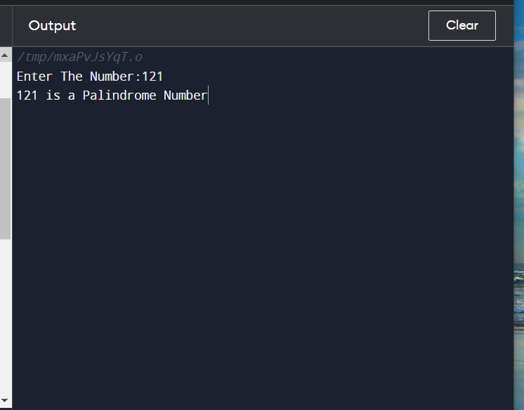

115 to find factorial of number

115 to find factorial of number

//input= 1 4

//expected output =1 2 6 24

#include <stdio.h>

void fun();

int main()

{

fun();

}

void fun()

{

int i,j,n1,n2;

long fact=1;

printf("Enter starting number: ");

scanf("%d",&n1);

printf("Enter ending number: ");

scanf("%d",&n2);

for(i=n1;i<=n2;i++)

{

fact=1;

for(j=1;j<=i;j++)

{

fact=fact*j;

}

printf("Factorial is: %ld ",fact);

}

}

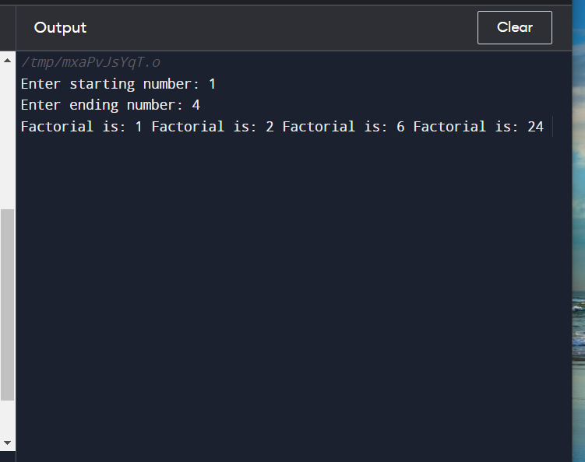

//116 Write a program to find min max of a given number

//input= 1 4

//expected output =1 2 6 24

#include <stdio.h>

void fun();

int main()

{

fun();

}

void fun()

{

int i,max,min,N,x;

printf("Enter N : ");

scanf("%d",&N);

max=0;

min=999;

i=1;

do

{

printf("Enter x-%d : ",i);

scanf("%d",&x);

if(max < x)

max = x;

if(min > x)

min = x;

i++;

}while(i<=N);

printf("\n max = %d",max);

printf("\n min = %d",min);

return 0;

}

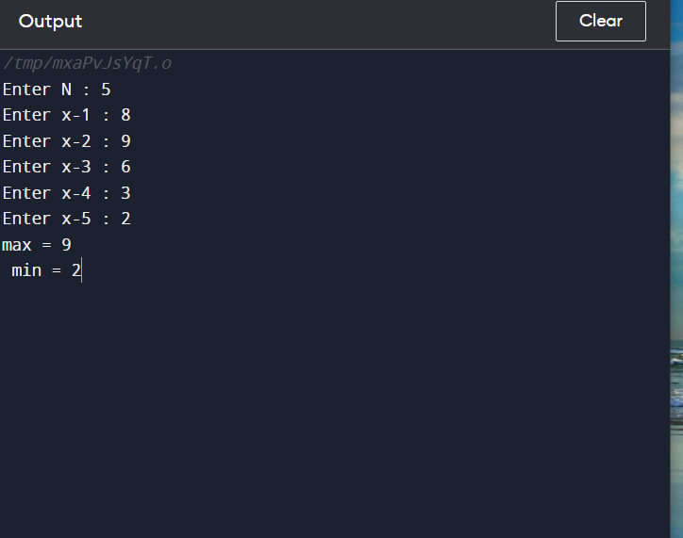

//117 Even numbers in a range

//input= 1 10

//expected output =2 4 6 8 10

#include <stdio.h>

void fun();

int main()

{

fun();

}

void fun()

{

int i, n;

/* Input upper limit of even number from user */

printf("Print all even numbers till: ");

scanf("%d", &n);

printf("Even numbers from 1 to %d are: \n", n);

for(i=1; i<=n; i++)

{

/* Check even condition before printing */

if(i%2 == 0)

{

printf("%d\n", i);

}

}

return 0;

}

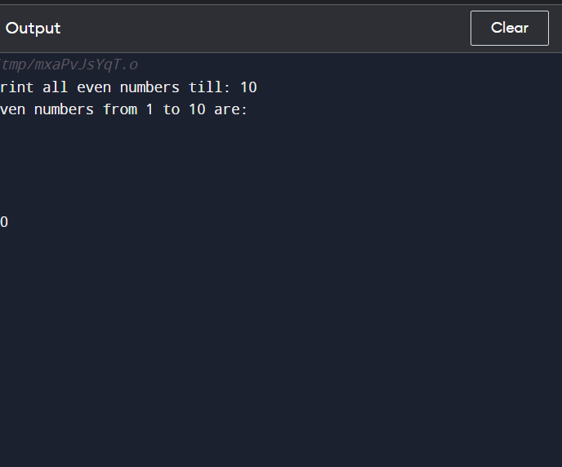

///116 Odd number in a range

//input= 1 10

//expected output =1 3 5 9 10

#include <stdio.h>

void fun();

int main()

{

fun();

}

void fun()

{

int i, n;

/* Input upper limit of even number from user */

printf("Print all odd numbers till: ");

scanf("%d", &n);

printf("odd numbers from 1 to %d are: \n", n);

for(i=1; i<=n; i++)

{

/* Check even condition before printing */

if(i%2 == 0)

{

printf("%d\n", i+1);

}

}

return 0;

}

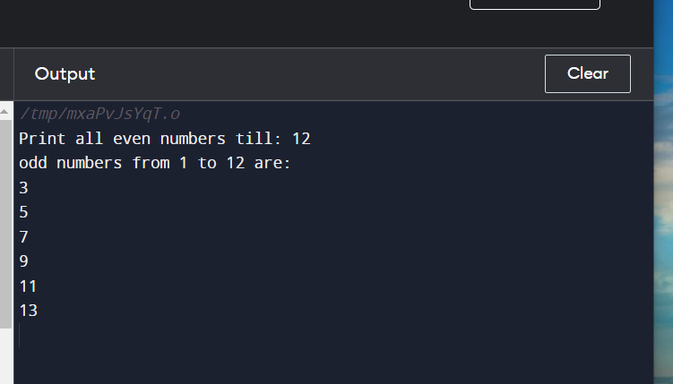

//117 write a program to print palindrome in range

//input= 1 100

//expected output =1 2 3 4 5 6 7 8 9 11 22 33

#include <stdio.h>

void fun();

int main()

{

fun();

}

void fun()

{

int temp,sum=0,rem,n,i;

/* Input upper limit of even number from user */

printf("Print Pallindrome odd numbers till: ");

scanf("%d", &n);

for(i=1; i<=n; i++)

{

temp=i;

while(temp!=0)

{

rem=temp%10;

sum=(sum*10) + rem;

temp=temp/10;

}

if (sum == i)

{

printf("%d is pallindrome\n",i);

}

sum=0;

}

}

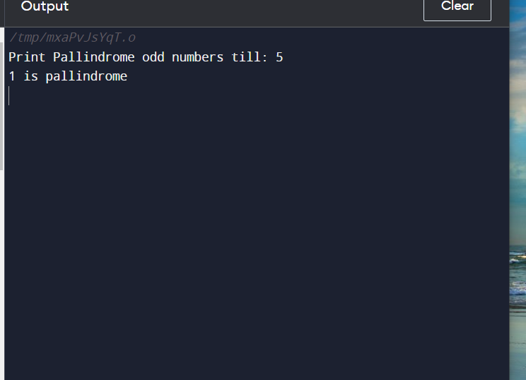

118 Printf prime numbers between 1 to 100

#include <stdio.h>

//input= 1 100

//expected output =1 3 5 7 9

void fun();

int main()

{

printf("hello");

fun();

}

void fun()

{

int temp,flag,k,n,i;

printf("Print prime numbers till: ");

scanf("%d", &n);

for(i=1; i<=n; i++)

{

temp=i;

// printf("value of temp is %d\n",temp);

if(i==1 || i==2)

{

printf("%d is prime\n",i);

}

for(k=2;k<i;k++)

{

{

if( (temp%k) ==0)

{

// printf("\n %d is not prime",a1);

}

else

{

printf("\n%d is prime\t",i);

}

}

break;

}

}

}

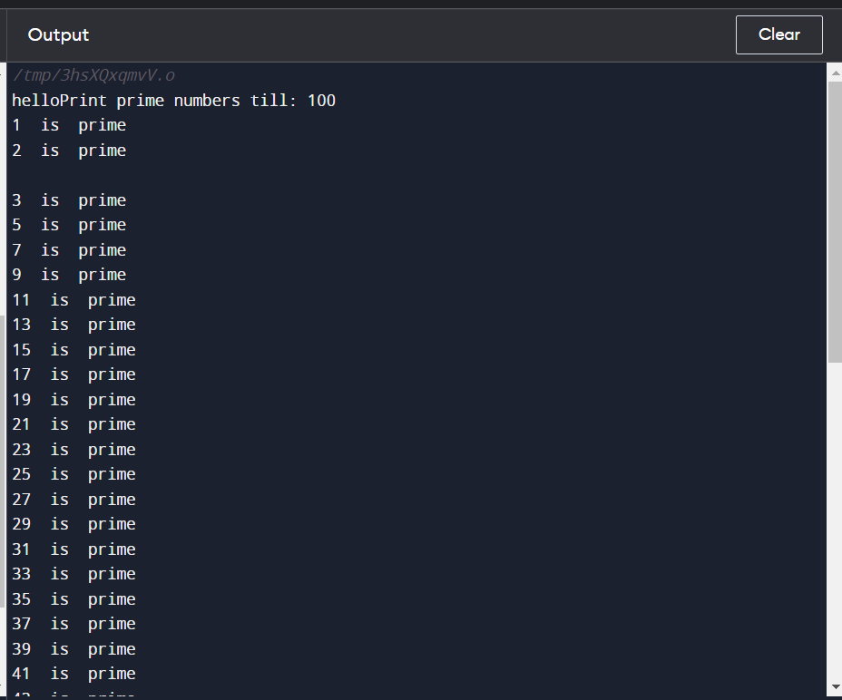

119 progrm to print array elements

#include <stdio.h>

//input= 1 100

//expected output =1 3 5 7 9

void fun();

int main()

{

fun();

}

void fun()

{

int loop; //loop counter

//declaring array with prime and not prime numbers

int arr[]={2, 200, 31, 13, 97, 10, 20, 11};

//calculate length of the array

int len = sizeof(arr)/sizeof(arr[0]);

//print array elements with message

//"prime" or "Not prime"

for(loop=0; loop<len; loop++)

{

printf("%d\t",arr[loop]);

}

printf("total count of prime is 5\n");

}

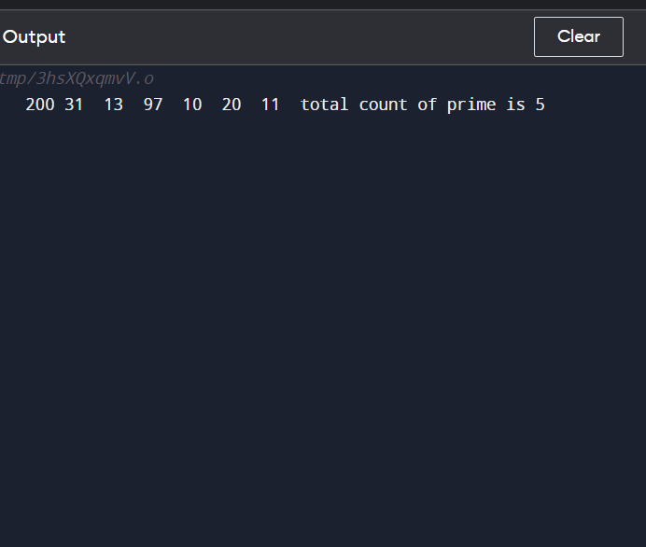

./// 120 sum of all elements of array

#include <stdio.h>

//input= 1 100

//expected output =1 3 5 7 9

void fun();

int main()

{

fun();

}

void fun()

{

int loop,sum=0; //loop counter

//declaring array with prime and not prime numbers

int arr[]={2, 200, 31, 13, 97, 10, 20, 11};

//calculate length of the array

int len = sizeof(arr)/sizeof(arr[0]);

//print array elements with message

//"prime" or "Not prime"

for(loop=0; loop<len; loop++)

{

sum=sum+arr[loop];

}

printf("%d\t",sum);

}

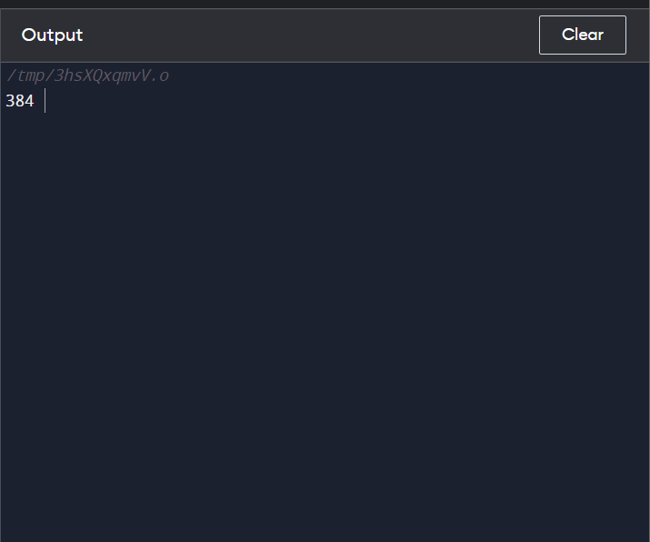

//122 prgm to find position of array

#include <stdio.h>

//input= 1 100

//expected output =1 3 5 7 9

void fun();

int main()

{

fun();

}

void fun()

{int i,n,sum=0,f,flag=0;

printf("\n Enter The Total Numbers:");

scanf("%d",&n);

int arr[n];

printf("\n Start Entering The Number:");

for(i=0;i<n;i++)

{

scanf("\n%d",&arr[i]);

}

printf("\nEnter number to search in given array \n");

scanf("\n%d",&f);

for(i=0;i<n;i++)

{

if(f==arr[i])

{

printf("position of number is :%d",++i);

flag=1;

break;

}

}

if (flag==0)

printf("Elemnt not found in arry");

return 0;

}

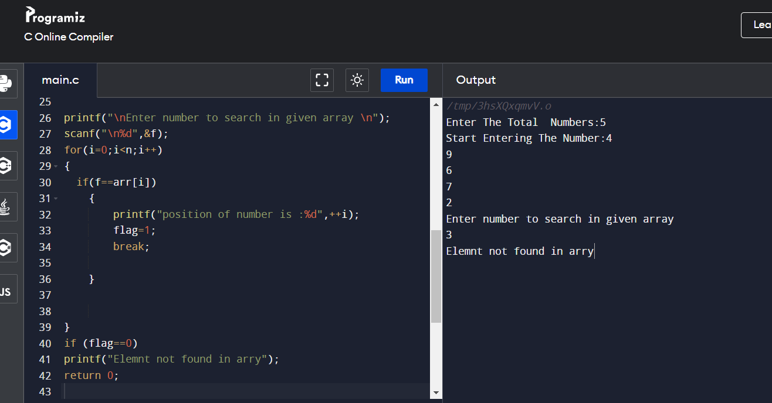

//125 write a prgrm to print in ascending order

#include <stdio.h>

//input= 1 100

//expected output =1 3 5 7 9

void fun();

int main()

{

fun();

}

void fun()

{

int i, j, a, n, number[30];

printf("Enter the value of N \n");

scanf("%d", &n);

printf("Enter the numbers \n");

for (i = 0; i < n; ++i)

scanf("%d", &number[i]);

for (i = 0; i < n; ++i)

{

for (j = i + 1; j < n; ++j)

{

if (number[i] > number[j])

{

a = number[i];

number[i] = number[j];

number[j] = a;

}

}

}

printf("The numbers arranged in ascending order are given below \n");

for (i = 0; i < n; ++i)

printf("%d\n", number[i]);

}

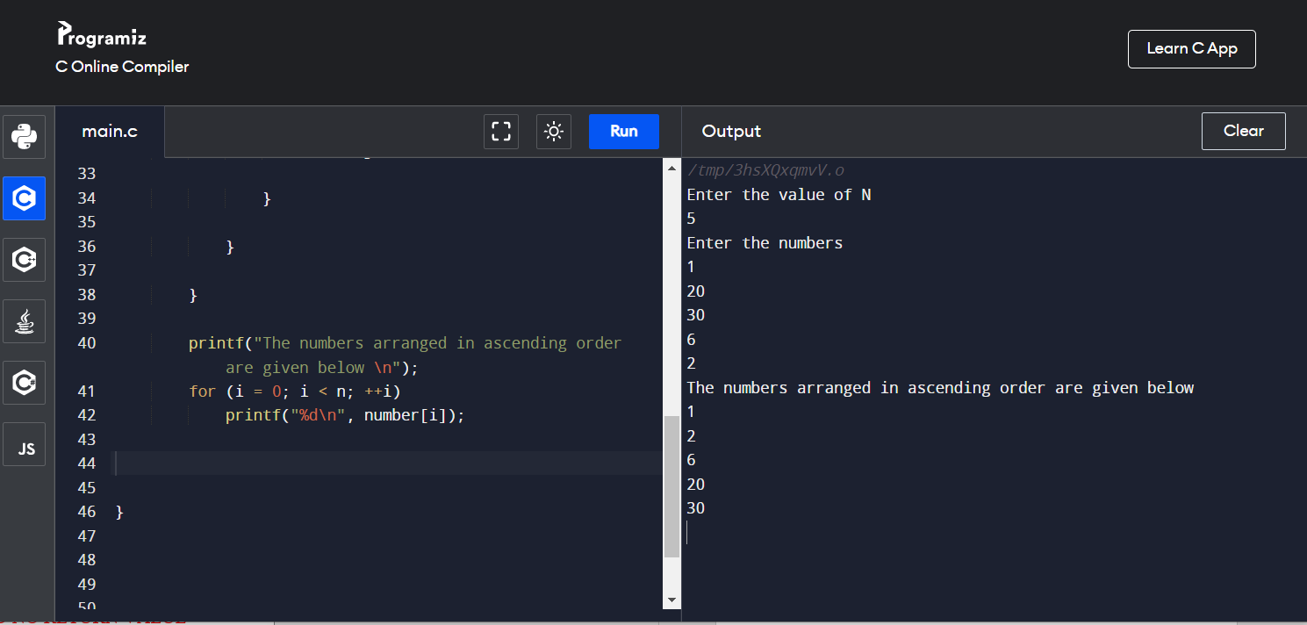

//121 Sort in descending order

#include <stdio.h>

//input= 1 100

//expected output =1 3 5 7 9

void fun();

int main()

{

fun();

}

void fun()

{

int i, j, a, n, number[30];

printf("Enter the value of N \n");

scanf("%d", &n);

printf("Enter the numbers \n");

for (i = 0; i < n; ++i)

scanf("%d", &number[i]);

for (i = 0; i < n; ++i)

{

for (j = i + 1; j < n; ++j)

{

if (number[i] < number[j])

{

a = number[i];

number[i] = number[j];

number[j] = a;

}

}

}

printf("The numbers arranged in descending order are given below \n");

for (i = 0; i < n; ++i)

printf("%d\n", number[i]);

}

//127 check wheter number is even or not

#include <stdio.h>

//input= 2 4 6 10 15

//expected output =2 4 6 10

void fun();

int main()

{

fun();

}

void fun()

{

int i, j, a, n, number[30];

printf("Enter the value of N \n");

scanf("%d", &n);

printf("Enter the numbers \n");

for (i = 0; i < n; ++i)

scanf("%d", &number[i]);

for (i = 0; i < n; ++i)

{

if(number[i]%2==0)

printf("%d is even\n",number[i]);

}

}

//128 prgrm to print no is odd or not

#include <stdio.h>

//input= 1 3 5 8 6

//expected output =1 3 5 ,3

void fun();

int main()

{

fun();

}

void fun()

{

int i, j, a, n, number[30],count=0;

printf("Enter the value of N \n");

scanf("%d", &n);

printf("Enter the numbers \n");

for (i = 0; i < n; ++i)

scanf("%d", &number[i]);

for (i = 0; i < n; ++i)

{

if(number[i]%2==1)

{printf("%d is odd\n",number[i]);

count++;

}

}

printf("total odd no are:%d",count);

}