Welcome Reader,

Introduction:
This is a Maven project which is used for automating REST APIs. Framework used is Rest Assured with BDD, Cucumber and Java with Junit integration.

Configuration Intsructions:
You can clone the project from
https://github.com/Nitin07AtWork/MS_Tajawal_TestSuite.git
Or you can download it as ZIP file after which you can import is as an existing Maven project in Eclipse IDE.

Usage Instructions:
- Once the project is imported then one can see POM.xml at the bottom of the project in Project explorer. One can use this file to add dependencies to the project if the framework needs to be scaled for further usage.

- TestRunner File is the driver file which can be used to execute the test cases/Scenario or Fetaure files. It works on tag identification and searches for the tag mentioned in the folder specified.
Path: \src\test\java\com\tajawal\runner\TestRunner.java

- For your convenience tag @hotels_Regression is mentioned in the Runner file which when triggered will execute all the scenarios on which the tag is placed in the feature files.

- To execute a scenario of your own choice, you can navigate to \src\test\resources\features and choose the file from which you want to execute the testcases.Select a feature file and you can add a tag with @ over a Scenario.Use the same tag in runner file for execution.

- \src\test\java\com\tajawal\stepdefs This directory contains all the step definitions which are utilized for the execution of steps mentioned in the Feature file under each scenario.For further scalability one can add new step definitions under this folder

- \src\test\java\com\tajawal\utilities This directory contains the utilitiy files which either contain classes which have reusable methods or contain classes which are used for the reporting purpose

- \src\test\resources\payloads This directory contains all the payloads which are to be used for creation of request body for the Rest endpoints. Please note that data is dynamically passed through the feature file which is overridden in the existing json structure mentioned in the json file.

- \src\test\resources\properties This directory contains the properties file which are to be used to access the configurable properties which are needed in order to execute the test cases on desired environment or for the purpose of creating URIs for different endpoints

Reporting
Once the test cases are executed, then the reports for those cases are stored under \target folder.One can refresh the target folder in order to see the latest test results under cucumber-html-report folder.There once can right click in index.html and open it with Web Browser. Doing so, will display the test report of the scenarios executed.
Same reports can be uploaded to Jira with the help of Extent Reports extension.
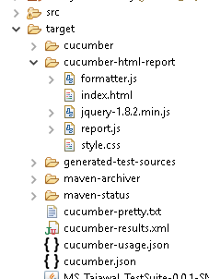

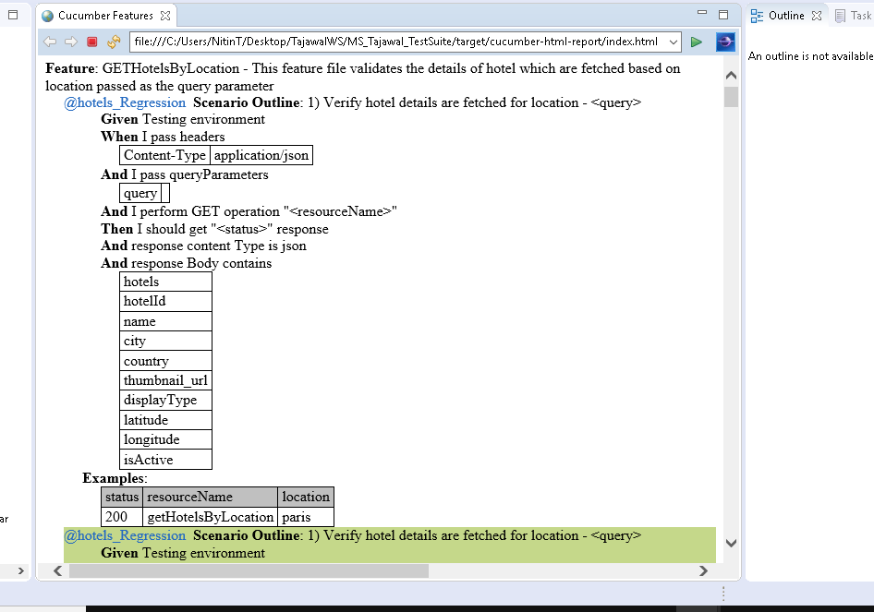

Thank you for reaching till here .In case of any issues, you can reach out on Nitin07.atwork@gmail.com

END OF DOCUMENT

