**ShopNest** **Store**

1. Top Categories by Total Price:

* Identify and visually represent the top 10 product categories by total sales.

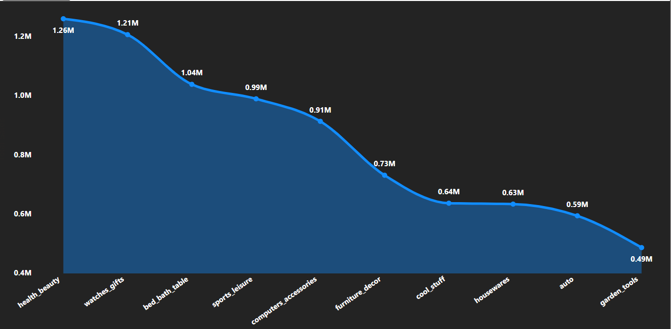

**Insights and Findings**

1. **Top Performing Category:**
   * **health beauty has the highest total sales (1.26M). This indicates it's the top-performing category in terms of revenue.**
2. **Significant Revenue:**
   * **watches_gifts follows closely with 1.21M in sales.**
   * **bed_bath_table also contributes significantly with 1.04M in sales.**
3. **Decreasing Trend:**
   * **The chart clearly shows a decreasing trend in sales as we move from left to right along the X-axis. This indicates that the categories are sorted in descending order of sales.**
4. **Mid-Range Performers:**
   * **Categories like sports_leisure, computers_accessories, and furniture_decor fall within a mid-range of sales, ranging from approximately 0.99M to 0.73M.**
5. **Lower Sales Categories:**
   * **Categories like cool_stuff, housewares, auto, and garden_tools have lower sales, ranging from 0.64M to 0.49M.**
6. **Visual Hierarchy:**
   * **The area chart effectively shows the relative contribution of each category to the total sales.**
   * **The decreasing trend is visually clear, making it easy to identify the top and bottom performers.**

2. Delayed Orders Analysis:

* Determine the number of delayed orders in each category. An order is considered delayed if the actual delivery date is later than the estimated delivery date.

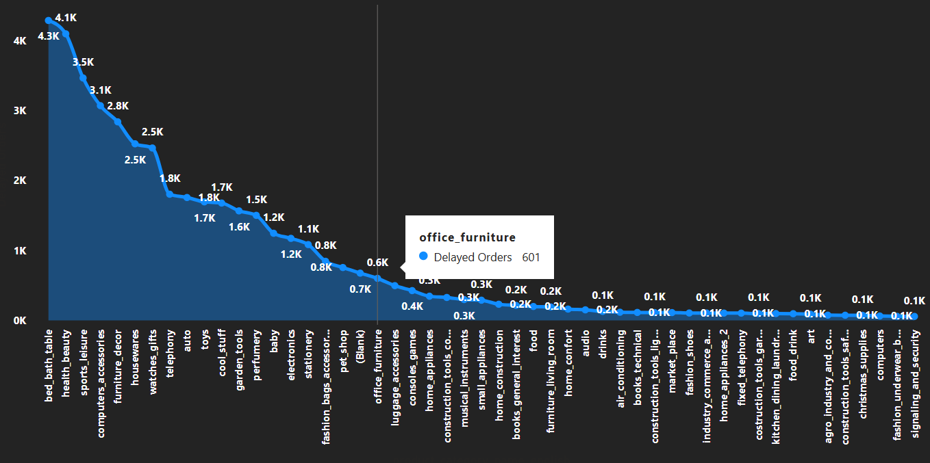

**Insights and Findings**

1. **Top Categories with Delayed Orders:**
   * **bed bath table** has the highest number of delayed orders (4.1K). This category significantly exceeds other categories in delayed orders.
   * **health beauty** and **sports leisure** follow, with 3.5K and 3.1K delayed orders, respectively.
   * **computers accessories** and **furniture decor** also have a substantial number of delayed orders (2.8K and 2.5K).
2. **Mid-Range Delayed Orders:**
   * Categories like **housewares**, **watches gifts**, **telephony**, **toys**, **cool stuff**, **garden tools**, **perfumery**, **baby**, and **electronics** show a moderate number of delayed orders, ranging from approximately 1.7K to 0.8K.
3. **Low Delayed Orders:**
   * Many categories have a very low number of delayed orders, often below 0.3K (300). These include categories like **home appliances**, **musical instruments**, **small appliances**, and numerous others towards the right side of the chart.
4. **Home Appliances Highlight:**
   * The chart specifically highlights **home appliances**, showing that this category has 346 delayed orders (0.3K). This is a relatively low number compared to the top categories.
5. **Long Tail Distribution:**
   * The chart demonstrates a long-tail distribution. A few categories have a large number of delayed orders, while many categories have very few.

**Insights in Relation to Delayed Orders**

* **Prioritize Problem Areas:** The categories with the highest number of delayed orders (bed bath table, health beauty, sports leisure, etc.) should be prioritized for investigation and improvement.
* **Identify Root Causes:** It's essential to determine the root causes of the delays in these top categories. This could involve analyzing factors such as:
  + Supplier delays
  + Logistics and shipping issues
  + Inventory management problems
  + High demand exceeding capacity

3. Monthly Comparison of Delayed and On-Time Orders:

* Create a dynamic visual that compares the number of delayed orders to the number of orders received earlier for each month. Utilize the drillthrough cross-report feature to provide a detailed analysis of late and on-time deliveries.

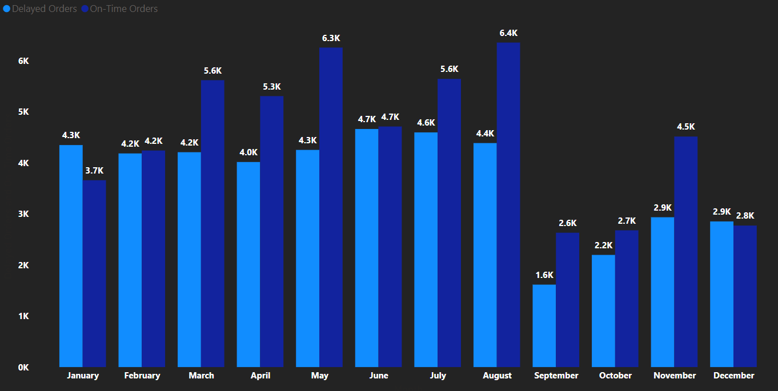

**Insights and Findings**

1. **Overall Trend:**
   * The chart shows a clear monthly comparison of delayed and on-time orders, allowing for trend analysis.
   * In most months, on-time orders exceed delayed orders, indicating a generally efficient delivery process.
2. **Peak On-Time Orders:**
   * **August** has the highest number of on-time orders (6.4K), indicating a peak in successful deliveries.
   * **June** also shows a high number of on-time orders (6.3K).
3. **Peak Delayed Orders:**
   * **June** has the highest number of delayed orders (4.7K), coinciding with a high volume of on-time orders. This suggests that while overall delivery volume was high, there were also more issues resulting in delays.
   * **July** also shows a relatively high number of delayed orders (4.6K).
4. **Low Delayed Orders:**
   * **September** has the lowest number of delayed orders (1.6K).
   * **October** also shows a low number of delayed orders (2.2K).
5. **• Low On-Time Orders:**
   * **October has the lowest number of on-time orders (2.2K).**
   * **September also shows a low number of on-time orders (2.6K).**

**4. Payment Method Analysis:**

* **Analyze the most frequently used payment methods by customers using a visually appealing representation, such as a pie chart or other suitable visuals.**

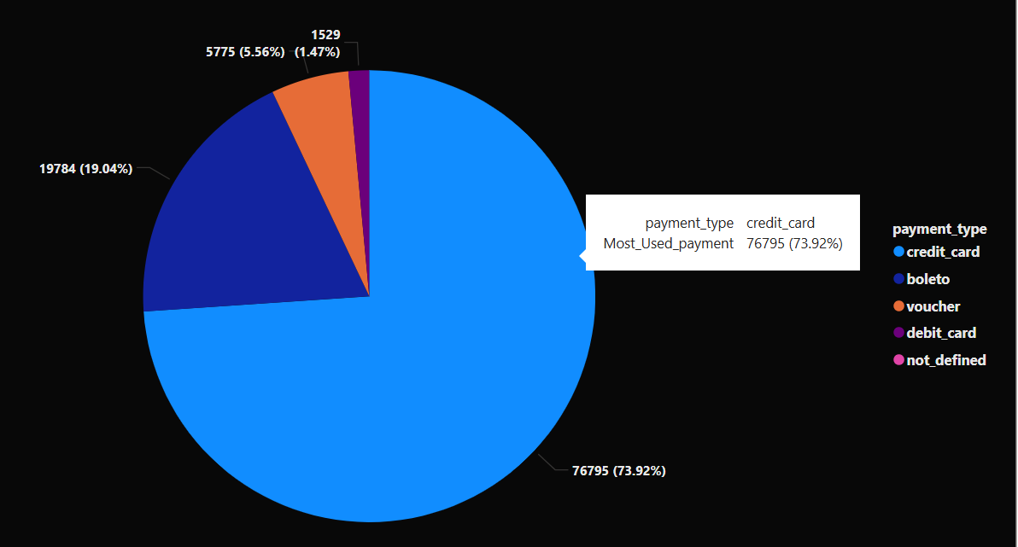

**Insights and Findings**

1. **Dominant Payment Method:**
   * **Credit card is the most frequently used payment method, representing 73.92% of all transactions (76,795 transactions). This indicates a strong preference for credit card payments among customers.**
2. **Significant Second Method:**
   * **Boleto (a Brazilian payment slip) is the second most common payment method, accounting for 19.04% of transactions (19,784 transactions). While significantly lower than credit card, it still represents a substantial portion of payments.**
3. **Less Common Methods:**
   * **Voucher represents 5.56% of transactions (5,775 transactions).**
   * **Debit card and not defined (likely missing or unknown data) account for very small percentages, 1.47% (1,529 transactions) and a negligible amount, respectively.**
4. **Clear Visual Hierarchy:**
   * **The pie chart effectively shows the dominance of credit card payments.**
   * **The large slice for credit card immediately draws attention to its significance.**
   * **The smaller slices for other payment methods are also clearly visible, allowing for easy comparison.**

**5. Product Rating Analysis:**

* **Determine the top 10 highest-rated products and the bottom 10 lowest-rated products using a bar or column chart.**

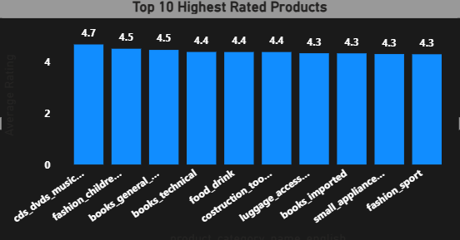

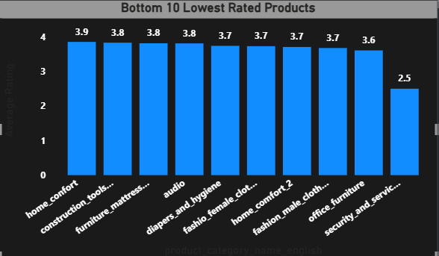

**Insights and Findings**

**Top 10 Highest Rated Products**

1. **High Average Ratings: All top 10 categories have average ratings above 4.3, indicating generally high customer satisfaction.**
2. **Top Performer: "cds_dvds_music..." has the highest average rating of 4.7.**
3. **Consistent High Ratings: The ratings are relatively close, ranging from 4.7 to 4.3, suggesting a consistent level of quality among these top categories.**
4. **Category Diversity: The top 10 includes a variety of categories, such as "fashion_children...", "books_general...", "food_drink", and "luggage_access...", indicating broad customer satisfaction across different product types.**

**Bottom 10 Lowest Rated Products**

1. **Lower Average Ratings: The bottom 10 categories have average ratings below 3.9, indicating areas of potential concern.**
2. **Lowest Performer: "security_and_servic..." has the lowest average rating of 2.5, significantly lower than the other bottom categories.**
3. **Category Diversity: Similar to the top 10, the bottom 10 includes a variety of categories, such as "home_confort", "furniture_mattress...", "audio", and "fashion_male_cloth...".**
4. **Rating Range: The ratings in the bottom 10 range from 3.9 to 2.5, showing a wider variation than the top 10.**

**6. State-wise Sales Analysis:**

* **Identify and visually represent states with high and low sales, providing a clear understanding of regional sales performance.**

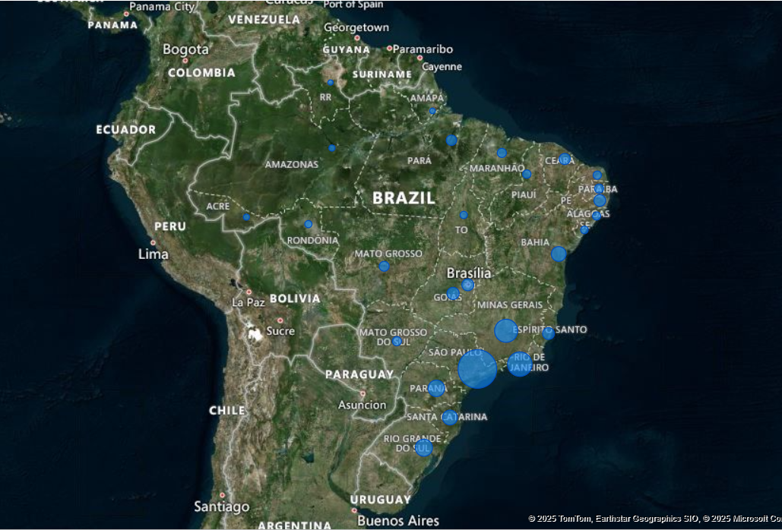

**Insights and Findings**

1. **Dominant State:**
   * **SP (São Paulo) has the highest total sales by a significant margin (5,200,992.91). This indicates a major market or region of high sales activity.**
2. **High Sales States:**
   * **RJ (Rio de Janeiro) and MG (Minas Gerais) also have high sales (1,822,446.55 and 1,584,373.46, respectively). These states represent significant sales contributors.**
3. **Mid-Range Sales States:**
   * **RS (Rio Grande do Sul), PR (Paraná), SC (Santa Catarina), BA (Bahia), GO (Goiás), DF (Distrito Federal), ES (Espírito Santo), CE (Ceará), and PE (Pernambuco) fall within a mid-range of sales, ranging from approximately 750,000 to 220,000. These states contribute moderately to the overall sales.**
4. **Low Sales States:**
   * **The remaining states show significantly lower sales figures, generally below 200,000. This suggests lower market activity or smaller population/economic bases in these regions. Notably:** 
     + **RR (Roraima) has the lowest sales (7,829.43).**
     + **AP (Amapá), AC (Acre), AM (Amazonas), MS (Mato Grosso do Sul), PB (Paraíba), PI (Piauí), RN (Rio Grande do Norte), RO (Rondônia), TO (Tocantins), MA (Maranhão) and MT (Mato Grosso) fall into this category.**
5. **Overall Sales:**
   * **The total sales across all states is 13,591,643.70.**

**7. Seasonal Sales Patterns:**

* **Investigate and visualize any seasonal patterns(Quarterly) or trends in sales data over the course of the year.**

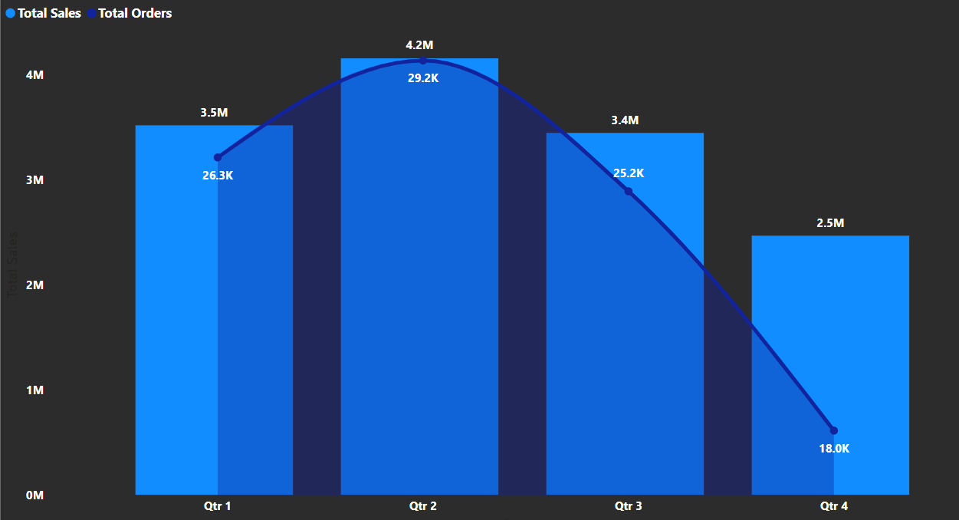

**Insights and Findings**

1. **Peak Sales and Orders:**
   * **Qtr 2 shows the highest sales (4.2M) and the highest number of orders (29.2K). This indicates a peak in business activity during this quarter.**
2. **Sales Trend:**
   * **Sales start at 3.5M in Qtr 1, peak at 4.2M in Qtr 2, decline to 3.4M in Qtr 3, and drop significantly to 2.5M in Qtr 4. This suggests a seasonal pattern with a strong peak in the second quarter and a significant decline in the fourth quarter.**
3. **Order Trend:**
   * **The order trend closely follows the sales trend. Orders start at 26.3K in Qtr 1, peak at 29.2K in Qtr 2, decline to 25.2K in Qtr 3, and drop to 18.0K in Qtr 4. This reinforces the seasonal pattern observed in sales.**
4. **Seasonal Variation:**
   * **There is a clear seasonal variation in both sales and orders. The second quarter shows a significant increase, while the fourth quarter shows a sharp decline.**

**Insights in Relation to Seasonal Sales Patterns**

* **Peak Season: The second quarter is the peak season for sales and orders. This could be due to various factors, such as:** 
  + **Seasonal promotions or marketing campaigns**
  + **Increased consumer spending during specific holidays or events**
  + **Favorable weather conditions or seasonal demand for certain products**
* **Off-Season: The fourth quarter is the off-season, with a significant decline in sales and orders. This could be due to:** 
  + **Post-holiday slowdown in consumer spending**
  + **Seasonal decline in demand for certain products**
  + **Potential impact of economic factors**

**8. Revenue Analysis:**

* **Determine the total revenue generated by ShopNest Store and analyze how it changes over time(Yearly). Represent this information through suitable visuals to highlight trends and patterns.**

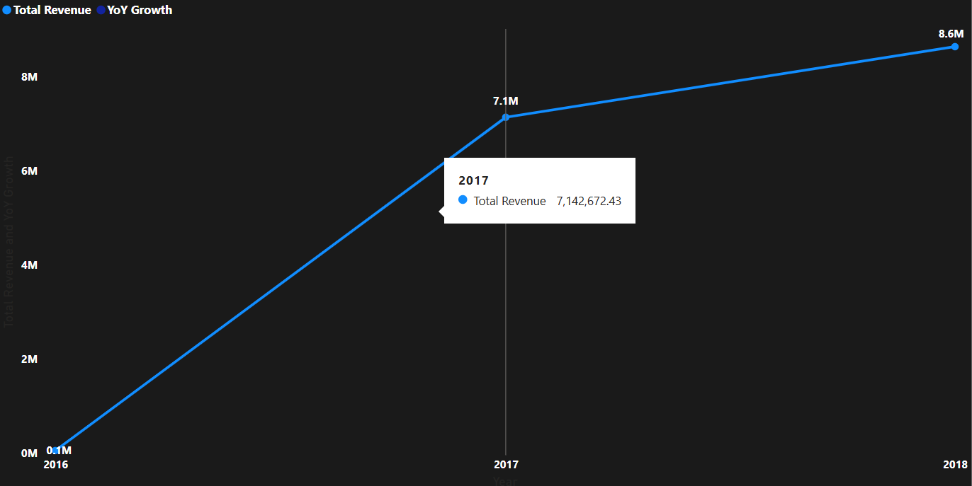

**Insights and Findings**

1. **Significant Revenue Growth:**
   * **There is a dramatic increase in revenue from 2016 to 2017. Revenue jumps from 57,183.21 in 2016 to 7,142,672.43 in 2017. This indicates a period of rapid expansion or significant business changes.**
2. **Continued Growth:**
   * **Revenue continues to grow from 2017 to 2018, reaching 8,643,697.60. This confirms a positive trend in revenue generation.**
3. **YoY Growth in 2018:**
   * **The YoY growth for 2018 is 1.20, which is a 20% increase from the previous year. This indicates a healthy growth rate, although not as dramatic as the jump from 2016 to 2017.**
4. **Total Revenue:**
   * **The total revenue generated over the three years is 15,843,553.24.**

**Insights in Relation to Revenue Analysis**

* **Rapid Expansion: The significant increase in revenue from 2016 to 2017 suggests a period of rapid expansion or a major change in business strategy.**
* **Sustained Growth: The continued growth in revenue from 2017 to 2018 indicates that the business is on a positive trajectory.**
* **Healthy YoY Growth: The 20% YoY growth in 2018 demonstrates a healthy and sustainable growth rate.**

**---------------------------------------END-------------------------------------------**