1b)

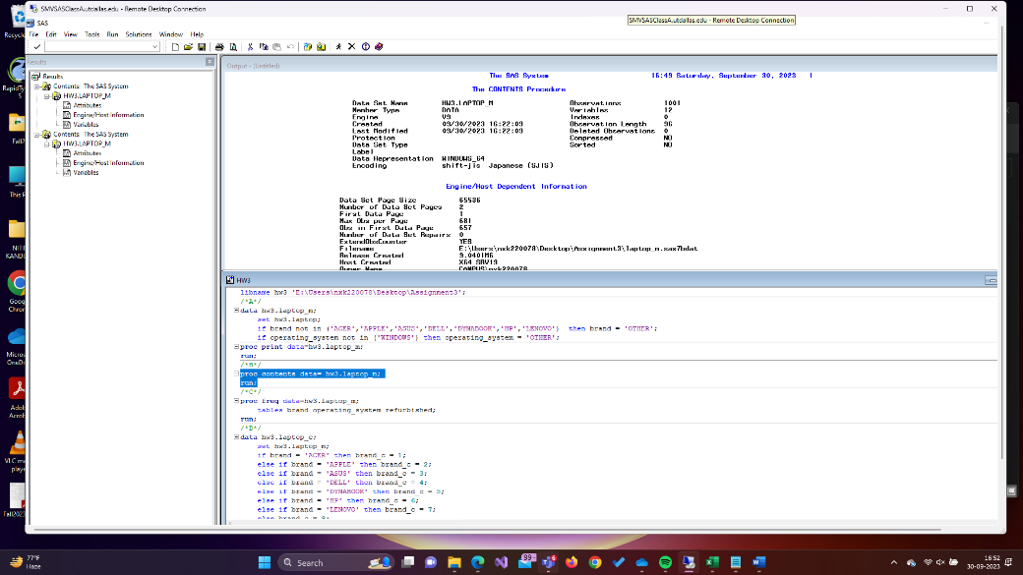

1c)

1d)

1e)

1f)

1h) **The adjusted R-Squared value for 1G is 0.8050, The R-Squared value for 1E is 0.7575**

**1G offers higher Adjusted R-Squared. A higher value indicates a better fit to the data.**