MSE-1

GitHub Actions CI workflow

Name: Nitin kumar
Roll: 202401100200217
Cse-c

1.Pull request URL used to validate the workflows
https://github.com/Nitin8604/github-skills-challenge/pull/1

2. Screenshot showing the GitHub Actions workflows
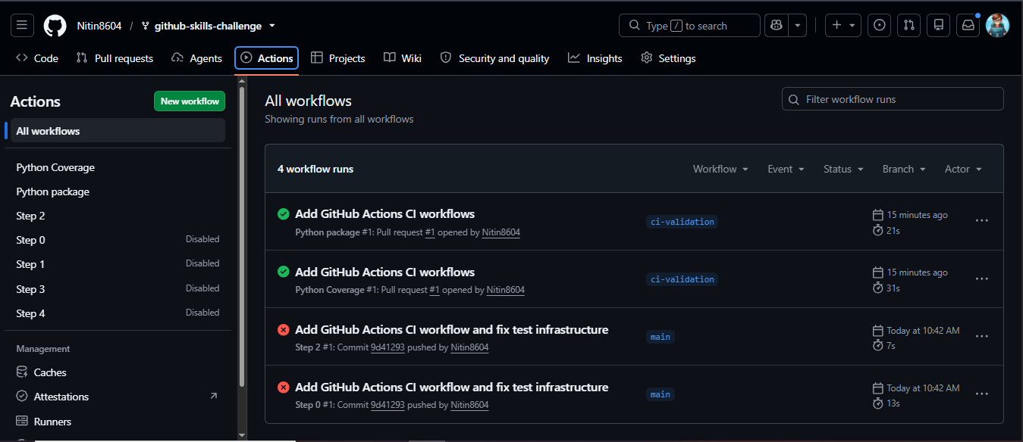
3. Screenshot showing a successful test workflow execution
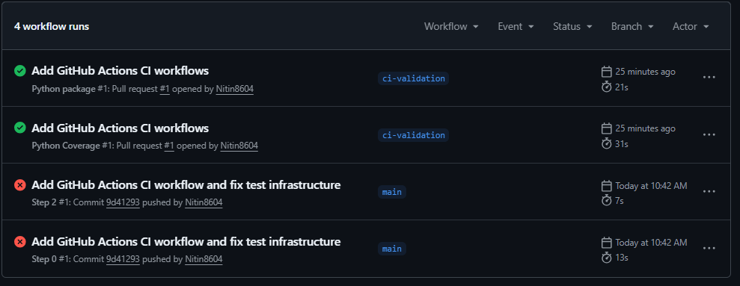
4. Screenshot showing the coverage result/comment on the pull request
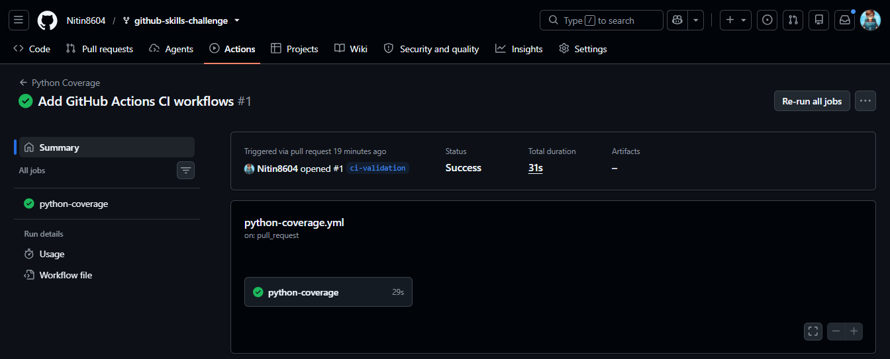
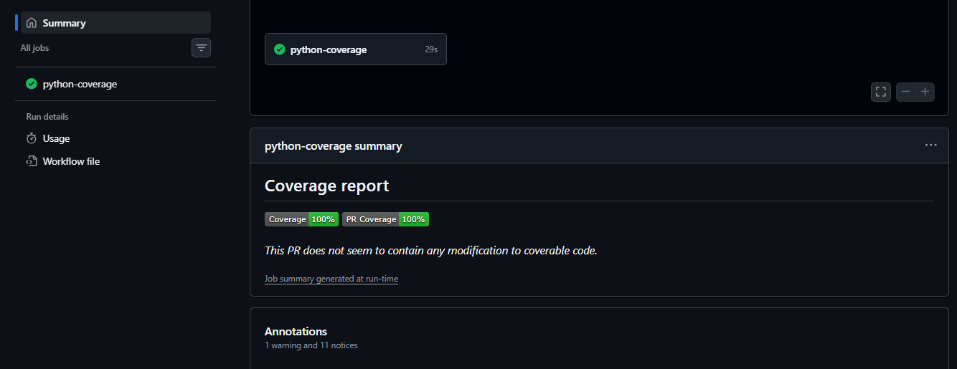
5. Screenshot showing the final repository/workflow files
