**Project Name:- “Hire Helper”**

**Project Member:**

**Rakshanda Meshram 210543181075**

**Sakshi Tekade 210543181087**

**Nitin Dange 210543181020**

**Pranav Chavan 210543181016**

**Abstract:**

This is project report on **"Hire Helper"** . During the making/devloping of this project we explored

new ideas and fuctionality.

This project is output of our planning , schedule,programming skill and the hard work, and this report

reflect our step taken at various level of programming skill, planning and schedule.

We have learnt a lot of during this project and liked the improvment in our testing

skills and deep concept related oh these kinds of project.

Our project **"Hire Helper"**. This is a web based application which help people

to find a service with different functionalities on internet. It is useful in the way

to booking service online.

In this project there are three module Admin , User, and Employee.

Admin can check , update and delete the data.customer can book the service after the login.Employee can register themselves on the site,

And further verification will done by admin.

**Implementation Technologies:**

1. **Spring Framework:**

Spring Framework is a Java platform that provides comprehensive infrastructure support for developing Java applications. Spring handles the infrastructure so you can focus on your application.

Spring enables you to build applications from “plain old Java objects” (POJOs) and to apply enterprise services non-invasively to POJOs. This capability applies to the Java SE programming model and to full and partial Java EE.

**1.1 Features of Spring Framework:**

**1. Lightweight**

Spring is modular lightweight framework which allows you to selectively use any of its modules on the top of Spring Core.

**2. Inversion of Control (IOC)**

This is another top feature of Spring framework where application dependencies are satisfied by the framework itself. Framework creates the object in runtime and satisfies application dependencies.

**3. Aspect Oriented Programming (AOP)**

Aspect Oriented Programming (AOP) is very popular in programming world and in Spring it is well implemented. Developer can use Aspect Oriented Programming (AOP feature of Spring to develop application in which business logic is separated from system services.

**4. Container**

Spring provides their own container for managing the bean lifecycle.

**5. MVC Framework**

Spring MVC Framework is used for developing MVC based web applications.

**6. Transaction Management**

Spring framework provides generic Transaction Management layer which can be used with or without J2EE(JEE) environment.

**7. JDBC Exception Handling**

Spring provides their own abstraction of JDBC exception which further simplifies the exception handling in program.

**1.2 Advantages of Spring Framework:**

**1. Solving difficulties of Enterprise application development**

Spring is solving the difficulties of development of complex applications, it provides Spring Core, Spring IoC and Spring AOP for integrating various components of business applications.

**2. Support Enterprise application development through POJOs**

Spring supports development of Enterprise application development using the POJO classes which removes the need of importing heavy Enterprise container during development. This makes application testing much easier.

**3. Easy integration other frameworks**

Spring designed to be used with all other frameworks of Java, you can use ORM, Struts, Hibernate and other frameworks of Java together. Spring framework do not impose any restriction on the frameworks to be used together.

**4. Application Testing**

Spring Container can be used to develop and run test cases outside enterprise container which makes testing much easier.

**5. Modularity**

Spring framework is modular framework and it comes with many modules such as Spring MVC, Spring ORM, Spring JDBC, Spring Transactions etc. which can used as per application requirement in modular fashion.

**6. Spring Transaction Management**

Spring Transaction Management interface is very flexible it can configure to use local transactions in small application which can be scaled to JTA for global transactions.

1. **The JDBC Template**

The central class of the Spring JDBC abstraction framework is the **JdbcTemplate** class that includes the most common logic in using the JDBC API to access data, such as handling the creation of connection, statement creation, statement execution, and release of resource. The**Jdbc-Template**class can be found in the **org.springframework.jdbc.core**package.

The **JdbcTemplate** class instances are thread-safe once configured. A single **JdbcTemplate** can be configured and injected into multiple DAOs.

We can use the **JdbcTemplate** to execute the different types of SQL statements. **Data Manipulation Language** (**DML**) is used for inserting, retrieving, updating, and deleting the data in the database such as **SELECT**, **INSERT**, or **UPDATE** statements

**2.1** **MySQL**

MySQL, the most popular Open Source SQL database management system, is developed, distributed, and supported by Oracle Corporation.

**Features of MySQL:**

* **MySQL is a database management system.**

A database is a structured collection of data. It may be anything from a simple shopping list to a picture gallery or the vast amounts of information in a corporate network. To add, access, and process data stored in a computer database, you need a database management system such as MySQL Server. Since computers are very good at handling large amounts of data, database management systems play a central role in computing, as standalone utilities, or as parts of other applications.

* **MySQL databases are relational.**

A relational database stores data in separate tables rather than putting all the data in one big storeroom. The database structures are organized into physical files optimized for speed. The logical model, with objects such as databases, tables, views, rows, and columns, offers a flexible programming environment.

* **MySQL software is Open Source.**

Open Source means that it is possible for anyone to use and modify the software. Anybody can download the MySQL software from the Internet and use it without paying anything.

* **The MySQL Database Server is very fast, reliable, scalable, and easy to use.**

MySQL Server was originally developed to handle large databases much faster than existing solutions and has been successfully used in highly demanding production environments for several years. Although under constant development, MySQL Server today offers a rich and useful set of functions. Its connectivity, speed, and security make MySQL Server highly suited for accessing databases on the Internet.

* **MySQL Server works in client/server or embedded systems.**

The MySQL Database Software is a client/server system that consists of a multithreaded SQL server that supports different back ends, several different client programs and libraries, administrative tools, and a wide range of application programming interfaces (APIs).

**3.ReactJS:-**

React JS is an open-source JavaScript library for building user interfaces – usually for single-page and mobile applications.

A user interface in React is built around components. Each of these components is a Javascript function defined by the user.

These components optionally accept inputs, i.e. props (properties), and return React elements that describe exactly how a section of the UI (user interface) should appear accordingly.

React applications are usually built around a single HTML element, often called the root node.

Since React elements are immutable (cannot be changed), the only way to “change” an element is to render a new one on the screen. React maintains a Virtual DOM which records all these element changes.

Elements are rendered on the screen by calling the ReactDOM.render() method which compares the real and virtual DOM elements, making as few changes as possible. The ReactDOM always attemps to avoid reloading the whole page in this diffing process.

**4.Hardware and Software Requirements (Minimum):**

**Hardware:**

1. Intel i3 processor 3rd generation or later / AMD Ryzen 200 2nd generation or later

2. 2 GB ddr3 ram.

3. Windows 7 Home edition or later.

4. 200 GB Sata HDD Space

5. Data Connection 200 kbps

**Software:**

1. Eclipse IDE
2. MySQL Workbench 8.0
3. Google Chrome version 79.0
4. Apache Tomcat Server 8.5
5. Maven Dependencies
6. VS Code
7. **ER Diagram:**

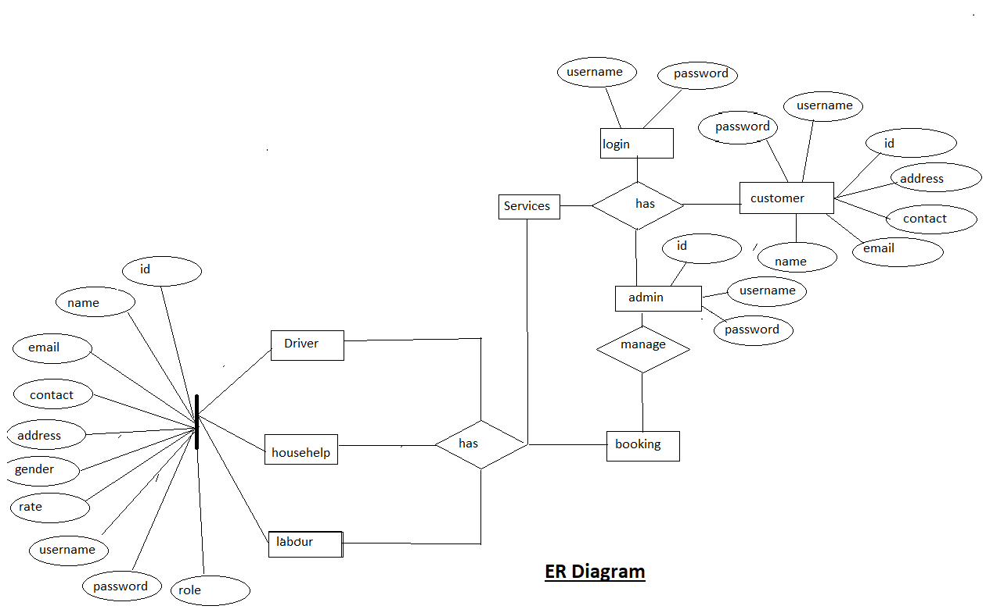

Figure 1: ER Diagram

1. **Table Structures:**
2. **Table name:Employee**

**Column name Type**

Id int AI PK

address varchar(255)

econtact varchar(255)

eemail varchar(255)

egender varchar(255)

elname varchar(255)

emname varchar(255)

ename varchar(255)

password varchar(255)

rate varchar(255)

role varchar(10)

username varchar(20)

yr_exp varchar(255)

1. **Table name:Admin_Table**

**Column name Type**

id int AI PK

password varchar(20)

role varchar(10)

username varchar(20)

1. **Table name:UserTable**

**Column name Type**

Id int AI PK

address varchar(20)

contact varchar(20)

email varchar(20)

fname varchar(20)

gender varchar(20)

lname varchar(20)

mname varchar(20)

password varchar(20)

role varchar(10)

username varchar(20)

1. **Table name:Booking**

**Column name Type**

id int AI PK

address varchar(255)

city varchar(255)

cont_num varchar(255)

email varchar(255)

end_date varchar(255)

fname varchar(255)

lname varchar(255)

start_date varchar(255)

employee_id int

user_id int

1. **UML Diagrams:**

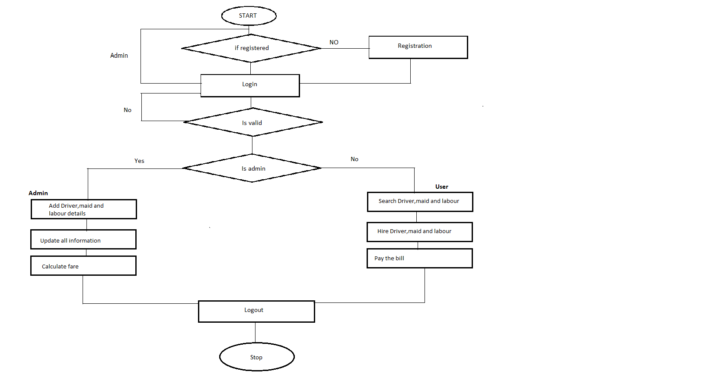

Figure 2: Flow Diagram

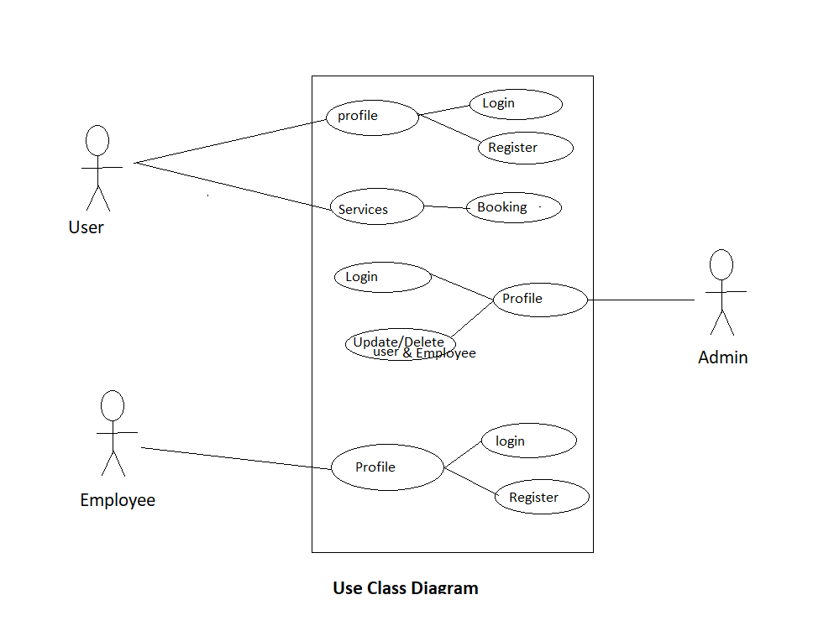

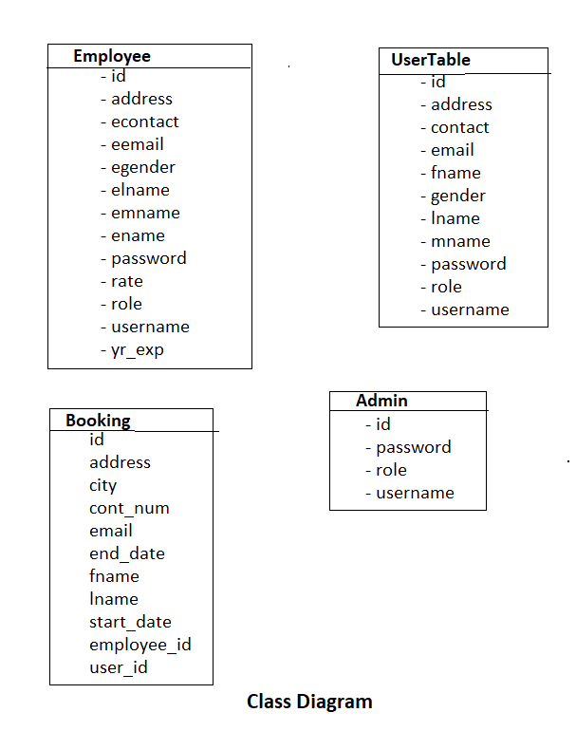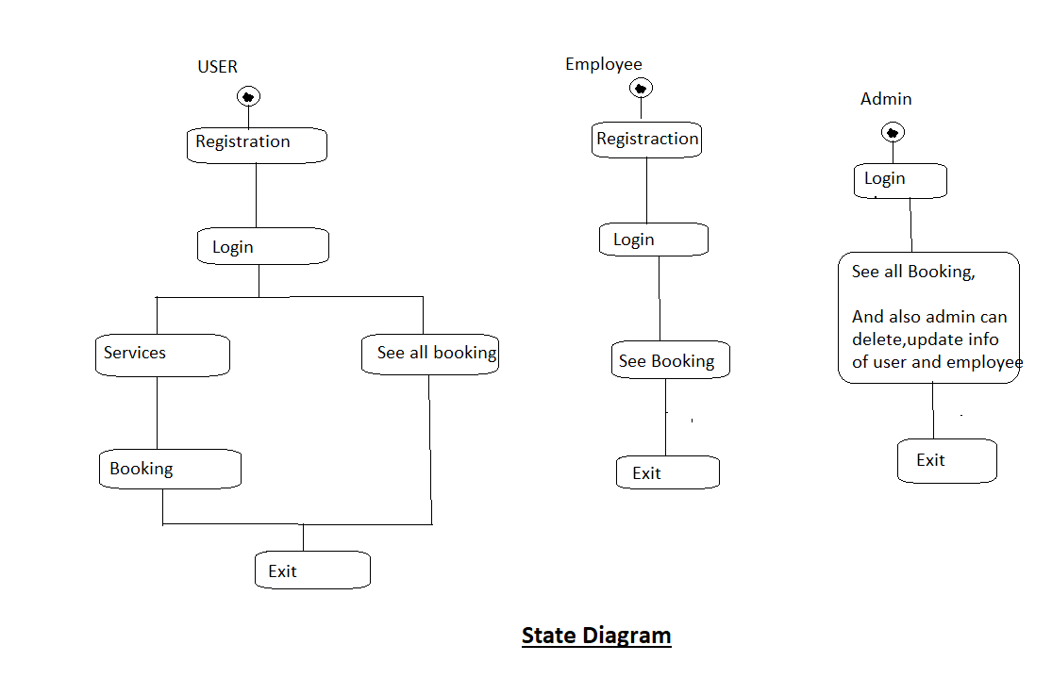

1. **End to End Flow of Application:**

**User:**

* 1. User will login to the portal or will have to register if he is not a

register user.

* 1. After registration User will login and service page will be displayed to him which will display the following services and according details about services.
  2. From that page user can select the services according to them.
  3. From that page user can select the services according to them.
  4. On the page user has to pick a what service they want, how long they want service ( according to rate ) and they can book service.

**Admin:**

1. There is on top of title bar one button of admin.
2. After click the admin botton , admin should have fill credential who manage the data of site .
3. Admin have right of update , delete of user and workers details.

**Employee:**

1. Three is one module added in site that Worker can register themself on that page .
2. There is option where worker can add their details.
3. They need to fill their data in that page and their details are add to list , where user ( customer ) can see the professionals.
4. **Future Scope of Project**
5. Adaption of different online payment using gateway.
6. Develop centralized system to back up user translation. If people lost their ID or Password then user can claim there wallet balance to retrieve.
7. In future we thinking to expand our idea in ruler areas.

**Thank You!**