**Angular Projects**

**Create a simple project to**

   1] Add new Product

   2] Update Product

   3] Delete Product

   4] Display products

**After [ Create Product ] Button click :**

**After [ Delete ] Button click :**

**After [OK] click Created Product deleted:**

**After [ Edit ] Button click:**

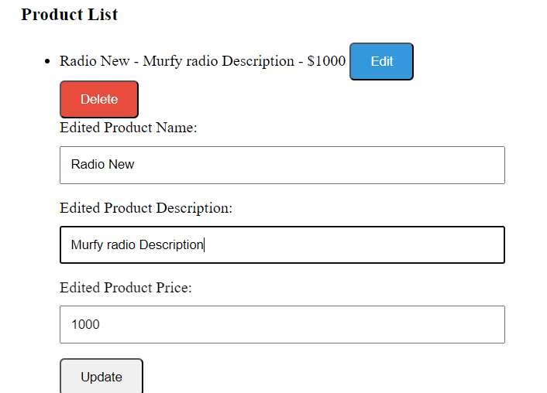

**After [Update] button click:**

