BusinessMatrix.network – UI/UX & Feature Change Requirements

Home Page Changes
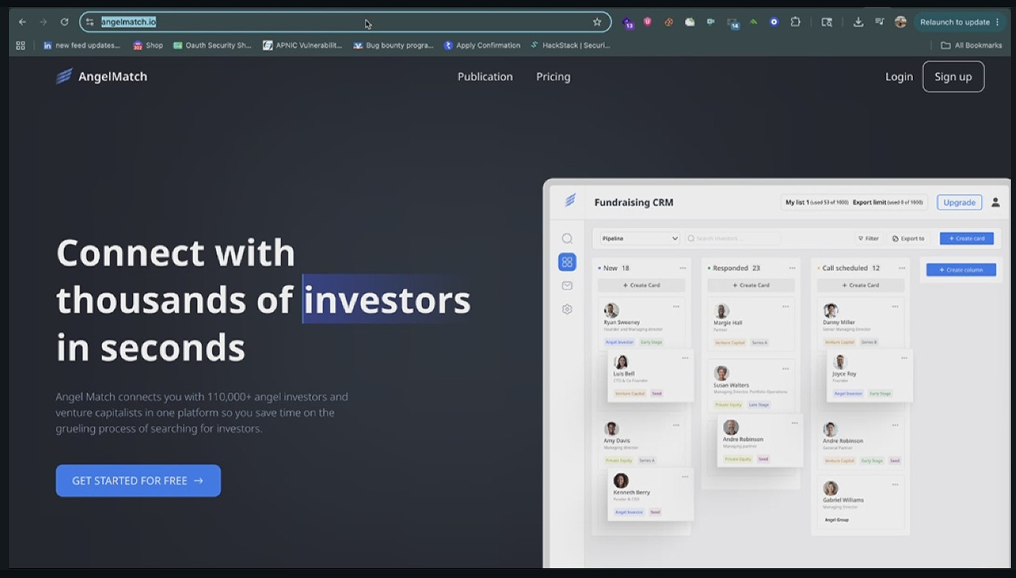
Default Home Page - Change the default home page

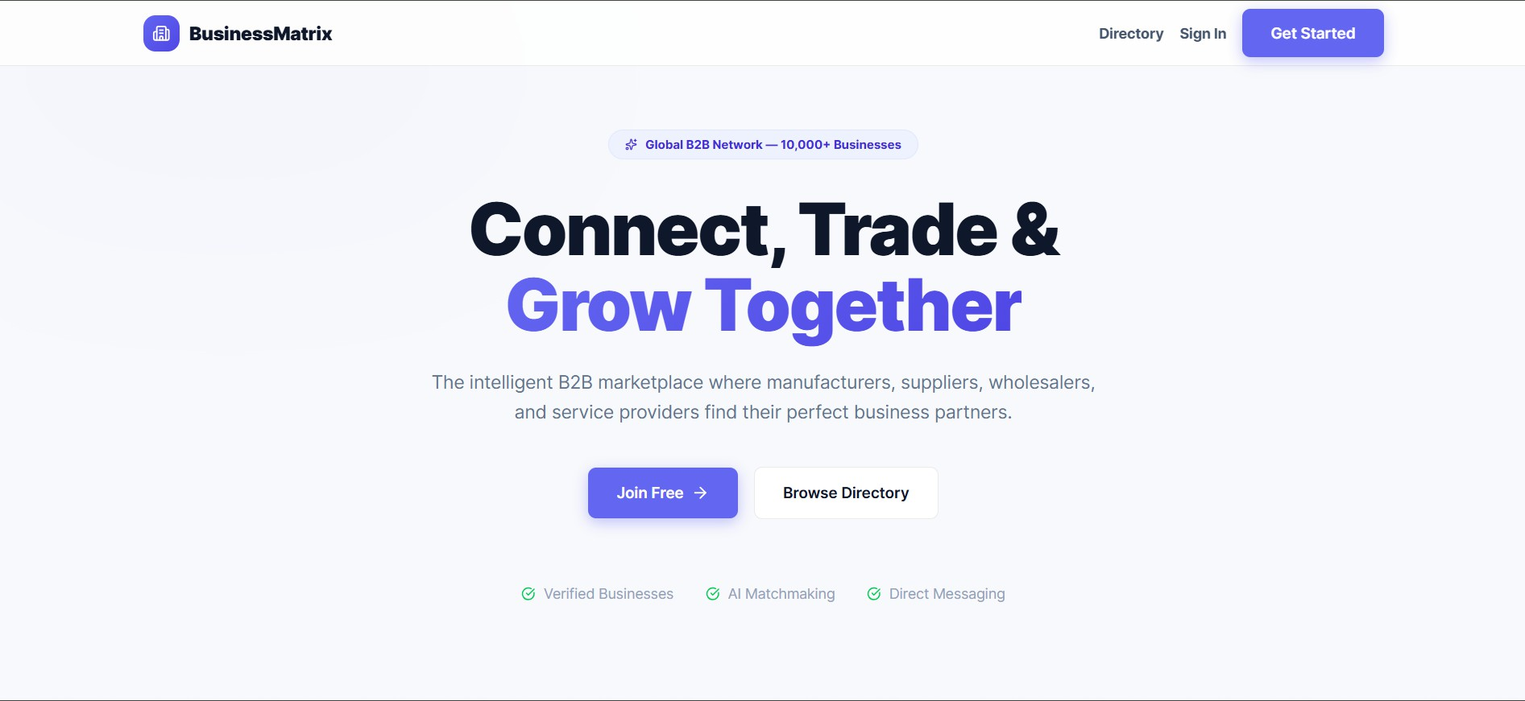

Phase 2 Updates:
- Update pricing section. and Replace “Truth full data” with current mock data.

Replace BusinessMatrix logo.
Apply theme-based color changes.
Change “Get Started” button text to “Register”

Directory Page Changes:

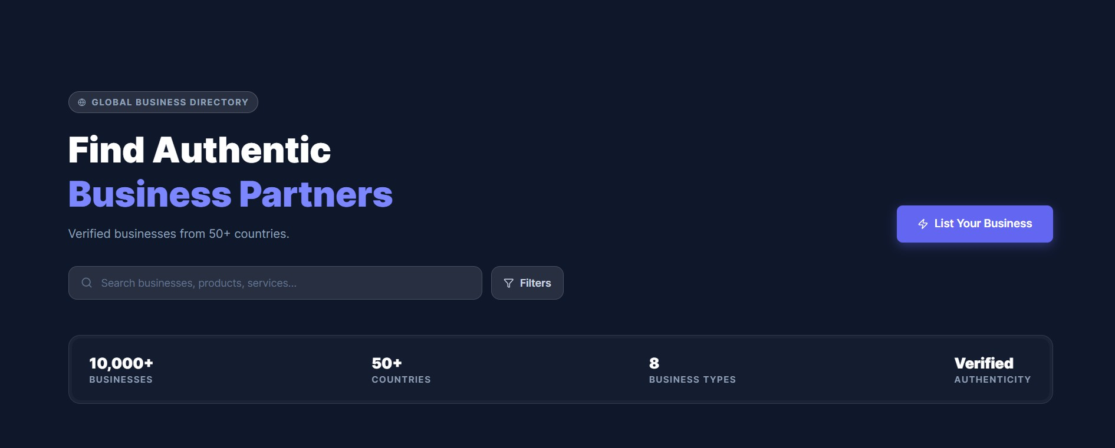

Directory:
Add logo on every page.
Remove text: “Global Business Directory”
Remove -ż 50+ (from across glob)
When user clicks List Business, redirect to Signup/Registration page
Search Business [ Enter Keywords]
Remove Filter button

Business Type Changes

Remove Supplier, Exporter and
Replace Wholesale with Wholesaler



Remove text:
“Join 10,000+ business”
“10000+ Business”
Remove free text from “List of Business”

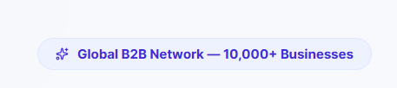

Remove “10000+ Business” Increase overall font size.

Home Screen Text Updates

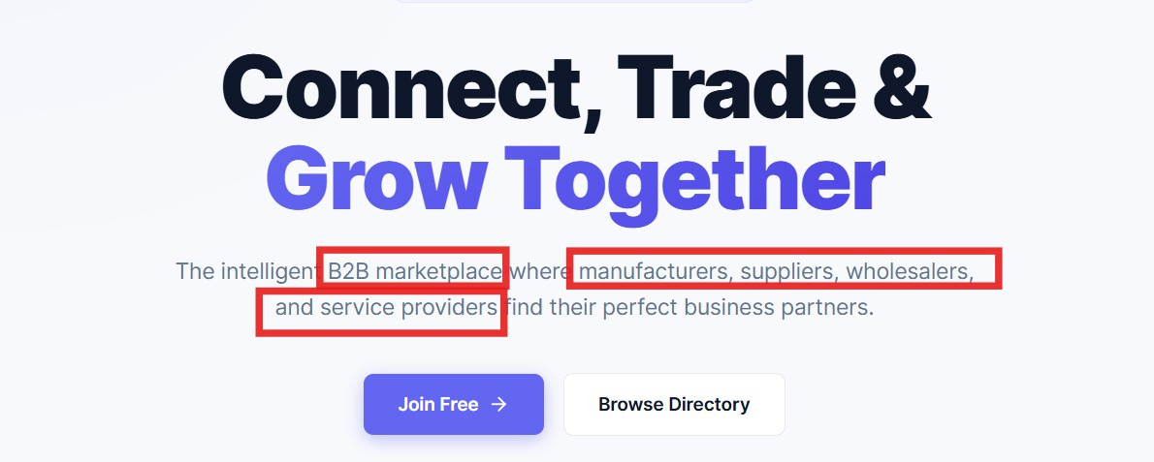

Update text:
“Intelligent B2B Platform”
Capitalize:
M, S, W, S in BusinessMatrix wording.
Change button text:
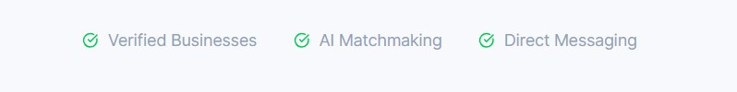
“Join Free” → “Join Now”

Increase badge font size.

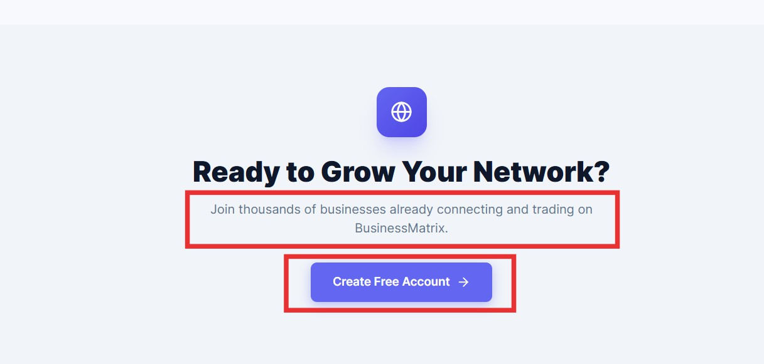

Update text:
“Join Existing Global business already connecting on BusinessMatrix.network”
Last button text:
“Create Account”

Sign In Page

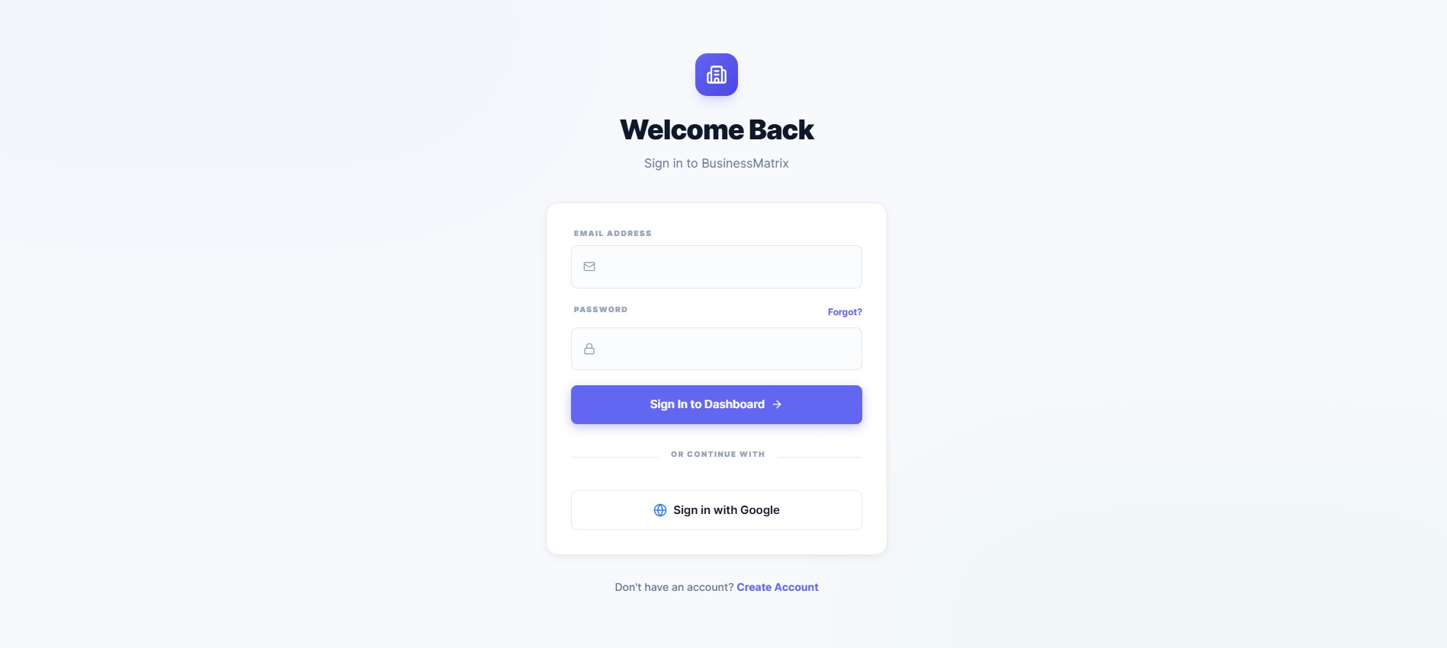

Add logo on Sign In page.

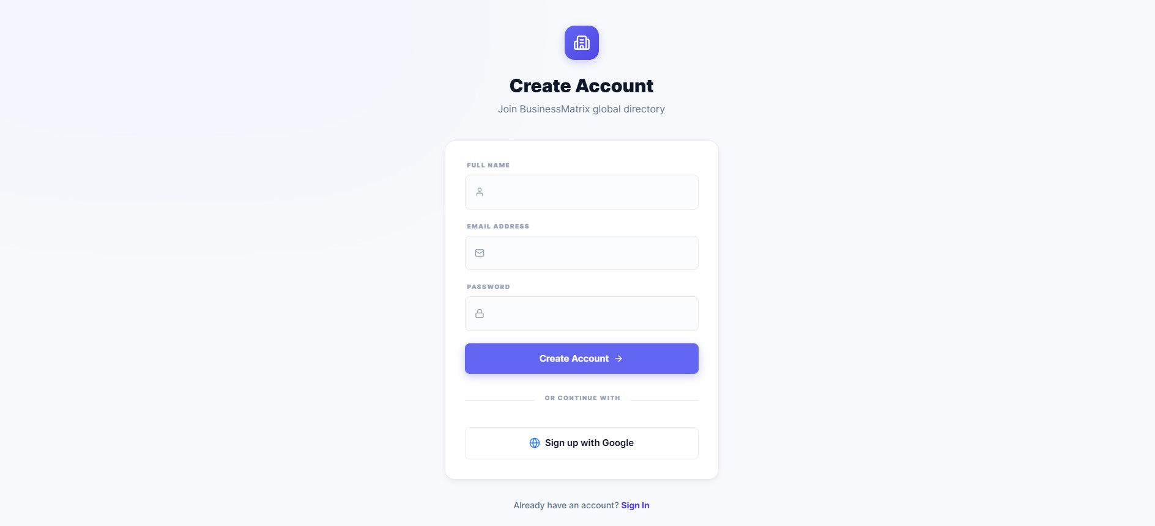
Registeration Page

Add logo on Register page.
Add heading:

“Join BusinessMatrix.network”
- Match color theme with application.
- Use dark font color for:
  - Full Name
  - Email
  - Password
- Add Confirm Password field.

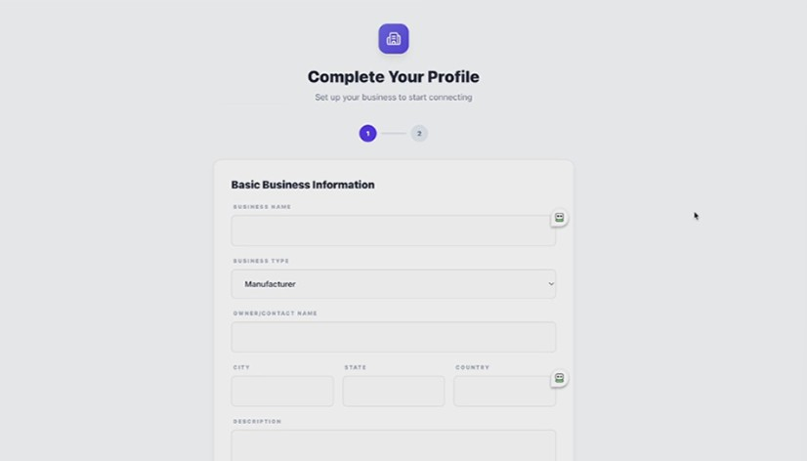

- Replace ‘Descriptionʼ to Business Description
- Remove “Export” and “Supplier” and replace “Wholesale” to “Wholesaler” and Add “Other” option.
Location Fields
- Country, State, City should be dropdowns.

Dashboard Changes

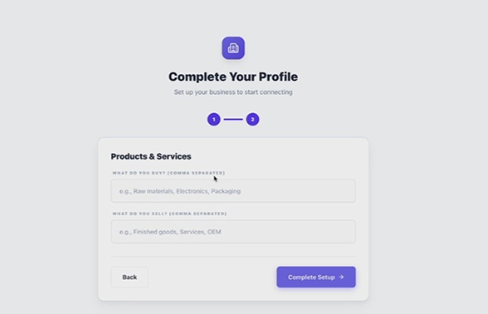

- Replace logo.
- Use dark font color for all label
- Add search suggestions.

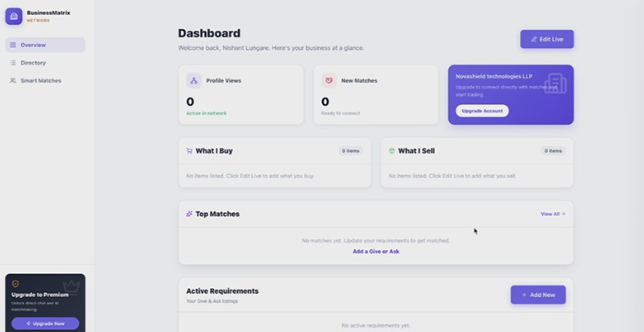

- Place logo on left side.
- In Dashboard,
1. Active Requirements 2. Top Matches

In Active Requirements:
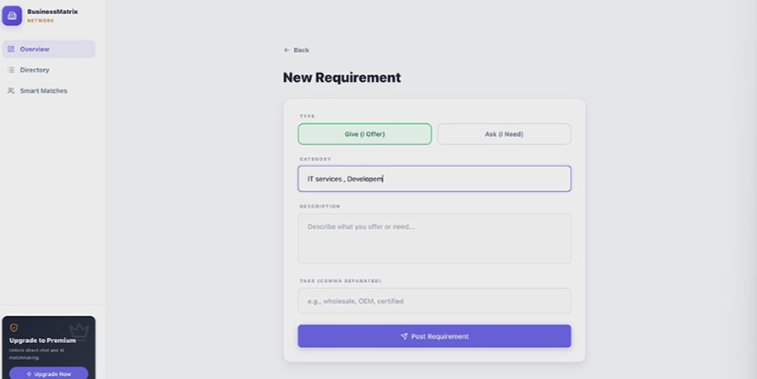
- Add popup window with confirmation on Post Requirement button.

What I Buy & What I Sell Section
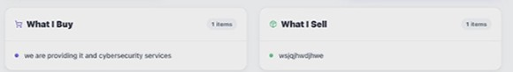
- Data should come from user registration details.

Labels
- Replace text with:
  - “Actively Buying”
  - “Actively Selling”

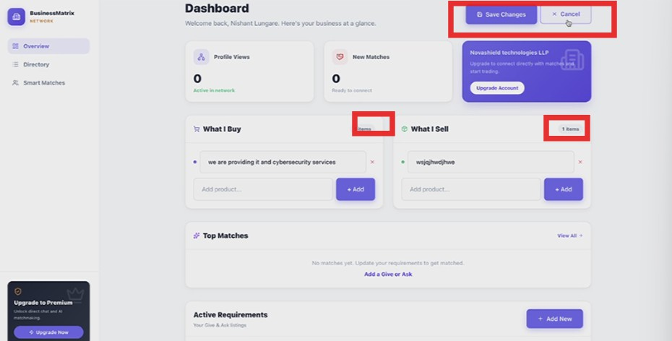

Features
- Add Edit button for:
  - Actively Buying
  - Actively Selling
- Remove top Edit Button and replace with Profile Icon so when User click that I con he can redirect to Profile page.

Table Layout
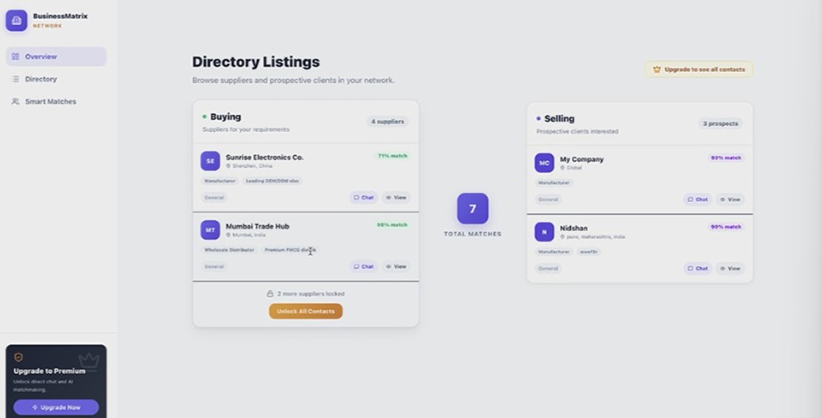
Create table layout:

- Left Side:
  - Actively Buying
- Right Side:
  - Actively Selling
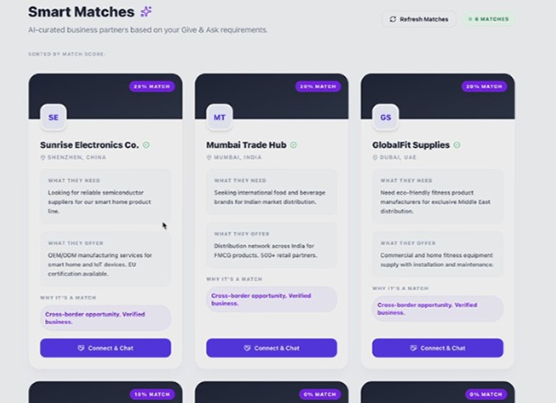
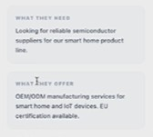
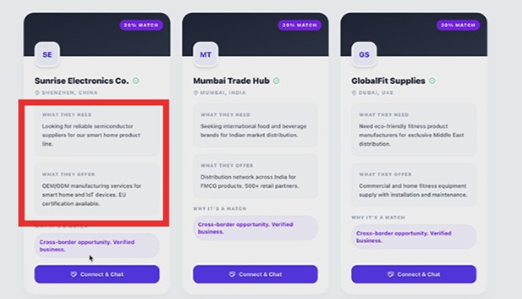

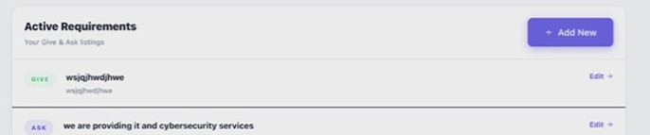

Create table layout:
- Left Side:
  - Actively Buying
- Right Side:
  - Actively Selling

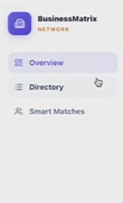

Selection Behavior
- Add click/select interaction behavior.

In Smart matches,

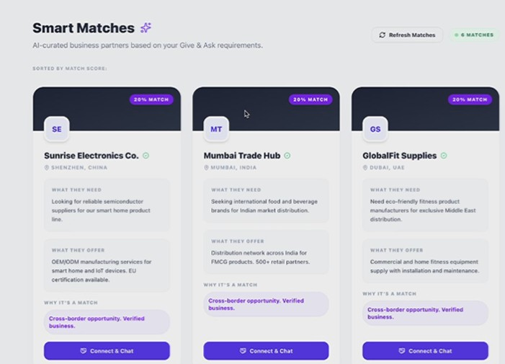

Layout
- Left Side:
  - Actively Buying
- Right Side:
  - Actively Selling

