

E-COMMERCE WEBSITE

A ONE STOP DESTINATION FOR ALL YOUR NEEDS.



HCL Technologies

**SYSTEM REQUIREMENT SPECIFICATION**

**FOR**

**ONLINE E-COMMERCE WEBSITE**

**By NITIN JOSHI | NIKHIL SAINI | KUNAL ROY | GARIMA CHAUHAN | DEEPAK KUMAR .**

**1.0. INTRODUCTION**  .

The E-Commerce System is mainly designed to provide fast and effective user environment for Online Shopping activities. This application software is based on Model view controller architecture.

The Client side forms used for display forms the view, database connections, business logics are developed and are represented as models, while controllers are pages used to link model with the view.

Their duty is to attend the customer, make new problem report, solving the problems and test the product before giving back to the customer.

The manager form deals with the Report generation and modification of customer details entered by call agent. In the primitive two tier architecture the validations of the data are performed in client side or at the server side.

**2.0. SOFTWARE REQUIREMENT SPECIFICATION .**

Purpose: The main purpose for preparing this document is to give a general insight into the analysis and requirements of the existing system or situation and for determining the operating characteristics of the system.

Scope: This Document plays a vital role in the development life cycle (SDLC) as it describes the complete requirement of the system. It is meant for use by the developers and will be the basic during testing phase. Any changes made to the requirements in the future will have to go through formal change approval process.

|  |  |
| --- | --- |
|  | **Minimum System Requirements** |
| Processor | Intel Core i3 |
| RAM | 4 GB |
| Storage | 256 GB HDD |
| Display | 14-inch FHD (1920 X 1080) |
| Battery | UPTO 2 HOURS |

**3.0. SYSTEM DESIGN AND ARCHITECTURE .**

**Implementation Modules:**

1. Admin
2. Customers(User)
3. Registration.

**ADMIN MODULE:**

This module provides administrator related functionalities. Administrator can create a new account either for manager or employee. By using this login id both manager and employee will log on to this portal and do all transactions which are assigned to them.

|  |  |
| --- | --- |
| Brief Description | Customer Registration |
| Basic Structure | This describes how a client register in to the system:   1. The client has to register himself into the system. 2. After the successful registration, client will get a success message. 3. The following information is required during registration.  * Name * Address * Email * Mobile Number |
| Additional stages | 1. The system will validate the information provided. If any invalid data is found, the input form will be redirected with error message. 2. After registration, If any user tried to log in with false credentials then it will pop out an error message. |
| Validation | 1. Name is required and minimum 3 characters and max 30 characters. 2. Address can be alphanumeric. 3. The Email should be valid. |

**USER MODULE:**

This module is about users of this portal. By using this module user can lodge any complaint about products such as Technical problem, Components problem and Service problem. User must be registered with the system. A user can check the complaint status. A user must send feedback after the petition complaint solved by same user login.

|  |  |
| --- | --- |
| Brief Description | User Login |
| Basic Structure | This describes how a user log-in in to the system:   1. The Customer has to register himself into the system. 2. After the successful login, user will be taken to the appropriate landing page. 3. The following information is required to login.  * username * password |
| Additional stages | 1. The system will validate the credentials provided. If credentials are invalid, login form will be redirected again with error message. |
| Validation | 1. Valid username 2. Valid password |

**COMPONENT DIAGRAM:**



**CLASS DIAGRAM:**



**SNAPSHOTS**

The Snapshots of the output received are as follows =>

**ADMIN PAGE:**

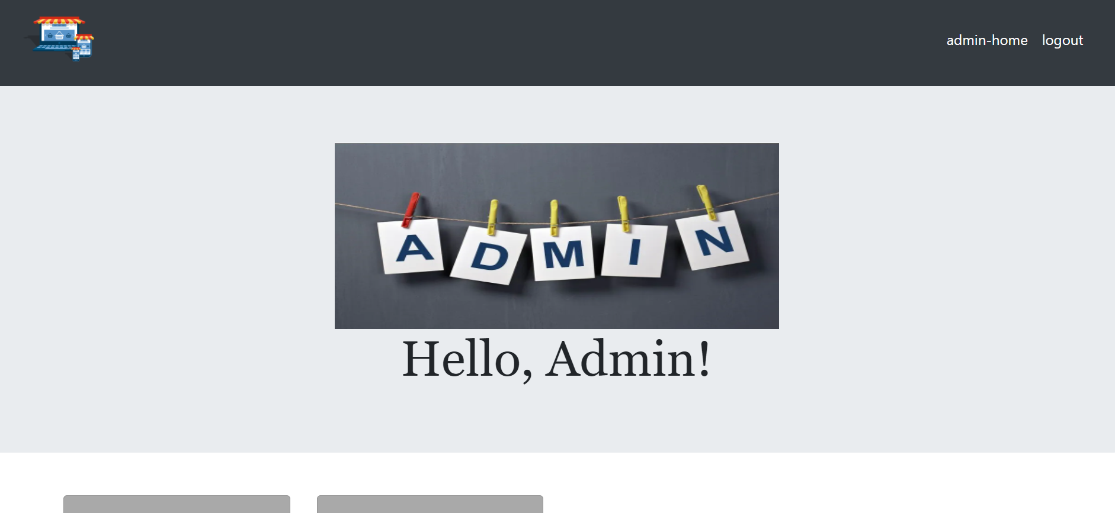

**CART PAGE:**

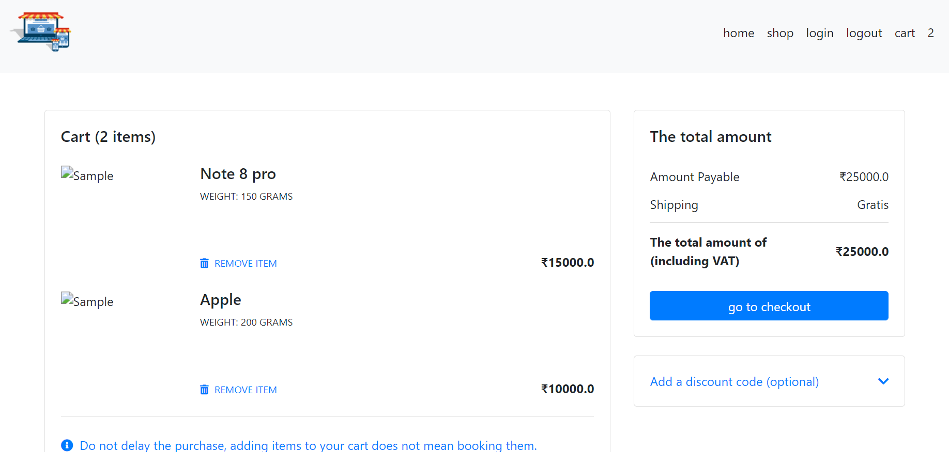

**ADD PRODUCTS:**

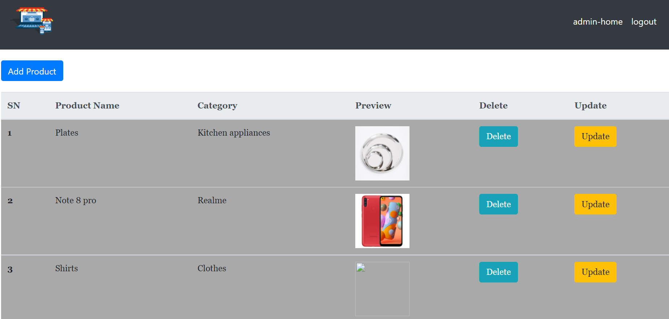

**ADD CATEGORY:**

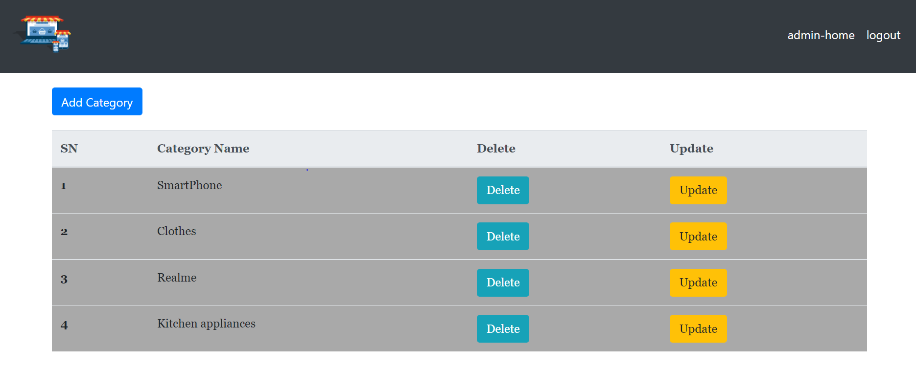

**PRODUCT DESCRIPTION:**

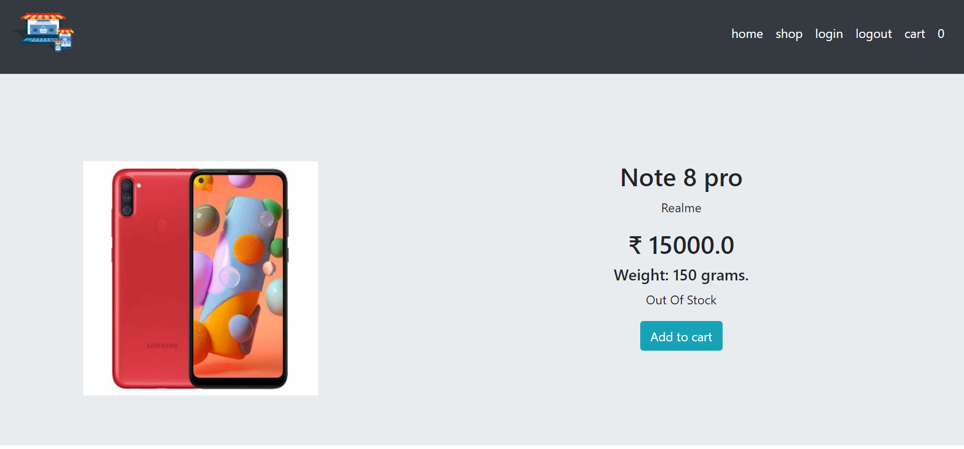

**CHECKOUT PAGE:**

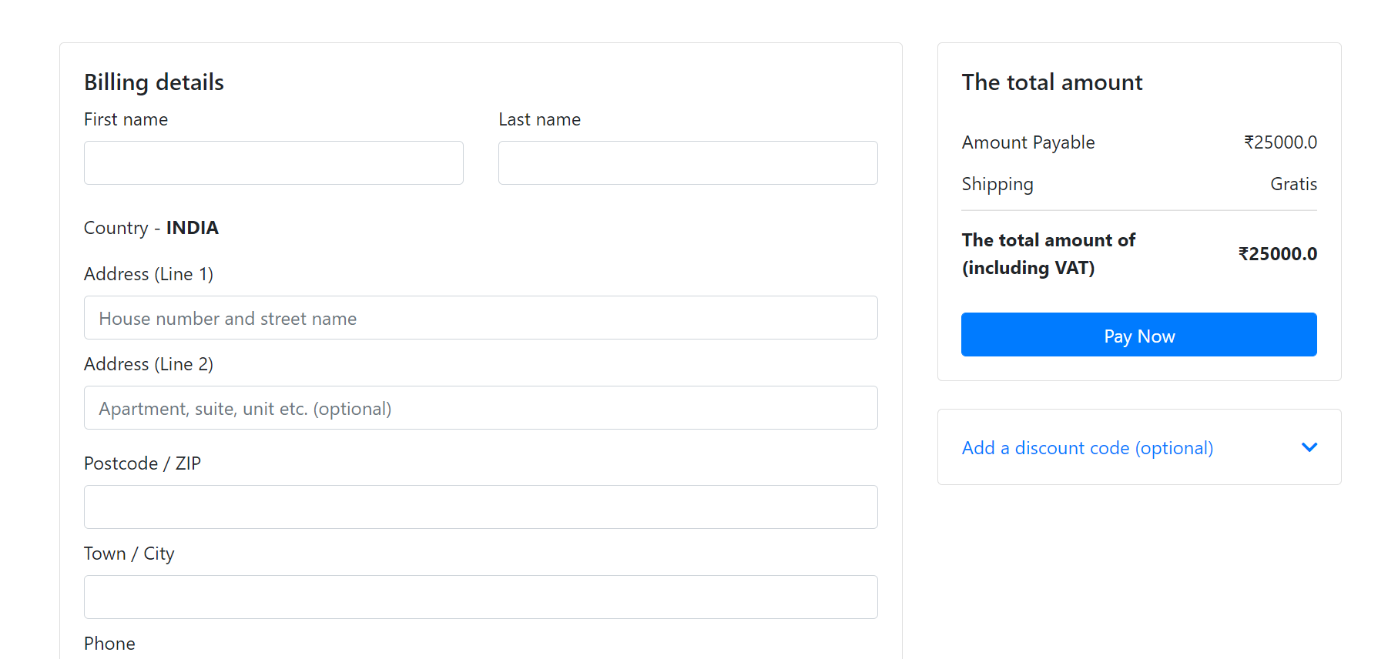

**SHOP PAGE:**

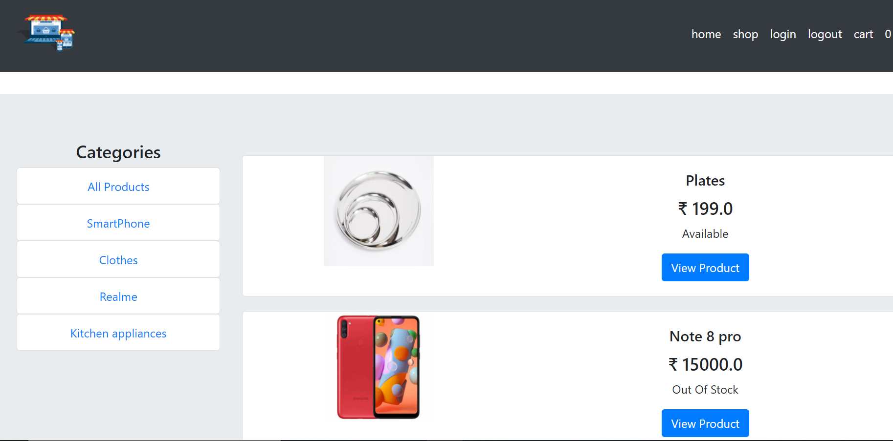

**4.0. CONCLUSION .**

* The project has been appreciated by all the users in the organization.
* It is easy to use, since it uses the GUI provided in the user dialog.
* User friendly screens are provided.
* The usage of software increases the efficiency, decreases the effort.
* It has been efficiently employed as a site management mechanism. It has been thoroughly tested and implemented.