## DESIGN AND FABRICATION OF ARDUINO BASED ROBOTIC ARM

Submitted in partial fulfillment of the requirements of the degree of

Bachelor of Engineering

By

**Nitin Khule & Nikhila Patil**

Guided By

## Prof. Mr. Sachin Shinde(Guide) Prof. Mr. Ganesh Durde(Co-Guide)



**Department of Mechanical Engineering**

# Datta Meghe College of Engineering

Plot No.98, Sector 3, Airoli, Navi Mumbai, Maharashtra-400708 2019-2020

# C:\Users\User\Desktop\dress\logo.jpgDatta Meghe College of Engineering

### Department of Mechanical Engineering

Plot No.98, Sector 3, Airoli, Navi Mumbai, Maharastra-400708 Affiliated to University of Mumbai

# Certificate

This is to certify that the short-term project entitled **"Design and Fabrication of Robotic Arm"** is a bonafide work of **Nitin Khule** and **Nikhila Patil**, submitted to the **University of Mumbai** in partial fulfillment of the requirements for the **Undergraduate degree Bachelor of Engineering in Mechanical Engineering** for the academic year **2019-2020**.

.

(Prof. Ganesh Durde) (Prof. Sachin M. Shinde)

**Project Co-Guide Project Guide**

(Prof. (Dr.) Vilas B. Shinde) (Prof. (Dr) S.D. Sawarkar)

**Head of the Department Principal**

# C:\Users\User\Desktop\dress\logo.jpgDatta Meghe College of Engineering

### Department of Mechanical Engineering

Plot No.98, Sector 3,Airoli, Navi Mumbai, Maharashtra - 400708 Affiliated to University of Mumbai 2018-2019

## Project Report Approval for B. E.

This project report entitled **"Design and Fabrication of Robotic Arm"** by **Nitin Khule** and **Nikhila Patil** is approved as a **short-term project** for the **Undergraduate degree of Bachelor of Engineering in Mechanical Engineering** for the academic year **2019-2020**.

Examiners

1.

2.

Date:

Place:

## Declaration

I declare that this written submission represents my ideas in my own words and where others' ideas or words have been included, I have adequately cited and referenced the original sources. I also declare that I have adhered to all principles of academic honesty and integrity and have not misrepresented or fabricated or falsified any data/fact/source in my submission. I understand that any violation of the above will be cause for disciplinary action by the Institute and can also evoke penal action from the sources which have thus not been properly cited or from whom proper permission has not been taken when needed.

(Nitin Khule)

(Nikhila Patil)

Date:

## Abstract

The robotic arm is operated & controlled wirelessly with the help of hand gestures. This project is the first phase of this longer-term desired effort. Anything is possible with the mighty power of Arduino. It is compact, it's straightforward, and makes embedding electronics into the world-at-large easy.

This project mainly analysis about different topologies and designs regarding the construction of this Arduino based gloves control hand. Although more complicated and precise (more expensive) versions of this concept have been developed, this is a project with many potential applications. Interactive robot control of this level has many uses in industrial manufacturing, medical research, and anything you want to be able to do with precision that is unsafe to touch. The basic components of the hand and glove are the hand itself, the servos, the Arduino, the glove, nRF and the flex sensors. The glove is mounted with flex sensors: variable resistors that change their value when bent. They're attached to one side of a voltage divider with resistors of a constant value on the other side. The Arduino reads the voltage change when the sensors are bent, and triggers the motors to move a proportional amount. The motor pull strings that rotates the arms.

**Keywords: -** Arduino, Variable Resistors, Servos.

## Table of Content

Abstract v

Table of Contents vi

List of Figures viii

List of Tables ix

Chapter 1

Introduction to Arduino Based Robotic Arm 1

* 1. Introduction 1
  2. History 2
  3. Applications 6
     1. Pick and Place 6
     2. Painting 6
     3. Welding 8
     4. Metal Cutting 8

Chapter 2

Literature Review 9

* + 1. Applications 12
  1. Problem Definition 13
  2. Objectives 13

Chapter 3 Methodology 15

Chapter 4

Design and Fabrication 17

* 1. Introduction 17
  2. Parts Description of Arduino Robotic Arm 18
     1. Bottom Plate 20
     2. Left Arm Servo Plate 20
  3. Assembly Procedure of Building the Robotic Arm 21

Chapter 5

Robotic Arm Automation 25

* 1. Introduction 25
     1. Controller 61
     2. Servo Motor 61
     3. OLED 62
     4. Power Supply 62
     5. Flex Sensor 63
  2. Programme 89

**Chapter 6**

**Result and Discussion** 49

* 1. **Construction of Robotic Arm** 49
  2. **Operation of Robotic Arm** 50
  3. **Results** 52

**Chapter 7**

**Future Enhancement and Conclusion** 53

* 1. **Future Enhancement** 53
  2. **Conclusion** 75

**Chapter 8 References** 83

## List of Figures

**Figure 1.1: Robotic Arm for Pick and Place operation** 4

**Figure 1.2: Robotic Arm for Spray Painting** 5

**Figure 1.3: Welding using Robotic Arm** 5

**Figure 1.4: Metal cutting Robotic Arm** 6

**Figure 3.1: Methodology** 15

**Figure 3.2: Methodology in Detail** 16

**Figure 4.1: Assembly of Robotic Arm** 19

**Figure 4.1.1: Assembly of Robotic Arm (Top View)** 20

**Figure 4.2: Left and Right Arm Servo Plate** 22

**Figure 4.3: Linkage Structure of Arm** 23

**Figure 5.1: Arduino Uno** 25

**Figure 5.2: Arduino Nano Circuit** 26

**Figure 5.3: Arduino Uno Circuit** 27

**Figure 5.4: OLED** 30

**Figure 5.5: Regulated Power Supply** 31

**Figure 5.6: Flex Sensor** 32

**Figure 5.7: Bend Angle of Flex Sensor** 33

**Figure 5.8: Interface of Flex Sensor Circuit** 33

**List of Table**

### Table No. 1: Literature Review 18

**Table No. 1:** Based on Design… 18

**Table No. 1:** Based on Motors and Controllers… 19

**Table No. 1:** Based on applications… 20

### Table No. 2 Bill of Material 29

# Chapter 1

**Introduction**

*This chapter contains basically what is Arduino based Robotic Arm, history of Arduino based Robotic Arm. The chapter also involves different applications of Arduino based Robotic Arm. Applications can be as per the requirement. End effector can be changed as per the requirement and Arduino can be programmed as per the end effector. End effector can be applications like Pick and place gripper, Metal cutting arm, painting arm or welding arm.*

* 1. **Introduction of Arduino based Robotic Arm**

Robotics is a current emerging technology in the field of science. A number of universities in world are working in this field. Robotics is the new emerging booming field, which will be of great use to society in the coming years. These days many types of wireless robots are being developed and are put to varied applications and uses. The Robotic Arm developed, is controlled wirelessly with the help of finger movement which transmits signals to the robot through an auto device fixed on the gloves put on hands rather than controlling it manually through a conventional remote controller. The Robot moves and acts in the manner depending on the direction made by the fingers pressing the switch. The robot moves in up, down, left or right directions and picks up objects from one place and keeps at another desired place as directed by the movements of fingers and hand. Robotic applications are widely used in research laboratories and industries to automate processes and reduce human errors. Some of the tasks performed by robots include assembly lines and motions that require force control with feedback to its controller.

This project describes and examines both tasks using a robotic Manipulator. In an assembly line, a robotic manipulator is often assigned to move an object from one position to another. One example of this application is in a research laboratory where pipets are used to transport substances from vials to a row of wells on a plate. The

automated process results in faster completion time with minimal errors and downtime. There are three manipulator linkages including the end effector which is a gripper connected through rotational joints.

# History

The Arduino project was started at the Interaction Design Institute Ivrea (IDII) in Ivrea,, Italy. At that time, the students used a BASIC Stamp micro controller at a cost of $50, a considerable expense for many students. In 2003 Hernando Barragán created the development platform wiring as a Master's thesis project at IDII, under the supervision of Massimo Banzi and Casey Reas. Casey Reas is known for co-creating, with Ben Fry, the Processing development platform. Aim was to create simple, low cost tools for creating digital projects by non-engineers. The Wiring platform consisted of a printed circuit board (PCB) with an ATmega168 microcontroller, an IDE based on Processing and library functions to easily program the microcontroller. In 2005, Massimo Banzi, with David Mellis, another IDII student, and David Cuartielles, added support for the cheaper ATmega8 microcontroller to Wiring. But instead of continuing the work on Wiring, they forked the project and renamed it *Arduino*.

The initial Arduino core team consisted of Massimo Banzi, David Cuartielles, Tom Igoe, Gianluca Martino, and David Mellis, but Barragán was not invited to participate. Following the completion of the Wiring platform, lighter and less expensive versions were distributed in the open-source community. It was estimated in mid-2011 that over 300,000 official Arduinos had been commercially produced, and in 2013 that 700,000 official boards were in users' hands.

In October 2016, Federico Musto, Arduino's former CEO, secured a 50% ownership of the company. In April 2017, Wired reported that Musto had "fabricated his academic record. On his company's website, personal LinkedIn accounts, and even on Italian

business documents, Musto was until recently listed as holding a PhD from the Massachusetts Institute of Technology. In some cases, his biography also claimed an MBA from New York University." Wired reported that neither university had any record of Musto's attendance, and Musto later admitted in an interview with Wired that he had never earned those degrees.

Around that same time, Massimo Banzi announced that the Arduino Foundation would be "a new beginning for Arduino." But a year later, the Foundation still hasn't been established, and the state of the project remains unclear. The controversy surrounding Musto continued when, in July 2017, he reportedly pulled many Open source licenses, schematics, and code from the Arduino website, prompting scrutiny and outcry. In October 2017, Arduino announced its partnership with ARM Holdings (ARM). The announcement said, in part, "ARM recognized independence as a core value of Arduino ... without any lock-in with the ARM architecture.” Arduino intends to continue to work with all technology vendors and architectures.

In early 2008, the five co-founders of the Arduino project created a company, Arduino LLC, to hold the trademarks associated with Arduino. The manufacture and sale of the boards was to be done by external companies, and Arduino LLC would get a royalty from them. The founding bylaws of Arduino LLC specified that each of the five founders transfer ownership of the Arduino brand to the newly formed company.

At the end of 2008, Gianluca Martino's company, Smart Projects, registered the Arduino trademark in Italy and kept this a secret from the other co-founders for about two years. This was revealed when the Arduino company tried to register the trademark in other areas of the world (they originally registered only in the US), and discovered that it was already registered in Italy. Negotiations with Gianluca and his firm to bring the trademark under control of the original Arduino company failed. In 2014, Smart Projects began refusing to pay royalties. They then appointed a new CEO, Federico Musto, who renamed the company Arduino SRL and created the website *arduino.org*, copying the graphics and layout of the original *arduino.cc*. This resulted in a rift in the Arduino development team. By 2017 Arduino AG owned many Arduino trademarks. In July 2017 BCMI, founded by Massimo Banzi, David Cuartielles, David Mellis and Tom Igoe, acquired Arduino AG and all the Arduino trademarks. Fabio Violante is the new CEO replacing Federico Musto, who no longer works for Arduino AG.

# Applications

Nowadays, manual labor is being reduced at big scale industries and factories to increase efficiency and gain profit by installing robots that can do repetitive works. A onetime installation of such a device may cost a huge amount, but in the long run, will turn out to be more profitable that manual labor. Out of the lot, a simple robotic arm is one of the most commonly installed machines.

The programmable robotic arm finds extensive applications in its use in extreme conditions:

Examples:

* Space Mission or Underwater Expeditions.
* Nuclear Power Plants.
* In toxic atmosphere where human surveillance is difficult.

Arduino based Robotic Arm has wide range of applications in industries which includes pick and place operations, painting, welding, metal cutting.

### Pick and Place

Arduino based Robotic Arm is used in pick and place operation. These type of robots are provided with a specific program that carries out pick and place operations in repetitive manner and at faster rate.

* + - * **Defense Applications**: It can be used for surveillance and also to pick up harmful objects like bombs and diffuse them safely.
      * **Industrial Applications**: These robots are used in manufacturing, to pick up the required parts and place it in correct position to complete the machinery fixture. It can be also used to place objects on the conveyer belt as well as pick up defective products from the conveyer belt.
      * **Medical Applications**: These robots can be used in various surgical operations like in joint replacement operations, orthopedic and internal surgery operations. It performs the operations with more precision and accuracy.



**Figure 1.1:** Robotic Arm for Pick and Place operation [Source: Sastrarobotics.com]

### Painting

Arduino based Robotic Arm can be used for spray painting such as Automobiles. It is also used for spraying a protective layer on pipes, various mechanical parts etc.

The automated painting system can be used in almost all painting and coating applications. Some of the applications of automated systems are stated below:

* In automobile industry for painting of automobile parts.
* In Furniture manufacturing industry for painting of furniture.
* For lacquer and primer coatings.
* For scratch resistant coatings.
* For corrosion resistant coatings.

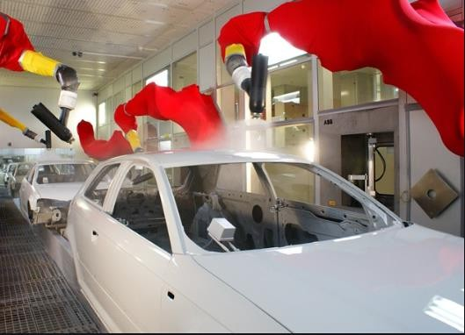

**Figure 1.2:** Robotic Arm for Spray Painting [source: Indiamart.com]

### Welding

Robot welding is the use of mechanized programmable tools (robots), which completely automate a welding process by both performing the weld and handling the part. Robot welding is commonly used for resistance spot welding and arc welding in high production applications, such as the automotive industry.

When human operates are engaged in welding operation, it is observed that flash, flumes, heat and sparks make this task a hazardous job.

The use of robots in welding operation will avoid them to come in contact with such environments and will also reduce costs. Robot operations are reprogrammable and highly beneficial for batch type and mass production. Consistent weldments are created with the use of robots.

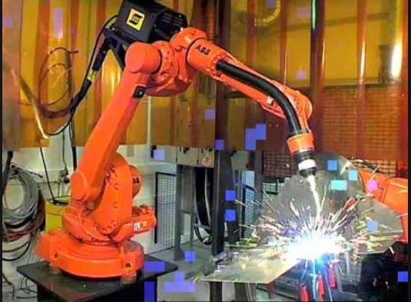

**Figure 1.3:** Welding using Robotic Arm [source: Online-Sciences.com]

### Metal Cutting

Metal cutting is “the process of removing unwanted material in the form of chips, from a block of metal, using cutting tool”. A person who specializes in machining is called a machinist.

Laser cutting is a very useful manufacturing process to cut different types of materials including paper, wood, plastic, and metal. The material melts in the beam path. This process can be automated with the help of robots to provide stability and cutting complex designs. Laser cutting is used primarily by manufacturers to cut metal and plastic parts.

Every method has its limitations in accuracy, cost, and effect on the material. For example, heat may damage the quality of heat treated alloys, and laser cutting is less suitable for highly reflective materials such as aluminum.

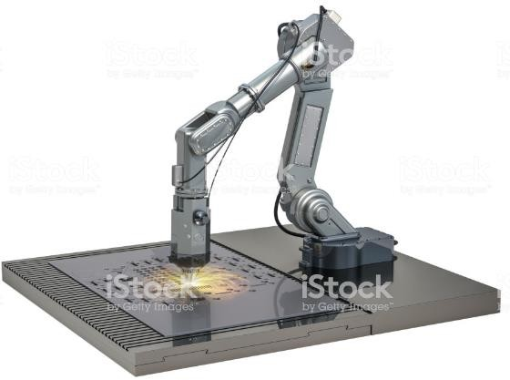

**Figure 1.4:** Metal cutting Robotic Arm.

# Chapter 2

# Literature Review

*This chapter contains literature review of research papers regarding Arduino based Robotic Arm written by different authors. The topic involves research papers based on design, binder characteristics, applications, motors and controllers used for Arduino Robotic Arm. Findings of various research papers are described in this*

*chapter along with the future scope need to improve.*

Different papers have different aspects and findings which are mentioned below.

Also, some points which can be improved discussed below as future scope.

* Mohamed et.al., 1991introduced a Pick and place robotic arm controlled by Computer vision. Here the robot picks the object at a specific orientation only. The gripper used here is a mechanical gripper. So it can’t handle the object safely. Objects in a specific orientation is only picked up by the robotic arm.[1]
* Anush et.al., 2011 introduced Design and Fabrication of Pick and Place Robot to Be Used in Library. Here the robot pick up the books from library and deliver this to the destination. The robotic arm used here can handed objects in any orientation. RFID tags are used to identify the books. This system is capable of doing this specific task only and it’s a line following robot. Each RFID has its own path, and this makes the system more complex.[2]
* Begum et.al., 2012 is designed an Autonomous android controlled robot design using wireless energy. Here the system works according to voice commands or speech delivered by the user and the robotic arm is capable of picking up the objects of any type and in any orientation. RF technology is used so line of sight is a major constrain in communication.[3]
* Yoshimi et.al., 2009 introducing a system for picking up operation of thin objects by robotic arm with two fingered parallel gripper. Thin objects like

paper and plastic cards are picked up by this robotic arm. The objects may slide down due to the use of parallel gripper. This method does not provide safety of the object.[4]

* Wang et.al., 2003 introduced that the efficiency and parameters range of abrasive machining processes were compared. The key technologies of high efficiency abrasive machining were investigated. It was concluded that high efficiency abrasive machining would be a promising technology in the future.[5]
* Suwanprateeb, “Three Dimensional Printing of Porous Polyethylene Structure Using Water based Binders. Thin objects like paper and plastic cards are picked up by this robotic arm[6].
* A. Shirkhodaie, S. Taban, and A. Soni, “Ai assisted multi-arm robotics,” in Robotics Automation. Proceedings.[7]
* Y. Huang et.al 2007, Development of a new type of machining robot-a new type of driving mechanism,” in Intelligent Processing Systems.[8]
* Kuijing et.al, 1998, Basic pose control algorithm of 5- dof hybrid robotic arm suitable for table tennis robot,” in Control Conference (CCC), 2010 29th Chinese. IEEE, 2010, pp. 3728–3733.[9]

**Table 2.**1**:** Literature Review on Related to Design, Application and Subject of Projects.

|  |  |  |  |
| --- | --- | --- | --- |
| **Sr.**  **No.** | **Author and Year of**  **Publication** | **Findings** | **Future Scope/ Loop Holes** |
| 1. | Mohamed et.al., 1991 | 1. Pick and Place robot chiefly used to cut shapes in hard and brittle materials. | 1. Machine was designed, fabricated and tested different parameters like material removal rate, size of abrasive particles, type of material used for the fabrication. |
| 2. | Anush et.al., 2011 | 1. The efficiency and parameters range of abrasive machining processes were compared. 2. The key technologies of high efficiency abrasive machining were investigated. | 1. It was concluded that high efficiency abrasive machining would be a promising technology in the future. |

|  |  |  |  |
| --- | --- | --- | --- |
| 3. | Begum et.al., 2012 | 1. Orthogonal array of Method is used for the optimization and for calculating the optimum value for maximum Material Removal Rate. | 1. Maximum Material Removal Rate can be obtained using abrasive particle. |
| 4. | Yoshimi et.al., 2009 | 1. Fabrication and machining on tempered glass, calculating the material removal varying various performance factor like pressure angle | 1. Statistically designed experiments based on Taguchi methods were performed using orthogonal arrays to analyze the responsible variable. Conceptual ratio for data analysis drew similar conclusions. |

|  |  |  |  |
| --- | --- | --- | --- |
| 5. | Wang et.al., 2003 | 1. A dimensional analysis technique is used to formulate the models as functions of the particle impact parameters. 2. The major process parameters that are known to effect the erosion process. | 1. Predictive mathematical models for the erosion rate in hole and channel machining on glasses by micro abrasive air jets have been developed using a dimensional analysis technique. |
| 6. | R. C. J. Suwanprateeb, 2007 | 1. Robotic arm Three Dimensional capable of Printing of Porous Polyethylene Structure Using binders. | 1. Semisolid binders can be used instead of water binders so that hin objects like paper and plastic cards are picked up by this robotic arm. |
| 7. | Shirkhodaie et.al, 2009 | 1. Multi-arm robotics in Robotics Automation. 2. Proceedings manipulators was   addressed in several research directions. | 1. In regard to the first direction, it should be made such that both arms would have all the necessary degrees-of-freedom (dof) to carry  out the task at hand individually. |

|  |  |  |  |
| --- | --- | --- | --- |
| 8. | Y. Huang et.al, 1999 | 1. Development of a new type of machining robot-a new type of driving mechanism. | 1. Machining accuracy can be probably the top property that people which can be used to determine the performance of a CNC machine. |
| 10. | Kuijing et.al, 1997 | 1. Basic pose control algorithm of 5- dof hybrid robotic arm suitable for table tennis robot is introduced in this paper. | 1. Conceptual ratio for data analysis drew similar conclusions. Was stated as conclusion in the paper. |

## Problem Description

* + - One of the applications of robots in industry is to perform repetitive motions with high accuracy. Some applications that require this ability can be seen in the manufacturing industry where assembly line requires fast and accurate work.
    - The repetitive nature of the process is disadvantageous for a person, since the person will be more prone to making mistakes compared to a mechanical robot that is programmed to perform the particular task and also hazardous environment.
    - One practical problem is that the process of mating components requires perfect alignment which is often difficult to achieve using robotic systems. A solution to the problem is to use passive compliance devices attached to the end effector which compensate for certain degree of misalignment.
    - This approach was examined using a device that was designed, built, and tested experimentally as described. Another application of robots in industry is to maintain contact and regulate the force applied onto a surface, such as polishing a surface without causing any damage. In the second part of design, the task was to develop a device to apply force onto the surface while tracking a continuous path

## Objectives

* + - Developing programme with standard robotic arm.
    - Actual interfacing and troubleshooting.
    - Application oriented programming.
    - To perform repetitive operations with high accuracy.

## Summary And Conclusion of Literature Review

* + - The Arduino based robotic arm is very useful in the hazardous places such as in nuclear power plants.
    - The Arduino based robotic arm can also be used in military operations such as loading and unloading of armed weapons and transportation of various new programs of army.
    - The Arduino based robotic arm can also be used in the surgery operations where it is difficult to operate a person with manual operation.
    - The Arduino based robotic arm can also be used in marine operations by operating the management of the loading and unloading of the good supply on the ship.
    - The Arduino based robotic arm can be useful in spraying operations of the car body by changing the end effector.
    - The Arduino based robotic arm can be used on the large scale for shifting like cranes.

# Chapter 3

**Methodology**

*This chapter contains the methodology opted for the project. This chapter explains what technology and design we have opted. The chart gives diagrammatic idea of different process selections.* The Arduino reads the voltage change when the sensors are bent, and triggers the servos to move a proportional amount.

This diagram mainly contain about different topologies and designs regarding the construction of this Arduino based animatronic hand. Although more complicated and precise (more expensive) versions of this concept have been developed, this is a project with many potential applications. Interactive robot control of this level, has many uses in industrial manufacturing, medical research, and able to do with precision that is unsafe to touch.

The basic components of the hand and glove are the hand itself, the servos, the Arduino, the glove, and the flex sensors. The glove is mounted with flex sensors: variable resistors that change their value when bent. They're attached to one side of a voltage divider with resistors of a constant value on the other side. Design and development gripper consists of four main parts which is the mechanical part, the gripper, electrical part and a controller. Each part will be designed stage by stage. In this project, a DC motor is used to control the movement of the robot. The data will be programmed and executed in the computer control and the output will be sent to the robot so that the robot will grab things and move it according to the place requirement.

The Arduino reads the voltage change when the sensors are bent, and triggers the servos to move a proportional amount. The servo pull strings that act as tendons, allowing the fingers to move.

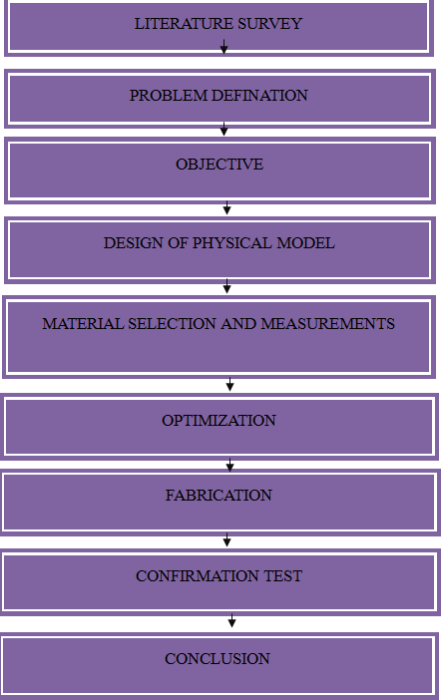

**Figure 3.1:** Methodology of Robotic Arm.

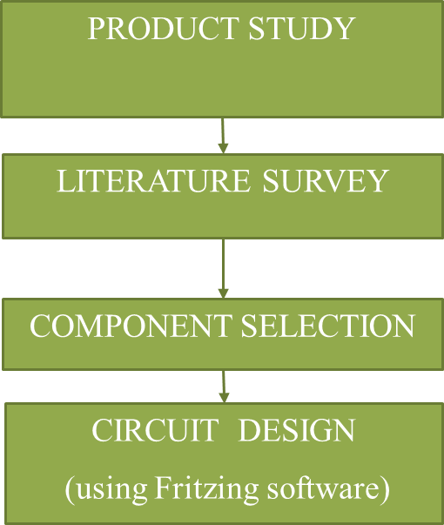 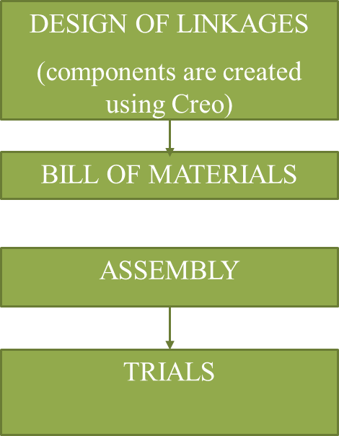 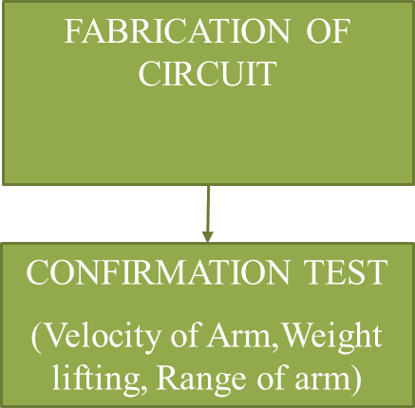

**Figure 3.2**: Methodology of Robotic Arm in Detail.

# Chapter 4

**Design and Fabrication of Robotic Arm**

*This chapter contains basic design of the whole system, detailed view of robotic arm assembly. Also detailed description of fabricated parts along with their drawing is specified. Robotic Arm linkages is designed in Creo parametric software. A number of researchers in the world are working in this field. Robotics is the new emerging booming field, which will be of great use to society in the coming years.*

## Introduction

There are different operations involved in the Robotic arm. The operations involve controlling two DOF using hand gesture and two DOF using Flex sensors. Robotics is a current emerging technology in the field of science. A number of researchers in the world are working in this field. Robotics is the new emerging booming field, which will be of great use to society in the coming years.

These days many types of wireless robots are being developed and are put to varied applications and uses. This has developed a robotic arm, with his own learning and resources, which is operated & controlled wireless with the help of finger movement which transmits signals to the robot through an auto device fixed on the gloves put on hands rather than manually controlling using hydraulic and pneumatic or controlling it manually through a conventional remote controller. The Robot moves and acts in the manner depending on the direction made by the fingers pressing the switch.

The robot moves in up, down, left or right directions and picks up objects from one place and keeps at another desired place as directed by the movements of fingers and hand. Robotic applications are widely used in research laboratories and industries to automate processes and reduce human errors. Some of the tasks performed by robots include assembly lines and motions that require force control with feedback to its

controller. This examines both tasks using a robotic Manipulator. In an assembly line, a robotic manipulator is often assigned to move an object from one position to another. One example of this application is in a research laboratory where pipits are used to transport substances from vials to a row of wells on a plate. The automated process results in faster completion time with minimal errors and downtime. There are three manipulator linkages including the end effector which is a gripper connected through rotational joints. The Design consists if two circuits that is the hand circuit or Arduino Nano circuit and Arm circuit or Arduino uno circuit.

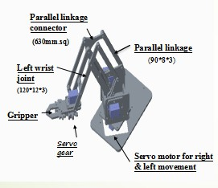

**Figure 4.1:** Assembly of Robotic Arm

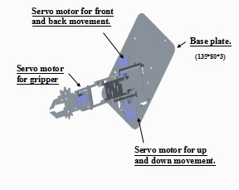

**Figure 4.1.1:** Assembly of Robotic Arm (top view)

**Table No.2:** Bill of Material

|  |  |  |  |
| --- | --- | --- | --- |
| **SR NO** | **PART NAME** | **MAT** | **QTY** |
| **1** | **SERVO MOTOR** | **STD** | **4 NOS** |
| **2** | **ACRYLIC SHEET** | **ACRYLIC** | **1 NO** |
| **3** | **BUSH** | **MS** | **2 NOS** |
| **4** | **ALUMINIUM SECTION** | **AL** | **1 M** |
| **5** | **BASE PLATE** | **MS** | **5 KG** |
| **6** | **BASE C CHANNEL** | **MS** | **1 NO** |
| **7** | **GRIPPER** | **STD** | **1 NO** |
| **8** | **NUT BOLTS** | **MS** | **10 NOS** |
| **9** | **AURDINO UNO** | **STD** | **1 NO** |
| **10** | **AURDINO NANO** | **STD** | **1 NO** |
| **12** | **OLED** | **STD** | **1 NO** |
| **13** | **nRF24L01** | **STD** | **2 NOS** |
| **11** | **DURACELL** | **STD** | **10 KG** |
| **12** | **ACCELEROMETER** | **STD** | **1 NO** |
| **14** | **HAND GLOVES** | **STD** | **1 NO** |
| **15** | **POWER SUPPLY** | **STD** | **2 NOS** |
| **16** | **SWITCH** | **STD** | **1 NO** |
| **17** | **BATTERY 12 V DC** | **DRY LEAD ACID** | **1 NO** |
| **19** | **CIRCUIT BOX** | **STD** | **1 NO** |

## Part Description of Robotic Arm

### Bottom Plate

It is the Aluminium plate subjected to dynamic loads. A servo motor is responsible for the swing of this base. Whole arm structure is mounted on the base as shown in the assembly of arm. It is made up of 3mm acrylic sheet which is fabricated using laser cutting operation. Left and Right arm servo plate is placed on the base and joint to the base using nuts and bolts .Column Base plates are designed to resist axial forces coming from top to bottom. And also transmits Uplift forces and Shear forces through rods and plate. Load coming from top to bottom, needs to transfer from structure to ground.

### Left and right arm servo plate

It is the plates supported by the base plate and is driven the servo motor. The overall the structure hold by this bottom base plate. It is also of acrylic sheet. Four legs are mounted on the on each corner of the plate to hold top plate. Two stepper motors are mounted on the bottom plate. A servo motor is responsible for left and right side movement of the arm and the other servo motor is responsible for up and down movement of the robotic arm. Detailed view of bottom plate is shown in fig. 4.2.

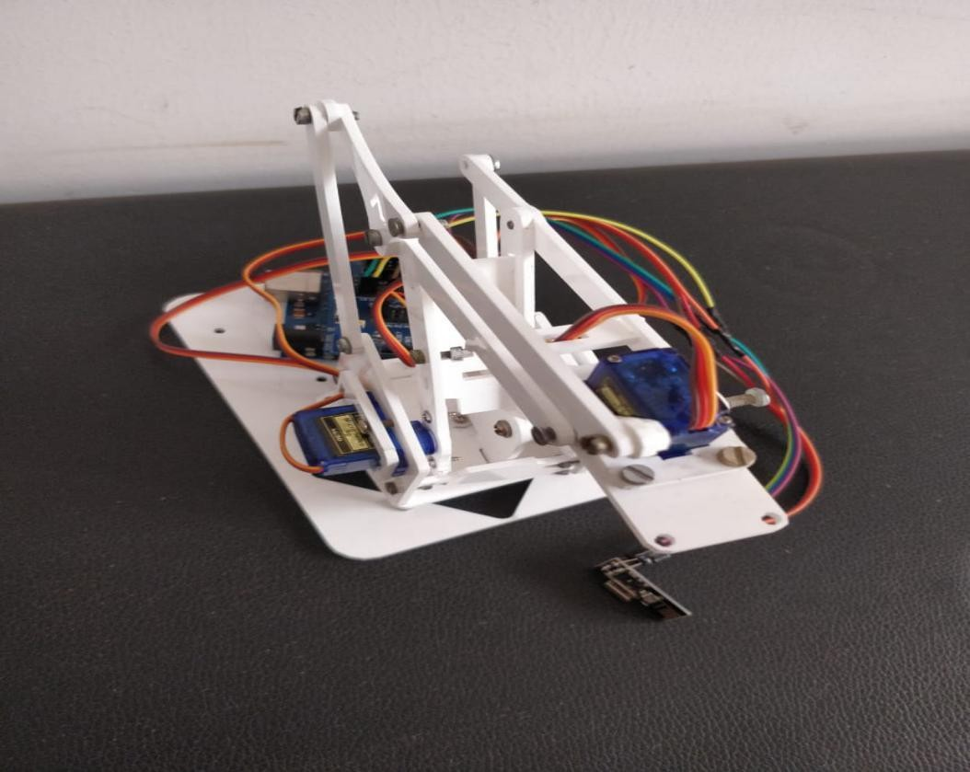

**Fig. 4.2:** Left and Right arm servo plate.

### Linkages

Structure of the Robotic Arm that is the linkages are made of Aluminium sections. They are two in numbers and are left arm servo plate and right arm servo plate. The material is 3mm acrylic sheet. They are bolted to each other and is connected to the base using nut and bolts Left and Right arm servo plate is placed on the base and joint to the base using nuts and bolts. Detailed view of Linkages is shown in fig. 4.3. Column Base plates are designed to resist axial forces coming from top to bottom. And also transmits Uplift forces and Shear forces through rods and plate. Load coming from top to bottom, needs to transfer from structure to ground.

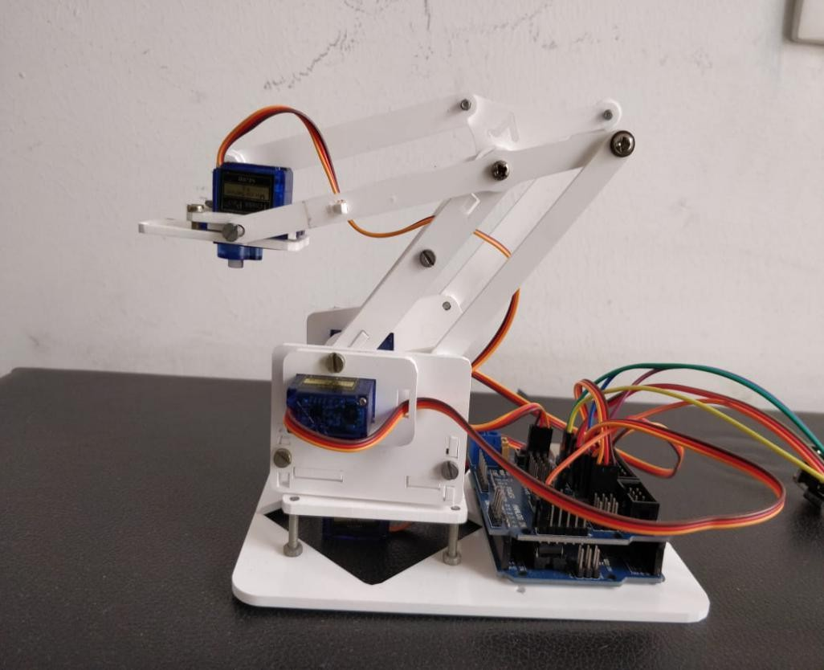

**Figure 4.1:** Linkage structure of arm.

# Chapter 5

# Robotic Arm Automation

*This chapter contains basic Electronic system. The chapter also involves selection of different controller, stepper motor, stepper, drivers used in the project. There are different electric components used in the robotic arm they are explained in the chapter below.*

## Introduction

The Arduino micro controller board controls all the movement process, as they are the most essential in the circuit. Electronics purpose of the designed is easy to connect and used by Beginner, Developer or Manufacturer. With the multiple quick connectors, these can put the power cables.

### Arduino

The controller is the brains of our Robotic Arm. Almost all arm controllers are based on the of the Arduino microcontroller. While a lot of variations exist. They are exchangeable and basically all do the same thing. Now and then the controller is a remained solitary circuit load up with chips on it, in most of the cases the controller is an .Arduino Uno (ATmega328)

The Arduino Uno is a microcontroller board based on the ATmega328. It has 14 digital input/output pins (of which 6 can be used as PWM outputs), 6 analog inputs, a 16 MHz ceramic resonator, a USB connection, a power jack, an ICSP header, and a reset button. It contains everything needed to support the microcontroller; simply connect it to a computer with a USB cable or power it with a AC-to-DC adapter or battery to get started. The Uno differs from all preceding boards in that it does not use

the FTDI USB-to-serial driver chip. Instead, it features the Atmega16U2 (Atmega8U2 up to version R2) programmed as a USB-to-serial converter.

* + - * 1.0 pinouts: added SDA and SCL pins that are near to the AREF pin and two other new pins placed near to the RESET pin, the IOREF that allow the shields to adapt to the voltage provided from the board. In future, shields will be compatible with both the board that uses the AVR, which operates with 5V and with the Arduino Due that operates with 3.3V. The second one is a not connected pin,that is reserved for future purposes.
      * Stronger RESET circuit.
      * Atmega 16U2 replace the 8U2."Uno" means one in Italian and is named to mark the upcoming release of Arduino 1.0. The Uno and version 1.0 will be the reference versions of Arduino, moving forward. The Uno is the latest in a series of USB.

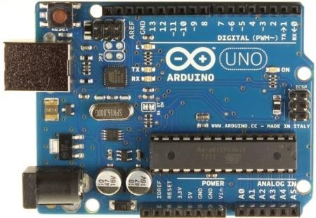

**Figure 5.1:** Arduino Uno

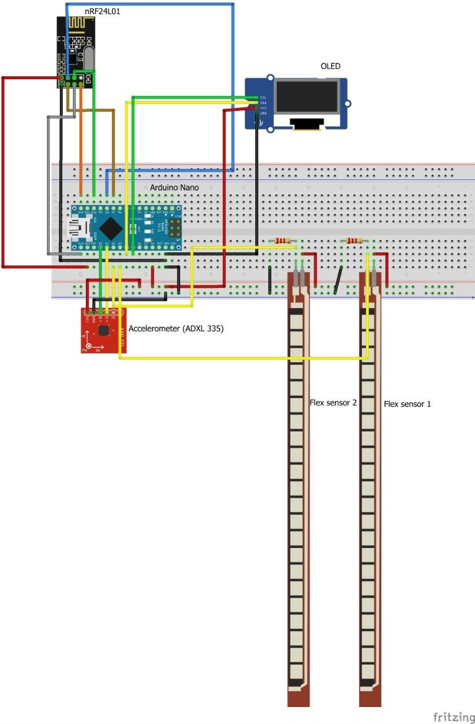

**Fig. 5.2:** Arduino Nano circuit.

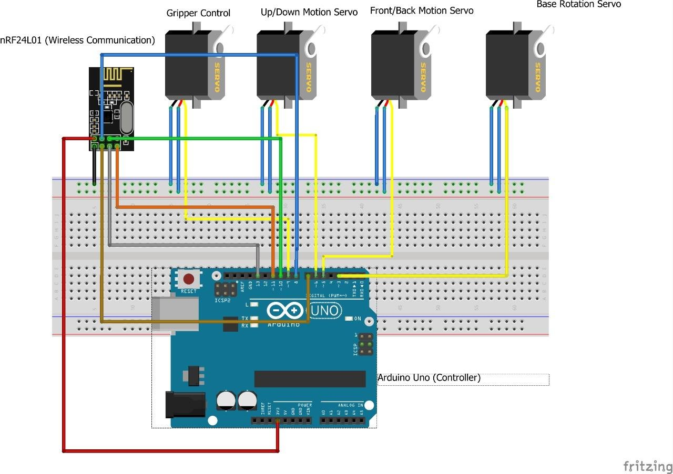

**Fig. 5.3:** Arduino Uno circuit.

**Technical specification:**

|  |  |
| --- | --- |
| Microcontroller | ATmega328 |
| Operating Voltage | 5V |
| Input Voltage  (recommended) | 7-12V |
| Input Voltage (limits) | 6-20V |
| Digital I/O Pins | 14 (of which 6 provide PWM output) |
| Analog Input Pins | 6 |

|  |  |
| --- | --- |
| DC Current per I/O Pin | 40 mA |
| DC Current for 3.3V Pin | 50 mA |
| Flash Memory | 32 KB (ATmega328) of which 0.5 KB used by bootloader |
| SRAM | 2 KB (ATmega328) |
| EEPROM | 1 KB (ATmega328) |
| Clock Speed | 16 MHz |

Note **:** The Arduino reference design can use an Atmega8, 168, or 328, Current models use an ATmega328, but an Atmega8 is shown in the schematic for reference. The pin configuration is identical on all three processors.

### Servo Motor

They have multiple coils that are organized in groups called "phases". By energizing each phase in sequence, the motor will rotate, one step at a time. With a computer controlled stepping you can achieve very precise positioning and/or speed control. For this reason, stepper motors are the motor of choice for many precision motion control applications. Stepper motors come in many different sizes and styles and electrical characteristics. This guide details what you need to know to pick the right motor for the job.

These motors are generally used in a variety of applications where precise position control is desirable and the cost or complexity of a feedback control system is unwarranted. Here are a few applications that are often found:. Printers CNC machines. Prototyping machines, Laser cutters• Pick and place machine, Linear actuators•, Hard drives etc.

For our Robotic arm, we are using a servo motor which satisfies the demand for the design and requirements of the arm. **Power** The Arduino Uno can be powered via the USB connection or with an external power supply. The power source is selected automatically. External (non-USB) power can come either from an AC-to-DC adapter (wall-wart) or battery. The adapter can be connected by plugging a 2.1mm center-

positive plug into the board's power jack. Leads from a battery can be inserted in the Gnd and Vin pin headers of the POWER connector. The board can operate on an external supply of 6 to 20 volts.

If supplied with less than 7V, however, the 5V pin may supply less than five volts and the board may be unstable. If using more than 12V, the voltage regulator may overheat and damage the board. The recommended range is 7 to 12 volts. The power pins are as follows:

* + - * **VIN.** The input voltage to the Arduino board when it's using an external power source (as opposed to 5 volts from the USB connection or other regulated power source). You can supply voltage through this pin, or, if supplying voltage via the power jack, access it through this pin.
      * **5V.**This pin outputs a regulated 5V from the regulator on the board. The board can be supplied with power either from the DC power jack (7 - 12V), the USB connector (5V), or the VIN pin of the board (7-12V). Supplying voltage via the 5V or 3.3V pins bypasses the regulator, and can damage your board. We don't advise it.
      * **3V3.** A 3.3 volt supply generated by the on-board regulator. Maximum current draw is 50 mA.
      * **GND.** Ground pins.
      * **IOREF.** This pin on the Arduino board provides the voltage reference with which the microcontroller operates. A properly configured shield can read the IOREF pin voltage and select the appropriate power source or enable voltage translators on the outputs for working with the 5V or 3.3V.
    1. **OLED** (Organic Light-Emitting Diode)

The organic light-emitting diode (OLED) display that we’ll use in this tutorial is the SSD1306 model: a monocolor, 0.96-inch display with 128×64 pixels as shown in following

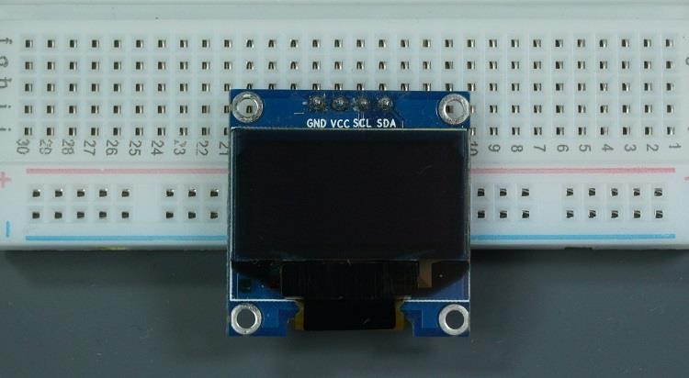

**Figure 5.4:** OLED [Source: Elekter.com]

The OLED display doesn’t require backlight, which results in a very nice contrast in dark environments. Additionally, its pixels consume energy only when they are on, so the OLED display consumes less power when compared with other displays.

The model we’re using here has only four pins and communicates with the Arduino using communication protocol. There are models that come with an extra RESET pin. There are also other OLED displays that communicate using SPI communication.

NRF24L01 transceiver module uses the 2.4 GHz band and it can operate with baud rates from 250 kbps up to 2 Mbps. If used in open space and with lower baud rate its range can reach up to 100 meters. The module can use 125 different channels which gives a possibility to have a network of 125 independently working modems in one place. Each channel can have up to 6 addresses, or each unit can communicate with up to 6 other units at the same time.

The power consumption of this module is just around 12mA during transmission, which is even lower than a single LED. The operating voltage of the module is from

1.9 to 3.6V.

Three of these pins are for the SPI communication and they need to be connected to the SPI pins of the Arduino, but note that each Arduino board have different SPI pins. The pins CSN and CE can be connected to any digital pin of the Arduino board and they are used for setting the module in standby or active mode, as well as for switching between transmit or command mode. The last pin is an interrupt pin which doesn’t have to be used.

### Power Supply

There are many types of power supply. Most are designed to convert high voltage AC mains electricity to a suitable low voltage supply for electronic circuits and other devices. A power supply can by broken down into a series of blocks, each of which performs a particular function. For example a 5V regulated supply:

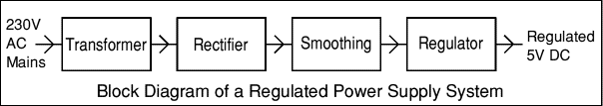

**Fig. 5.5:** Regulated power supply system.

Each of the blocks is described in more detail below:

* [Transformer](http://www.kpsec.freeuk.com/powersup.htm#transformer) - steps down high voltage AC mains to low voltage AC.
* [Rectifier](http://www.kpsec.freeuk.com/powersup.htm#rectifier) - converts AC to DC, but the DC output is varying.
* [Smoothing](http://www.kpsec.freeuk.com/powersup.htm#smoothing) - smoothes the DC from varying greatly to a small ripple.
* [Regulator](http://www.kpsec.freeuk.com/powersup.htm#regulator) - eliminates ripple by setting DC output to a fixed voltage.

Power supplies made from these blocks are described below with a circuit diagram and a graph of their output:

* [Transformer only](http://www.kpsec.freeuk.com/powersup.htm#tonly)
* [Transformer + Rectifier](http://www.kpsec.freeuk.com/powersup.htm#tr)
* [Transformer + Rectifier + Smoothing](http://www.kpsec.freeuk.com/powersup.htm#trs)
* [Transformer + Rectifier + Smoothing + Regulator](http://www.kpsec.freeuk.com/powersup.htm#trsr).

### Flex sensor

A Flex Sensor or sometimes called as Bend Sensor is a device that measures the amount of bend or angular deflection. Usually, a Flex Sensor is made up of a variable resistive surface and the amount of resistance is varied by bending the sensor. The Flex Sensor used in this project is shown in the following image. It is about 8 cm long.

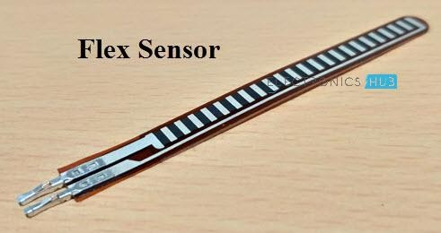

**Figure 5.6:** Flex Sensor [Source: Electronicshub.org]

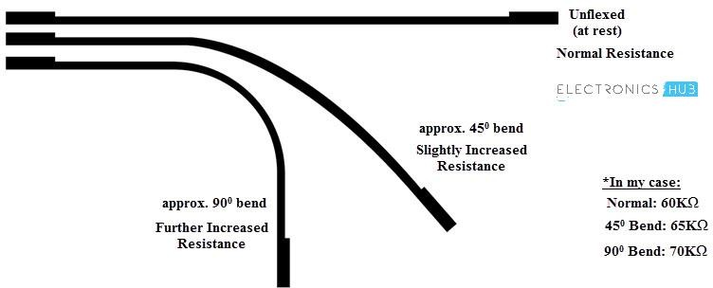

**Figure 5.7:** Bend Angles of Flex Sensor [source: Electronicshub.org]

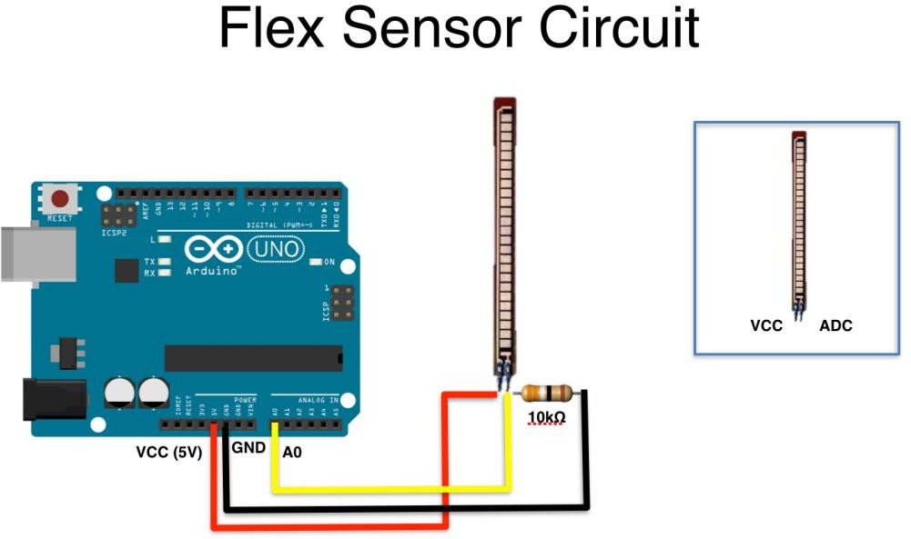

**Figure 5.8:** Interface Of Flex Sensor Circuit [Source: Ardunitydoc.com]

The glove is mounted with flex sensors: variable resistors that change their value when bent. They're attached to one side of a voltage divider with resistors of a constant value on the other side. The Arduino reads the voltage change when the sensors

are bent, and triggers the motors to move a proportional amount. The motor pull strings that rotates the arms.

## Programs of Arduino Uno and Arduino Nano :

### Program of Arduino Nano mounted on gloves:

**/**/Add the necessary libraries

//You can find all the necessary library links in the video description. #include <SPI.h> //SPI library for communicate with the nRF24L01+ #include "RF24.h" //The main library of the nRF24L01+

#include "Wire.h" //For communicate

//Define the object to access and cotrol the Gyro and Accelerometer (We don't use the Gyro data)

int ax, ay, grip, mod; int grip_t = 500;

int grip_open = 0; // values of servo motor in degree for it’s open position int grip_close = 90; // values of servo motor in degree for it’s closed position int mod_t = 500;

//Define packet for the direction (X axis and Y axis) int data[4];

//Define object from RF24 library - 9 and 10 are a digital pin numbers to which signals CE and CSN are connected.

RF24 radio(7, 8);

//Create a pipe addresses for the communicate const uint64_t pipe = 0xE8E8F0F0E1LL; void setup(void) {

Serial.begin(9600);

radio.begin(); //Start the nRF24 communicate radio.openWritingPipe(pipe); //Sets the address of the receiver to which the

program will send data.

pinMode(A0, INPUT); pinMode(A1, INPUT); pinMode(A2, INPUT); pinMode(A3, INPUT);

}

void loop(void) {

ax = analogRead(A0); ay = analogRead(A1); grip = analogRead(A2); mod = analogRead(A3);

//grip call

if (grip < grip_t)

{ //close

for (int i = grip_open; i < grip_close; i++)

{

data[3] = i;

}

}

if (grip > grip_t)

{ //open

for (int i = grip_close; i > grip_open; i--)

{

data[3] = i;

}

}

//mod check

if (mod < mod_t)

{ //nomal mode if (ax < 400)

{

data[0] += 1;

if (data[0] > 170)

{

data[0] = 170;

}

}

if (ax > 600)

{

data[0] -= 1;

if (data[0] < 10)

{

data[0] = 10;

}

}

if (ay < 400)

{

data[1] += 1;

if (data[1] > 170)

{

data[1] = 170;

}

}

if (ay > 600)

{

data[1] -= 1;

if (data[1] < 10)

{

data[1] = 10;

}

}

}

else { //other mode if (ay < 400)

{

data[2] += 1;

if (data[2] > 170)

{

data[2] = 170;

}

}

if (ay > 600)

{

data[2] -= 1;

if (data[2] < 10)

{

data[2] = 10;

}

}

}

radio.write(data, sizeof(data));

}

### Program for Arduino Uno mounted on arm:

#include <Servo.h>

//Add the necessary libraries

//You can find all the necessary library links in the video description #include <SPI.h> //SPI library for communicate with the nRF24L01+ #include "RF24.h" //The main library of the nRF24L01+

#define rot 0

#define sh 1

#define el 2

#define grip 3

//Define enable pins of the Motors

//const int enbA = 3;

//const int enbB = 5;

//Define control pins of the Motors

//If the motors rotate in the opposite direction, you can change the positions of the following pin numbers

//const int IN1 = 2; //Right Motor (-)

//const int IN2 = 4; //Right Motor (+)

//const int IN3 = 7; //Left Motor (+)

//const int IN4 = 6; //Right Motor (-)

//Define variable for the motors speeds

//I have defined a variable for each of the two motors

//This way you can synchronize the rotation speed difference between the two motors

//int RightSpd = 130;

//int LeftSpd = 150;

//Define packet for the direction (X axis and Y axis) int data[4];

//Define object from RF24 library - 9 and 10 are a digital pin numbers to which signals CE and CSN are connected

RF24 radio(7, 8);

//Create a pipe addresses for the communicate const uint64_t pipe = 0xE8E8F0F0E1LL; Servo rot;

Servo sh; Servo el; Servo grip; void setup() {

//Define the motor pins as OUTPUT Serial.begin(9600);

radio.begin(); //Start the nRF24 communicate radio.openReadingPipe(1, pipe); //Sets the address of the transmitter to which the

program will receive data. radio.startListening(); rot.attach(3); sh.attach(4);

el.attach(5); grip.attach(9); rot.write(90); sh.write(90);

el.write(90);

grip.write(90);

}

void loop() {

if (radio.available())

{

radio.read(data, sizeof(data)); rot.write(data[0]);

sh.write(data[1]);

el.write(data[2]); grip.write(data[3]);

}

}

# Chapter 6 Result and Discussion

*The robotic arm was designed with four degrees of freedom and programmed to accomplish accurately simple light material lifting task to assist in the production line in any industry. Robotic arm method is used in this project to fabricate the components of the robotic arm. Therefore, it provided more precise dimensions and huge time and cost- saving in fabrication. The robotic arm is equipped with 4 servo motors to link the parts and bring arm movement.*

## Construction of the robotic arm

The process of conversion of raw material in to finished products using the three resources as Man, machine and finished sub-components. Manufacturing is the term by which we transform resource inputs to create Useful goods and services as outputs. Manufacturing can also be said as an intentional act of producing something useful.

It is the phase after the design. Hence referring to those values we will plan. The various processes using the following machines: -

* + 1. Universal lathe
    2. Milling machine
    3. Grinding machine
    4. Power saw
    5. Drill machine
    6. Electric arc welding machine

Manufacturing Process: - The following are the various manufacturing process used in mechanical engineering.

1. Primary Shaping Process:-

The process used for the preliminary shaping of the machine component is known as primary shaping process.

1. Machine Process :-

The process used for giving final shape to the machine component, according to planned dimensions is known as machining process. The common operation drilling, boring etc.

1. Surface Finishing Process:-

The process used to provide a good shape surface finish for the machine components are known as surface finishing processes. The common operation used for the process are polishing, buffing, lapping etc.

1. Joining Process :

The process used for joining machine components are known as joining process. The common operation used for this process are soldering, brazing, welding etc.

1. Process Affecting Change In Properties:-

These are intended to import specific properties to material e.g. heat treatment, hot working, cold rolling etc.

## Operation of the Robotic Arm

Here we are having four pots provided to the user that is by rotating these four pots, we supply variable voltage at the ADC channels of UNO. So the digital values of Arduino are under control of user. These digital values are to adjust the servo motor position, thus the servo position is in control of user and by rotating these pots we can move the joints of Robotic arm and we can pick or grab or place any object**.** The voltage across variable resistors is not completely linear it will be a noisy one. So to filter out this noise, capacitors are placed across each resistor.

Robotic Arm is controlled by flex sensors and we control it with the help of control switches, we can move these servos by switching the switches to pick objects, with some practice we can easily pick and move the object from one place to another. We have used low torque motors here but we can use more powerful to pick heavy object.

Practice is required for rotating the pots accordingly and thus by when the ADC values are from 0-1023 it will match the servo degree of rotation that is from 0 to 180 degree and we get an appropriate output. Thought there was many vibration in the system still. I made use of capacitor 1000 micro farad and 100 nano farad do that we can use of it and block the noise and improve the stability of the robotic arm. The whole circuit it works accordingly when we apply a 5V supply to the system and we get a suitable output. Thus representing how it works accordingly. Still there is a problem of vibration in the system that can reduce in the future enhancement that is maybe we can use high power servo motor and by the help of it vibration can be reduced even the grabbing power is less that it can pick a very heavy object just a lighter object.

In future this structure can be modified and made of heavier materials and power supply or either accelerometer or simple ac, dc motors thus we will get a structure that would be able to pick object easily and grab heavy object easily and act like a perfect crane.

## Results

1. Linear velocity of arm is calculated to be 36 millimeter per second for the servos programmed to rotate 1 degree in 32 milli-seconds. Arduino Nano is programmed such that the servo motor rotates 360 degrees in 11520 milliseconds or 11.52 seconds. Thus for covering the circumference with diameter of 400 mm.on the basis of the above calculations linear velocity of arm is resulted as 32 milli seconds.
2. It can pick and place a weight up to 0.8 kg with servomotor having accuracy of drive of 0.5 degree. The arm is made to first lift the load starting from 0.3 kg and gradually increased the load. It can lift a load up to 1.4 kg but can pick and place a load up to 0.8 kg as in the assembly line.
3. It is circular range is 200 mm i.e the reach of the arm from origin. Firstly the arm is fully stretched to its maximum level that is front movement is actuated fully and front movement of arm is actuated fully, then the distance of the extreme is measured by scale from the origin.
4. Semicircular working Envelope is 100 mm since the arm cannot access inner reach up to 100 mm. As per the dimensions of the linkages structure, arm cannot work under the range of 100 mm from the origin that is its working envelope is reduced by 100 mm. Since its working range is 200 mm, working envelope is calculated to be 100 mm.

# Chapter 7

**Future Enhancement and Conclusion**

*Robotic arm is integrated into a production line, the production speed will increase as the* ***robot*** *reduces the cycle time between each work piece. Also, the quality of the product begins to improve because of the* ***robot's*** *ability to accurately sand down edges, produce straighter welds or drill precise holes.*

## Future Enhancement

* + - Future enhancement can include further improvement that is by adding 360 degree rotary servo motor and making it more stable.
    - Setup can be modified that will pick more weight compared to present model.
    - Ultrasonic sensor can even be placed on the arm so that it can detect and simultaneously pick the object and keep it on other place.
    - The robot so programmed for picks and place operation can be made versatile and more efficient by providing the feedback.
    - Making it to work on own than any human interventions.
    - It can be made possible by image processing tool interfaced with this Arduino.
    - The features that can be added on to improve its efficiency.
    - It operate on its own thought without any human intervention are line follower, obstacle avoider, metal detector, bomb diffuser etc.

## Conclusion:

* + - This proposed work is an overview of how we can make use of nRF24L01 and flex sensors for interfacing of a robotic arm and control it using arduino UNO. Also used for high loaded industrial application work.
    - Depending upon the application, end effector can be modified. End effector can be anything such as pick and place, drill etc.
    - Robotic arms, many areas are developable. Thanks to the robotic arms, many tasks are made easier and the resulting error level has been reduced to a minimum. For example; some pharmacy-based drug-giving robots and a projected robot arm have been developed. In addition to this, the ability to move the robot arm is further increased, and when the camera is placed in the finger area and the sensitivity is increased, it can be used in a wide range of applications from the medical sector to the automation systems.
    - With the robotic arms developed in this way, the risk of infecting the patient in the medical sector is minimized, while the human errors are minimized during the surgical intervention. Despite the fact that the robotic arm made by this project is of prototype quality, it has a quality that can be improved for more robotic systems. Besides these, robotic arm sector, which is open to development, will keep its importance in the future.
    - The purpose of the project is to provide control of 4 axes moving robot arm design and this robot arm with a suitable micro controller and Bluetooth module with android application. The necessary theoretical and practical information for this purpose has been obtained and the necessary infrastructure has been established for the project. During the process of making and developing the project, a lot of theoretical knowledge has been transferred to the practice and it has been ensured that it is suitable for the purpose of the project.

# References

1. S Mohamed, “New Approaches to Robotics”, Science, vol. 253, pp. 1227- 1232, 13

September 1991.

1. J. Anush, J. Adams and H. Molle “Arduino Robotics”, Springer Science and Business Media, 2011.
2. N F Begum, M. Couceiro, C. Figueiredo and R. Rocha, "TraxBot: Assembling and Programming of a Mobile Robotic Platform". In Proc. of the 4th International Conference on Agents and Artificial Intelligence (ICAART 2012), Vilamoura, Portugal, Feb 6-8, 2012.
3. T Yoshimi, B. Gerkey, R. Wheeler, and A. Y. Ng, "ROS: an open-source Robot Operating System," in Proc. Open-Source Software workshop of the International Conference on Robotics and Automation, Kobe, Japan, May, 2009.
4. S Wang and A. Howard, "The Player/Stage Project: Tools for Multi - Robot and Distributed Sensor Systems", In Proc. of the Intl. Conf. on Advanced Robotics, pp. 317-323, Coimbra, Portugal, 2003.
5. WMHW Kadir, RE Samin, BSK Ibrahim. Internet controlled a robotic arm.

Procedia Engineering. 2012.

1. MAK Yusoff, RE Samin, mobile robotic arm. Procedia Engineering. 2012.
2. AM Al-Busaidi, Development of an educational environment for online control of a biped robot using MATLAB and Arduino, (MECHATRONICS), 9th France-Japan.2012.
3. HS Juang, KY Lurrr. Design and control of a two-wheel self-balancing robot using the Arduino microcontroller board. Control and Automation (ICCA), 2013.
4. R Krishna, GS Bala, SS ASC, BBP Sarma. Design and implementation of a robotic arm based on haptic technology. Int. J. of Eng. Research. 2012.
5. Araújo, D. Portugal, M. Couceiro, C. Figueiredo and R. Rocha, "TraxBot: Assembling and Programming of a Mobile Robotic Platform". In Proc. of the 4th

International Conference on Agents and Artificial Intelligence (ICAART 2012), Vilamoura, Portugal, Feb 6-8, 2012.

1. M. Quigley, B. Gerkey, K. Conley, J. Faust, T. Foote, J. Leibs, E. Berger, R. Wheeler, and A. Y. Ng, "ROS: an open-source Robot Operating System," in Proc. Open-Source Software workshop of the International Conference on Robotics and Automation, Kobe, Japan, May, 2009.
2. R. Rusu and S. Cousins, "3D is here: Point Cloud Library (PCL)", In Proc. of International Conference on Robotics and Automation (ICRA 2011), Shanghai, China, May 2011.
3. Upadhyaya TK, Kosta S, Jyoti R, Palandoken M; Negative refractive index material-inspired 90-deg electrically tilted ultra wideband resonator. Opt. Eng. 0001;53(10):107104. doi:10.1117/1.OE.53.10.107104.